GoREST API Testing & Automation with Postman

Names: INGABIRE Marie Noelle
Module: Web Infrastructure_ Formative Assignment
API Used: GoREST - Public REST API with Bearer Token Authentication
Base URL: https://gorest.co.in/public/v2
Github Repository: https://github.com/Noelle-1220/API_Testing_Formative

1.API Choice

To carry out this assignment , I used GoREST as it is the best API because it is free, supports full CRUD(Create, Read, Update and Delete) and also uses a simpler Bearer Token instead of a complex OAuth2 flow.

GoREST uses a personal access token model unlike other API, GoREST allows a user to log in with a username/password and get a static token (generated at gorest.co.in/public/v2 ) tied to the account (either Github or Google). The token acts as your authorization proof to carry out requests like GET, POST, PUT/PATCH and DELETE.

2. GoREST API Endpoint Documentation

Purpose | Method | Endpoint | Auth Required? | Request Body
List all users | GET | {{base_url}}/users | None (Public read) | None
Get one user | GET | {{base_url}}/User/  [{user_id}} | None (public read) | None
Create user | POST | {{base_url}}/users | Authorization: Bearer {{auth_token}} Content-Type: application/json | JSON: name, email, gender, status
Update user | PUT/PATCH | {{base_url}}/users/{{user_id}} | Authorization: Bearer {{auth_token}}, Content-Type: application/json | JSON with fields to update
Delete user | DELETE | {{base_url}}/users/{{user_id}} | Authorization: Bearer {{auth_token}} | None

3. Authentication Process

Method Used: Bearer Token (GoREST Personal Access Token)

The token generated was added in the GoREST Env (a Postman Environment) as auth_token. At the collection/folder level,I set the Authorization tab to Bear Token using {{auth_token}} as the token value. Setting it at the Collection level allows every request inside the folder to automatically inherit the exact authentication without repeating it per each request I make.

This way of authentication satisfies the underlying goal as a login-based pre-request script, but abides by GoREST’s actual token model rather than simulating a login flow.
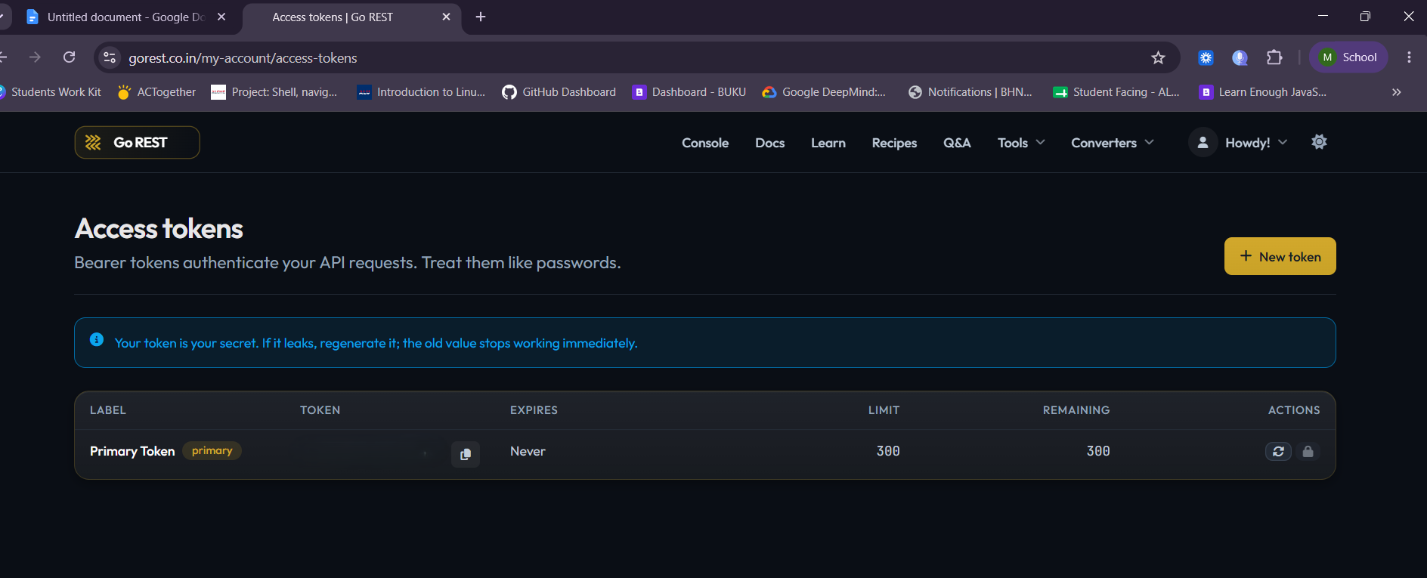

4.Postman Environment & Variables

GoREST Env is a postman environment created to contain following variables:

Variable | Purpose
base_url | Stores the API’s base url, making variable reuse easier since it’s updated in one place.
auth_token | Stores the Bearer Token used to authenticate write operations.
user_id | Initially left empty then populated after the user is created (POST) and reused across the remaining CRUD operations.

All requests reference these variables using postman’s {{variable_name}} syntax. Using this method allows us to only update changes in the environment instead of updating each request individually.

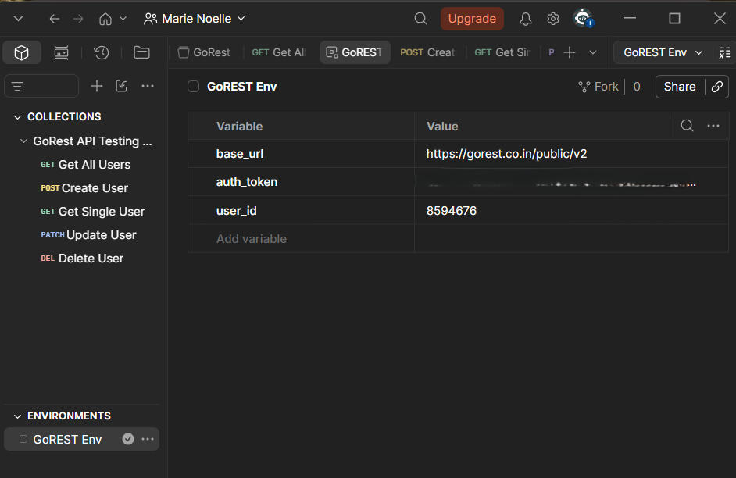

5. CRUD Operation _ Explanation and Screenshots

- Get all User:

- Request: GET {{base_url}}/users retrieves all users that used the GoREST API. I carried out this step to ensure the environment and auth_token are functioning properly
- Response: the request returned a 200 status indicating all were in place and green flagged. The result listed all users as I requested.
- Screenshot:
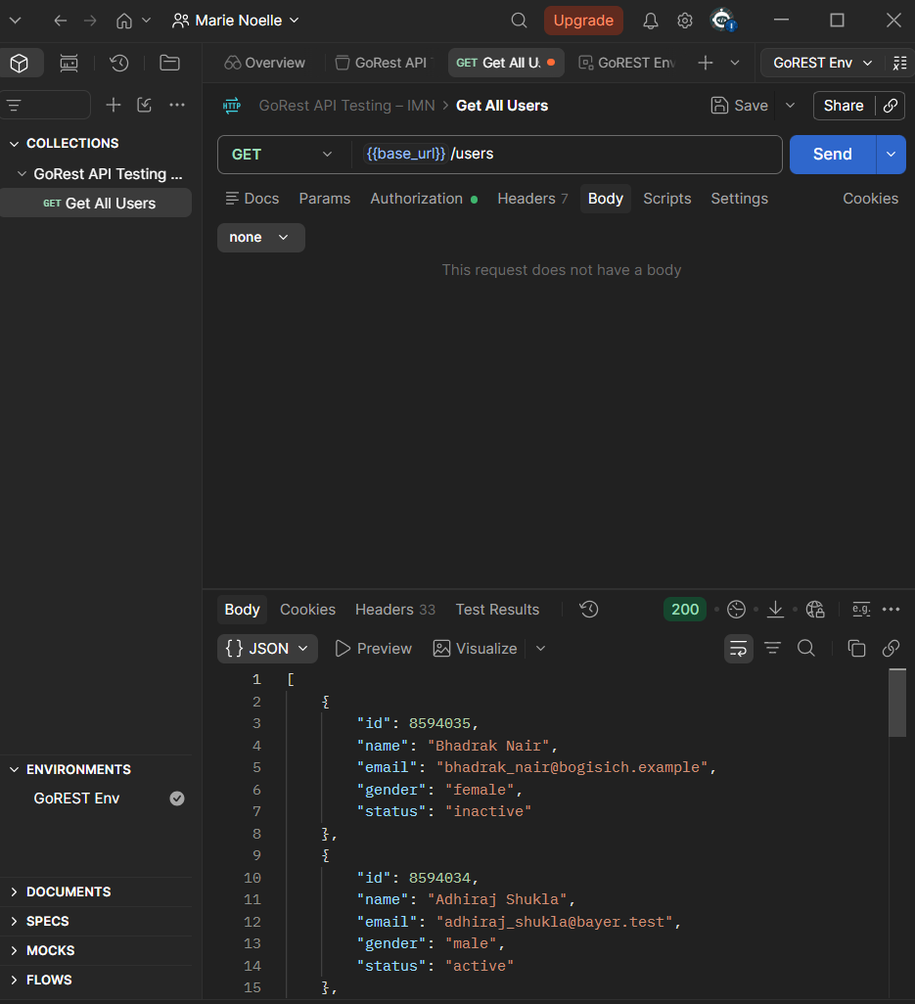

- POST - Creating my user

- Request: POST {{base_url}}/users
- Body:
{
"name": "YOUR_NAME_HERE",
"gender": "male",
"email": "YOUR_EMAIL_HERE_{{$randomInt}}@example.com",
"status": "active"
}
- Response: a 201 indicating the user was created successfully. The result comes bearing an Id which will be considered a unique user id and the value for variable {user_id} . “{$randomInt}}” is a Postman dynamic variable that ensures there is not similar email which keeps my email accepted by GoREST.
- Post-response script:
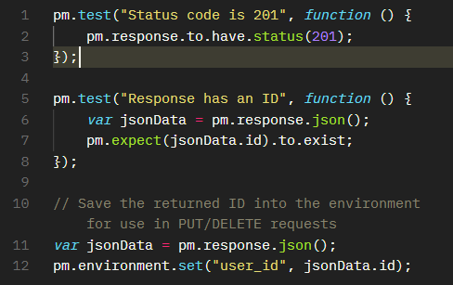

- Screenshot:
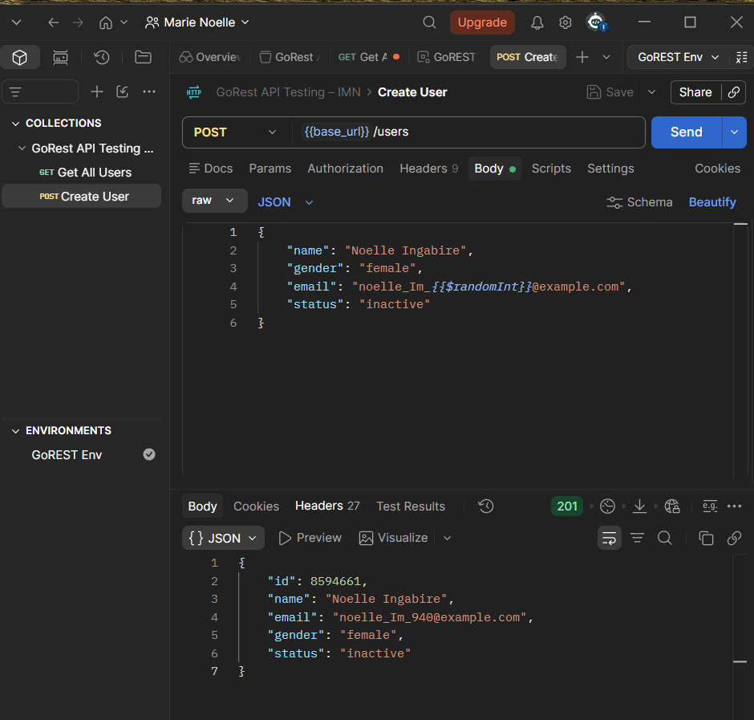

- Get Single User

- Request: {{base_url}}/users/{{user_id}}
- Script:
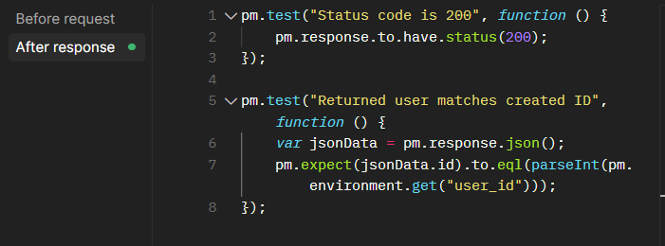
- Response: a 200 indicating the request was successful. Reference to the image below.
- Screenshot:
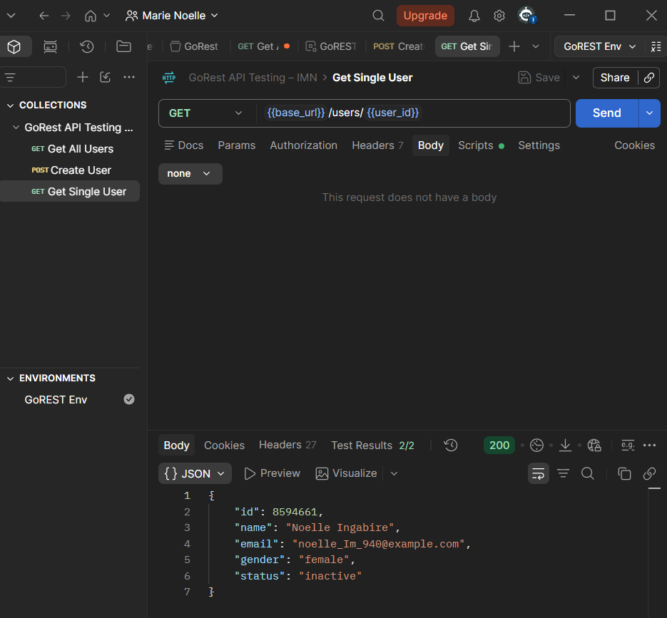

- PUT/PATCH - Update the user

- Request:PATCH {{base_url}}/users/{{user_id}} , I used PATCH to only update and inside specific areas of my request instead of PUT as I would have to write all the body details even those I do not intend to change.
- Body:
raw=>JSON
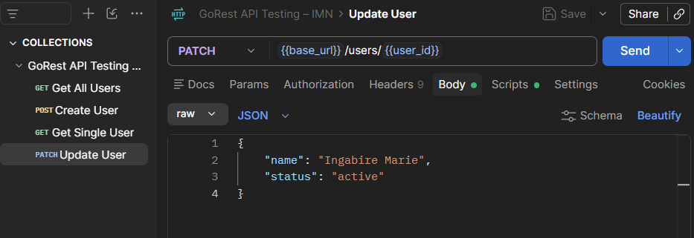
- Script:
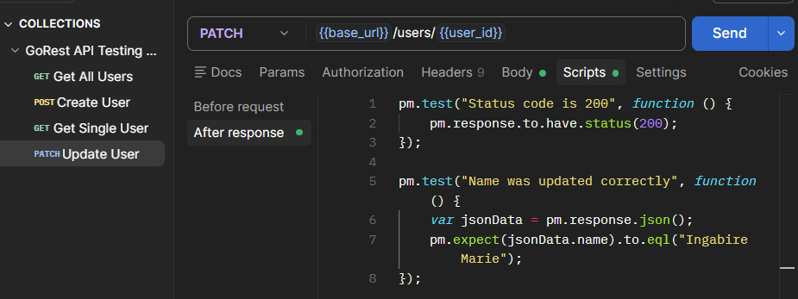
- Response: a 200 indicating it was successful. More details reference to the below image.
- Screenshot:
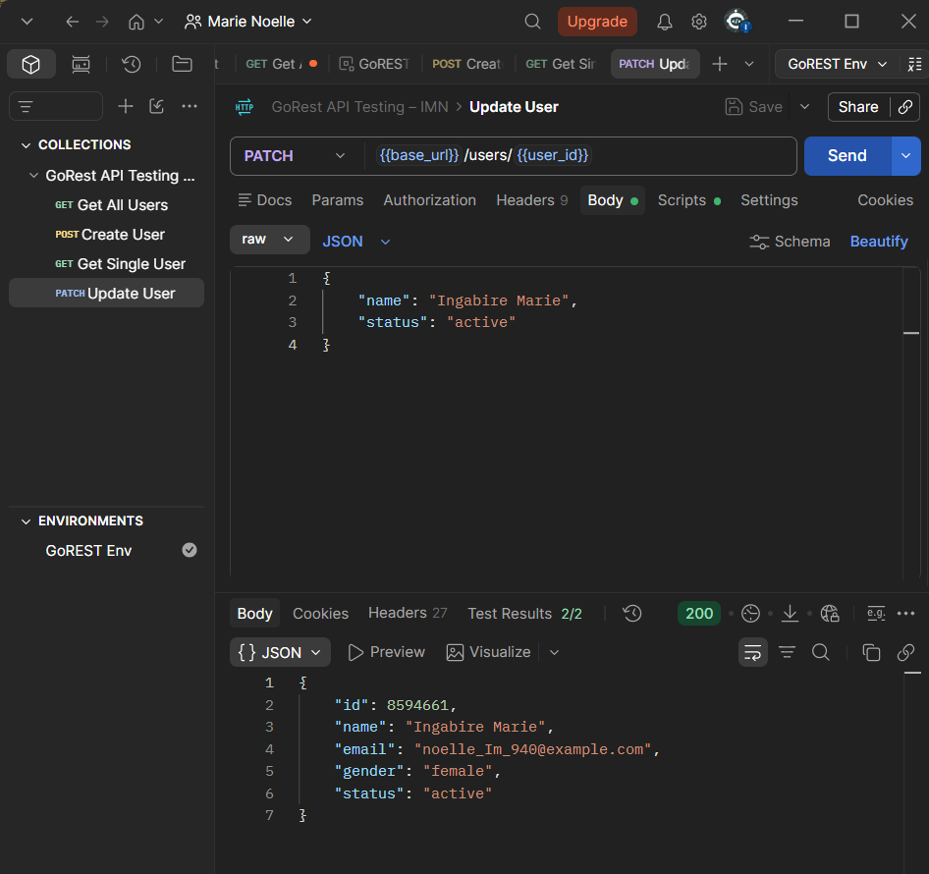

- DELETE - Remove the User

- Request: DELETE {{base_url}}/users/{{user_id}}
- Script:
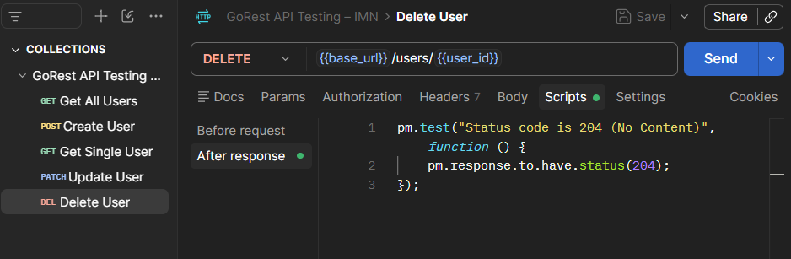
- Response: a 204 code meaning No Content which indicates the deletion was a success, more details reference to the image below.
- Screenshot:
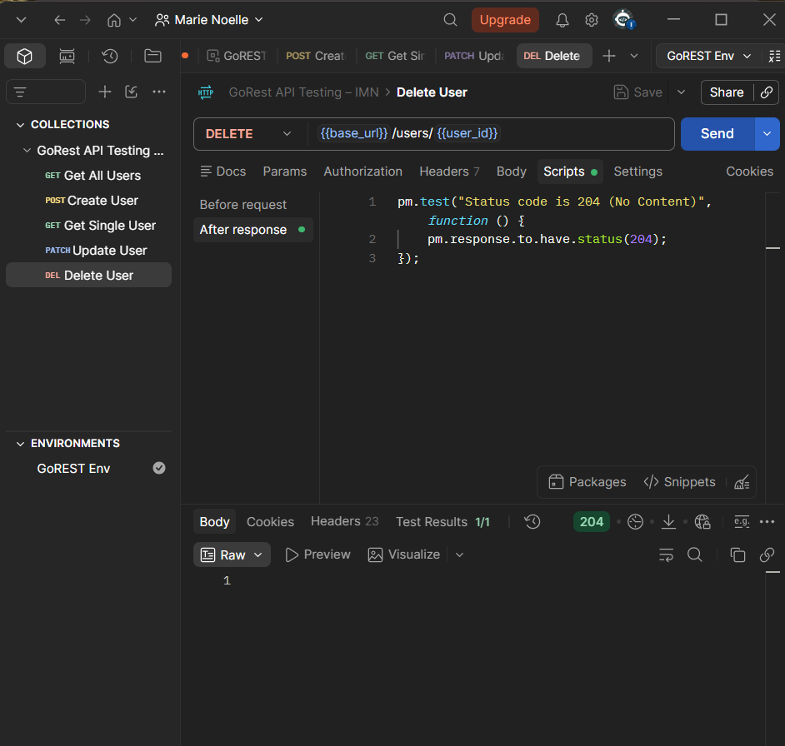

6. Successful Collection Runner

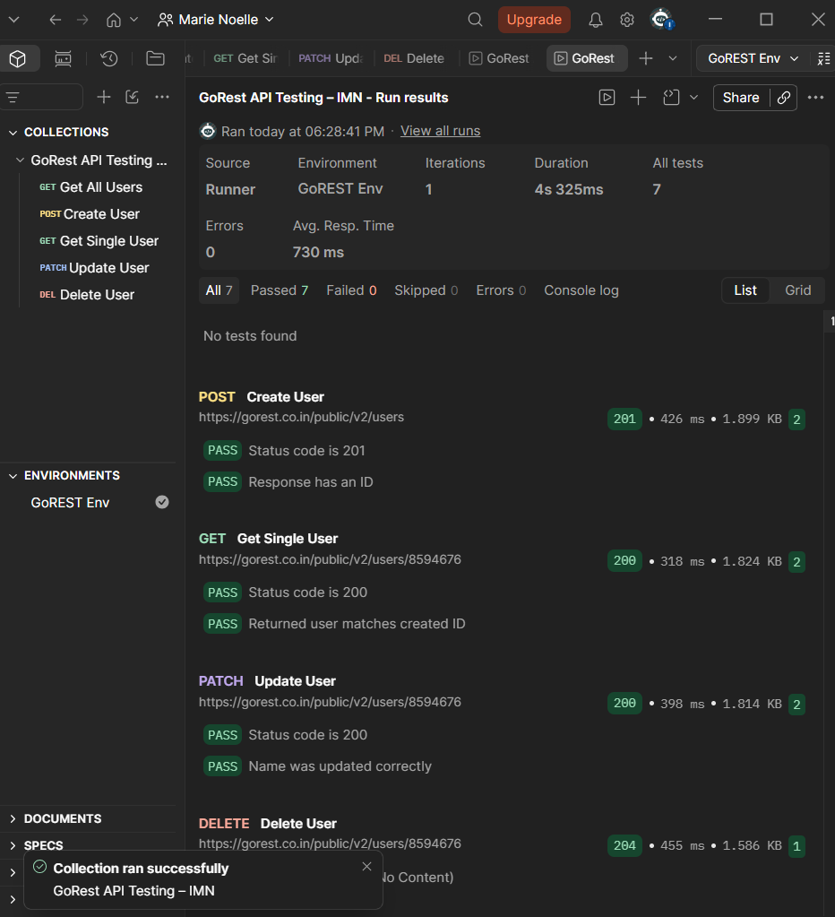

7. Deliverable Included in this Repository

- GoREST API Testing - IMN_collection.JSON
- GoREST Env_environment.JSON
- Screenshots Folder

