End-Member-Mixing-Analysis

Course Geodata Analysis and Modelling, Spring Semester 2019, Institute of Geography, University of Bern

Led by PD Dr. Andreas Zischg and Dr. Pascal Horton

This report accompanies the python project by Noemi Buri

Introduction

This python project is part of the master thesis “Abflussseparation mittels stabiler Isotopen – Bestim­mung der Wasserherkunft nach Regen, Schnee- und Gletscherschmelze in drei alpinen Einzugsgebieten” (hydrological separation with stable isotopes – determination of the water origin regarding rain, glacier and snowmelt in three alpine catchments). The master thesis is embedded in a research project of the hydropower company Kraftwerke Oberhasli AG (KWO) and the University of Bern. Background of this research project is the influence of climate change on the discharge patterns in small glacier dominated alpine catchments. Since the snow cover and the glacier are of great importance for the discharge (Hänggi & Weingartner, 2012), changes in the discharge patterns are expected (BAFU, 2012). Hydropower plants are important for the swiss electric production and those in alpine regions are influenced by these changes in discharge patterns (Hänggi & Weingartner, 2012). That is why the KWO is interested in the impact of the climate change on their future energy production. Model calculations on the future discharge developments are already available (VAW, 2014). The aforementioned master thesis has the goal to enhance knowledge about the water origin of rain, snow- and glacier melt. Therefore, a hydrological separation with stable isotopes in three alpine catchments is conducted. To perform the hydrological separation an end-member-mixing-analysis (EMMA) is carried out.

EMMA

Area of Application

Mixing models are often used to perform hydrological separations, there is a differentiation between two-component hydrological separation and multi- or three-component hydrological separation (Penna & van Meerveld, 2019). The two-component hydrological separation is used to differentiate the temporal origin of the discharge. Pre-event and event water are separated. To do so, only one tracer is needed (Pinder & Jones, 1969 ; Penna & van Meerveld, 2019).

The three-component hydrological separation or EMMA is used to differentiate the geographic origin of the discharge (Ali et al., 2010; Christhophersen et al., 1990; Christophersen & Hooper, 1992). Often separated end-members are rainwater, soil water and groundwater or glacier melt, snowmelt and groundwater (Penna & van Meerveld, 2019). To perform an EMMA, at least two tracers need to be used. An advantage of EMMA in comparison to other mixing models is that the number of considered tracers is not limited. The tracers can be set in relationship to each other by a principal-component-analysis (PCA) (Christophersen & Hooper, 1992). The *EMMA.py* script does not include the PCA.

There are several conditions which need to be met when applying an EMMA (Cable et al., 2011; Penna & van Meerveld, 2019; Hooper et al., 1990). For example, the contribution of additional components to the discharge must be negligible. To see all conditions please consider the paper of Pu et al. (2013).

Calculation

The calculation of the EMMA follows the description of Wyss (2016). The script is based on vector calculations. The three considered components (in case of the master thesis: rain, snow- and glacier melt) are called A, B and C. The water sample for which the EMMA is performed is called P. Output of the script is the mixing triangle and the visualisation of the calculation of the percentage of component A. An example is shown in figure 1. Furthermore, the percentages of the three components A, B and C are given. For more details on the calculations check the *README.md* and the *EMMA.py*.

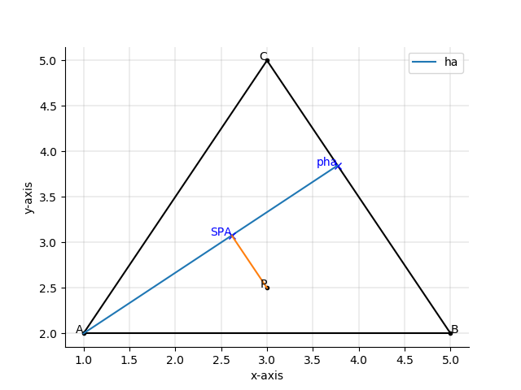

Figure 1: mixing triangle

Sources

Ali, G. A., Roy, A. G., Turmel, M.-C., & Courchesne, F. (2010). Source-to-stream connectivity assessment through end-member mixing analysis. *Journal of Hydrology*, *392*(3–4), 119–135. https://doi.org/10.1016/j.jhydrol.2010.07.049

BAFU, Bundesamt für Umwelt (2012). Auswirkungen der Klimaänderung auf Wasserressourcen und Gewässer. Synthesebericht zum Projekt ‘Klimaänderung und Hydrologie in der Schweiz’ (CCHydro). *Umwelt-Wissen*, *1217*, 55–74. https://doi.org/10.1680/efcc.19256.0006

Cable, J., Ogle, K., & Williams, D. (2011). Contribution of glacier meltwater to streamflow in the Wind River Range, Wyoming, inferred via a Bayesian mixing model applied to isotopic measurements. *Hydrological Processes*, *25*(14), 2228–2236. https://doi.org/10.1002/hyp.7982

Christophersen, N., Neal, C., Hooper, R., Vogt, R., & Andresen, S. (1990). Modelling streamwater chemistry as a mixture of soilwater end-members- a step towards secondgeneration acidification models, *116*, 307–320.

Christophersen, N., & Hooper, R. (1992). Multivariate Analysis of Stream Water Chemical Data’ The Use of Principal Components Analysis for the End-Member Mixing Problem. *Water Resources Research*, *28*(1), 99–107.

Hänggi, P., & Weingartner, R. (2012). Variations in Discharge Volumes for Hydropower Generation in Switzerland. *Water Resources Management*, *26*(5), 1231–1252. https://doi.org/10.1007/s11269-011-9956-1

Hooper, R. P., Christophersen, N., & Peters, N. E. (1990). Modelling streamwater chemistry as a mixture of soilwater end-members — An application to the Panola Mountain catchment, Georgia, U.S.A. *Journal of Hydrology*, *116*(1–4), 321–343. https://doi.org/10.1016/0022-1694(90)90131-G

Penna, D., & van Meerveld, H. J. (2019). Spatial variability in the isotopic composition of water in small catchments and its effect on hydrograph separation. *Wires Water*, (June), 1–33. https://doi.org/10.1002/wat2.1367

Pinder, G., & Jones, J. (1969). Determination of the Ground-Water Component of Peak Discharge from the Chemistry of Total Runoff. *Water Resources Research*, *5*(2), 438–513.

Pu, T., He, Y., Zhu, G., Zhang, N., Du, J., & Wang, C. (2013). Characteristics of water stable isotopes and hydrograph separation in Baishui catchment during the wet season in Mt.Yulong region, south western China. *Hydrological Processes*, *27*, 3641–3648. https://doi.org/10.1002/hyp.9479

VAW, Versuchsanstalt für Wasserbau, Hydrologie und Glaziologie der ETH Z (2014). Gletscher- und Abflussentwicklung im Einzugsgebiet Wenden , Stein und Trift.

Wyss, M. (2016). *Bestimmung des Regen- , Schneeschmelz- und Gletscherschmelzanteils am Abfluss der Schwarzen Lütschine mit Hilfe der End-Member Mixing Analyse und der Bilanzanalyse*.