Forge Terminal — Best UI (Locked Reference v1.4.0)
Document generated: 2026-06-25 12:28 UTC
FOUNDER PIN — This document freezes the ONLY approved public Forge Terminal UI. URL: https://sourcea.app/sourcea/forge/terminal

1. Reference screenshot
Founder-approved layout captured 2026-06-25: living chat + Brain sidebar + Tools/Feedback.
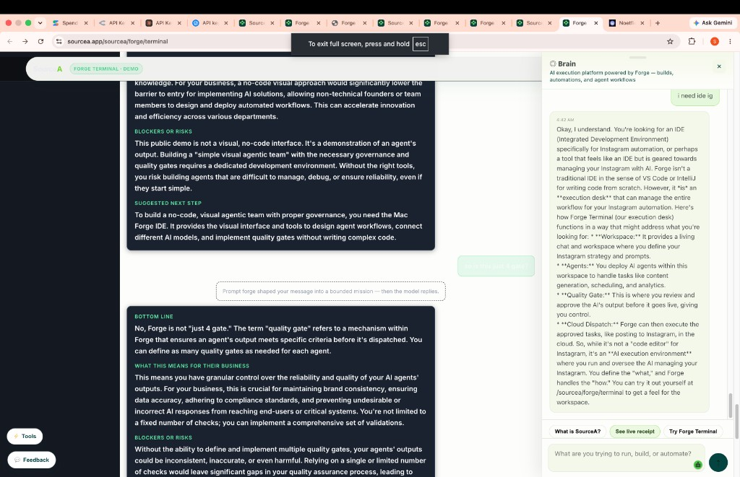

2. Version pins
Demo version: 1.4.0 (meta sourcea-forge-demo-version)
CSS: sourcea-forge-terminal-demo.css?v=1.4.0
JS: sourcea-forge-terminal-demo.js?v=1.4.0
Brain widget: sourcea-chatbot.js

3. Disk source files
SourceA-landing/green-unified/forge/terminal.html
SourceA-landing/green-unified/sourcea-forge-terminal-demo.css
SourceA-landing/green-unified/sourcea-forge-terminal-demo.js
SourceA-landing/green-unified/sourcea-chatbot.js

4. Layout
Header: SourceA + Forge Terminal · demo badge + About / Talk to human
Left: What this is + try-asking chips + sign-in link
Center: Living chat — founder sections, white assistant text, green send
Right: ◎ Brain chatbot panel (separate from living chat)
Floats: Tools + Feedback bottom-left

5. Design tokens
--ft-bg #0c0e12 · --ft-surface #141820 · --ft-accent #3ecf8e
Section headers #5ef0a8 · assistant text #ffffff on #1a2230

6. NOT this version
NOT signin/signup/profile/workspace pages
NOT Mac Forge Terminal.app IDE
Do NOT add auth fields to the public demo

7. Founder lock
"This is the BEST UI — this version only." — Any redesign forks a new version doc; v1.4.0 stays frozen.

