**Documentaion**

**Noha Nael**

**2103130**

**Introduction**

* **Objective:** This notebook aims to classify audio files into two categories: cats and dogs, using machine learning techniques
* **Dataset:** The training and test datasets are located in specified directories.

**Importing Necessary Libraries:**

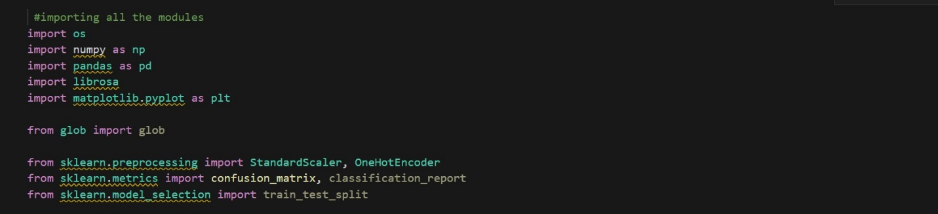

**Loading and Shuffling Training and testing Data:**

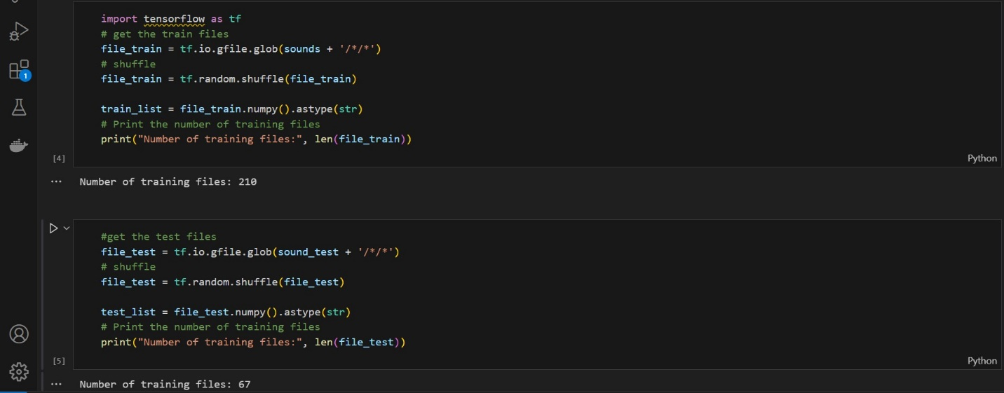

In this code snippet there’s we initialize lists for Labels and Paths and convert labels to numerical values so that the data becomes suitable for feeding into a model

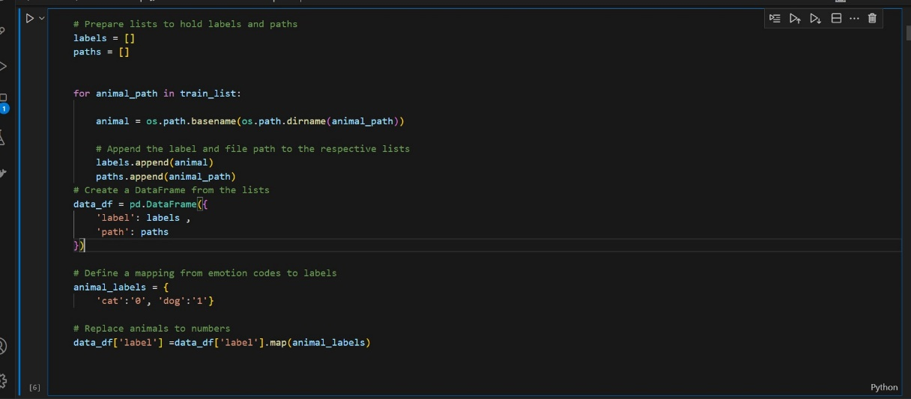

Displaying the Dataframe :

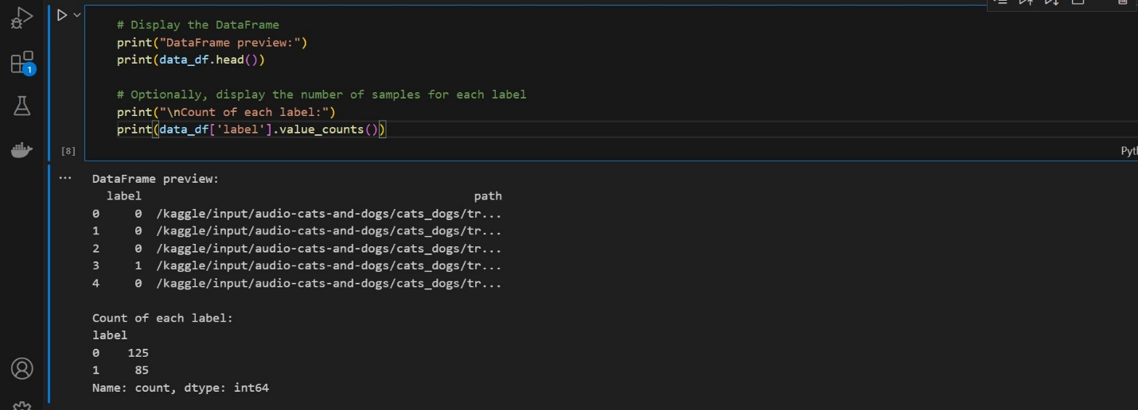

Data Visualization:

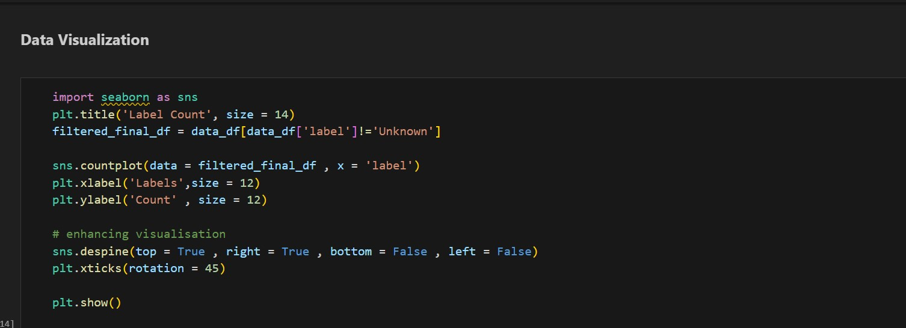

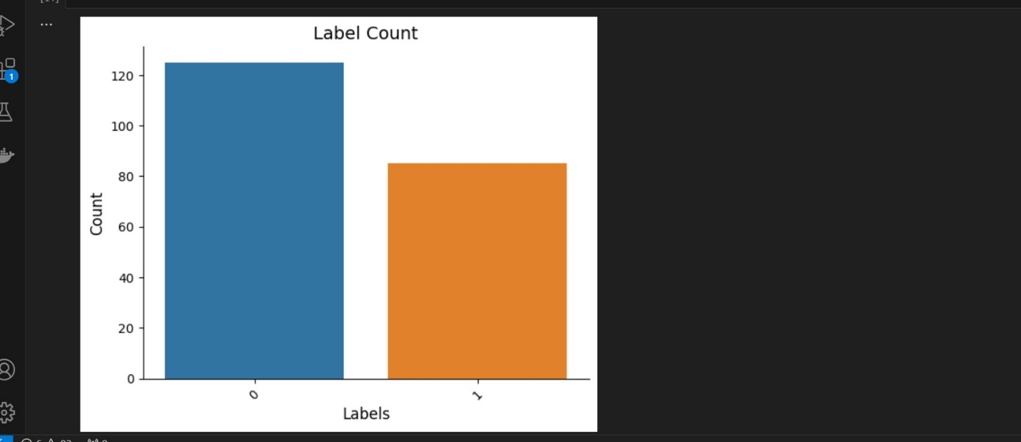

The code snippet defines three functions to visualize different audio representations.

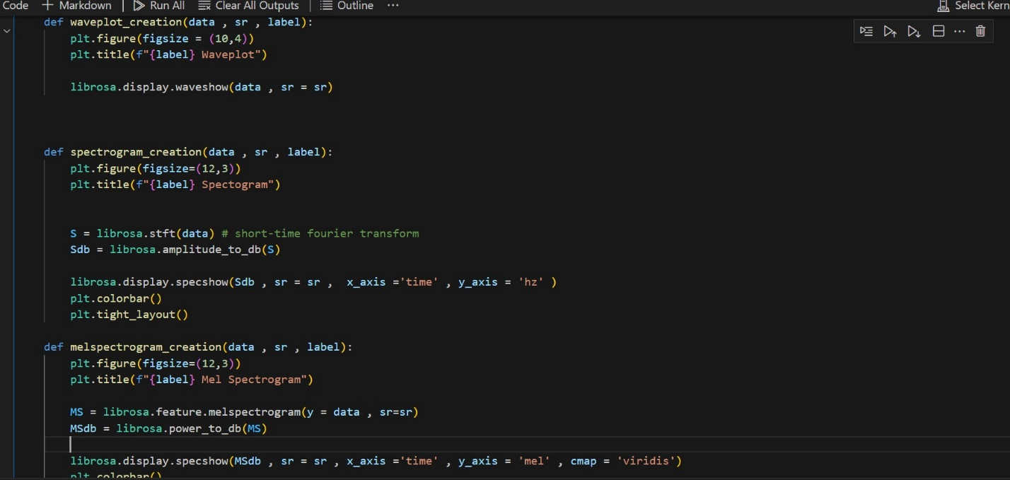

**Waveform**: shows how the amplitude of the signal changes over time

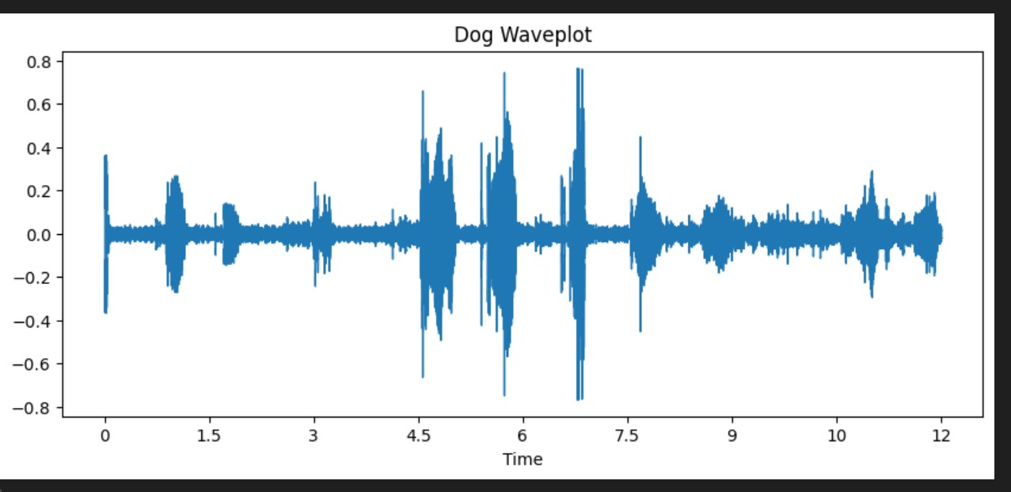

**Spectrogram:** visual representation of the spectrum of frequencies

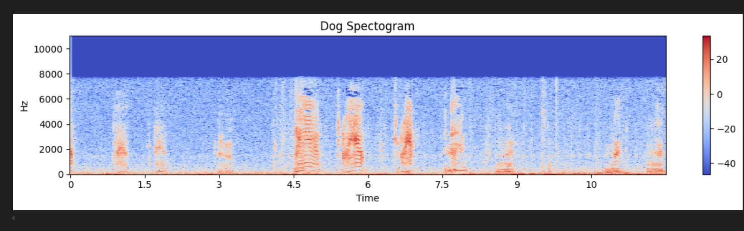

**Mel spectrogram:** the frequency axis is converted to the mel scale, which more closely approximates the human ear's response to different frequencies.

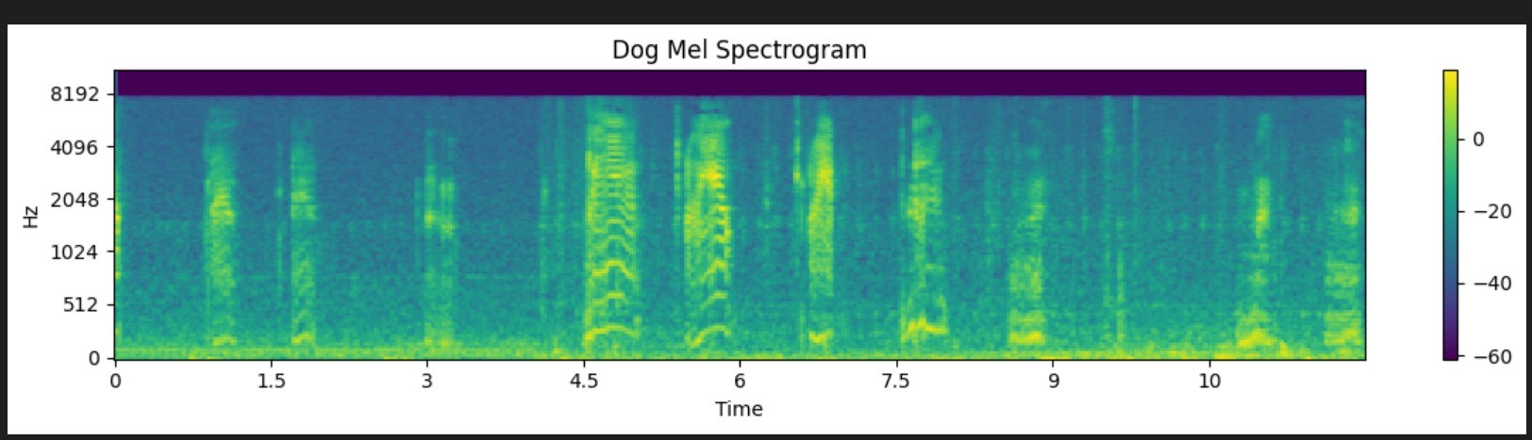

**Data augmentation:**

**Noise Injection**: is a common data augmentation technique that simulates real-world noise, making the model more robust to such variations.

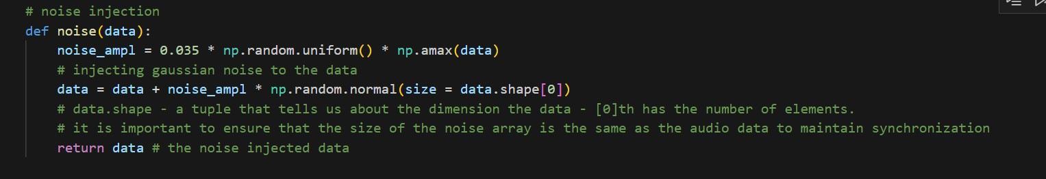

**Time Stretching:** Time stretching can simulate variations in the speed at which the sounds are produced**.**

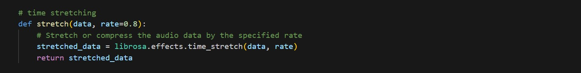

**Time Shifting:** This function shifts the audio signal in time, simulating a situation where the sound starts slightly earlier or later. It helps the model become less sensitive to the timing of features.

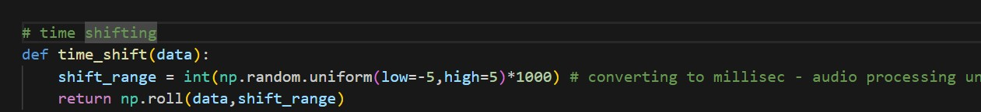

**Pitch Shifting:** simulates variations in the tone of the sound, which could represent different speakers, instruments, or vocal pitches.

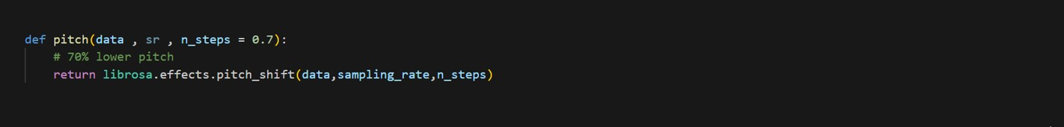

**Feature extraction:**

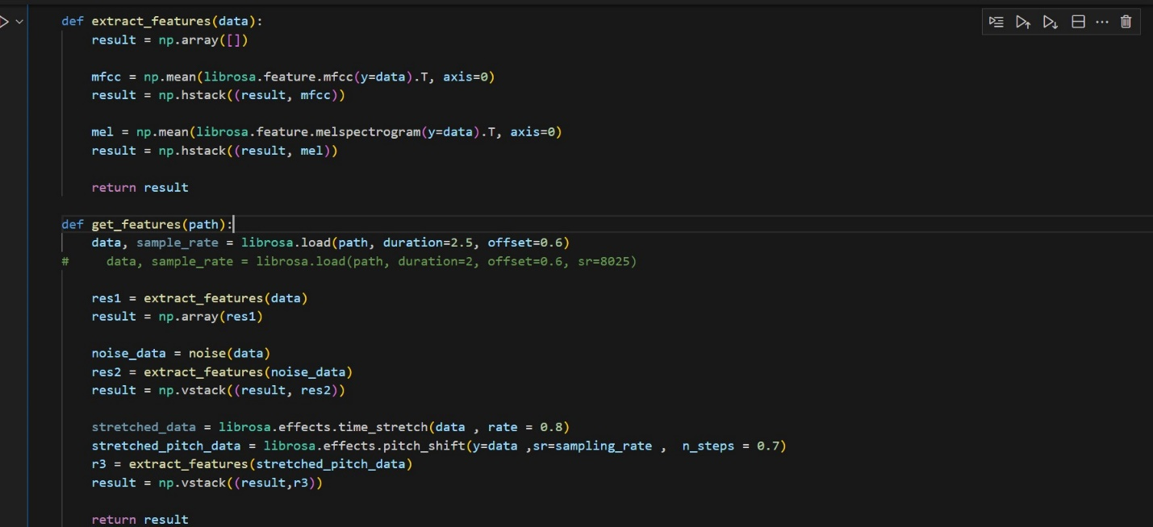

**This code snippet processes a dataset of audio files to extract features and prepare them for a machine learning model.**

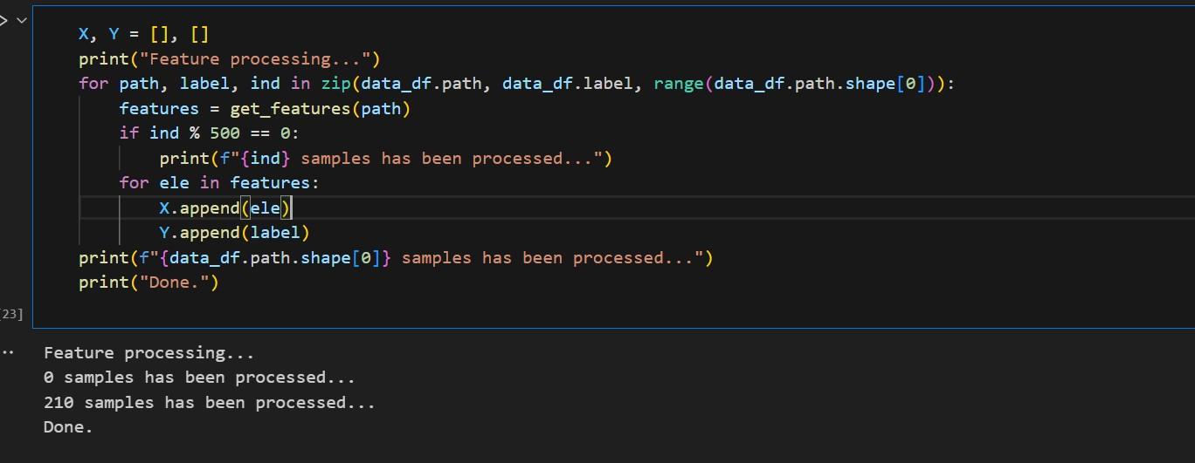

**Normalizing the dataset:**

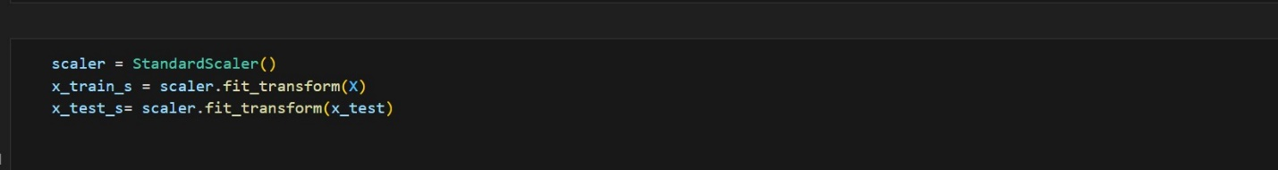

**CNN MODEL:**

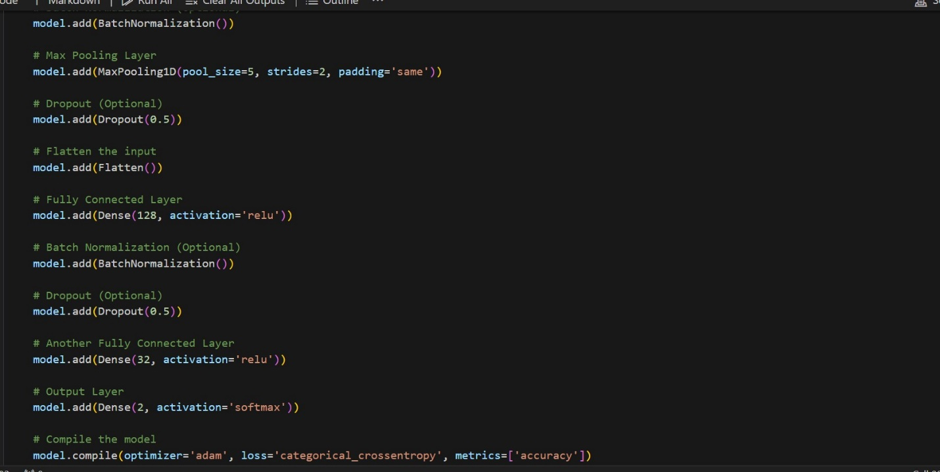

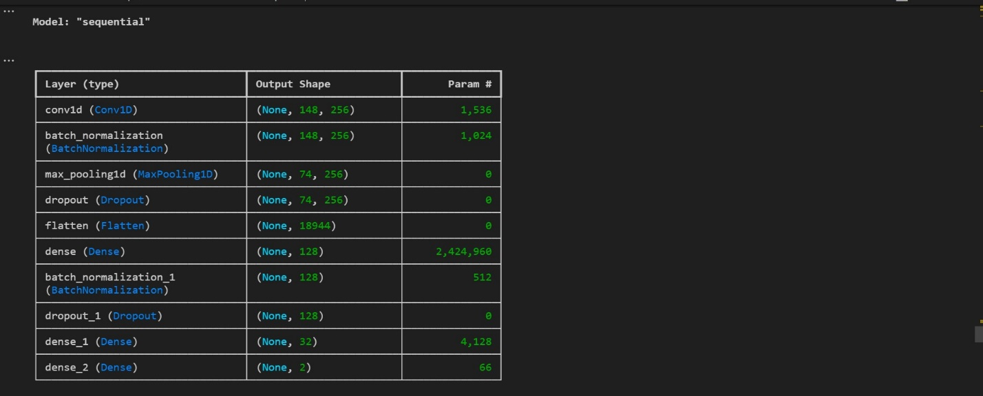

**Fitting the model:**

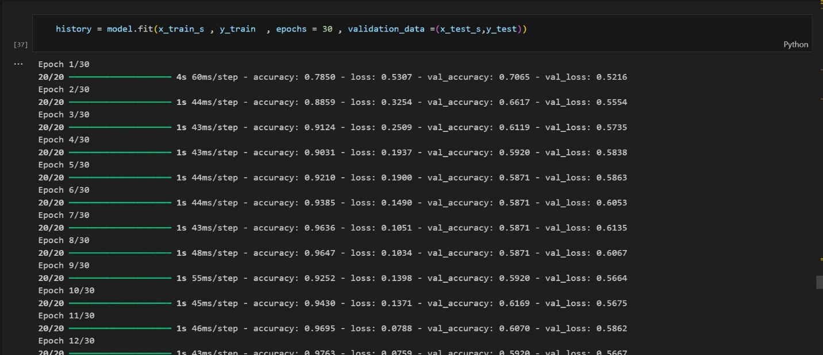

**The testing data accuracy is 85%**

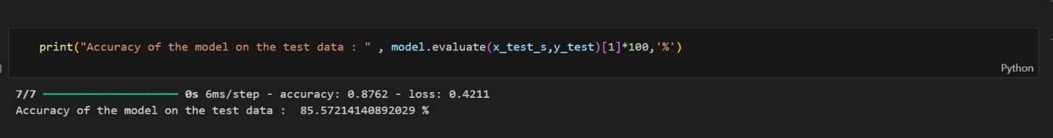

**Visualizing the training and testing accuracy**

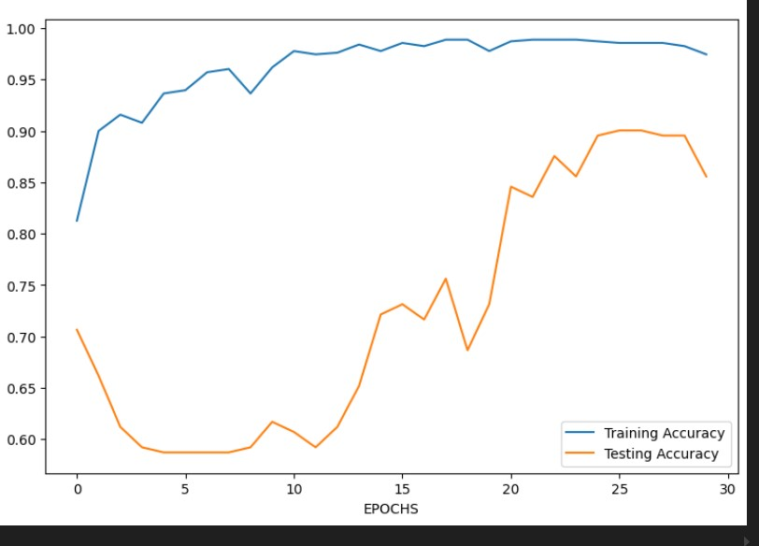

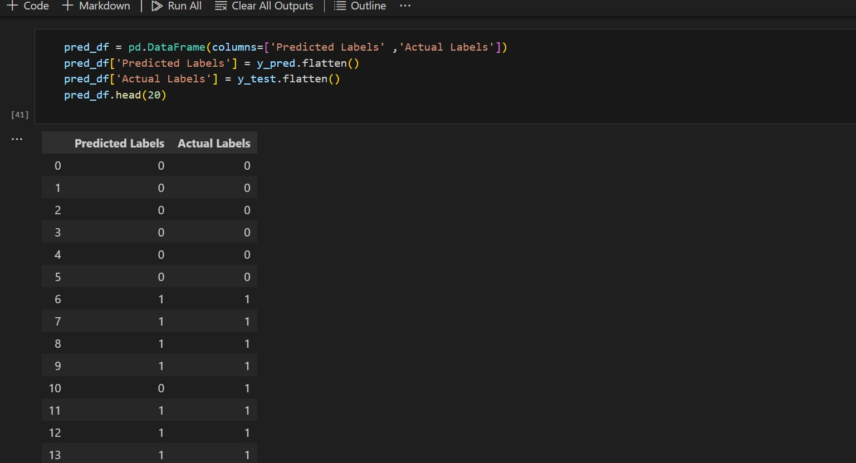

**The Confusion Matrix :**

