Characteristics and Characterization of High-Temperature Superconductor Materials

1st Chen Yihao  
*School of Physics and Astronomy*   
*Beijing Normal University*Beijing, China  
202211140007@mail.bnu.edu.cn

*Abstract*—This experiment utilized cryogenic equipment and high-temperature superconductors to measure the variations in thermometer resistance and superconductor resistance with temperature through electrical measurements. Within the temperature range from the normal boiling point of liquid nitrogen to room temperature, the platinum resistance thermometer exhibited a good linear relationship with temperature. Thus, the relationship between the resistance of the superconductor and temperature during the cooling process was determined using the platinum resistance thermometer, and the superconducting transition curve was plotted. The phenomenon of superconducting levitation was achieved using high-temperature superconductors and magnets. Observations were made on the field-cooled and zero-field-cooled phenomena of magnetic levitation in high-temperature superconductors, and the relationship curve between levitation force and the distance between the superconductor and the magnet was measured.

Keywords—High-temperature Superconductor, Zero-field cooling, Field cooling, Thermoelectric voltage, Superconducting Levitation

# Introduction

In 1911, Onnes first discovered the phenomenon of superconductivity when the resistance of mercury abruptly vanished near 4.2 K. In 1933, Meissner observed that the magnetic field inside a superconductor remains constant and is zero, a phenomenon now known as the Meissner effect.

Since the discovery of superconductivity, efforts have been directed toward increasing the transition temperature of superconductors. In 1941, German physicist Arthur discovered the first superconducting material surpassing the liquid helium region: niobium nitride (NbN), with a critical temperature of up to 15 K. In 1954, Matthias identified niobium-tin (Nb₃Sn), which exhibited a critical temperature of 18.3 K. In 1973, further advancements led to the development of niobium-germanium (Nb₃Ge) thin films, achieving a critical temperature of 23.2 K. In 1987, Professors Chu Ching-Wu and Wu Maw-Kuen discovered oxide superconductors with transition temperatures above liquid nitrogen temperature (77.3 K). Among these was the now well-known YBCO, with a critical temperature of 90 K. Subsequently, a series of high-temperature oxide superconductors were discovered.

With the advent of high-temperature superconducting materials, the applications of superconductivity have expanded significantly, including technologies such as superconducting magnetic levitation trains, superconducting gravimeters, superconducting computers, and superconducting microwave devices.

The remainder of the paper is structured as follows: Section II covers the experimental principles related to superconducting phenomena and the temperature dependence of resistance. In Section III, we introduce the experimental methods employed in our study. Finally, Section IV presents the key conclusions and discussions. Experimental data and additional materials are provided in the appendix.

# Experimental Principle

## Superconducting Phenomenon, Critical Parameters, and Practical Superconductors

### Superconducting Phenomenon and Meissner Effect

When the temperature of a conductor drops below a certain value, its resistance abruptly falls to zero. This is known as the phenomenon of superconductivity, and materials exhibiting such superconducting properties are called superconductors. It is important to note that superconductivity occurs only with direct current (DC); under alternating current (AC), the resistance does not drop to zero.

The Meissner effect is a hallmark of superconductivity, characterized by the complete expulsion of magnetic flux from the interior of a superconducting material. Regardless of the order in which the magnetic field is applied, the magnetic flux density inside the superconductor is always zero when it is in the superconducting state. Even when cooled to a superconducting state in an external magnetic field, there is never any internal magnetic field, regardless of the history of the applied magnetic field.

### Critical Parameters

To maintain a superconductor in the superconducting state, it must be kept below the following three critical values. If any of these conditions is violated, the superconducting state will be destroyed.

#### Critical Temperature

The critical temperature of superconductivity is defined as the highest temperature at which a superconductor exhibits superconducting properties when current, magnetic field, and other external conditions (such as stress or irradiation) are zero or sufficiently low so as not to affect the measurement of the transition temperature. However, in experiments, although the resistance drops sharply upon reaching a certain temperature, the drop typically occurs over a process. Therefore, the critical temperature of superconductivity is commonly defined as the temperature at which the resistance of the sample under test decreases to half of its value at the onset of the transition. The curve of resistance versus temperature for a superconducting material is shown in Figure 1.

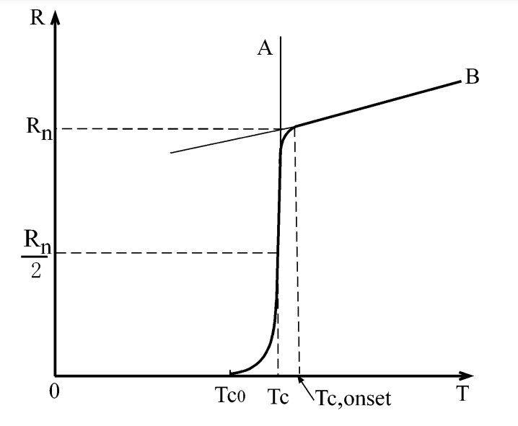

1. Resistance transition curve of superconductor and the definition of critical temperature Tc

#### Critical Magnetic Field

When the magnetic field reaches a certain value, it becomes energetically favorable for the sample to return to the normal state, effectively destroying its superconductivity. This magnetic field should be defined as the critical magnetic field . However, because the transition occurs over a range, similar to the definition of the critical temperature, the critical magnetic field of a superconductor is defined as the magnetic field corresponding to

Experiments have also revealed two distinct types of magnetic behavior. For Type I superconductors the critical magnetic field , under the critical temperature , approximately follows a parabolic relationship with temperature.

The relationship is illustrated in Figure 2.

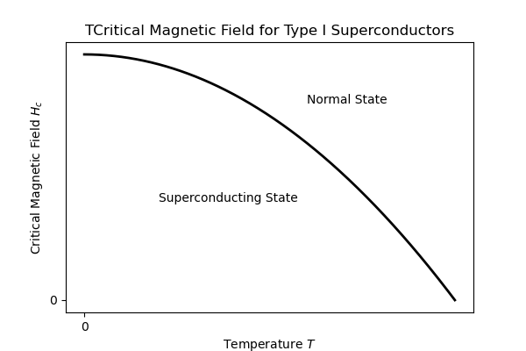

1. The critical magnetic field of Type I superconductors varies with temperature

For Type II superconductors, a transitional region exists between the superconducting state and the normal state, known as the mixed state. Consequently, Type II superconductors have two critical magnetic fields: the lower critical field and the upper critical field .

When , the superconductor exhibits a Meissner state with the same magnetic properties as a Type I superconductor. However, when , the system retains its zero-resistance property, but magnetic flux begins to penetrate the superconductor. The magnetic moment gradually decreases until it reaches zero, where the superconductor transitions completely into the normal state.

The approximate temperature dependence of the two critical magnetic fields for Type II superconductors is shown in Figure 3.

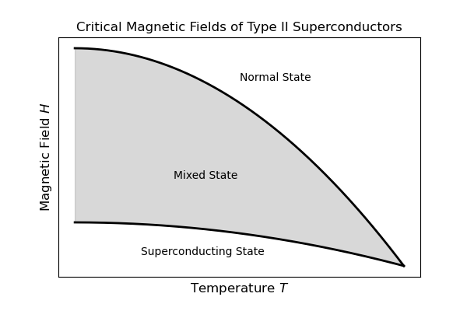

1. The critical magnetic field of Type Ⅱ superconductors varies with temperature

#### Critical Current Density

Experiments have shown that when a superconductor carries current, the zero-resistance superconducting state is limited by the magnitude of the current. When the current reaches a certain critical value , the superconductor transitions back to the normal state. This current is called the critical current, and the corresponding current density is referred to as the critical current density.

### Practical Superconductors

#### Flux Pinning and Irreversible Magnetization

High-temperature superconductors exhibit hysteresis loops, indicating that they are inherently non-ideal Type II superconductors.

When an external magnetic field increases from zero, the superconductor remains in the Meissner state as long as . When , the magnetic field starts to penetrate the superconductor in the form of magnetic flux quanta. Defects within the superconductor hinder the entry of these flux lines, creating a "resistance" to their motion. The flux lines can only fully penetrate the superconductor once the magnetic field increases sufficiently to overcome this "resistance." Similarly, when the external magnetic field decreases from , the flux lines encounter resistance, making it difficult for them to exit the superconductor. This results in the trapping of some magnetic flux within non-ideal Type II superconductors.

#### Pinning Effect

In non-ideal Type II superconductors, vortex lines are unevenly distributed. These vortex lines experience a Lorentz repulsive force directed from the interior toward the edges. However, experiments indicate that the vortex lines remain stably distributed, suggesting that, in addition to the Lorentz force, they are also influenced by another force. This phenomenon is known as the pinning effect. The force that hinders the motion of the vortex lines originates from defects, and this force is referred to as the pinning force, while the defects are called pinning centers.

## Resistance Temperature Characteristic

### Resistance-Temperature Characteristics of Pure Metal Materials

Platinum is a commonly used pure metallic material for making thermometers. The resistance of pure metal crystals arises from the scattering of electrons by the thermal vibrations of the lattice itself and by defects within the lattice. Impurities and defects in real materials also contribute to electron scattering. According to the Matthiessen's rule in the theory of electrical conduction in metals, the total resistivity of a metal is expressed as:

whererepresents the resistivity due to thermal vibrations, andrepresents the resistivity caused by impurities and defects.

At high temperatures , is proportional to. At low temperatures, is proportional to, where is the Debye temperature.

Therefore, in the temperature range from the normal boiling point of liquid nitrogen to room temperature, platinum resistance exhibits a good linear relationship with temperature, as shown in Figure 4.

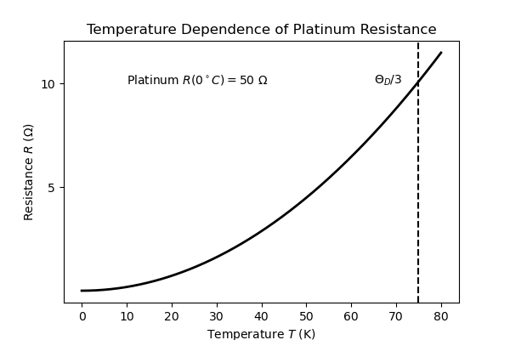

1. Temperature-Resistance Relationship of Platinum

### Resistance-Temperature Characteristics of Semiconductor Materials

Semiconductors exhibit a negative temperature coefficient of resistance within a certain temperature range. Based on the resistance-temperature relationship in the low-temperature region, thermometers made of semiconductor materials can compensate for the limitations of metallic resistance thermometers, such as reduced resistance and sensitivity at low temperatures. Commonly used semiconductor thermometers include germanium resistance thermometers, silicon resistance thermometers, carbon resistance thermometers, and thermistor thermometers.

# Experimental Methods

## Experimental Setup

1. Low-temperature generation and control: Low-temperature thermostats and stainless steel Dewar flasks.

2. Electrical measurement: BW2 high-temperature superconductor characteristic testing device and PZ158 digital DC voltmeter.

3. High-temperature superconductor magnetic levitation demonstration and measurement equipment.

## Experimental Content

### Measuring Room Temperature

After connecting the circuit, calibrate the platinum thermometer according to the standard parameters in Table Ⅰ. Set the current output of the superconducting sample to 5 mA, then measure and record the current and voltage data of the superconducting sample at room temperature.

### Filling Liquid Nitrogen

Safety precautions must be observed when handling liquid nitrogen. Before starting the experiment, check the stainless steel Dewar container for any remaining liquid nitrogen or other debris; if present, it must be emptied. When filling liquid nitrogen, ensure the liquid nitrogen level is approximately 30 cm below the mouth of the container. The placement of the thermostat block is crucial. While inserting the thermostat block, continuously monitor the rate of change in the platinum resistance thermometer readings.

### Plotting the Superconducting Transition Curve

When the temperature of the copper thermostat block starts to decrease, observe and measure the resistance of the platinum resistance thermometer and the sample voltage as they change with temperature. Use the platinum resistance reference table shown in Fig. 9, the temperature of the copper thermostat block can be calculated from the resistance measured by the platinum thermometer.

During the experiment, it is necessary to continuously adjust the relative position of the thermostat block and the liquid nitrogen surface to control the rate of temperature change. Ensure that the block does not come into contact with the liquid nitrogen. As the temperature approaches 130 K, nearing the superconducting transition temperature, the sample voltage begins to change rapidly.

When the voltage of the superconducting sample drops to zero, due to the residual electromotive force in the circuit, it is necessary to press the reverse current button to verify. If the voltage remains zero after the reverse current is applied, it can be confirmed that the superconducting sample has reached the superconducting state.

Calculate the resistance of the platinum resistance thermometer based on the voltage V across the sample and the standard current Similarly, calculate the resistance of the superconducting sample using the measured voltage and current across its two ends.

Plot the resistance values as the vertical axis against temperature as the horizontal axis. On the curve of the superconducting sample's resistance versus temperature, determine the onset temperature of the superconducting transition , the critical temperature , and the zero-resistance temperature.

### Demonstration of Magnetic Levitation in High-Temperature Superconductors

#### Mixed State Effect

Place a piece of foam block on the superconductor, then place a magnet on the foam block. Pour liquid nitrogen to cool the superconductor to below its critical temperature, at which point the superconductor transitions to the superconducting state. Remove the foam block, observe the phenomenon, and explain its cause.

#### Meissner Effect

Individually cool the superconductor with liquid nitrogen to below its critical temperature to transition it to the superconducting state, then place the magnet on the superconductor. Observe the phenomenon and explain its cause.

### Measuring the Magnetic Levitation Force of High-Temperature Superconductors

#### Zero-Field Cooling

Adjust the position and pressure to move the magnet away from the sample. Then pour liquid nitrogen to cool the sample to the superconducting state. Rotate the adjustment lever to slowly bring the magnet closer to the superconductor. When the distance between the magnet and the sample is approximately 2 mm, reverse the adjustment lever to gradually move the magnet away from the superconductor. Use a computer to record the pressure and displacement data, and plot the curve for analysis.

#### Field Cooling

Adjust the position and pressure to bring the magnet as close as possible to the sample. Then pour liquid nitrogen to cool the sample to the superconducting state. Rotate the adjustment lever to gradually move the magnet away from the superconductor. When the magnet is at its farthest distance from the sample, reverse the adjustment lever to gradually bring the magnet closer to the superconductor. After the magnet returns to its initial position, reverse the adjustment lever again to gradually move the magnet away from the superconductor. Use a computer to record the pressure and displacement data, and plot the curve for analysis.

# Results and Discussion

## Resistance-temperature characteristics of superconductors

### Measure the room temperature

The parameters of the thermometer and superconducting sample at room temperature are shown in Table Ⅱ. We can calculate the resistance of the thermometer and sample at room temperature as

According to the platinum resistance reference table, we can get the temperature of the platinum resistance thermometer, which is equal to the room temperature now.

The electrical parameters of the superconducting sample:

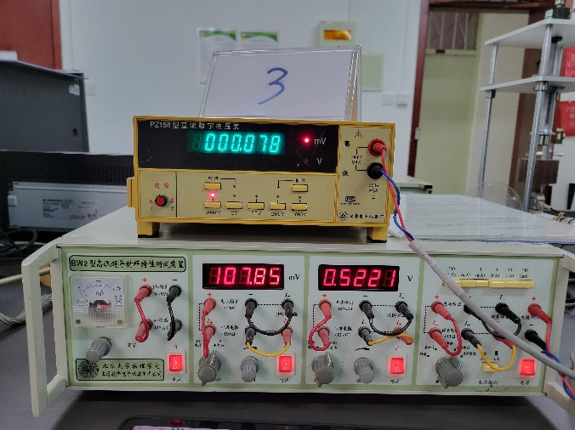

1. Measure the room temperature

### Plotting the Superconducting Transition Curve

During the cooling process, the raw data of each parameter measured are shown in Table Ⅲ. With equations

We can get the resistanceof the superconductor sample and the platinum resistance thermometer. Use the platinum resistance reference table shown in Fig. 9, the temperature of the copper thermostat block can be calculated.

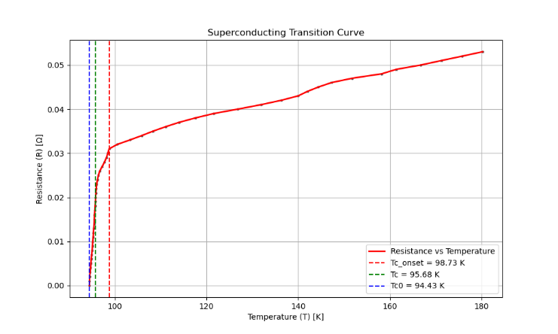

1. Superconducting Transition Curve

Based on the figure and data, the onset temperature of the superconducting transition of the sample is approximately 98.73 K, the critical temperature is around 95.68 K, and the zero-resistance temperature is about 94.43 K.

The change in the resistance of the superconductor with temperature decreases gradually before reaching the superconducting transition temperature. At the transition temperature, the rate of decrease progressively increases, then drops sharply to zero. The experimentally obtained transition curve is generally consistent with the theoretical behavior shown in Figure 1.

The curve is not entirely smooth and contains some rough sections. This phenomenon may be caused by the fact that data was recorded manually, making it impossible to ensure a perfect correspondence between parameters. Some asynchrony in the data recording process likely contributed to the roughness of the curve.

## Demonstration of Magnetic Levitation in High-Temperature Superconductors

### Mixed State Effect

In Figure 6, after the high-temperature superconducting disk transitions to the superconducting state, the magnet is levitated. Regardless of which side of the magnet faces the superconductor, a self-stabilizing state is achieved between the superconductor and the magnet, which is known as the pinning effect. This occurs because, upon cooling below the superconducting critical temperature in a magnetic field, the high-temperature superconductor enters the mixed state, where some magnetic flux lines are expelled while others are pinned. In the superconducting state, the superconductor can behave like a magnet, attracting iron nails and exhibiting quasi-permanent magnetism.

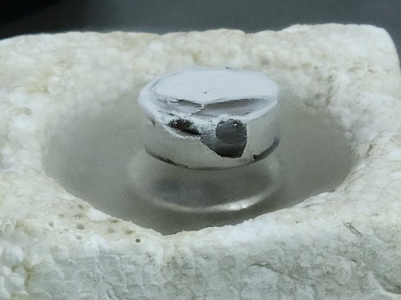

1. Mixed state effect

### Measuring the Magnetic Levitation Force of High-Temperature Superconductors

The pressure-displacement diagrams obtained after following the experimental procedure are shown in Figures 7 and 8. When the curve lies above the horizontal axis, it represents repulsive force, and when it lies below the horizontal axis, it represents attractive force.

#### Zero-Field Cooling

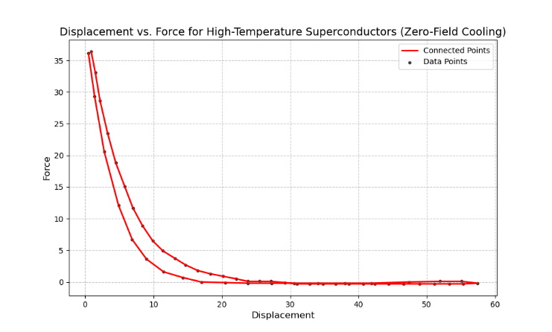

1. Force-Displacement for High-Temperature Superconductors in Zero-Field Cooling

As shown in Figure 7, when the magnet moves from a distant position (right side of the figure) to a closer position (left side of the figure) and then returns, the reason for the curves observed in the figure is as follows:

1. When the magnet approaches the superconductor, it experiences a repulsive force that increases as the distance decreases. This occurs because, as the magnet moves closer from a distant position, the superconductor remains in the Meissner state, and the magnetic field forms flux quanta that are excluded from the superconductor. However, defects hinder the entry of flux into the superconductor, requiring the external magnetic field to increase continuously. The magnet must be brought closer to the superconductor to overcome this "resistance," allowing some flux to enter the superconductor.

2. When the magnet moves away from the superconductor, the repulsive force experienced by the magnet weakens, ultimately stabilizing near zero. This occurs because, in the previous stage, some flux quanta entered the superconductor and remained pinned.

#### Field Cooling

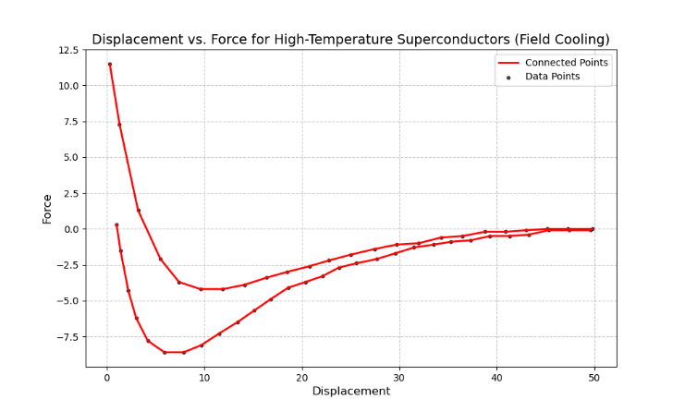

1. Force-Displacement for High-Temperature Superconductors in Field Cooling

As shown in Figure 12, when the magnet moves from a distant position (right side of the figure) to a closer position (left side of the figure) and then returns to a distant position, the reasons for the curves observed in the figure are as follows:

1. When the magnet moves away from the superconductor, it experiences an attractive force that increases initially and then gradually weakens until it approaches zero. This is because, under the field cooling condition, the superconductor enters the mixed state during cooling, retaining a large amount of flux. At this stage, the magnet is subjected to a relatively strong attractive force. As the magnet moves away, the repulsive force of the superconductor and the attractive force of the pinned flux combine to generate an overall attractive force. As the distance increases, the attractive force gradually diminishes. At a certain distance, the two forces balance out, the attractive force weakens, and at a sufficient distance, the total force approaches zero.

2. When the magnet moves closer to the superconductor, it experiences a repulsive force that decreases with decreasing distance, while the repulsive force gradually increases. This behavior is similar to the zero-field cooling condition. However, since the superconductor contains pinned flux, stronger attractive interactions are generated, resulting in a weaker repulsive force from the superconductor on the magnet compared to the zero-field cooling condition.

3. When the magnet moves away from the superconductor, the repulsive force weakens and transitions into an attractive force, ultimately stabilizing near zero. This behavior is similar to the zero-field cooling condition. However, due to the hysteresis of the pinned flux, the overall force differs from that under the zero-field cooling condition.

# conclusion

Through the high-temperature superconductor experiment, we gained an understanding of the two fundamental characteristics of superconductors: perfect conductivity and perfect diamagnetism. By mapping the superconducting transition curve, we determined key parameters such as the onset temperature, critical temperature, and zero-resistance temperature, deepening our comprehension of the superconducting transition process.

Additionally, the experiment provided insights into the differences between Type I and Type II superconductors. Phenomena observed during field cooling and zero-field cooling were analyzed, and the relationship between the magnetic levitation force and distance under these conditions was studied.

Appendix A

TABLE Ⅰ.

Instrument current parameters

|  |  |
| --- | --- |
| **Platinum resistance thermometer** | **Superconducting samples** |
| Current output (mA) | Current output (mA) |
| 1 | 5 |

TABLE Ⅱ.

values ​​of parameters at room temperature

|  |  |
| --- | --- |
| **Platinum resistance thermometer** | **Superconducting samples** |
| Voltage (mV) | Voltage (mV) |
| 107.85 | 0.078 |

TABLE Ⅲ.

values ​​of parameters during cooling process

|  |  |  |  |
| --- | --- | --- | --- |
| **Platinum resistance thermometer (mV)** | **Superconducting samples (mV)** | **Platinum resistance thermometer (mV)** | **Superconducting samples (mV)** |
| 107.85 | 0.078 | 37.32 | 0.038 |
| 107.45 | 0.077 | 35.82 | 0.037 |
| 106.91 | 0.076 | 34.56 | 0.036 |
| 105.01 | 0.075 | 33.41 | 0.035 |
| 103.79 | 0.074 | 32.37 | 0.034 |
| 101.36 | 0.072 | 31.27 | 0.033 |
| 100.68 | 0.071 | 30.11 | 0.032 |
| 98.85 | 0.07 | 29.36 | 0.031 |
| 97.56 | 0.069 | 29.24 | 0.03 |
| 95.85 | 0.068 | 29.11 | 0.029 |
| 93.93 | 0.067 | 28.93 | 0.028 |
| 92.09 | 0.066 | 28.72 | 0.027 |
| 89.66 | 0.065 | 28.5 | 0.026 |
| 86.15 | 0.064 | 28.37 | 0.025 |
| 84.52 | 0.063 | 28.29 | 0.024 |
| 82.24 | 0.062 | 28.21 | 0.023 |
| 80.63 | 0.061 | 28.17 | 0.022 |
| 78.13 | 0.06 | 28.14 | 0.021 |
| 76.38 | 0.059 | 28.11 | 0.02 |
| 74.22 | 0.058 | 28.1 | 0.019 |
| 72.01 | 0.057 | 28.07 | 0.018 |
| 69.99 | 0.056 | 28.05 | 0.017 |
| 67.87 | 0.055 | 28 | 0.016 |
| 65.7 | 0.054 | 27.99 | 0.015 |
| 63.83 | 0.053 | 27.97 | 0.014 |
| 61.94 | 0.052 | 27.94 | 0.013 |
| 60.02 | 0.051 | 27.91 | 0.012 |
| 58.14 | 0.05 | 27.89 | 0.011 |
| 55.84 | 0.049 | 27.85 | 0.01 |
| 54.52 | 0.048 | 27.82 | 0.009 |
| 51.8 | 0.047 | 27.79 | 0.008 |
| 49.87 | 0.046 | 27.75 | 0.007 |
| 48.67 | 0.045 | 27.71 | 0.006 |
| 47.65 | 0.044 | 27.68 | 0.005 |
| 46.81 | 0.043 | 27.65 | 0.004 |
| 45.25 | 0.042 | 27.6 | 0.003 |
| 43.37 | 0.041 | 27.56 | 0.002 |
| 41.25 | 0.04 | 27.55 | 0.001 |
| 39.02 | 0.039 | 27.54 | 0 |

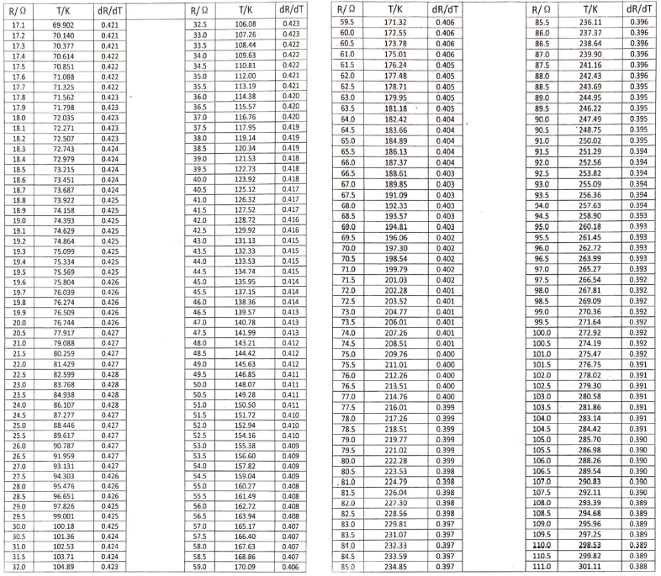

1. The platinum resistance reference table



1. Raw data