|  |  |
| --- | --- |
| 00000 | 4.2G |
| 00001 | 3.69G |
| 00010 | 2.92G |
| 00011 | 2.72G |
| 00100 | 2.13G |
| 00101 | 1.96G |
| 00110 | 1.76G |
| 00111 | 1.69G |
| 01000 | 1.09G |
| 01001 | 1.066G |
| 01010 | 980M |
| 01011 | 920M |
| 01100 | 909M |
| 01101 | 836M |
| 01110 | 790M |
| 01111 | 813M |
| 10000 | 350M |
| 10001 | 330M |
| 10010 | 325M |
| 10011 | 317M |
| 10100 | 312M |
| 10101 | 302M |
| 10110 | 305M |
| 10111 | 280M |
| 11000 | 270M |
| 11001 | 270M |
| 11010 | 270M |
| 11011 | 270M |
| 11100 | 270M |
| 11101 | 244M |
| 11110 | 244M |
| 11111 | 240M |

Observed Results:   
Oscillating from 250MHz to 4.2GHz   
  
Frequency Range w.r.t capacitor bank:

Feedback and Amplitude Control  
  
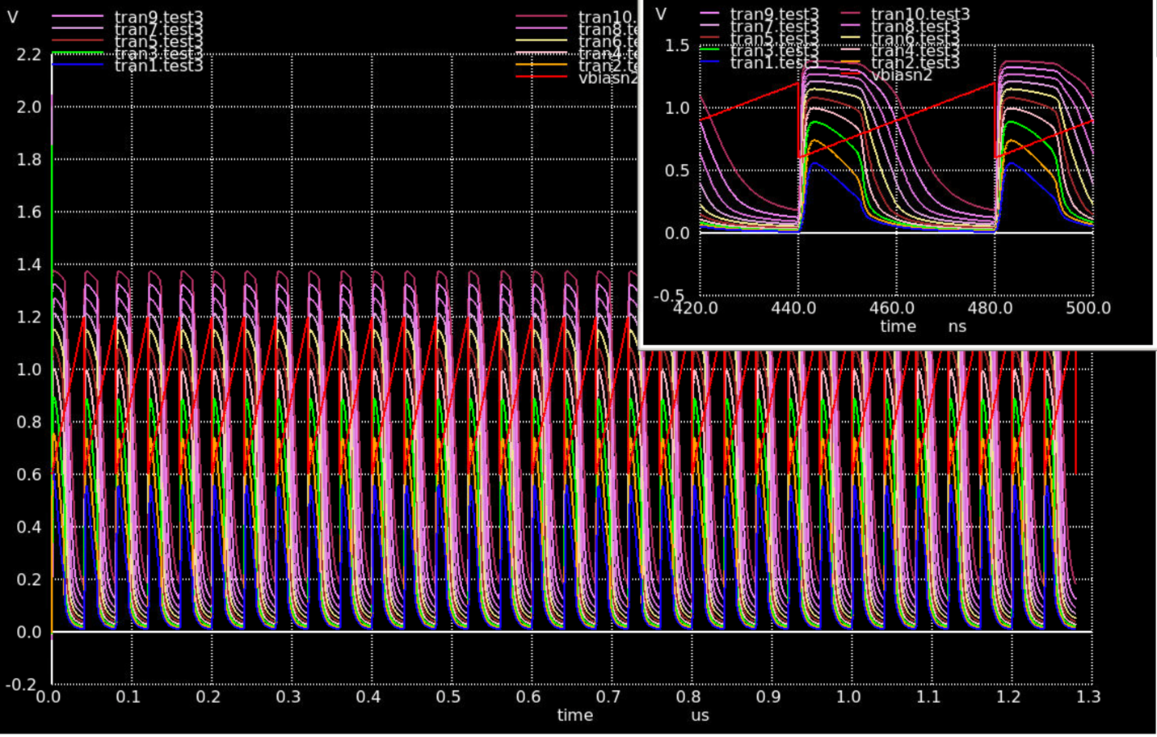

Oscillating Waveform:

