**House Rent**

CSE 3200: System Development Project



**Supervised By : Submitted By :**

**H.M. Abdul Fattah Nohel Nath**

Lecturer, Roll:1607013

Department of Computer Science and Engineering **Mahmudur Rahman**

Khulna University of Engineering & Technology Roll:1607049

Khulna, Bangladesh.

Department of Computer Science and Engineering

Khulna University of Engineering & Technology

Khulna, Bangladesh

**House Rent**

CSE 3200: System Development Project



**Supervised By : Submitted By :**

**H.M. Abdul Fattah Nohel Nath**

Lecturer, Roll:1607013

Department of Computer Science and Engineering **Mahmudur Rahman**

Khulna University of Engineering & Technology Roll:1607049

Khulna, Bangladesh.

Signature

Department of Computer Science and Engineering

Khulna University of Engineering & Technology

Khulna, Bangladesh

**Acknowledgement**

First of all, we would like to express our gratitude to our supervisor, Md. H.M. Abdul Fattah Sir for his demonstration of guidance, giving useful advice, conceptualize the project which enabled us to have clear understanding of our project.

We would like to thank again to our project supervisor and whoever has guided us most of the time and supported us throughout the project. Without him we cannot fulfill the project.

**Table of Contents**

**Title Page No.**

Title Page …………………………………………………………………………………1

Acknowledgement ..………………………………………………………………………2

Table of Contents ...………………………………………………………………….......3

**Chapter 1: Introduction …………………………………………………...6-7**

1.1 Introduction…………………………………………………………………………...6

1.2 Statement of the Problem……………………………………………………………..6

1.3 Objectives……………………………………………………………………………..6

1.4 Organization of Project………………………………………………………………...7

1.5 Requirements…………………………………………………………….……………..7

**Chapter 2: Project Detail…………………………………………………..8-9**

2.1 User Management……………………………………………………………………..8

2.2 Activity diagram………………………………………………………………………9

**Chapter 3: Features and Operations…………………………………….10-16**

3.1 User interface…………………………………………………………………………10

3.1.1 Front page…………………………………………………………………………..10

3.1.2 Login page………………………………………………………………………….11

3.1.3 Registration page…………………………………………………………………...11

3.1.3 Renter and owner page view……………………………………………………….12

3.1.4 Navigation Drawer Layout………………………………………………………....13

3.1.5 Add of house………………………………………………………………………..14

3.1.6 House details and search by locations……………………………………………...15

3.1.7 Show rating option and Profile ……………………………………………………15

3.1.8 Changing password ,Locations and house details…………………….....................16

**Chapter 4: Conclusion and Recommendation…………………………..17-18**

4.1 Conclusion……………………………………………………………………………17

4.2 Limitations……………………………………………………………………………17

4.3 Future Development………………………………………………………………….18

**References………………………………………………………………….**18

**Chapter 1**

**Introduction**

* 1. **Introduction**

This project is based on online renting house with the help of google map for android operating system.

Renting house is almost a curse for the people. At that time renting an apartment is generally cheaper than mortgage. Other than that, other financial components such as utilities and maintenance are cheaper too because of the smaller space and usually it has been included in the rent. An apartment tends to be more safe and secure. So it is very important to manage a system for the people who try to find houses in different locations. In the smart phone generation people wanted to solve all the problems by their phone. So an android based application for renting house is very much important for all types of people.

**1.2 Statement of Problem**

Renting house is almost a curse for the people. At that time renting an apartment is generally cheaper than mortgage. Other than that, other financial components such as utilities and maintenance are cheaper too because of the smaller space and usually it has been included in the rent. An apartment tends to be more safe and secure. So it is very important to manage a system for the people who try to find houses in different locations. In the smart phone generation people wanted to solve all the problems by their phone. So an android based application for renting house is very much important for all types of people.

**1.3 Objectives**

* To optimize and have complete control over the Owners and renters.
* To improve the efficiency of renting houses.
* To reduce the manual work for renters and owners.
* To perform all functionalities more accurately and faster.
* To get a complete system of online House renting system.
* This project is focused on the online based shop management system around our country and further.
* This complex system is represented in a ordered system for a better user experience.
* It enhances correctness and reduces human labour.

**1.4 Organization of Project**

* Registration
* Login
* List of House
* Proper Monitoring
* Proper House Details
* Proper profile Management

**1.5 Requirements**

* Android studio
* Android based phone
* Internet connection
* A realtime database system
* Users

**Chapter 2**

**Project Details**

This section describes about the detail of this software. There are several modules in the House Rent. They are:

* Renter Management
* Owner Management

House Rent app is an application which helps house holders and the renters whom are trying to find houses, the apps manages the features of finding home with simple android app. It be large or small, to optimize and have complete control over their houses. Nowadays these applications are grabbing the market like anything. This application helps the people to do all functionalities more accurately and in a faster way. It reduces the manual works and improves the efficiency of searching homes. The application helps people rented to maintain day to day records in the system. It’s very useful in keeping a proper record of the database.

This app provides a wide range of advantages for the travelling people, some people try to find home without manually visit, so they need to search people who can help them to find a house. But by this apps virtually anyone can do the work quickly and painlessly. In fact, this is better and highly desirable alternative to waiting until getting home .It’s just one click away. It’s fast, easy and comfortable to access. All is just at your fingertip. This house rent app can have a vast visual appeal and a strong stimulating effect on all the home finding people. House rent app, all preferences are specified directly by the customer, so there is no room for confusions or misunderstandings.

It’s open to its customer 24*7. By using the system, you can give your renters the flexibility to contact with you, even if that happens outside the business hours. Over all this app can bring a revolution for the people who are get harassed to find house.

**2.1 User Management**

In the user management module there are two types of actions. The first one is registration and other one is login. For registration user need to enter appropriate information. In the system there will be a number verification reply, by which the phone number will be verified. There are few rules in entering the information during the time of registration and login.

**2.2 Activity diagram**

In this diagram we discuss about the whole activities and the connection among the activity. We can get a idea from this flow chart about this app. Different types of signs are used to make this flow chart.

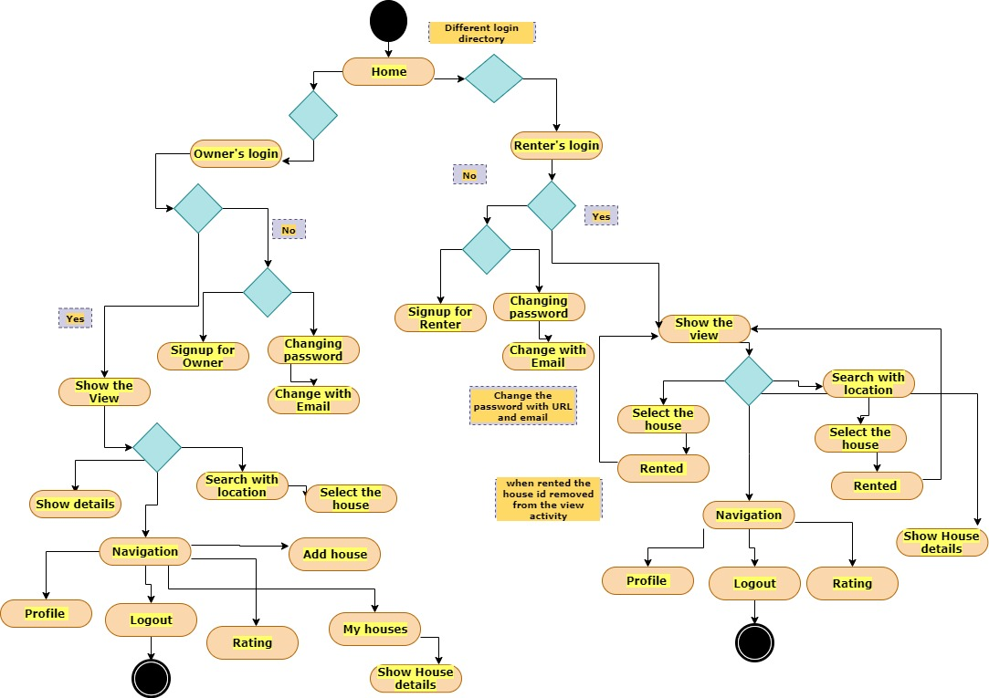

Figure 2.2 : Activity Diagram.

**Chapter 3**

**Features and Operations**

In this application there are two main parts and they are:

**3.1 User interface**

Now here is the detail about the user interface

**3.1.1 Front page and Login page**

To use this application user needs to open the app and then we found the Login page. Here both renter and owner can login using the next two activities.

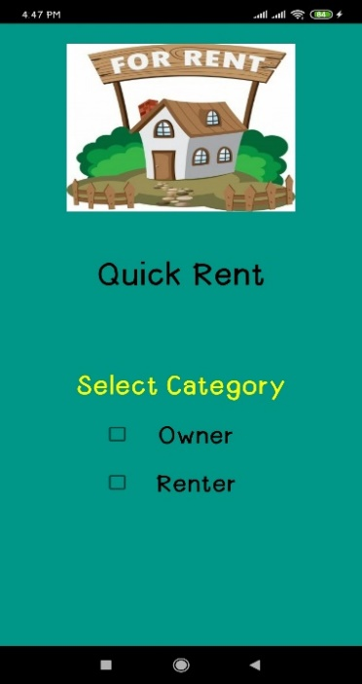

**Figure 3.1.11 : Front Page**

There is another activity for signup the owner from doing the full procedure owner can see the view page.In the renter page the user also need to provide the email and password for the login.

|  |  |
| --- | --- |
|  |  |

**Figure 3.1.12: Renter & Owner Login Page**

**3.1.2 Registration page**

If the person is not registered yet, he/she needs to be registered .There are five information field is needed to be filled for registration process.

|  |  |
| --- | --- |
|  |  |

**Figure 3.1.2: Renter and Owner Signup Page**

**3.1.3 Renter and owner page view**

After entering login the both owner and renter can see the page but the mandatory change comes from the navigation drawer.

|  |
| --- |
|  |

**Figure 3.1.3 : Renter and Owner view page**

**3.1.4 Navigation drawer layout**

Navigation drawer are almost the same but in the owner drawer extra two options Add house and My houses are got.

Basically in owner activity Add house option can help the owner to add house details which he wanted to give rent.

And from the button of my houses he can see the multiple houses what he added before and the renting condition of the houses.

|  |  |
| --- | --- |
|  |  |

**Figure 3.1.4 : Navigation drawer layout**

**3.1.5 Add of house**

Here owner can add a new house and the added house goes to the view page

|  |  |
| --- | --- |
|  |  |

**Figure 3.1.5 : Adding House**

**3.1.6 House search by locations**

Owner and renter both are search the houses by the search bar.

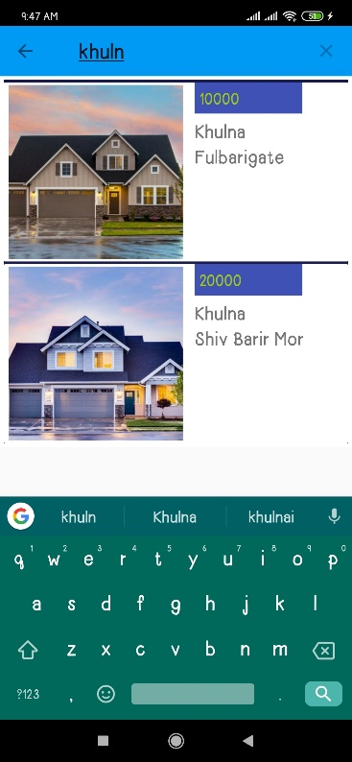

**Figure 3.1.6 : House search by locations**

**3.1.7 Show Rating options and profiles**

In the drawer people can see the profiles and the rating options

|  |  |
| --- | --- |
|  |  |

**Figure 3.1.7 : Rating option and profile**

**3.1.8 Changing Password, Locations & House Details**

If user can forget password they will change it through the email authorization .And for viewing the house details we can use the activity .Both owner and renter can see the page.

**Figure 3.12 : Order Control**

|  |  |
| --- | --- |
|  |  |

**Figure 3.1.8 : Changing password and house details.**

|  |
| --- |
|  |

**Figure 3.1.9 : View Locations**

**Chapter 4**

**Conclusion and Recommendation**

**4.1 Conclusion**

Renting House app is much easier and considerably cheaper to create and maintain a great looking menu that will impel renters to find the house easily. Switching the focus from offline house searching to online searching means less hassle of handling undecided calling clients and the staff time lost in the process and that means significant money savings for the customers.

* The system is designed to reduce human labor and efficiently for finding house in different areas.
* It provides a flexible way of online renting house.
* We hope that it will help people to reduce both time and trouble.

## 4.2 Limitations

Since this is our first project it has some limitation. Due to less knowledge in  particular fields and limited time we were not able to fulfill all our expectations that we expected we could do while the project got started. We hope this limitations are considerable. Some of the project limitations are:

* It is suitable for a small online renting house system.
* It’s can’t show the exact locations sometimes because all over the locations are not included in the app.
* This app doesn’t properly maintained through the country.

## 4.3 Future Development

The following section describes the work that will be implemented with future releases of the software.

* Using all the locations properly to the house based location.
* Enhance user interface by adding more user interactive features. Provide deals and promotional.
* Offer details facilities of the houses to home page.
* Payment options: Add more payment options such as PayPal, Gift cards etc.
* Allow to save payment details for future use.
* Allow to process a renter as a Guest.
* Renting process estimate: Provide renter a visual graphical renter status bar.
* Try to make the apps auto update location based so in the certain location renter can see the latest houses near him.

**References**

1. https://developer.android.com
2. https://firebase.org/
3. https://www.youtube.com/watch?v=vpObpZ5MYSE
4. https://www.youtube.com/watch?v=h62bcMwahTU