Ballad, Noileen Mae E. October 18, 2019

BSTM 191-HRO 191 Assignment #2

1. **ADDING TWO NUMBERS**

**Procedure:**

1. Input the two numbers.
2. Process the two numbers by addition.
3. Output the sum of the two numbers.

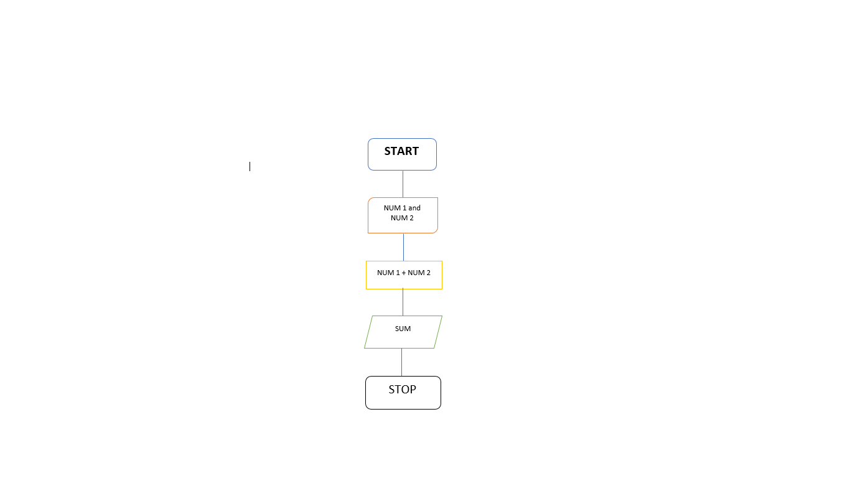

1. **AREA OF CIRCLE USING RADIUS AND DIAMETER**

**Procedure:**

1. Input Radius and Diameter.
2. Process the given formula.
3. **A = π * r2**
4. **A = πd**
5. Output answer.

Start

**Input Radius and Diameter**

Solving the area of circle with the radius?

Solving for the area of the circle with the diameter?

YES

Output Print Radius

**A = π * r2**

**A = 3.14 * 42**

NO

**A = πd**

YES

Stop

Output Print Diameter

NO