Ballad, Noileen Mae E. October 24, 2019

TM191/HRO191 Assignment #3

**Pseudocode Exercise**

1. **ADDING TWO NUMBERS**

**Procedure:**

1. Input the two numbers.
2. Process the two numbers by addition.
3. Output the sum of the two numbers.

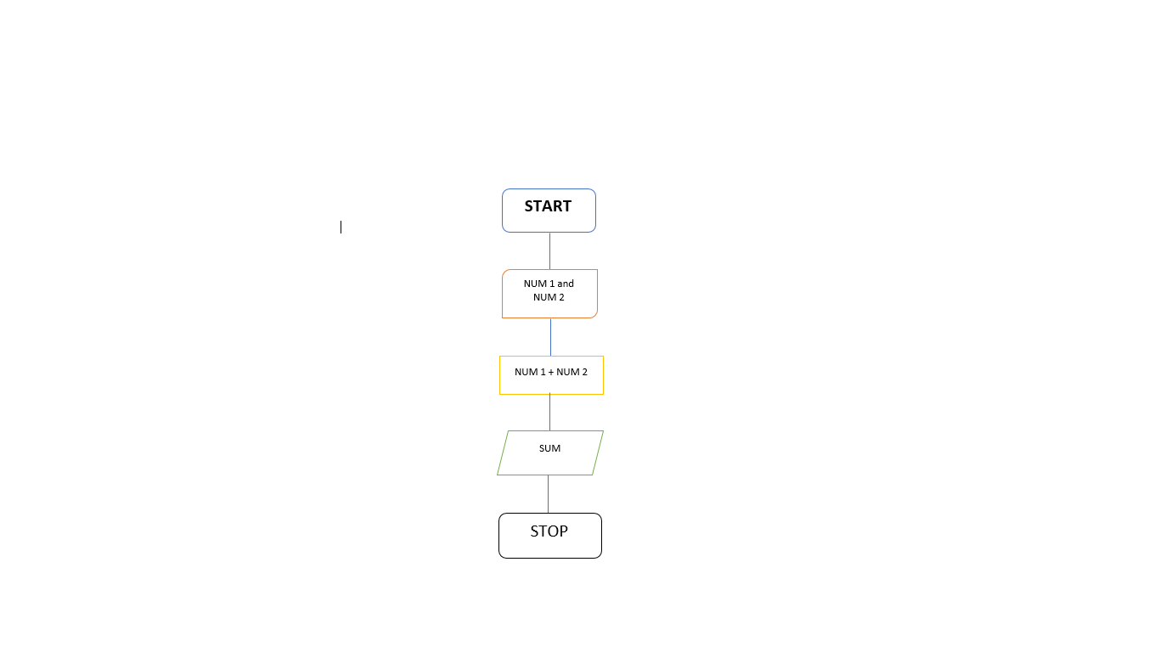

**Pseudocode:**

Start

Input NUM1 and NUM2

Process the equation using addition (+)

Add NUM1 and NUM2

Output of the answer

Stop

1. **AREA OF CIRCLE USING RADIUS AND DIAMETER**

**Pseudocode:**

Start

Input Radius and Diameter

Ask question “Are you solving the area of circle with the radius?”

If yes, input radius, then process the equation, output of the answer, STOP

If No, then “are you solving the area of circle with the diameter?”

If yes, input diameter, process the eaquation, output of the answer, STOP

If both NO

STOP

**Procedure:**

1. Input Radius and Diameter.
2. Process the given formula.
3. **A = π * r2**
4. **A = πd**
5. Output answer.

Start

**Input Radius and Diameter**

Solving the area of circle with the radius?

Solving for the area of the circle with the diameter?

YES

Output Print Radius

**A = π * r2**

**A = 3.14 * 42**

NO

**A = πd**

YES

Stop

Output Print Diameter

NO

1. **ODD or EVEN**

**Procedure:**

1. Input number
2. Identify if it’s ODD or Even
3. Output answer

**Flowchart:**

Is this an ODD number?

Input Number

Is this an EVEN number?

NO NO

YES YES

Output/Answer

Output/ Answer

**Pseudocode:**

start

Input number

Tell if the number is ODD or EVEN number

If the number is ODD number, then enter the output of the answer, STOP

If the number is not ODD number, then it is an EVEN number, output of the answer, STOP

If the number is not both ODD or EVEN number, then STOP

stop