Ballad, Noileen Mae E.

TM191/HRO191

**FLOWGORITHM EXERCISES:**

In doing the flowgorithm exercises, there are a lot of things to be familiarize especially where these symbols used to and what should be the flow to make this program run without errors. Because it is really different when you are just drawing the flowchart in the paper, in making a flowchart in the flowgorithm. You need to make the program work. We make the program of Adding two numbers, getting the area of a circle using radius and diameter and the Determining odd or even. In the first program of adding the two numbers, it is just really simple because you only need to declare what will you going to input, after that input num1 and num2, process that equation then get the output or answer then stop. It is more complicated in the Area of circle using radius and diameter because it is really hard to use the If sign and there are a lot of things to declare. I am really confused in this kind of program. But in the end I get to know where the errors are. Same with the last in determining odd or even, it is just the same but this is much easier than the second. Because it does not have much computation.

**ADDING TWO NUMBERS**

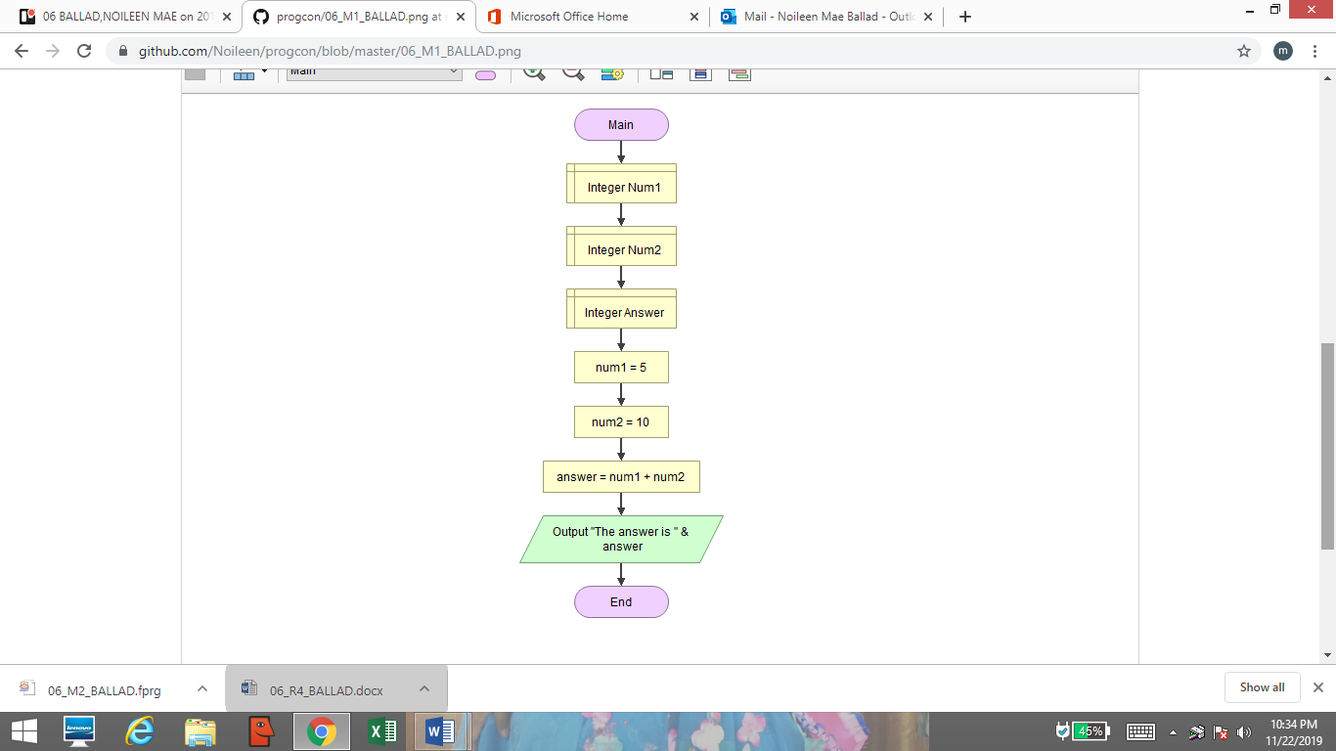

**GETTING THE AREA OF CIRCLE USING THE RADIUS AND DIAMETER**

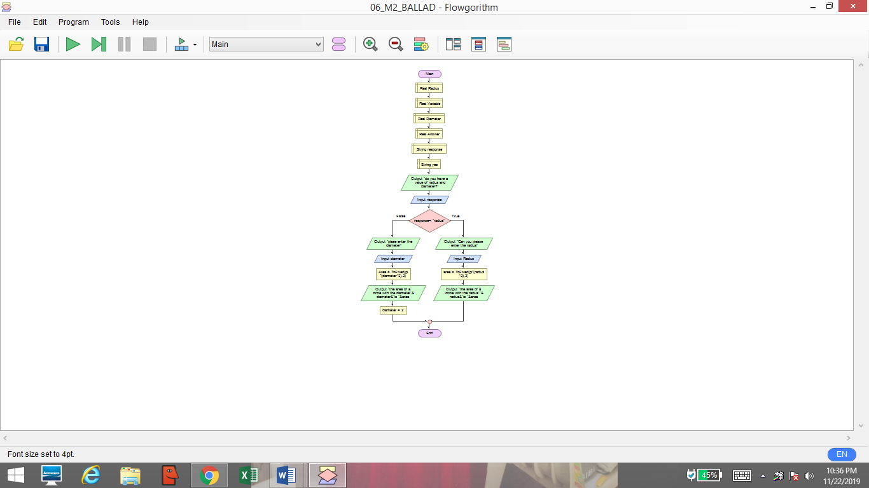

**DETERMINING ODD OR EVEN**

