Isys2120 Data and Information Management

Week 1

**Outline**

• Data and DBMS in context

• The relational data model

– Terminology

– Practice understanding relational data

• Careers and people’s roles

• DBMS versus other ways to manage shared data

• Some big ideas

Terminology

• Data: Facts that can be recorded

• Database: A collection of data, is persistant and shared

• Database Management System (DBMS): software package designed to store and manage one or more databases

• Meta-data: descriptions of the format of the data

Relational DBMS: data is stored as instance, containing different entries, and matching data indicates connection.

Instance: contents of the database at a single time

Schema: the structure of data in a particular database( what tables, what metadata(column name))

**Data practice**

**Data design**: to decide what schema will be used for the data.

It proceed in stages:

– first produce a conceptual or semantic model,

– then translate this into a relational schema,

– then evaluate the schema for quality, and improve it if needed

**Languages**: DDL&DML

**Level of abstraction**: DB -> physical schema-> logical schema -> view(multiple)

* **View**: how a user **sees** the data
* **Logical schema**: the **structure of data** shared among all users
* **Physical schema**: the **files and indexes** used for storage on disk

Data Independence

• Applications are insulated from how data is structured and stored

• Logical data independence: Protection from changes in logical schema (eg introducing an extra column in a table)

• Physical data independence: Protection from changes in physical structure and location of data

• Data independence is one of the most important benefits of using a DBMS

**Roles&career**s

Roles with DBMS

• End users- people who do something that advances the organization’ s purpose (business manager)

• DB application programmers- produce the applications that end users can run

• Database administrator (DBA)- manage effective & efficient use of resources in providing access to data

• DBMS Vendor Staff- DBMS software’s support provider from mother company

**Files vs DBMS**

**Files**: accessed directly by all the programs that need to use the data.

Pros: good for storing data for long time; easy to send and share

Cons: **low Integrity**(possible dup data); many **programs** needed(formats) ; assess control is mediocre; no central authority(no unified organize) ; Atomicity of updates(half-complete action cause error);

**DBMS**:

Pros: solve all cons above.

Cons: simple processing performance; money cost; handle specialised data poorly.

Week 2

**Outline**

- Introduction to SQL

- **Joins** and **Aggregate** Functions, **Set** operations

- Conceptual Database Design using the **Entity Relationship Model**

Introduction to SQL

Select

* SELECT a FROM b WHERE c ORDER by d ASC/DESC 正常选择
* SELECT DISTINCT/ALL a FROM b 选择全部/不同的行
* SELECT a, b, 2*c(c is numerical) FROM d 多重选择， 选择时运算
* SELECT a AS xxx 选择后重命名列

Where

* WHERE a < 0 AND b = 0 筛选条件
* WHERE a BETWEEN 2 AND 4 区间内筛选条件

String operation

* ‘%’ match any substring %代表一切子字符串 eg comp%
* ‘_’ match any char _代表一切字符 eg comp2_17

Date and Time

* EXTRACT component FROM date 从日期提取元素 eg EXTRACT year FROM enroldate
* TO_DATE (string, templete) 将字符串变为日期 eg TO_DATE(’01-03-2012’, ‘DD-MM-YYYY’)
* +/- INTERVAL 加减日期区间 eg ‘2012-04-01’ + INTERVAL ’36 HOUR’

Aliases

* SELECT A.name, M.name FROM Academic A, Academic M WHERE A.manager = M.empid

列出所有科研者以及他对应上级的名字

**JOIN function**

SQL join operators

* R natural join S
* R inner join S on <join condition>
* R inner join S using (<list of attributes>)

Eg List all students and in which courses they enrolled.

* select name, uos_code, semester

from Student natural join Enrolled

eg Who is teaching “ISYS2120”?

* select name

from UnitOfStudy inner join Academic on lecturer=empid

where uos_code=‘ISYS2120

**Aggregate function**

These functions operate on the multiset of values of a column of a relation, and return a value

* avg: average value
* min: minimum value
* max: maximum value
* sum: sum of values
* count: number of values

Must use **distinct** in addition to aggregate over sets, all these function **ignore NULL except ‘count’**.

**Conceptual database**

Database design sequence:

* requirement analysis: what data, what application, what operation is needed

conceptual design:

* develop high level description of data that match user need.

Logical design:

* convert conceptual design into logical database schema.

Physical design:

* convert logical schema into physical database.

Conceptual data model

Goal: Specification of database schema

Methodology:

* **Conceptual Design**: A technique for understanding and capturing business information requirements **graphically**
* Conceptual Database Design does **not** imply how data is implemented, created, modified, used, or deleted.
* An conceptual data model is model & database independent

Entity Relationship Model

Entity: object that store data

Entity type: collection of entity that share common attributes

Attribute: describe one property of an entity type

Domain: possible value of an attribute( 0 or 1, 1 – 10)

Key: minimal set of attributes that uniquely identifies an entity in the set.(primary key)

Relationship: relates two or more entities(number of entity = degree of relationship)

Relationship Type: set of similar relationships

Relationship attribute:

* E.g., John enrols in ISYS2120 in the Second Semester 2018
* **2018 sec sem** is the attribute of relation **enrol**.

Relationship role: Each participating entity can be named with an explicit role.

* E.g. John is value of Student role, ISYS2120 value of Subject role

Multiplicity

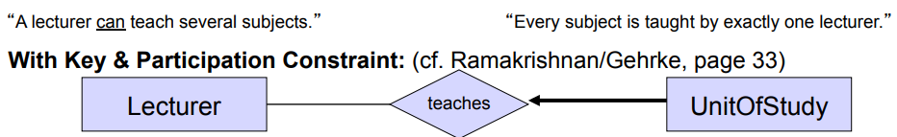

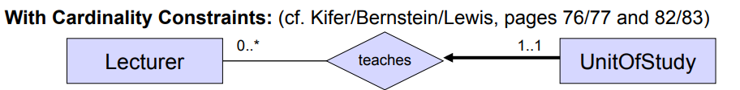

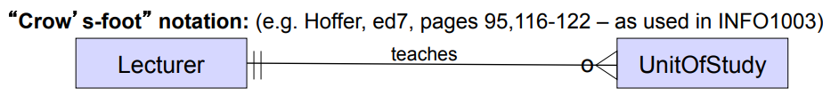

Weak entities

Weak entity type: An entity type that does not have a primary key.

* Can be seen as an exclusive ‘part-of’ relationship
* Its existence depends on the existence of one or more identifying entity types
* it must relate to the identifying entity set via a total, one-to-many identifying relationship type from the identifying to the weak entity set
* Examples: child from parents, payment of a loan

The **discriminator** (or **partial key**) of a weak entity type is the set of attributes that distinguishes among all the entities of a weak entity type related to the same owning entity.

