ISYS 2160 Information Systems in the Internet Age

Week1 Systems Approach/Socio-Technical Systems

**What’s a system**?

* A ‘system’ is made up of inter-related components that work together to achieve the overall objectives of the whole system

Software system

– A software system has many more components such as specification, programs, configuration files, test results, user documentation, etc

**Process** view of system:（系统模型：输入， 处理， 输出， 反馈， 分析）

– Inputs to the system (from the ext. envt.)

– Throughput processing/Transformation

– Outputs of the system (to the ext. envt.)

– Feedback Mechanisms

– Modelling of the overall system with a view to developing optimal solution.

**Key System Principles**

– 1. Openness:

- System behaviour can only be understood in relation to the external environment

- Distinction between the system and the environment – systems boundary

- Controllable and uncontrollable variables

- Role of leadership and managing upward in purposeful systems

– 2. Purposefulness:

– Value-guided systems

– Role of understanding (why actors do what they do)

– Rational, emotional and cultural dimensions

– Reaction- response- action

– 3. Emergent Property:

– Property of the whole that cannot be deduced from the properties of the parts

– Emergent properties as the product of complex interactions among several elements

– Interactions among five basic processes:

throughput, decision making, learning and control, membership, and conflict management.

– Measurement system

– 4. Multidimensionality:

– Multiple interacting dimensions

– Seemingly opposing tendencies not only co-exist to form a complementary relationship

– Plurality of structures and processes.

– 5. Counter-intuitiveness:

– Actions intended to produce certain outcomes may generate opposite results.

– Beyond certain point, quantitative change can lead to qualitative change

– difference in degree versus difference in kind

– Inflection Points

**The Systems Approach(Systems thinking)**

**Definition**: analysing complex systems from the perspective of the total system, the goals of the overall system, the individual components or subsystems, and the inter-relationships and inter-dependencies between the components.

**System Theory**: investigates both the principles common to all complex entities, and the (usually mathematical) models that can be used to represent them.

Types of Systems:

– Teleological vs. ateleological systems

– Open vs. closed systems

– Mechanical Systems

– Biological/Living systems

– Social Systems

– Socio-technical systems: a technical component and a social (human/organisational/societal) component which interact with each other in multiple ways.

Structure of Systems

– Overall objective represented as concrete measure(s) of performance,

– Inputs and Resources

– Process(es)

– Feedback Mechanisms

– Outputs

– System Boundary

– System Environment

Week 2: Internet and E-Commerce

**Agenda**

– Understand the definition and varieties of **e-business and ecommerce**. （电商， 电子经济的定义和特性）

– Discuss the various issues in **business-to-consumer (B2C)** ecommerce. （商对客）

– Discuss the various issues in **business-to-business (B2B)** ecommerce. （商对商）

**E-Commerce vs. E-Business**

**Electronic Commerce (E-Commerce) （电商）**

– Conducting business electronically

**– Sharing business information**

**– Maintaining business relationships**

**– Performing business transactions**

– Outward-facing processes

**Electronic Business (E-Business)（电子经济）**

- A much broader concept than ecommerce

- Also includes internal processes: production, inventory management, risk management, knowledge management

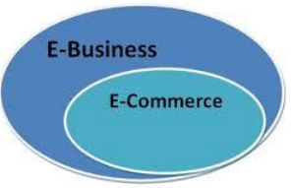

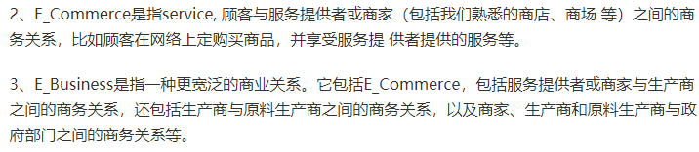

**Unique Features of E-Commerce（电商的特性）**

|  |  |  |
| --- | --- | --- |
| EC Features | Description | Example |
| **Global Reach（全球抵达）** | Products and services can be marketed over vast distances | Almost anyone can access Amazon.com |
| **Integration（实时功能）** | Web sites can be linked to corporate databases to provide **real-time** access to **personalized** information | Customers can check account balances at commonwealth netbank |
| **Mass customization（个性化服务）** | Firms can tailor their products and services to meet a customer’s particular needs. | Customers can build their own PC on www.dell.com |
| **Interactive communication（商客沟通）** | Companies can communicate with customers, improving the image of responsiveness. | Customers can receive real-time online support (e.g. Apple.com) |
| **Universal Standards（通用标准）** | The technical standards for conducting e-commerce are the universal standards (Internet Standards). |  |
| **Information Density（信息富裕）** | Reduces information costs and raise quality |  |
| **Disintermediation（无需中介）**  收益：省去中介费用  支出：网站维护 信息传输 | Cutting out the “middleman” and reaching customers more directly and efficiently | Customers can purchase shoes from Adidas website directly instead of going to retail stores |

**Forms of E-Commerce（电商的形式）**

– Dimensions

– Product

– Process

– Delivery Method

• **Brick-and-mortar** business

– Only physical presence

– Choose not to performs any e-commerce functions

• **Click-and-mortar** business

– Both physical presence and Web presence

– E-Commerce functions

– E.g., Coles Click & Collect

– Shoppers can return products locally

• **Click-and-order** business/Pure play

– Only interact with customers over the Internet

– E.g., Amazon

**EC Revenue Models（利润来源）**

|  |  |  |
| --- | --- | --- |
| Revenue Type | Description | Who is Doing This? |
| Traditional sales（正常销售） | A consumer buys a product/service from the Web site | Chemistwarehouse.com, iTunes.com |
| Web advertising（广告） | Fees are generated from advertisers in exchange for advertisement | Facebook.com, Answers.com |
| Affiliate marketing（推荐位） | Paying businesses that bring or refer customers to another business | Amazon.com’s Associates Program |
| Subscription（订阅） | Users pay a monthly or yearly recurring fee for the product/service | Netflix.com, World of Warcraft, Linkedin Premium |
| Licensing（授权软件） | Users pay a fee for using protected intellectual property | Symantec, Norton |
| Transaction fees/Brokerage（手续费） | A commission is paid to the business for aiding in the transaction | PayPal.com, eBay.com, Groupon.com |

**B2C E-Commerce (e-Tailing)（商对客电子零售）**

– Some definitions:

– Retailers – A sales intermediary that operates between manufacturers and customers

– E-tailers – Retailers that sell over the Internet

– **Benefits** of e-tailing 电子零售优点

• **Product**: With no store size and shelf space restrictions, companies can sell a far wider variety of goods.

• **Place**: Internet storefronts are available on almost every computer connected to the Internet.

• **Price**: The efficiency of online retailers, with high volumes and low overhead allow for very competitive pricing.

– **Drawbacks** of e-tailing 电子零售缺点

• **Product delivery**: Additional time for products to be delivered

• **Direct product experience**: Lack of sensory information

Sales strategy

– Blockbuster Strategy

– Focus marketing resources on a small number of likely best sellers

– Long Tail Strategy

– Cater to niche(缝隙市场) markets in addition to (or instead of) purely selling mainstream products

**Long Tail Strategy**

– Merchandise assortments are growing

– Goods don’t have to be displayed on store shelves, physical and cost constraints on selection disappear

– Search and recommendation tools can keep a selection vastness from overwhelming customers

– Online channels change the shape of the demand curve

– Consumers value niche products geared to their particular interests more than they value products designed for mass appeal

– The tail will steadily grow not only longer (as more obscure products are made available) but also flatter (as consumers discover products better suited to their tastes)

– Obscure products erode the immense share traditionally enjoyed by a relatively small number of hits

– Many small markets in niche products that don’t individually sell well enough for traditional retail and broadcast distribution will together exceed the size of the existing market of hits

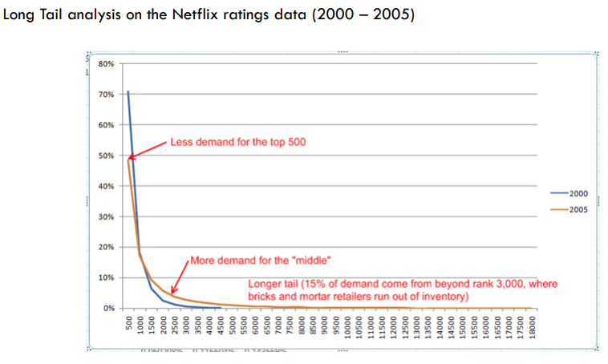

– Some innovative e-tailing models:

– Auction

• Prices are determined dynamically by competitive bidding

– Name Your Own Price (e.g. Priceline)

• A special type of reverse auction originally pioneered by Priceline

• A buyer specifies a price and a product or service, and sellers accept bids

• Sellers' brands are not revealed to customers prior to the consummation of a transaction

• Enables sellers to sell products and services at discounted prices without cannibalizing their own retail sales and without competing with their own distributors

– Group Buying (e.g. Groupon)

Attracting and Retaining Online Customers

– Designing Web Sites to Meet Online Consumers’ Needs

– Structural Firmness

• Characteristics that influence the Web site’s security and performance

– Functional Convenience

• Characteristics that make the interaction with the Web site easier or more convenient

– Representational Delight

• Characteristics that stimulate a consumer’s senses

– The website should offer things like: community, review, advertising, web analytics

**Business-to-Business(B2B) E-Commerce(商对商)**

– B2B e-commerce

- Transactions conducted between different businesses, not involving the end consumer

- Both the sellers and the buyers are business organizations

• Companies attempt to electronically automate trading or communication processes in order to improve them

• B2B transactions require proprietary information (such as orders for parts) to be communicated to an organization's business partners

– Private E-Marketplaces

• Sell-side e-marketplace

– One company sells either standard and/or customized products to qualified companies electronically

– Forward auction » Sellers solicit bids from many potential buyers

• Buy-side e-marketplace

– One company makes purchases from invited suppliers

– Reverse Auctions » One buyer, usually an organization, seeks to buy a product or a service, and suppliers submit bids » Request for Quotation (RFQ)

– Public E-Marketplaces (Exchanges)

• Many sellers and many buyers

• **Vertical exchanges** – Connects buyers and sellers in a given industry – E.g. ChemConnect.com

• **Horizontal exchanges** – Connect buyers and sellers across many industries – E.g. Globalsources.com, Alibaba.com

• **Functional exchanges** – Needed services (e.g. temporary help or extra office space) are traded on an “as-need” basis

– Key Drivers （推动电商的因素）

• Aavailability of secure broadband Internet platform and private and public B2B e-marketplaces

• Need for collaborations between suppliers and buyers

• Ability to save money, reduce delays and improve collaborations

• Emergence of effective technologies for intra- and interorganizational integration