Lecture 1: The IT Services Lifecycle

Learning Outcome:

– Describe the Colesworth Case Study

– List the stages of the IT Services Lifecycle

– Map these stages on to example applications

IT projects and IT services

– a project is a temporary endeavour undertaken to create a unique result

– A service applies the result of that project (and others) to the continuous delivery of outcomes for the service user

– in the context of the organisation’s strategies

– Subject to continual improvement processes

– Ratio of development to management in IT budget is c. 20/80

IT services lifecycle

– Its purpose is to transform an organisation’s IT capabilities into services which meet its business goals and maximise business value

– Life cycle components: Strategy, Design, Transition, Operation, Continual Improvement

Strategy: (business goal and resource management)

Business value;

Resources;

Management

Design: (design base on goal and idea)

Requirement;

Quality;

Design of build&test

Transition: (actual development)

Development;

Test;

Change Management

Release & Deployment Management;

Configuration & knowledge management;

Operation: (maintenance and reaction)

Event management;

Request fulfilment;

Incident management;

Problem management;

Access management;

Monitoring & control;

Continual Improvement: (review and improve)

Measurement

Allignment

Reporting & Analysis

Review Assessment

Service Improvement

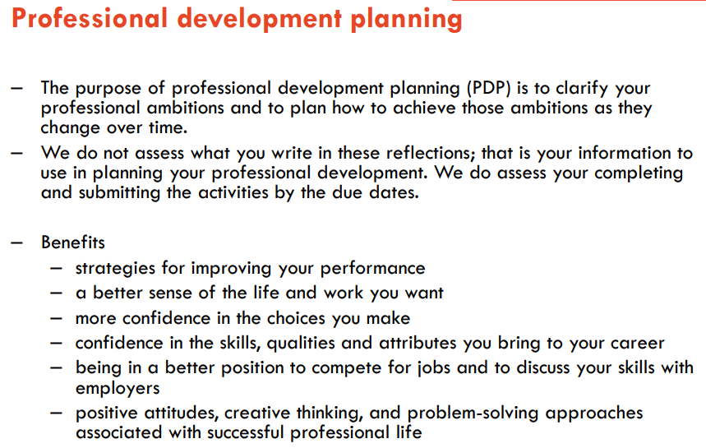

Lecture 2