Elec1601 Lab Report for Week3

Shuwei Zhang

1. Introduction
   1. Purpose:
      * 1. To establish the therotical & practical understanding and acknowledgement about Buzzer and Light sensors.
        2. To develop further knowledge about how these components are used in industry.
        3. Try to design & prototype product ideas based on Buzzers and light sensors.
   2. Objective:
      * 1. Use the Arduino board to build a circuit consists of buzzers, and light sensors, with the help of diagram given.
        2. Use the Arduino programming tool to make the circuit function properly.
        3. Design and prototype more ideas about the products that can be developed from the learned knowledge.
2. Material:
   1. Arduino board: The Arduino board is used to construct all the components, providing a building place.
   2. Light sensor: light sensors (photocells) change its resistance when exposed to light. The amount of change is depended on the strength of light it exposed to.

In real life, one of the applications of light sensors is used in the smartphone screen brightness adjustment system. The light sensor will detect the brightness of the environment, then the circuit will adjust the brightness of screen automatically to protect user’s eye.

* 1. Buzzer: buzzers are like small speakers, they vibrates in different frequency according to the digital electric signal they received, and it can be controlled by programming.
  2. Wires: copper wires are used to connect different electrical components.
  3. Computer: computer is used to program for the Arduino board.

1. Connection:
   1. 11.2.7. The Buzzer:
      1. Circuit diagram

Software used: <https://www.circuitlab.com/editor/#>

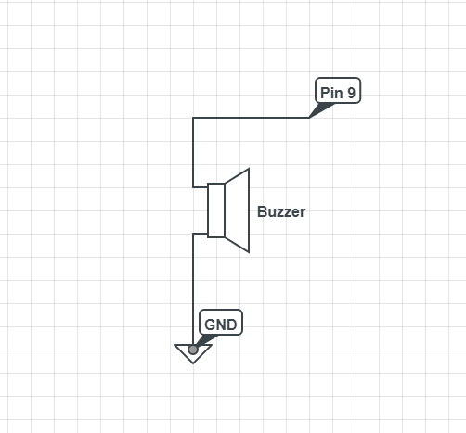

* + 1. Code used to exercise the circuit