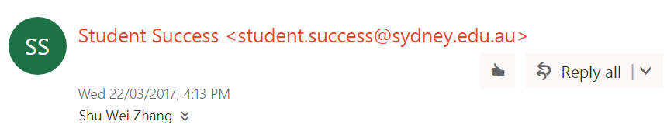

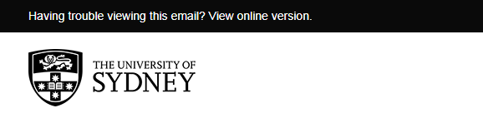

Dear Ted:

The School of IT is going to hold a workshop session that helps students to improve their skills on future career over the next two weeks. Some of the best IT companies in Australia will be invited to give talk. Register now to secure your place:

[Register to attend](https://careerhub.sydney.edu.au/students/events/detail/2603580/interview-skills)

**THE UNIVERSITY OF SYDNEY**  
Level 5, Jane Foss Russell (JFR) Building GO2 | The University of Sydney | NSW | 2006

**T** +61 2 8627 8403 | **F** +61 2 8627 8477