1-TOPS Submission Document 1.0

Function of the SoC 2
High-level Block Diagram 3
Interface pins 5
Clocks 6
Key modules 6
CPU & Instructions Used 6
FFT Block 7
Memory Modules 7
Work in progress/Things to be figured out: 8

Function of the SoC
The proposed System-on-Chip (SoC) is designed to selectively filter specific sounds from real-time audio based on reference audio samples recorded by the user. The primary application is in assistive headphones for people on the autism spectrum, who may find certain individual-specific sounds triggering. Instead of conventional active noise cancellation, which suppresses all environmental sound, this system allows users to suppress only personalised, selected sounds while allowing the rest of the auditory environment to remain audible.
The filtering is achieved by comparing the spectral characteristics of incoming real-time audio with the spectral characteristics of previously recorded trigger sounds.
The SoC operates in two modes: record mode and real-time mode, which can be toggled using a GPIO push button. In record mode, the user records fixed-length audio samples of sounds they wish to suppress using a microphone. These samples are processed to learn characteristic spectral patterns of the trigger sound. In real-time mode, the SoC continuously captures environmental audio through the microphone, processes it, and outputs filtered audio to a DAC connected to headphones.
In both modes, audio input is received through a microphone that transmits PCM samples via an I²S interface. The incoming samples are collected into frames of 256 samples, where successive frames overlap by 50%, and passed to an FFT accelerator for spectral analysis. The FFT output is then processed by the CPU. After the required processing in the spectral domain, the modified frequency components are forwarded to the IFFT block for time-domain reconstruction of the audio signal. The reconstructed samples are then transmitted through the I²S interface to the DAC, which converts the digital signal into an analog signal that is finally played through the speaker.
In record mode, the recorded audio is used to compute feature vectors representing the characteristic spectral directions of the trigger sound. These vectors are learned using Oja’s rule, an online variant of Principal Component Analysis (PCA). As successive frames are processed, the vectors gradually align with the principal spectral directions of the trigger sound subspace, representing the dominant spectral patterns of the sound. The learned trigger vectors are then stored in flash memory for use during real-time filtering.
In real-time mode, each incoming frame’s spectrum is compared against the learned trigger subspace. If the similarity score exceeds a predefined threshold, the frequency bins corresponding to the trigger sound’s learned trigger patterns are attenuated. The modified spectrum is then transformed back to the time domain using an inverse FFT, and overlap-add reconstruction is used to produce the filtered audio signal.

High-level Block Diagram
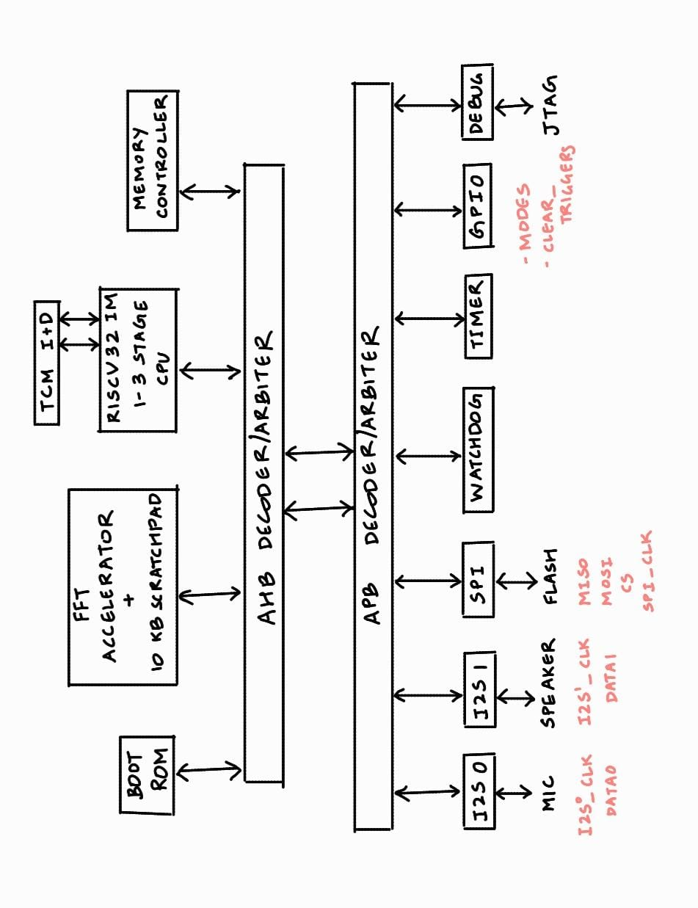
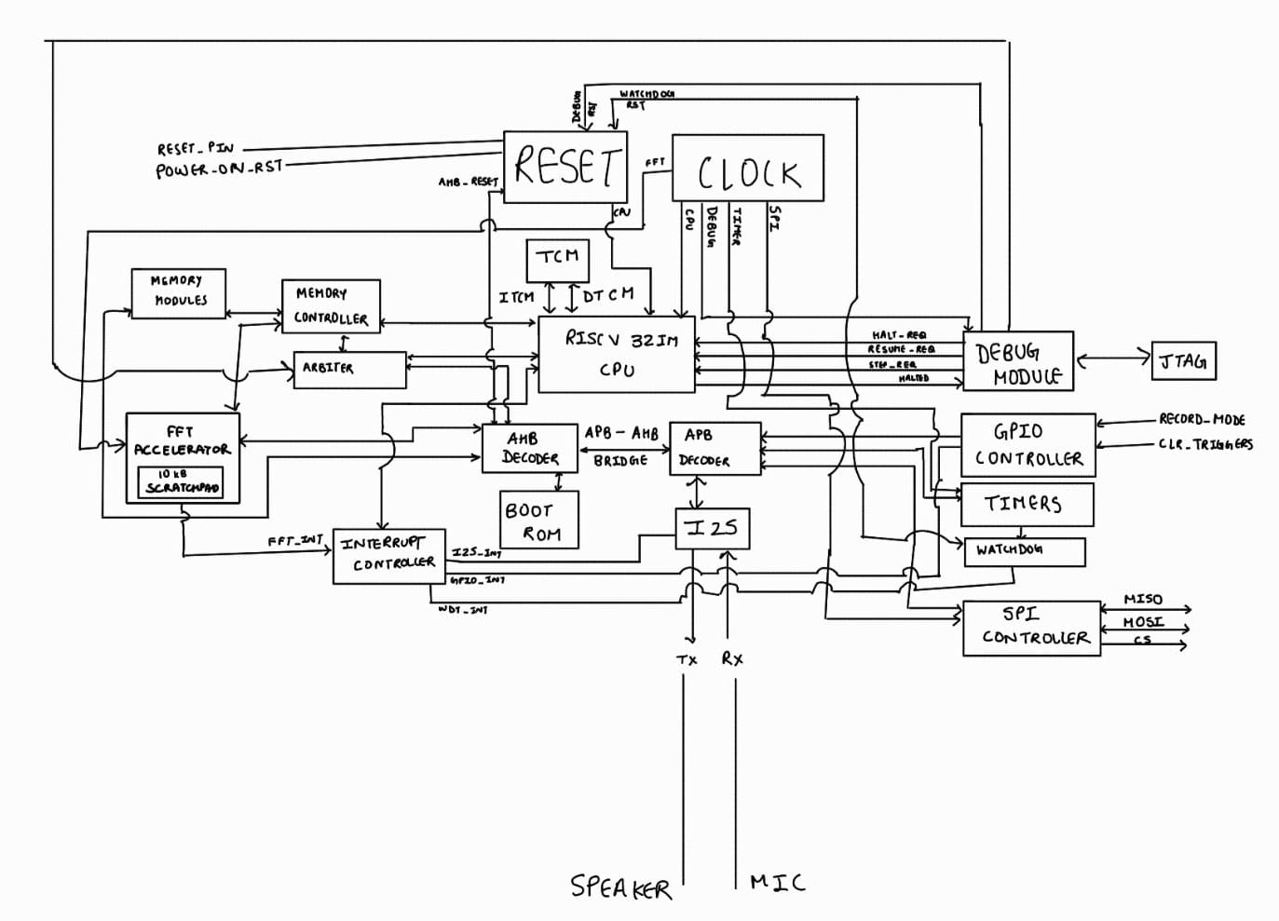

Interface pins
Interface pins of the SoC are listed below:

Port name | Direction | Function | Voltage (V)
core_clk | Input | Primary clock source | 1.8
rst_n | Input | SoC reset | 1.8
rx_i2s_sck | Output | Serial clock to MIC ADC | 1.8
rx_i2s_sd | Input | Serial data from MIC ADC | 1.8
rx_i2s_ws | Output | Serial Word select to MIC ADC | 1.8
tx_i2s_sck | Output | Serial clock to Speaker DAC | 1.8
tx_i2s_sd | Output | Serial data to Speaker DAC | 1.8
tx_i2s_ws | Output | Serial Word to Speaker DAC | 1.8
rec_real | Input | 1’b1 - record mode to receive the trigger pattern  1’b0 (default) - real time filter mode | 1.8
clr_rec | Input | Clears the recorded trigger patterns (sense the rise edge for clear)  1’b0 (default) | 1.8
spi_sck | Output | SPI clock | 1.8
spi_mosi | Output | SPI Master out Slave in | 1.8
spi_miso | Input | SPI Master in Slave out | 1.8
spi_cs | Output | SPI chip select | 1.8
tck | Input | JTAG Clock | 1.8
tms | Input | JTAG mode select | 1.8
tdi | Input | JTAG Data in | 1.8
tdo | Output | JTAG Data out | 1.8
trst_n | Input | JTAG reset | 1.8
func_test | Input | JTAG compliance pin to choose debug or test/dft | 1’b0 - func  1’b1 - Test
Gpio (tbd) | (tbd)… | (tbd) | (tbd)

Clocks
Main clock domains of the SoC are described below:

Clock name | Clock frequency | Source
core_clk | 150MHz - 200MHz | External source - through clock IO
i2s_lrclk | 15KHz | Divided from core_clk
i2s_blclk | 1MHz | Divided from core_clk
i2s_mclk | 3.84MHz | TBD (external source!)
spi_clk | 25MHz | Divided from core_clk
apb_clk | 75MHz - 100MHz | 1:2 of core_clk
ahb_clk | 150MHz - 200MHz | 1:1 of core_clk

Key modules

CPU & Instructions Used
ISA: RV32I processor with the M extension
Pipeline: 1–3 stage in-order
Privilege: M-mode
Memory: 8–32 KB SRAM(on chip), 4 KB Boot ROM

TCM
- DTCM
16 kB to store 4 trigger vectors of 4 kB each (number of triggers which can be stored can be increased based on exactly how much area we have left at the end)
10 B for coefficients and gains used while filtering
- ITCM
Size yet to be decided

Integer instructions:
ADD, ADDI, SUB
SLL, SLLI, SRL, SRLI, SRA, SRAI
LW, LH, SW, SH
BEQ, BNE, BLT, BGE
JAL, JALR
LUI, AUIPC

M extension: MUL, DIV, REM

FFT Block
A 256 point FFT accelerator is used for frequency domain calculations. It performs FFT (Fast Fourier Transform) as well as IFFT (Inverse Fast Fourier Transform).
It has 10 kB scratchpad memory to store the inputs and stage-by-stage output.

It consists of three submodules namely Top_Module, Butterfly_Module, Twiddle_Module.

- Top_Module:
  - Contains an FSM which will decide whether to Read/ Write data, calculate FFT or calculate IFFT.
  - Keeps track of the stage which the Butterfly_Module block is executing.
- Butterfly_Module:
  - Contains one instance of FFT butterfly which performs the mathematical operations of A+B*W and A-B*W where A and B are the inputs and W is the twiddle factor of that particular stage
- Twiddle_Module:
  - Serves as the storage module storing the necessary values for FFT and IFFT.

Memory Modules
1 kB FIFO for 1 frame of input sound samples i.e. inputs of FFT
1 kB FIFO for frequency spectrum of input sound i.e. output of FFT
0.5 kB buffer for magnitude spectrum of FFT output
0.5 kB buffer for phase spectrum of FFT output
0.5 kB buffer for filtered magnitude spectrum of FFT output
1 kB FIFO for frequency spectrum of filtered sound i.e. input of IFFT
1 kB FIFO for 1 frame of input sound samples i.e. outputs of IFFT
Boot ROM
Total: 11 kB + Boot ROM
Implementation of each memory block as SRAM/flops will be decided based on area.

Work in progress/Things to be figured out
- CPU microarchitecture
- Robust boot sequence
- Currently the filtration process does not work for some types of sounds, the logic needs to be modified and optimized more.
- Decide between using XIP and pulling all instructions to TCM while booting. Need to decide if there is an option to overwrite the code externally by using flash or JTAG.
- Finalise memory size for on-chip SRAM, boot ROM and flash memory based on leftover area and firmware size.

