**MU009- UK violent crime tracker using sonification**

**Intro**

This patch has been created using Max MSP on a Windows machine. Its design was originally created to use sonification (displaying data and information through the medium of visual or sonic and still understand the context of the information) to show the level of violent crime over the last six years within the UK and which regions within the UK. The map works by displaying a map of the UK with the regions of the UK highlighted in assorted colours. When a region is selected a song that was written by a band or performer from that area will begin to play and the timer for the data will begin. The higher pitched the song becomes the more violent that area is.

**Equipment List**

For this patch, you will need;

* Laptop or desktop computer
* Max MSP installed on your machine
* Access to crime statistic (provided within git hub)
* A selection of music to play (Also provided in git hub)

**Development Diary/Instructions**

The premise and construction of this patch is very simple the size of the patch is only due to the number of songs being played with need to be manipulated. So in essence, most items within this patch have been copy and pasted ten times.

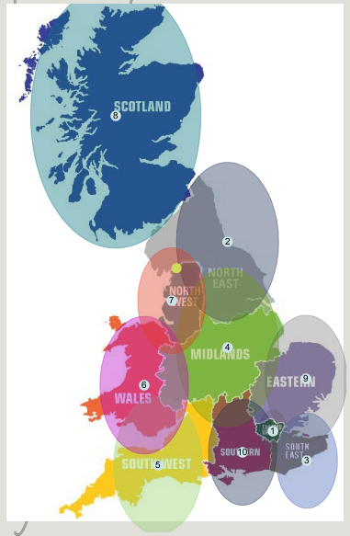The first step in this patch was to find the JPEG of the map and the songs that would be played for each region all of which can be found in the repository. Once these items had been found online I downloaded a ready made MAX MPS audio player and load the tracks into them. I then used the zones object and placed a zone over each region of the map of the UK. This can be seen in the image below.

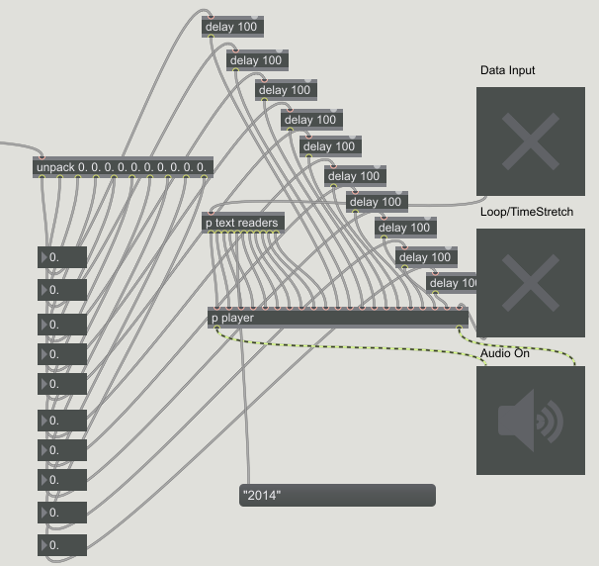I then used the information that is outputted from the zones object to trigger the player using a number of IF objects to trigger the specific song from the area selected from the map. A delay was of 100 milliseconds was added before the information hit the player to stop the player from becoming over loaded with information. This can be seen in the image below.

Within the player sub-patch is a number of objects that are used to change the music being outputted form the player. The first image below shows the pitch shifter objects which are responsibly for changing the pitch of the music. The second image shows objects that can change the speed of the music being played. This is not used for this patch at this time but has been included for future developments in the patch. The third picture show objects that simply loop the music if the patch is running for an extended time. The upper section of the first picture also shows the incoming information from the text readers. The changing numbers coming in from the text readers is what changes the pitch of the outputted music.

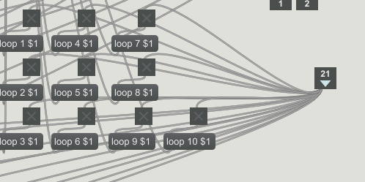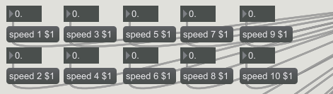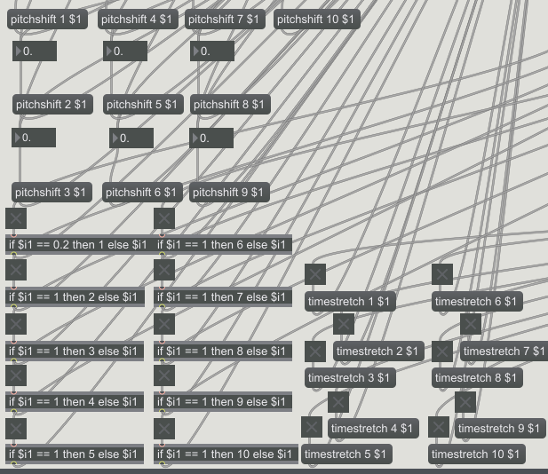

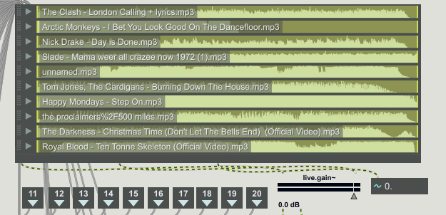This next image below show the player for the patch.

The last section of this patch is the text reading objects which can be seen in the picture below. They work by reading text files which were originally spreadsheet that were found online at a government website for statistics. When saving as on the spreadsheet there is an option available to save the files as a text file.

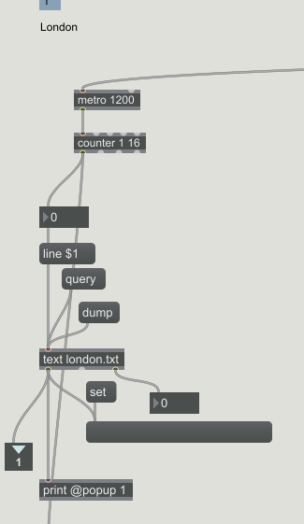This information is then pushed into the pitch shifter object along with a bang to activate the object. At the bottom of the picture is another text reader object which is reading from a text file that consists of the years displayed in number form just to be used as a visual guide for the patch whilst in presentation mode.

**Expansion**

I believe this patch as a concept has a great deal of potential. I would like to use this same idea of violent crime spread over a much larger time scale so the effect could be heard over a greater span of data. This Patch could be used with a great number of different data entry points for example the local economy of a specific area or could even be fed live data from a weather station.