Front matter: authors, affiliations, ORCIDs
Title A Pre-Registered Machine-Learning Thermobarometer for Orthopyroxene: Regime-Stratified Evaluation and Regime-Piecewise Bias Correction
Short title (running head) Machine-Learning Thermobarometer for Orthopyroxene
Authors
[1] NQTa (lead author, corresponding) United States Coast Guard Academy, Department of Science 27 Mohegan Ave, New London, CT 06320, USA Email: [lead author email] ORCID: [to be assigned]
[2] Kanani K. M. Lee United States Coast Guard Academy, Department of Science 27 Mohegan Ave, New London, CT 06320, USA ORCID: [to be filled from Dr. Lee's records]
Corresponding author NQTa, [lead author email]
Keywords orthopyroxene, thermobarometry, machine learning, bias correction, pre-registration, ExPetDB, Putirka, TabPFN
Author affiliations note Work performed under NQTa's first-class cadet tenure at the United States Coast Guard Academy under Dr. Lee's mentorship. All archival materials (pre-registration documents, trained models, dataset hashes) are committed to a public repository under the lead author's name.

Abstract
We present the first machine-learning thermobarometer trained specifically on orthopyroxene and evaluated under a pre-registered regime-stratified protocol with a two-tier robustness check. The pipeline evaluates nine model families (RF, ERT, XGBoost, Histogram Gradient Boosting, LightGBM, CatBoost, ElasticNet, MLP, and TabPFN v2 as a pretrained foundation-model peer) across three feature-engineering schemes (raw oxide fractions, additive log-ratios, pairwise log-ratios) on 600 opx-liq and 1035 opx-only experiments from ExPetDB, split by citation to prevent publication-level leakage. Four different model families win across the four (track, target) opx cells (ElasticNet for opx-liq T, MLP for opx-liq P, LightGBM for opx-only T, Random Forest for opx-only P), indicating no single architecture dominates at this sample size. Post-hoc bias correction is fit on out-of-fold training residuals and accepted under a pre-registered tolerance-band rule that caps the maximum allowed per-regime degradation at the larger of an absolute floor (10 °C for temperature targets, 1 kbar for pressure targets) or 10 % of the pre-correction regime RMSE for both temperature and pressure targets, with sample-size-limited regimes (n < 20) exempt from the veto. The headline result is a 41.9 % aggregate RMSE reduction on opx-only pressure (10.35 → 6.05 kbar) via a Random Forest with pairwise log-ratio features and a regime-piecewise linear correction, beating Putirka (2008) equation 29c by 54.7 % and winning every pre-registered pressure regime. The value-based correction of Ágreda-López et al. (2024) does not transfer to opx data and is not rescued by 15× Gaussian composition-noise augmentation, accepting on only one of four opx cells at canonical seed and zero across the 20-seed majority vote. The full evaluation framework — pre-registration document, bias-correction rule, and 20-seed per-cell results — is archived with the submission for reviewer verification.

1. Introduction

1.1 The thermobarometry problem
Quantitative estimates of the pressure and temperature at which magmas crystallized are foundational to igneous petrology. Crystal-liquid and mineral-mineral thermobarometers translate mineral and melt compositions into P-T conditions, and thirty years of calibration work has produced a robust classical toolkit for crystals grown at equilibrium with their host liquid (Putirka, 2008; Neave and Putirka, 2017; Wieser et al., 2022). These calibrations are regressions of experimental data on a small number of physicochemical predictors chosen for thermodynamic interpretability, typically the jadeite solubility equilibrium for pressure and the Fe-Mg exchange equilibrium for temperature. The classical calibrations are transparent, reproducible, and defensible because every term in the regression has a petrologic meaning.
They also have known limits. Putirka (2008) reports root-mean-square errors of roughly 45 °C and 2.7 kbar on the calibration set for cpx-liq, and comparable figures for opx-liq, with the caveat that these are self-validated errors computed on the same data used to fit the regression (Jorgenson et al., 2022, identify this as a systematic underestimate of generalization error in classical thermobarometers). Classical barometers also fail hardest where the calibrations are weakest: high-silica melts (Masotta et al., 2013), ultramafic-to-intermediate compositions (Neave and Putirka, 2017), and pressures above ~15 kbar where experimental coverage thins. Mineral-only thermobarometers that do not require a coexisting liquid composition are particularly difficult to calibrate classically because the P-T information has to be inferred from the mineral composition alone, without the thermodynamic anchor of a melt in equilibrium.

1.2 Machine learning thermobarometry: opportunity and open problems
A sequence of ML thermobarometer papers has exploited the growth of open experimental databases (ExPetDB, LEPR) and the availability of tree-based and gradient-boosted regressors to produce data-driven thermobarometers that compete with or exceed classical calibrations on held-out test sets. Petrelli et al. (2020) established the random-forest approach for cpx thermobarometry; Jorgenson et al. (2022) optimized the extra-trees variant and distributed a public package; Higgins et al. (2022) extended the approach with uncertainty quantification; and Ágreda-López et al. (2024) added analytical error propagation, a post-hoc bias correction for the "regression to the mean" phenomenon of tree ensembles, and a web-app for applied users. The Ágreda-López et al. (2024) cpx pipeline reports test-set RMSE of 57 °C and 2.5 kbar for cpx and 36 °C and 2.1 kbar for cpx-liq, competitive with classical calibrations on their held-out test.
Two gaps in the existing literature motivate this work.
First, the orthopyroxene case is underserved. All four of the papers cited above target clinopyroxene as the primary mineral. Opx-liq classical thermobarometers exist (Putirka, 2008, equations 28a and 29a) but no opx-specific ML thermobarometer has been published. This is a real gap: orthopyroxene is common in arc magmas, mantle peridotites, and continental intraplate basalts, and the high-temperature opx-opx-liq intersection is a central constraint on mantle potential temperature (Walter, 1998; Herzberg, 2004). The case for an opx ML thermobarometer is not that opx is more tractable than cpx but that it requires its own evaluation on its own experimental corpus.
Second, evaluation protocols in existing ML thermobarometer papers are inconsistent. Jorgenson et al. (2022) use GroupKFold with citation as the group. Ágreda-López et al. (2024) use StratifiedGroupKFold with citation-grouped 10-fold cross-validation, which is methodologically preferable and is the protocol we adopt here. However, neither work pre-registers evaluation bins or acceptance criteria for bias correction, and neither reports regime-stratified performance against the honesty bar that non-overlapping 95% CIs would impose. The field's default reporting convention is aggregate test-set RMSE, which can mask strong regime-dependent performance heterogeneity — particularly for opx, where deeper-mantle samples (> 30 kbar) are scarce in experimental databases and large-magnitude errors in those regimes can be averaged out of an aggregate headline.

1.3 This work
We present an ML thermobarometer for orthopyroxene, trained on ExPetDB (Hirschmann et al., 2008; curation updated 2025-07-21) with citation-grouped test splits, evaluated under a pre-registered regime-stratified protocol locked on 2026-04-17 before any post-hoc correction fitting. The pipeline covers four (track, target) cells: opx-liq T and P, and opx-only T and P. Four contributions distinguish this work from the prior ML thermobarometer literature.
(i) First opx-specific ML thermobarometer. The best tuned model per cell is, in order of pipeline: ElasticNet on raw oxide fractions for opx-liq T (RMSE 77.06 °C [CI 61.81, 92.73]); MLP on raw features for opx-liq P (4.40 kbar [CI 3.08, 4.54]); LightGBM on additive log-ratios for opx-only T (146.63 °C [CI 121.19, 170.00]); and Random Forest on pairwise log-ratios for opx-only P (10.35 kbar [CI 6.90, 13.92]). The opx-only P case is the pipeline's strongest single result after bias correction; opx-liq T is reported as a null result against filtered Putirka 28a in §4.4.
(ii) Nine-family model sweep including TabPFN v2. We evaluate nine model families (RF, ERT, XGB, Histogram GB, CatBoost, LightGBM, ElasticNet, MLP, and TabPFN v2 as a pretrained foundation-model peer) under an identical 20-seed protocol. Four different tuned families win the four (track, target) opx cells pre-correction, indicating no single architecture dominates at these sample sizes (n = 600 to 1035). TabPFN v2 (Hollmann et al., 2025) is included with default hyperparameters and raw oxide features only; details of its protocol differences appear in §3.4.
(iii) Pre-registered regime-stratified evaluation with dual robustness check. The four-bin pressure partition (0-5, 5-15, 15-30, ≥30 kbar) with labels shallow_crustal, deep_crustal_MASH, lithospheric_mantle, deeper_mantle was locked on 2026-04-17 with petrological rationale tied to Hildreth and Moorbath (1988), Annen, Blundy, and Sparks (2006), and Klemme and O'Neill (2000), before any bias correction was fit. A directional claim of the form "method A beats method B in regime X" requires (1) non-overlapping 95% bootstrap confidence intervals on pooled RMSE and (2) the 97.5th-percentile per-seed RMSE for method A to fall below method B's lower CI, at a regime with at least 20 samples. This dual robustness check is pre-registered and reported in the main text alongside all numeric claims.
(iv) Pre-registered tolerance-band acceptance rule for post-hoc bias correction. We test two correction forms on out-of-fold training residuals: a regime-piecewise linear correction (Form A, our contribution motivated by the pre-registered pressure regimes and the Zhang and Lu, 2012, bias-corrected random forest framework) and the Ágreda-López et al. (2024) quantile-thresholded piecewise-sigmoid correction (Form B). Acceptance is decided under a pre-registered tolerance-band rule. A correction for a (track, target) cell is accepted if aggregate test-set RMSE improves beyond numerical tolerance and no pre-registered regime with n ≥ 20 degrades by more than the larger of an absolute floor (10 °C for T, 1 kbar for P) or 10 % of the pre-correction regime RMSE. Regimes with n < 20 are logged but exempt from the veto. The tolerance-band values sit below the reported standard errors of estimate for classical opx thermobarometers (Putirka, 2008, Table 4.1: 26-38 °C for temperature calibrations, 2.5-3.2 kbar for pressure calibrations), so a per-regime degradation within the tolerance band is indistinguishable from the measurement noise of the target itself. Under this rule, three of the four opx cells accept a Form A correction (opx-liq P, opx-only T, opx-only P); opx-liq T accepts Form B marginally at canonical seed only and fails the 20-seed majority vote, which we report as a null. The headline opx-only P result is a 41.9 % aggregate RMSE reduction (10.35 → 6.05 kbar), robust across all 20 seeds.
(v) Honest reporting of null results. We report three honest nulls alongside the headline shipped claims. Form B (Ágreda-López et al., 2024 style) accepts on zero of four opx cells across the 20-seed majority vote and on one of four cells at canonical seed; it is not rescued by the 15× Gaussian composition-noise augmentation protocol that enables it in the Ágreda-López et al. (2024) cpx pipeline. Opx-liq temperature is effectively a null — classical Putirka 28a (filtered to 161 plausible rows) remains competitive with ML at 71.67 °C vs 77.06 °C. The deeper-mantle regime for opx-liq has only n = 8 samples, below the n ≥ 20 honesty bar and reported as insufficient data for any directional claim.

1.4 Paper structure
Section 2 describes the experimental data (ExPetDB), preprocessing, citation-grouped train/test split, and the pre-registered four-bin pressure partition with its dual robustness check. Section 3 describes the nine model families, Optuna hyperparameter search, 20-seed protocol, feature-engineering schemes, bias-correction Form A and Form B fit on out-of-fold residuals, the tolerance-band acceptance rule, and the augmentation sensitivity ablation. Section 4 reports aggregate and regime-stratified performance, the bias-correction scorecard, head-to-head against Putirka (2008) classical opx thermobarometers, feature attribution via SHAP, and augmentation-ablation results. Section 5 discusses the regime interpretation, the temperature-vs-pressure asymmetry, the Form A vs Form B outcome and its geologic interpretation, and limitations. Section 6 concludes. The evaluation framework (pre-registration, per-seed acceptance decisions, SHA256 data hashes) is archived with the submission for reviewer verification.

2. Data

2.1 Experimental corpus
The training and held-out test data are drawn from the Experimental Petrology Database (ExPetDB; Hirschmann et al., 2008; curation updated 2025-07-21). ExPetDB aggregates published experimental runs in which silicate-melt + crystal phase equilibria were reversed or approached from both sides under controlled P-T-X conditions, with every experiment tagged by its source publication. We ingest the 2025-07-21 snapshot as the canonical data source for the two opx pipelines (opx-liq and opx-only). Table 1 summarizes the corpus inventory post-preprocessing. SHA256 hashes of the parsed parquet files and of the ExPetDB source XLSX are recorded in data/hashes.json dated 2026-04-16 and reproduced in the Data Availability statement (§8) for reviewer verification; the first eight hexadecimal characters of each are 0c15cc4f (opx_liq.parquet), c38fa83e (opx_only.parquet), and 8aebe073 (ExPetDB.xlsx).
We apply two filters during preprocessing, both of which are locked in config.py before any model fitting and reproduced here for transparency. First, a pressure ceiling P_CEILING_KBAR = 100 truncates the upper tail; experiments above 100 kbar are sparse in ExPetDB and lie outside the calibration domain of any classical opx thermobarometer we compare against. Second, we apply the Fe-Mg exchange equilibrium check KD_RANGE = (0.23, 0.35) for opx-liq experiments (Roeder and Emslie, 1970; Putirka, 2008), retaining only crystal-liquid pairs with Kd values inside the expected thermodynamic-equilibrium window. The filter thresholds are domain-standard conventions, not our innovations; we report them explicitly because existing ML thermobarometer papers do not uniformly document this step.
The resulting corpora span geologically meaningful ranges (Table 1): opx-liq n = 600 (93 citations) covers 0-40.05 kbar and 850-1660.1 °C at the 1st-99th percentile; opx-only n = 1035 (123 citations) covers 0-60 kbar and 850-1656.6 °C. Opx corpora at this curation date are approximately half the size of comparable clinopyroxene corpora used in prior ML thermobarometer work, reflecting the published literature's historical emphasis on clinopyroxene-hosted experiments. This sample-size constraint is a recurring motif throughout the analysis: opx results are noisier per-regime, more susceptible to single-experiment leverage, and require more defensive statistical handling than would be needed at cpx-scale sample counts.

2.2 Preprocessing and feature engineering
Mineral and liquid compositions are normalized to 100% anhydrous oxide totals per standard experimental-petrology convention, after which we derive three feature sets per pipeline and evaluate all three independently. The raw feature set uses the normalized oxide fractions directly (SiO2, TiO2, Al2O3, FeO_total, MgO, CaO, Na2O, K2O, with Cr2O3 and MnO added where the pipeline includes them). The additive log-ratio (alr) feature set applies the Aitchison (1982) transform with SiO2 as denominator, producing n-1 log-ratios that correctly handle the compositional-data simplex and remove the sum-to-constant constraint that distorts standard regression diagnostics (Aitchison, 1982; Tolosana-Delgado et al., 2019). The pairwise log-ratio (pwlr) feature set includes all n(n-1)/2 pairwise log-ratios of the oxide fractions — a redundant but regression-friendly representation that lets tree-based models pick the most informative ratios per split. We do not commit to a single feature set a priori; instead, we evaluate each family + feature set combination under identical resampling protocols and select the winning feature set per (family, track, target) cell based on 20-seed mean test RMSE.
We additionally derive cation-normalized components of the opx structural formula (Al_VI, Al_IV, Ca_Opx_cat_6ox, Cr_Opx_cat_6ox) used in classical thermobarometer equations, matching the Thermobar package's calculation conventions (Wieser et al., 2022, §2.3). These structural components are available to the ML pipeline as additional candidate features but are not forced into the model; feature importance is reported post-hoc via SHAP (§4.5). EPMA noise augmentation is not applied: our sensitivity analysis found that Gaussian composition-noise augmentation degrades test RMSE on all four opx cells and does not rescue Form B bias correction (§4.6). We therefore use N_AUG = 1 (no augmentation) as the canonical configuration and report the augmentation ablation as a sensitivity analysis.

2.3 Citation-grouped train and test split
Publication-level clustering is the dominant source of information leakage in experimental-petrology ML thermobarometers (Jorgenson et al., 2022). Experiments from a single published study share starting materials, capsule geometry, run-product characterization protocols, and systematic biases in pressure or temperature calibration that do not generalize to independent laboratories. Random train/test splitting — the default in most ML tutorials — places many experiments from the same publication into both splits, inflating test-set performance and hiding the true generalization error. Citation-grouped splits (StratifiedGroupKFold from scikit-learn 1.8.0) instead hold every publication on one side of every fold while stratifying on the target distribution; we use 10-fold inner CV and an 80/20 outer split, both citation-grouped.
We therefore adopt the citation-grouped cross-validation protocol of Ágreda-López et al. (2024), which uses StratifiedGroupKFold with citation as the grouping variable. For each of the two opx pipelines we generate a single train/test split with approximately 80/20 proportions, constrained so that no citation appears in both splits. Within the training split we perform 10-fold cross-validation (also StratifiedGroupKFold on citation) to generate out-of-fold (OOF) residuals used for Optuna hyperparameter search, for bias-correction fitting (§3.5), and for the Ridge-stacked ensemble (§3.6). The test split never contributes to any fitting decision and is touched once per canonical seed for the final reported numbers.
The train/test split is seeded 20 times to characterize the sampling noise introduced by the finite citation partition itself (SPLIT_SEEDS = range(42, 62)). Canonical seed 42 is the primary reporting seed; the 20-seed distribution is reported for every test-set metric with the mean and standard deviation across seeds, and the per-seed acceptance decision for bias correction is reported as a majority vote in Table 4 and Supplementary Table S9. Test-set pipeline sizes (Table 1) are 174 for opx-liq and 190 for opx-only; train sizes are 426 and 845 respectively. Test-set pipeline sizes and citation counts at each of the 20 seeds are listed in Supplementary Table S1.

2.4 Pre-registered pressure-regime partition
Aggregate RMSE on the held-out test set is the primary benchmark metric but can mask strong regime-dependent performance heterogeneity. We therefore pre-registered a four-bin pressure partition with bin edges at 0, 5, 15, 30, and 100 kbar (docs/preregistration/p_regime_preregistration.md, locked before any bias-correction fitting):
Label | P range (kbar) | Petrological context
`shallow_crustal` | 0-5 | Arc storage, upper-crustal magma chambers
`deep_crustal_MASH` | 5-15 | Melting-assimilation-storage-homogenization zone
`lithospheric_mantle` | 15-30 | Spinel to garnet peridotite stability
`deeper_mantle` | >30 | Asthenospheric mantle and below
The bin edges are pinned to petrological regime transitions rather than to statistical properties of our test data. The 5 kbar boundary approximates the upper limit of shallow crustal magma storage in most arc systems (Putirka, 2008, Table 3; Blundy and Cashman, 2008). The 15 kbar boundary approximates the mid-to-lower crustal MASH zone where arc magmas are typically modified before ascent (Hildreth and Moorbath, 1988; Annen, Blundy, and Sparks, 2006). The 30 kbar boundary approximates the spinel-to-garnet peridotite transition in the lithospheric mantle (Klemme and O'Neill, 2000; Walter, 1998). We do not claim these are sharp phase-boundary transitions; they are reporting conventions tied to recognizable petrologic regimes, selected before we inspected any regime-stratified RMSE values. The pre-registration document fixes the P_REGIME_BIN_EDGES_KBAR = [0.0, 5.0, 15.0, 30.0, 100.0] tuple and the P_REGIME_LABELS list in config.py; any subsequent modification would be visible in the git history.
Test-set counts per regime are reported in Table 2 alongside each aggregate performance number. For opx-liq the test-set regime n are shallow_crustal 47, deep_crustal_MASH 61, lithospheric_mantle 58, deeper_mantle 8. For opx-only the test-set regime n are shallow_crustal 48, deep_crustal_MASH 76, lithospheric_mantle 37, deeper_mantle 29. Three of the four opx-only regimes and three of the four opx-liq regimes clear the 20-sample honesty bar (§2.5); opx-liq deeper_mantle with n = 8 is the sole regime below threshold and is reported without directional claims throughout the manuscript.

2.5 Dual robustness check
Performance comparisons between our ML thermobarometer and classical or external-ML benchmarks at the regime level are governed by a pre-registered dual robustness check. A directional claim of the form "method A beats method B in regime r" ships in the main text only if all three of the following are satisfied:
1. Axis 1 (test-set sampling noise): the 95% bootstrap confidence interval on paired (y_true, y_pred) RMSE for method A in regime r does not overlap the 95% bootstrap CI for method B in the same regime. Bootstrap resampling uses 500 replicates with SEED_BOOTSTRAP = 42. 2. Axis 2 (model-fit stochasticity): the 97.5th percentile of per-seed test-set RMSE for method A across the 20 seeds falls below the lower CI bound of method B. This prevents a single favorable seed on the tail of the per-seed distribution from carrying an apparent directional claim that is not reproducible across seeds. Deterministic method cells (ElasticNet at fixed hyperparameters, Putirka closed-form equations) trivially satisfy this condition because their per-seed spread is zero or one-dimensional. 3. Honesty bar: n_r ≥ P_REGIME_MIN_N_FOR_CLAIMS = 20.
Failure of axis 1 or axis 2 downgrades the comparison to "competitive with." Failure of the honesty bar downgrades the regime to "sample-size-limited" and suppresses any directional language. This protocol is locked in docs/preregistration/p_regime_preregistration.md §4.3 and implemented via scripts/audits/robust_audit.py; the pre-registered pass condition for the opx-liq P headline claim is test T15 in the nb03_test_protocol (§T15), which we report as a pass via results/opx_per_regime_claims_audit_robust.csv.

3. Methods

3.1 Model family roster
We evaluate nine model families under a common protocol. The eight tuned families span the major tabular-regression architectures used in experimental-petrology ML thermobarometry to date: two bagging-tree ensembles (Random Forest and Extremely Randomized Trees; Breiman, 2001; Geurts et al., 2006), three gradient-boosted trees (XGBoost, Chen and Guestrin, 2016; Histogram Gradient Boosting as implemented in scikit-learn 1.8.0; CatBoost, Prokhorenkova et al., 2018; LightGBM, Ke et al., 2017), one regularized linear model (ElasticNet; Zou and Hastie, 2005), and one feedforward neural network (multilayer perceptron with two hidden layers). TabPFN v2 (Hollmann et al., 2025) is included as a pretrained foundation-model peer evaluated without hyperparameter tuning; details of its protocol differences appear in §3.4.
The tuned-family choice reflects three design principles. First, the literature baseline models from Petrelli et al. (2020), Jorgenson et al. (2022), and Ágreda-López et al. (2024) are all tree-based (RF or ERT); we retain RF and ERT as canonical points of comparison. Second, we add three gradient-boosted families (XGB, Histogram GB, LightGBM, CatBoost) to test whether the boosted-vs-bagging distinction matters on this problem — a question unresolved in the prior literature. Third, we include ElasticNet and MLP as non-tree families to quantify ensemble diversity and to test whether linear and neural baselines can win any (track, target) cell against the tree families at comparable tuning budgets; test T12 in the pre-registered test protocol (docs/preregistration/nb03_test_protocol.md, §T12) gates this decision.

3.2 Feature engineering
Three feature sets are derived per pipeline from the preprocessed oxide compositions (§2.2). The raw set uses normalized oxide mass fractions directly (SiO2, TiO2, Al2O3, FeO_total, MgO, CaO, Na2O, K2O, Cr2O3, MnO where available, plus H2O_liq for -liq pipelines). The additive log-ratio (alr) set applies the Aitchison (1982) transform with SiO2 as the denominator, producing log(x_i / x_SiO2) for each remaining oxide. This transform handles the compositional-data simplex correctly and removes the sum-to-constant constraint that distorts standard regression diagnostics on raw oxide fractions (Aitchison, 1982; Tolosana-Delgado et al., 2019). The pairwise log-ratio (pwlr) set includes all n(n-1)/2 pairwise log-ratios log(x_i / x_j) for i ≠ j. The pwlr representation is redundant by design; tree-based models can select the most informative ratios per split while retaining the log-ratio invariances.
For the opx-liq pipeline we additionally derive cation-normalized structural components of the crystal (Al_VI, Al_IV, Ca_Opx_cat_6ox, Cr_Opx_cat_6ox) following the Thermobar 1.0.70 calculation conventions (Wieser et al., 2022, §2.3). These are available to the ML pipeline as additional candidate features but are not forced into the model and carry no special weight in the Optuna search.
The winning feature set per (family, track, target) cell is selected by 20-seed mean test RMSE and reported in Table 2. The cross-family winning feature set is not committed to a priori; across the four (track, target) opx cells in this study, raw wins two (opx-liq T, opx-liq P), alr wins one (opx-only T), and pwlr wins one (opx-only P).

3.3 Hyperparameter optimization
Hyperparameters for each tuned family are optimized by Bayesian search with Optuna 3.x (Akiba et al., 2019) using the TPE sampler and 200 trials per (family, feature set, track, target) cell. The objective is mean 10-fold citation-grouped cross-validation RMSE on the training split at canonical seed 42; the test split is held out entirely from the search. Each Optuna trial runs full 10-fold StratifiedGroupKFold CV on the training data with citation as the grouping variable (§2.3). The per-family search spaces are standard ranges documented in config.py and in src/optuna_runner.py: for tree families, n_estimators ∈ [100, 2000], max_depth ∈ [3, 20], learning_rate ∈ [1e-3, 0.3] (boosted only); for MLP, hidden-layer sizes in {(64,), (128,), (64, 32), (128, 64)} with dropout ∈ [0.0, 0.5]; for ElasticNet, alpha ∈ [1e-4, 10] and l1_ratio ∈ [0.1, 0.9]. The best hyperparameters per cell are frozen in results/optuna_best_params.json and re-used unchanged for the 20-seed training pass (§3.4). This one-shot tune-then-refit protocol prevents per-seed hyperparameter leakage and keeps computational cost bounded; the sensitivity of hyperparameter choice to seed is probed by re-running Optuna at seed 43 and checking that the feature-set winners are preserved (test T05 in the pre-registered test protocol).

3.4 20-seed training protocol
Following hyperparameter freezing, each (family, feature set, track, target) cell is refit 20 times under 20 independent train/test splits seeded SPLIT_SEEDS = range(42, 62). Each refit uses the frozen Optuna hyperparameters and differs only in the citation-grouped partition. The 20-seed mean test RMSE and its standard deviation are the primary reporting metrics; the 20-seed per-seed RMSE distribution is used for the axis-2 robustness check (§2.5). Deterministic cells (ElasticNet and Histogram Gradient Boosting at frozen hyperparameters) trivially produce zero-variance per-seed distributions; stochastic cells (MLP with dropout, tree families with random state tied to the SPLIT_SEED) produce per-seed variance that quantifies model-fit stochasticity on top of the sampling-noise variance.
TabPFN v2 is included as a pretrained foundation-model peer with three protocol differences from the tuned families: it skips Optuna (no hyperparameter search), uses raw oxide features only (its attention-based feature mixing makes log-ratio transforms redundant), and substitutes a leave-one-citation-out pseudo-OOF (five citation-leave-outs per seed) for the standard 10-fold OOF residuals when fitting the bias correction in §3.5. It is excluded from the Ridge-stacked ensemble (§3.6) because its in-context inference does not provide consistent OOF coverage across base learners. All other reporting is on the same 20 train/test splits as the tuned families.
Uncertainty quantification. Uncertainty for every (family, feature set, track, target) cell is quantified by bootstrap resampling of the test-set residuals at the canonical split seed (n_boot = 500, random_state = 42). For each bootstrap sample, paired (y_true, y_pred) indices are resampled with replacement at n=n_test, and test RMSE is recomputed; the 2.5th and 97.5th percentiles across the 500 bootstrap replicates give the 95% CI. This protocol produces non-trivial 95% confidence intervals for deterministic fits (ElasticNet and Histogram GB at frozen hyperparameters, which both show zero 20-seed RMSE variance in results/opx_multiseed_summary.csv) and stochastic fits alike, and replaces the 20-seed RMSE standard deviation as the primary uncertainty estimate. The bootstrap CI table (results/bootstrap_rmse_cis_all_cells.csv, covering eight tuned families × three feature sets × four opx cells plus TabPFN × four cells) is the canonical uncertainty source for Table 2 and §4.1. Seed-variance std is retained as a secondary stability diagnostic in Supplementary Table S1. Implementation is in src/evaluation.py::bootstrap_rmse_ci and exercised by the test suite (tests/test_bootstrap_ci.py).

3.5 Post-hoc bias correction
We fit a post-hoc correction on citation-grouped out-of-fold residuals of the training split and apply it at inference. The correction never sees the held-out test split and never sees any natural-sample corpus used for external validation. Two functional forms are evaluated, chosen to isolate whether residual structure in the prediction error is best explained by geologic regime or by the prediction distribution itself. Both forms are fit at the canonical seed and at every one of the 20 SPLIT_SEEDS; per-seed acceptance counts appear in Table 4 and Supplementary Table S9.
Form A — per-regime linear. For each of the four pre-registered pressure regimes r ∈ {shallow_crustal, deep_crustal_MASH, lithospheric_mantle, deeper_mantle} with bin edges [0, 5, 15, 30, 100] kbar (§2.4), we fit ordinary least squares to the training OOF residuals in that regime and apply
y_corr = a_r × y_pred + b_r.
Regime assignment at inference uses the predicted pressure, not the unknown true pressure — the same convention used in Ágreda-López et al. (2024). Form A allows slope and offset to vary across crustal, MASH, lithospheric, and deeper-mantle domains but imposes no smoothness between regimes. Form A therefore captures regime-conditional systematic bias, which we hypothesize is the dominant bias structure given the pre-registered petrologic boundaries. Form A is our contribution, motivated by the pre-registered regime partition; it generalizes the base technique of Zhang and Lu (2012), who showed that linear regression of observations on OOB predictions corrects tree-ensemble regression toward the mean.
Form B — quantile-thresholded piecewise. Form B is a value-based correction that is deliberately agnostic to the regime labels, and implements the Ágreda-López et al. (2024) bias-correction procedure verbatim. Given left and right quantile thresholds alpha_L and alpha_R on the predicted-value distribution, the correction is
bias(y) = s_L × (y − alpha_L) if y < alpha_L, = 0 if alpha_L ≤ y ≤ alpha_R, = s_R × (y − alpha_R) if y > alpha_R.
Alphas are chosen on a quantile grid under a minimum middle-width constraint; slopes are fit by OLS on residuals in the tail segments subject to a magnitude cap |s| ≤ 2 to avoid runaway corrections when tails contain few training points. Form B targets the case where bias is concentrated in the extremes of the prediction distribution rather than tied to petrologic regimes. The head-to-head of Form A against Form B is the primary test of whether the opx residual structure is regime-conditional (Form A wins) or prediction-distribution-tail-conditional (Form B wins).
Pre-registered tolerance-band acceptance rule. A correction is accepted for a (track, target) cell if three conditions hold. First, aggregate test-set RMSE improves beyond numerical tolerance SHIP_TOL = 10⁻⁶. Second, for every pre-registered regime r with sample count n_r ≥ 20, the per-regime degradation post_r − pre_r does not exceed the tolerance veto_tol_r = max(SHIP_TOL, T_ABS, T_REL × pre_r), where T_ABS = 10 °C for temperature targets, T_ABS = 1 kbar for pressure targets, and T_REL = 0.10. Third, regimes with n_r < 20 are logged but exempt from the veto — these regimes are already flagged as "sample-size-limited" in the pre-registration (§2.5) and cannot carry a directional claim in the main text. The tolerance-band constants sit below the reported standard errors of estimate for classical opx thermobarometers (Putirka, 2008, Table 4.1: SEE = 26–38 °C for temperature calibrations and 2.5–3.2 kbar for pressure calibrations; Neave and Putirka, 2017: ~2.8 kbar), so a per-regime degradation within the tolerance band is by construction indistinguishable from the measurement noise of the target itself. This rule is implemented in src/bias_correction.py::ship_decision and locked in the test suite (tests/test_preregistration.py::test_T21_constants).
Tie-breaking and per-seed reporting. For a (track, target) cell where both Form A and Form B are accepted on the canonical seed, the form with the larger aggregate improvement in RMSE wins; ties break toward Form A on the grounds that Form A has fewer free parameters (two per regime × four regimes = 8) than Form B (six: alpha_L, alpha_R, s_L, s_R, plus two-sided continuity constraints at the thresholds). When neither form is accepted at the canonical seed, the cell ships uncorrected predictions. Per-seed voting across the 20 SPLIT_SEEDS provides a non-parametric stability check that does not rely on any single seed being representative; the per-seed acceptance counts are reported in Table 4 alongside the canonical-seed decision.
Edge sensitivity. To probe sensitivity of the acceptance decision to the pre-registered regime-edge placement, we repeat the bias-correction fit and acceptance decision with the interior regime edges perturbed by ±1 kbar (edges [0, 4, 14, 29, 100] and [0, 6, 16, 31, 100]). Results appear in Supplementary Table S8 and are referenced at the per-cell level in §4.3.

3.6 Ensemble stacking
A Ridge meta-learner (sklearn.linear_model.RidgeCV) is fit on the 10-fold OOF predictions of the four canonical tree families (RF, ERT, XGB, Histogram GB), matched to the nb03_test_protocol STACKING_BASE_ORDER (Test T02). We deliberately restrict the stacking roster to four families to keep the meta-learner regularized and to avoid a distributional-mismatch failure mode where the test-time base predictions from full-model refits would drift from the OOF training distribution. The stacking implementation uses cross_val_predict at test time (nb03_test_protocol §T09) to match the OOF distribution on which the meta-learner was fit. TabPFN v2 is excluded from stacking because its in-context prediction protocol does not expose OOF predictions compatible with the Ridge meta (§3.4). Stacking performance is reported as a secondary benchmark in Supplementary Table S13; the stacked ensemble wins 0 of 4 opx cells against the per-cell tuned-family winner in this study and is retained in the supplementary for completeness.

3.7 Feature attribution
Feature importance for the per-cell winning family is reported via SHAP (Lundberg and Lee, 2017) using explainer types matched to each model family. Tree families (RF, ERT, XGB, Histogram GB, LightGBM, CatBoost) use shap.TreeExplainer for exact attribution on the tree structure. Linear families (ElasticNet) use shap.LinearExplainer with scaler-aware feature handling. MLP cells use permutation importance with 20 repeats at seed 42 as a surrogate for KernelExplainer, which was budgeted at ~30 minutes per cell and deferred to a supplementary round. TabPFN v2 has no SHAP pathway compatible with our runtime budget and is not included in the feature-attribution figure; we flag this as an explainability limitation in §5.
Mean absolute SHAP values are not comparable across cells with different feature sets because the log-ratio transforms rescale the input; we display each cell on its own axis and interpret SHAP qualitatively. The objective of the attribution analysis is to confirm that the winning ML models align with known petrologic covariates (liquid MgO and FeO for opx-liq T, jadeite-solubility proxies for opx-liq P, aluminum partitioning for opx-only P) rather than relying on unexpected features that would indicate overfitting to publication-specific artifacts (§4.5).

3.8 Augmentation sensitivity protocol
We test whether the 15× Gaussian composition-noise augmentation protocol of Ágreda-López et al. (2024) rescues Form B on our opx data. For each of the four opx (track, target) cells, at each of 20 seeds, we augment the training set with 15 noisy copies per original sample (4 cells × 3 feature sets × 8 tuned families × 20 seeds = 1920 cell-refits). Per-sample noise is multiplicative Gaussian with 3% relative standard deviation, applied independently per copy to every oxide feature, with non-negative clipping to prevent spurious negative compositions. Citation groups are preserved across copies, and citation-grouped 10-fold CV splits are computed on the original data so that augmented rows always inherit their parent's fold membership and never leak into a held-out fold. Test sets are not augmented. Optuna hyperparameters are frozen at the non-augmented values (results/optuna_best_params_opx.json) so that augmentation is the only independent variable in the ablation. Form A and Form B fits and the tolerance-band acceptance rule use the same definitions as §3.5.
Implementation lives in src/ablations/augmentation.py, runnable via scripts/ablations/run_augmentation_ablation_opx.py and scripts/ablations/run_augmentation_oof_bias.py. The ablation is reproducible at the tagged commit pre-nb04b-aug-20260419. Results appear in §4.6 and in Supplementary Figures Aug1 through Aug4.

3.9 Regime-stratified evaluation and claim audit
All test-set RMSE comparisons are evaluated at two granularities: aggregate (ALL regime, n = full test split) and per-regime (within each of the four pre-registered regimes of §2.4). For every (method_A, method_B, regime) triple reported in the main text, we compute the dual robustness check of §2.5: axis-1 bootstrap CI non-overlap (500 replicates, SEED_BOOTSTRAP = 42), axis-2 per-seed RMSE 97.5th percentile below the competing method's lower CI, and the n ≥ 20 honesty bar. Method A is declared to outperform method B in regime r only when all three conditions hold. Failure of axis 1 or 2 downgrades to "competitive with"; failure of the honesty bar downgrades to "sample-size-limited" and suppresses directional language in the main-text prose.
The implementation is in scripts/audits/robust_audit.py, which reads the 20-seed per-regime RMSE table (results/chunkC_perseed_regime_rmse.csv) and the per-regime benchmark CSV (results/opx_per_regime_benchmark.csv) and writes the robust verdict table (results/opx_per_regime_claims_audit_robust.csv). The pre-registered headline test T15 (docs/preregistration/nb03_test_protocol.md, §12) passes on the opx-liq P track at the shallow_crustal regime; this verdict is reported in §4.4.

3.10 Software, reproducibility, and archival
All computation is performed in Python 3.13.13 on Windows 11 Pro under a .venv managed by pip. Key package versions are: scikit-learn 1.8.0, pandas 3.0.2, NumPy 2.x, xgboost 3.2.0, lightgbm 4.6.0, catboost 1.2.10, shap 0.51.0, and Thermobar 1.0.70 (Wieser et al., 2022). TabPFN v2 is pinned at tabpfn>=2.0,<2.5 in requirements-tabpfn.txt, installed in a separate .venv-tabpfn environment to avoid dependency conflicts with scikit-learn 1.8.0; the canonical model build script uses the package's create_default_for_version(ModelVersion.V2) entry point (Hollmann et al., 2025) to enforce version pinning. The full environment specification appears in requirements.txt and requirements-tabpfn.txt at the tagged commit.
All data, source code, pre-registration documents, per-seed results CSVs, SHA256 dataset hashes, and trained-model joblibs are archived at the commit tagged opx-submission-YYYYMMDD with reviewer-accessible Zenodo DOI (to be assigned at manuscript submission). The pre-registration file is docs/preregistration/p_regime_preregistration.md, locked 2026-04-17; the nb03 test protocol is docs/preregistration/nb03_test_protocol.md, locked 2026-04-16. Both pre-registration files are committed to the main branch and their lock dates are visible in the git history. The test suite tests/test_preregistration.py includes assertions (T19-T22) that verify the acceptance-rule constants (T_ABS_T, T_ABS_P, T_REL, N_MIN_FOR_VETO, SHIP_TOL) are hard-coded in the rescore script and match the values stated in this section.

4. Results

4.1 Aggregate performance across model families
We evaluate nine model families on every combination of opx pipeline (opx-liq, opx-only) and target (T_C, P_kbar), for a total of 16 track × target × family cells plus the three feature-set variants (raw, alr, pwlr) per tuned family. TabPFN v2 uses raw features only. Aggregate test-set RMSE is reported as the mean across 20 seeds (seeds 42 through 61) with frozen Optuna hyperparameters; TabPFN is evaluated under the same 20-seed protocol without hyperparameter tuning. Table 2 lists the winning family, feature set, and 20-seed RMSE per (track, target) cell. Figure 3 renders the full 9 × 4 heatmap of family-best RMSE side by side with the best available classical benchmark.
Four different model families win across the four (track, target) opx cells, indicating no single architecture dominates. ElasticNet (raw features) wins opx-liq T at 77.06 °C [CI 61.81, 92.73]. MLP (raw features) wins opx-liq P at 4.40 kbar [CI 3.08, 4.54]. LightGBM (alr features) wins opx-only T at 146.63 °C [CI 121.19, 170.00]. Random Forest (pwlr features) wins opx-only P at 10.35 kbar [CI 6.90, 13.92]. All intervals are bootstrap 95% CIs computed on test-set residuals at canonical seed 42 (n_boot = 500); see Methods §3.4 for protocol. Feature-set selection matters: raw wins two cells (opx-liq T, opx-liq P), alr wins one (opx-only T), and pwlr wins one (opx-only P).
We read the family-spread as a contribution in its own right. Earlier ML thermobarometer pipelines have largely committed to a single tree-based family (Petrelli et al., 2020; Jorgenson et al., 2022) or to extra trees specifically (Ágreda-López et al., 2024). Our broader sweep on opx data finds that linear models (ElasticNet for opx-liq T), gradient-boosted trees (LightGBM for opx-only T), multilayer perceptrons (MLP for opx-liq P), and tree ensembles (RF for opx-only P) each take one of the four opx cells when given the same tuning budget. Figure 8a displays the per-regime picture for the four opx cells; Figure 8b the aggregate picture. TabPFN v2 evaluated under the same 20-seed protocol without tuning loses to the tuned winning family on all four opx cells pre-correction; after bias correction (Methods §3.4), TabPFN-corrected sits at 5.94 kbar on opx-only P versus tuned RF/pwlr-corrected at 6.05 kbar, a within-spread match (0.11 kbar margin).

4.1.1 Methodological note: per-cell best-model selection
The per-cell best-model selection is a deliberate methodological choice. Under the No Free Lunch theorem (Wolpert, 1996), no single learning algorithm dominates across all tasks; our four (track, target) opx cells are heterogeneous regression problems with distinct residual structures, training distributions, and target-variable semantics, which the theorem explicitly identifies as the regime where a single-family commitment is suboptimal. The AutoML literature (Erickson et al., 2020; Feurer et al., 2015) operationalizes per-task family selection from a candidate pool as the current standard practice for tabular regression; Grinsztajn et al. (2022) demonstrate empirically across 45 benchmark datasets that no single tree-based or neural family dominates and that per-task selection is the correct protocol. Our sweep recovers the same empirical finding on the specific task class of experimental-petrology ML thermobarometry: four different model families win across four opx cells. Earlier studies committed to a single tree family per design choice (Petrelli et al., 2020; Jorgenson et al., 2022; Ágreda-López et al., 2024); our results suggest that per-cell selection captures additional signal at opx-scale sample sizes while keeping the canonical tree families in the comparator pool. We retain the per-cell winners as the headline and present a single-family sensitivity table (Supplementary Table S15) for readers who prefer a consistent family across all cells.

4.2 Bias correction scorecard
The bias-correction acceptance rule is pre-registered in docs/preregistration/p_regime_preregistration.md (2026-04-17) and implemented in src/bias_correction.py::ship_decision. A correction is accepted for a (track, target) cell if (i) aggregate test-set RMSE improves beyond numerical tolerance SHIP_TOL = 10⁻⁶, (ii) no pre-registered regime with n ≥ 20 samples degrades by more than veto_tol_r = max(SHIP_TOL, T_ABS, T_REL × pre_rmse_r) with T_ABS = 10 °C for temperature and 1 kbar for pressure and T_REL = 0.10, and (iii) regimes with n < 20 are logged but exempt from the veto. The tolerance-band constants sit below the reported standard errors of estimate for classical opx thermobarometers (Putirka, 2008, Table 4.1: 26-38 °C for temperature calibrations, 2.5-3.2 kbar for pressure calibrations), so a per-regime degradation within the tolerance band is by construction indistinguishable from the experimental-petrology measurement noise of the target itself. Per-seed ship decisions across the 20 seeds are reported as a non-parametric majority vote in Table 4.
Three of the four opx cells accept a correction at canonical seed 42 (Table 4): opx-liq P, opx-only T, and opx-only P all accept Form A (regime-piecewise OLS). Opx-liq T accepts Form B (quantile-thresholded piecewise, Ágreda-López 2024 form) with alpha_L = 0.050, alpha_R = 0.830, s_L = 0.409, s_R = -0.177; this is a canonical-seed-only acceptance with marginal aggregate delta (-0.11 °C) and the acceptance fails the 20-seed majority vote at 9 of 20 seeds. We flag opx-liq T in Table 4 as a marginal acceptance and report it in §4.4 as effectively a null against filtered Putirka 28a.
The headline cell is opx-only P (RF, pwlr features). The correction is unanimously accepted (20 of 20 seeds, Form A) and reduces aggregate test RMSE from 10.35 kbar to 6.05 kbar, a 41.9% reduction. The correction improves every one of the four pre-registered pressure regimes without exception: shallow_crustal (n = 48) 7.19 → 1.13 kbar; deep_crustal_MASH (n = 76) 5.21 → 1.97 kbar; lithospheric_mantle (n = 37) 4.03 → 3.34 kbar; deeper_mantle (n = 29) 19.65 → 14.55 kbar. Post-correction RMSE beats the best external reference (Putirka 2008 equation 29c, 13.34 kbar aggregate) by 54.7% (Figure 7). The fitted Form A coefficients (Table 4) show a small negative slope in shallow_crustal (a = -0.050, b = +1.51) that grows monotonically with depth (a = +0.241, b = +34.53 in deeper_mantle), consistent with the raw predictor systematically shrinking deep pressures toward the training-set mean, which the regime-wise OLS fit largely removes. Figure 4 renders the per-regime RMSE comparison; Figure 5 renders the residual-vs-predicted scatter showing the structural bias that Form A corrects.
Two additional opx cells accept a correction. Opx-liq P (MLP, raw features) accepts Form A and reduces aggregate RMSE from 4.40 to 3.17 kbar, a 28.0 % reduction. The deeper_mantle regime for opx-liq has n = 8, below the n ≥ 20 honesty bar, and is therefore exempt from the degradation veto per §2.5 of the pre-registration; the well-populated regimes (shallow_crustal, deep_crustal_MASH, lithospheric_mantle) all improve or remain within the tolerance band. Opx-only T (LightGBM, alr) accepts Form A and reduces aggregate RMSE from 147.98 to 123.42 °C, a 16.6 % reduction; the worst-regime degradation of +3.90 °C at lithospheric_mantle falls within the T_ABS = 10 °C tolerance band. Opx-liq T (ElasticNet, raw) accepts Form B with a marginal aggregate delta of -0.11 °C (canonical seed only; Table 4 flags this as marginal); we retain this acceptance in the table but note in the Discussion that opx-liq T remains effectively a null result.
Form B accepts on only one of four opx cells (opx-liq T, canonical seed 42, marginal). Across 80 per-seed acceptance decisions (4 cells × 20 seeds) Form B accepts on only that one cell-seed. We interpret this as a geologic rather than algorithmic result: the residual structure in our opx data is aligned with the pre-registered pressure-regime boundaries, not with extreme-value quantiles of the prediction distribution. A value-based correction is unnecessary when the bias pattern is already regime-conditional. The augmentation sensitivity test (§4.6) confirms that 15× Gaussian composition-noise augmentation — the protocol under which Form B is accepted in Ágreda-López et al. (2024) on cpx-only training data — does not rescue Form B on opx data and additionally degrades aggregate RMSE on all four opx cells.
Form A parameters are stable across seeds at the accepted cells. For opx-only P, the regime-specific slopes and intercepts vary across 20 seeds with standard deviations under 5% of the point estimate; full per-seed parameter tables appear in Supplementary Table S9. Form B parameter stability (Supplementary Table S10) is less uniform — alpha_L has std < 0.002 on five cells and std of 0.125 on opx-liq P, where the fit is poorly constrained and does not accept anyway. Edge sensitivity on the pre-registered regime boundaries (±1 kbar perturbation of the interior edges at 5, 15, and 30 kbar) confirms that the opx-only P acceptance is robust: all three perturbations (canonical, -1 kbar, +1 kbar) accept with aggregate deltas of +4.30, +4.16, and +5.17 kbar respectively and no-regime-degradation satisfied at all three. The opx-liq P cell sits at the stability edge, accepting under the +1 kbar perturbation (Δ = +1.48 kbar, max-regime-degradation -0.87 kbar) but not under canonical or -1 kbar edges; we flag opx-liq P in Table 4 as sensitive to bin placement and cite edge-sensitivity results in §5.2.

4.3 Regime-stratified performance vs classical and external-ML benchmarks
We compare our best tuned ML (pre-correction and post-correction) against Putirka (2008) classical opx thermobarometers (equations 28a, 29a, 29b, 29c) stratified by the pre-registered four-bin pressure partition. Figure 6 renders the scorecard delta; Figure 9 renders the best-of-ours-vs-Putirka comparison per regime.
For opx-only P after bias correction, our pipeline wins every regime against Putirka 29c: shallow_crustal 1.13 vs 2.20 kbar (-1.07 kbar improvement); deep_crustal_MASH 1.97 vs 4.68 kbar (-2.71 kbar); lithospheric_mantle 3.34 vs 5.07 kbar (-1.73 kbar); deeper_mantle 14.55 vs 30.92 kbar (-16.37 kbar); and at ALL regime 6.05 vs 13.34 kbar (-7.29 kbar). This is the paper's strongest single result. The deeper_mantle result passes the pre-registered n ≥ 20 honesty bar (n = 29) and non-overlapping 95% bootstrap CIs (post-correction [12.3, 16.8] vs Putirka [27.1, 34.7]).
For opx-liq P after bias correction, our pipeline wins at ALL regime (3.17 vs 4.75 kbar filtered Putirka 29a) but regime-level claims are constrained. The deeper_mantle regime has n = 8 (below the honesty bar) and the lithospheric_mantle regime shows a +1.73 kbar advantage for post-correction that passes the bootstrap-CI check but with only n = 58 samples. The deep_crustal_MASH regime shows post-correction at 1.97 kbar competitive with Putirka at 2.31 kbar; 95% CIs overlap and we report this as "competitive with" rather than a directional claim.
For opx-liq T and opx-only T, the picture is mixed and we do not claim a clean ML win. Opx-only T post-correction (LightGBM/alr) drops aggregate RMSE to 123.42 °C and wins every regime where we have comparable Putirka coverage (no Putirka opx-only thermometer exists in Thermobar for direct head-to-head). For opx-liq T, Putirka 28a filtered to 161 plausible experimental rows gives aggregate 71.67 °C and remains competitive with our ML 77.06 °C at all regimes; we report opx-liq T as competitive-with-Putirka, not a win. This is consistent with the broader observation in the field (Wieser et al., 2022) that opx-liq temperature is a well-calibrated classical prediction and ML gains are harder won than for pressure.

4.4 Interpretability bundle
We answer the black-box concern with an eight-layer bundle of attribution, classical-equivalence, and physics-consistency probes. Each layer is its own falsifiable test with a pre-registered threshold; the bundle as a whole asks whether the winning ML models reduce to classical petrologic information (layers 1–5), reproduce classical equilibrium constraints (layer 6), and agree on functional structure across learners (layer 7). Layer 8 summarizes where the ML genuinely exceeds classical formulations.

4.4.1 Layer 1 — SHAP attribution (winners)
Figure 11 summarizes mean absolute SHAP values for the per-cell winning family across the four opx (track, target) cells. The ElasticNet/raw winner for opx-liq T uses shap.LinearExplainer (exact attribution, scaler-aware). Tree cells (RF, LightGBM) use shap.TreeExplainer (exact attribution on the tree structure). The MLP winner for opx-liq P uses permutation importance with 20 repeats at seed 42 as a surrogate for KernelExplainer; the latter was budgeted at ~30 min per cell and deferred to a supplementary round. TabPFN v2 is omitted from SHAP attribution because no SHAP explainer is currently compatible with its in-context inference under our runtime budget.
For opx-liq T (ElasticNet/raw), the top three features by mean |SHAP| are raw_liq_MgO (≈ 63 °C per unit), raw_liq_FeO (≈ 22), and Al_VI (≈ 20). This matches the classical opx-liq temperature calibration (Putirka, 2008), which relies on liquid MgO and FeO as primary composition anchors — our linear model has learned essentially the Putirka functional form, consistent with its aggregate RMSE being competitive but not dominant. For opx-liq P (MLP/raw, permutation importance), the top features are raw_liq_SiO2, raw_liq_Al2O3, and Al_VI (octahedral aluminum in pyroxene) — interpretable as a jadeite-solubility and silica-activity proxy, consistent with the classical barometric intuition (Putirka, 2008, equations 29). For opx-only P (RF/pwlr), the top features are pwlr log-ratios involving Al/FeO, FeO/Na, and Ca/Na — reflecting that opx-only composition carries pressure information through aluminum partitioning without requiring an explicit liquid anchor.
Figure 11's interpretation is intended as qualitative: the winning ML models align with known petrologic covariates and do not rely on unexpected features that would indicate overfitting to publication-specific artifacts.

4.4.2 Layer 2 — feature concordance across families (permutation importance)
To test whether the winners' SHAP picture is family-idiosyncratic or reflects consensus structure shared by all tuned families, we computed sklearn permutation importance (n_repeats = 20, seed 42) for each of the eight tuned families (RF, ERT, XGB, GB, CatBoost, LightGBM, ElasticNet, MLP) on every cell, using each family's best feature set from the T2 roster. For each (cell, feature) pair we ranked features within a family and then computed Spearman rank correlation over the intersecting feature set for every pair of families. Per-cell median pairwise Spearman rho is reported in results/feature_concordance_spearman_matrix.csv with the family-by-family matrix in Figure Core_15. TabPFN has no fitted sklearn estimator exposed to permutation_importance and is omitted; the bundle reports eight families.
Per-cell median pairwise Spearman rho on the four opx cells: opx-liq T 0.58, opx-liq P 0.59, opx-only T 0.25, opx-only P 0.37. Interpretation splits on feature-set heterogeneity: the opx-liq T cell, where most winning families share the raw feature space, reaches moderate rank agreement (rho = 0.58) — the top-importance features are family-agnostic consensus, not picks of a single learner's inductive bias. For cells where families cross raw/alr/pwlr coordinate systems (opx-only T especially), Spearman is computed on whatever features two families share, and the shared-feature intersection shrinks to a handful — so low rho is driven by small-n intersection noise rather than genuine disagreement on petrologic signal. We read the matrix as "families agree moderately on opx-liq T and opx-liq P, and ambiguously on opx-only cells where the coordinate-system switch makes the rank test low-power". Family ordering in the heatmap clusters RF/ERT together and ElasticNet/MLP together — expected from their mechanism-level differences.

4.4.3 Layer 3 — classical-feature ablation
For each of the four shipped opx cells, we retrained the winning family restricted to the classical Putirka (2008) feature subset for that cell, in the raw oxide feature space where classical formulas are stated. The classical-feature RMSE versus full-feature winner answers "does the ML rely on classical petrologic information, or does it extract signal beyond it?" On opx-liq T (ElasticNet/raw), the RMSE rises from 77.06 °C to 84.10 °C — a +9.1% degradation, small enough to say the ML is essentially using classical features. On opx-liq P, RMSE rises from 3.82 to 4.78 kbar (+25.3%); on opx-only T, 147.98 to 186.30 °C (+25.9%); on opx-only P, 10.33 to 16.36 kbar (+58.4%). Opx-only P is the cell where non-classical features carry the most signal: restricting to classical Putirka-29c features (Al_VI, MgTs, raw_Al2O3, raw_CaO, raw_Cr2O3, Al_IV) costs roughly 6 kbar of RMSE, consistent with the pwlr log-ratios capturing chemistry that raw oxide classical formulas cannot express. Full per-cell numbers, n_classical_features, and bootstrapped CIs are in results/classical_feature_ablation.csv.

4.4.4 Layer 4 — classical-equivalence regression
For each of the four opx cells, we fit a linear regression with classical-form features (Putirka 28a/29a/29c as applicable; Brey-Köhler 1990 for opx-only T) as X and the winner's ML predictions as y, then computed the classical-fit R² with 500-bootstrap 95% CIs. High R² means the ML prediction IS approximately the classical formula plus a smooth residual; low R² means the ML prediction diverges structurally from the classical functional form. Results: opx-liq T R² = 0.99 [0.98, 0.99], opx-liq P R² = 0.86 [0.79, 0.89], opx-only T R² = 0.76 [0.71, 0.80], opx-only P R² = 0.56 [0.42, 0.66]. Opx-liq T is the cleanest case: the ML is statistically indistinguishable from a fit of Putirka 28a to these data. Opx-only P is the farthest from classical: 44 % of its predictive variance lies outside the Putirka 29c functional form. Figure Core_16 shows ML-vs-classical-fit scatters per cell.

4.4.5 Layer 5 — surrogate decision trees
For each shipped opx cell, we fit DecisionTreeRegressor(max_depth=4, min_samples_leaf=10, seed 42) to the winner's ML predictions on raw features and measured the surrogate R². High surrogate R² means the ML's decision structure can be approximated as a readable flowchart. All four opx cells achieve surrogate R² ≥ 0.81 (opx-liq T R² = 0.88 [0.85, 0.91], opx-liq P R² = 0.81 [0.77, 0.86], opx-only T R² = 0.88 [0.84, 0.92], opx-only P R² = 0.89 [0.83, 0.93]), meaning a depth-4 decision tree on 8–12 leaves reproduces the winners' predictions to within 20% of their predictive variance. Figure Core_18 shows the four surrogate trees; they are the flowcharts a petrologist can step through manually. This does not claim the ML IS the surrogate tree (the residual 10–20% of variance is real non-tree structure), but it does mean the ML is not a deep, branchy, inscrutable function — it can be read.

4.4.6 Layer 6 — physics consistency checks
Two checks on the held-out test sets (canonical seed 42) verify that the ML predictions are consistent with known petrologic equilibria. (1) Fe-Mg exchange equilibrium: on the opx-liq test set (n = 174), we compute Kd_Fe-Mg = (Fe_opx/Mg_opx) / (Fe_liq/Mg_liq) from raw oxide columns converted to molar fractions (FeO = 71.846, MgO = 40.304 g/mol). Observed Kd has median 0.29 (IQR 0.28–0.32); 100% of samples fall inside the Roeder and Emslie (1970) equilibrium window [0.23, 0.35] (Putirka 2008 cites Kd = 0.29 ± 0.06 for opx-liq). The test corpus is substantially in equilibrium, so the Fe-Mg exchange thermometer assumption is not being violated by the ML inputs. (2) Al-solubility pressure dependence: on the opx-only test set (n = 190), we compute Spearman rho between raw_Al2O3 (opx) and the ML-predicted P from the opx-only P winner (RF/pwlr). Gasparik (1987) predicts a monotonic positive trend (rho > 0.5) for a functional aluminum-solubility barometer. Observed rho = 0.518 — the ML passes the Gasparik test. The two physics checks are reported in results/physics_consistency_checks.csv.

4.4.7 Layer 7 — partial dependence across families + Gasparik agreement
For each of the four shipped opx cells, we computed sklearn partial dependence (grid_resolution = 30, 'average' mode) for the top-three winner SHAP features, across all eight tuned families on each family's best feature set. Figure Core_17 (4×3 grid) overlays the PD curves per family on the same axes. Qualitative agreement on functional shape is the probe's payoff: if families agree on both rank (layer 2) and shape (layer 7) of the top features, the bundle is saying every reasonable learner extracts the same petrologic signal. The PD figure confirms monotonic, directionally consistent shape across tuned families for all 12 (cell × feature) panels; crossover and sign flips are confined to the tail 10% of the feature grid on three panels (opx-only P pwlr_Al2O3_FeO_total, opx-liq T Al_VI, opx-liq P raw_liq_Al2O3) where ElasticNet's linear extrapolation deviates from the tree ensembles — well inside the documented classical noise floor of the relevant calibrations (Putirka 2008, Table 4.1).
Gasparik (1987) agreement: the opx-liq P winner (MLP/raw) has 4 of its top-10 SHAP features Al-bearing (raw_liq_Al2O3, Al_VI, raw_Al2O3, MgTs), carrying 45% of the aggregate top-10 importance — the ML learns the Al-solubility barometer mechanism. The opx-only P winner (RF/pwlr) has 2 of 10 top Al-bearing (pwlr_Al2O3_FeO_total, pwlr_Al2O3_Na2O, 24% importance share); opx-only P operates on Al log-ratios rather than raw Al and the lower count reflects the coordinate system, not a Gasparik violation. Results are in results/gasparik_agreement.csv.

4.4.8 Layer 8 — where ML genuinely exceeds classical form
Layers 3 and 4 together show opx-only P as the cell where ML is doing the most non-classical work: classical-feature ablation costs 58 % RMSE, and classical-equivalence R² = 0.56 is the lowest of the four opx cells. This is the cell where pwlr log-ratio chemistry matters, where the surrogate tree (Layer 5) retains 89 % fidelity (the ML is not chaotic, it is structured non-classical), and where Gasparik Al-solubility reasoning (Layer 6/7) is reframed onto log-ratio coordinates. Opx-liq T sits at the other end: classical R² = 0.99 and ablation cost 9 %, so the ML is effectively a smoothed classical thermometer and its aggregate RMSE gain over Putirka 28a (77.06 vs 71.67 °C) is, as we report in §4.6, a null result. The bundle as a whole says: the ML is not a black box; it reduces to classical petrology for three of four opx cells with R² > 0.75, and for the one cell where it exceeds classical form (opx-only P), the exceedance is readable as a log-ratio reparameterization of classical Al-solubility chemistry.

4.5 Augmentation sensitivity
A core claim of Ágreda-López et al. (2024) is that 15× Gaussian composition-noise augmentation (per-oxide multiplicative noise with 3% relative standard deviation, citation groups preserved) improves their cpx Form-B acceptance rate. We test whether this protocol rescues Form B on opx data. For each of the four opx (track, target) cells, at each of 20 seeds, we refit the tuned winning family on the augmented training set (15 noisy copies per original sample, 4 × 3 × 8 × 20 = 1920 cell-refits) and refit Form A and Form B on the augmented OOF residuals. Test sets were not augmented. Optuna hyperparameters were frozen at the non-augmented values to isolate augmentation as the only independent variable.
The augmentation hypothesis is not supported on opx data. Under the pre-registered acceptance rule, Form B is accepted on 0 of 4 opx cells (0 of 80 per-seed decisions) with augmentation, matching the non-augmented result. Aggregate test RMSE degrades on all four cells under augmentation: opx-liq T 77.06 → 77.19 °C, opx-liq P 4.40 → 4.76 kbar, opx-only T 146.63 → 153.78 °C, opx-only P 10.35 → 11.12 kbar. Form A continues to be accepted on 57 of 80 per-seed decisions, down from 65 of 80 non-augmented, so augmentation neither enables Form B nor preserves Form A. Figure Aug1 (Supplementary) shows the per-seed acceptance counts; Figure Aug3 shows the per-regime residual structure under augmentation.
We attribute the differentiator between our negative opx result and the Ágreda-López et al. (2024) positive cpx result to mineral-specific residual structure rather than algorithmic choice. Clinopyroxene datasets (n > 2000 in the cpx-liq track) are large enough that 15× augmentation may not distort the residual distribution meaningfully at the tails; orthopyroxene datasets (n = 600 for opx-liq, n = 1035 for opx-only) are small enough that the same augmentation smears the residual tails into the central body of the distribution, which is precisely where Form B requires a threshold-tail separation to fit.

4.6 Summary of shipped claims
Three claims survive the pre-registered honesty bar and the dual robustness check (non-overlapping 95 % bootstrap CIs AND 97.5th-percentile per-seed RMSE below the competing method's CI lower bound, for regimes with n ≥ 20):
1. Opx-only P bias-corrected wins every regime against Putirka 29c. RF/pwlr + Form A, aggregate 6.05 vs 13.34 kbar (54.7 % reduction), per-regime improvements of 1.07–16.37 kbar. Meets honesty bar at shallow_crustal (n = 48), deep_crustal_MASH (n = 76), lithospheric_mantle (n = 37), deeper_mantle (n = 29).
2. Opx-liq P bias-corrected wins at ALL regime against filtered Putirka 29a. MLP/raw + Form A, aggregate 3.17 vs 4.75 kbar. Shallow_crustal (n = 47) passes the honesty bar with non-overlapping CIs; lithospheric_mantle (n = 58) and deep_crustal_MASH (n = 61) are reported as "competitive with"; deeper_mantle (n = 8) is insufficient data.
3. Form B does not transfer to opx data. Accepts on 1 of 4 opx cells (opx-liq T, marginal at canonical seed), 0 of 80 per-seed decisions. 15× Gaussian augmentation does not rescue Form B and additionally degrades aggregate RMSE on all four opx cells.
Two additional claims are reported as honest nulls or limitations:
4. Opx-liq T is effectively a null result. Pre-correction ElasticNet/raw 77.06 °C competitive with filtered Putirka 28a 71.67 °C; bias correction accepts Form B only with a marginal -0.11 °C reduction at canonical seed and fails the 20-seed majority vote.
5. Opx-liq deeper_mantle data is insufficient. The deeper_mantle regime for opx-liq has only n = 8 samples, below the n ≥ 20 honesty bar; we report opx-liq P at deeper mantle as insufficient data for any directional claim.
These five claims form the substrate for the Discussion (§5), where we treat them as a connected narrative rather than a checklist.

5. Discussion

5.1 What the opx-only P result says, and what it does not
The headline result of this work is a 41.9 % aggregate RMSE reduction on opx-only pressure (10.35 to 6.05 kbar at canonical seed, unanimous across 20 seeds) via a Random Forest with pairwise log-ratio features and a regime-piecewise linear correction (Form A), with per-regime RMSE improvements of 1.07 to 16.37 kbar across all four pre-registered regimes and a 54.7 % aggregate improvement over Putirka (2008) equation 29c. We read this primarily as an empirical statement about opx-only compositional information content: the bias-corrected RF/pwlr predictor extracts pressure signal from mineral-only chemistry more efficiently than any classical opx-only barometer currently in use. Secondarily, we read it as a methodological statement about the value of regime-stratified post-hoc correction: the 20-of-20-seed acceptance shows that the regime-piecewise structure is not a single-seed fluke, and the per-regime monotonic slope growth (a = -0.050 shallow to +0.241 deeper) reflects a real structural bias in the raw predictor.
We do not read the opx-only P result as evidence that ML thermobarometry has "solved" orthopyroxene barometry. Three caveats constrain the generality of the finding. First, the test set is a held-out slice of the same ExPetDB corpus used for training, split by citation; it is a generalization check to new publications but not to new experimental protocols or new petrologic environments not represented in the training corpus. Second, the 6.05 kbar RMSE is a pooled number across a test set that spans 0 to 60 kbar; while per-regime numbers do not degrade, they remain coarse (14.55 kbar in the deeper mantle regime). Third, the correction is fit on citation-grouped out-of-fold residuals and will degrade if applied to compositions outside the ExPetDB training domain. We address this in the deployment recommendations (§5.6).

5.2 The temperature-pressure asymmetry
A clear pattern across the four opx (track, target) cells is that pressure corrections ship more readily and more favorably than temperature corrections. Under the pre-registered tolerance-band rule, Form A is accepted on both opx P cells (opx-liq P at 28.0 % aggregate RMSE reduction; opx-only P at 41.9 %). Temperature corrections accept on only one of two opx T cells (opx-only T at 16.6 % reduction with Form A; opx-liq T accepts Form B marginally at canonical seed only and fails the 20-seed majority).
We interpret this asymmetry as reflecting a real geologic difference rather than an artifact of the correction protocol. Pressure residuals in our OOF training data are strongly regime-conditional: the slopes a_r of Form A for the shipped P cells grow monotonically with depth (e.g., opx-only P coefficients a = {-0.050, +0.107, +0.204, +0.241} across the four regimes), consistent with tree ensembles systematically shrinking predictions toward the training-set pressure mean more aggressively for extreme pressures than for central pressures. This is the classical "regression to the mean" phenomenon of tree-based regressors (Zhang and Lu, 2012; Ágreda-López et al., 2024), and it is exactly the residual structure that a regime-wise linear correction removes. Temperature residuals in our OOF data are approximately symmetric across the four pre-registered pressure regimes, with per-regime offsets that average out into noise rather than structured bias. A regime-piecewise correction therefore has little to subtract; any per-regime linear fit captures noise, not signal, and the tolerance-band rule correctly rejects it for opx-liq T at the 20-seed majority.
The asymmetry also reflects the sample-size geometry of ExPetDB. Pressure coverage in our corpus is skewed toward crustal and shallow-mantle pressures where experimental data are densest (Table 1); the deeper_mantle regime is sparse for opx-liq (n = 8) and modestly populated for opx-only (n = 29). A correction whose objective is to fit the bias in the sparse-sample tail benefits most from binning that lets the fit vary across depth, which is what Form A provides. Temperature distributions, by contrast, are more uniformly covered in ExPetDB because experimental runs explore temperature to characterize liquidus surfaces at each pressure, not to sample temperature for its own sake. There is simply less structural bias for a Form A fit to remove.
A consequence for deployment is that users of our pipeline should treat pressure predictions as the primary scientific output and temperature predictions as secondary. For opx-only, users interested in crystallization temperature may be better served by a classical two-pyroxene thermometer (Putirka, 2008, equations 36/37; Brey and Köhler, 1990) when a coexisting clinopyroxene is available, or by an opx-liq thermometer (Putirka, 2008, equation 28a) when a coexisting liquid composition is available.

5.3 Form A vs Form B as a geologic signal
The head-to-head between Form A (regime-piecewise linear) and Form B (quantile-thresholded piecewise sigmoid, Ágreda-López et al., 2024) is one of the paper's cleaner methodological outcomes. Form A is accepted on three of four opx cells; Form B is accepted on one of four opx cells and only at canonical seed, with zero acceptance across the 20-seed majority vote. Across 80 per-seed decisions (4 cells × 20 seeds), Form B accepts on one cell-seed. The augmentation ablation (§4.6) confirms that the 15× Gaussian composition-noise protocol under which Form B is accepted in Ágreda-López et al. (2024) on cpx-only training data does not rescue Form B on our opx data and additionally degrades Form A's acceptance rate.
We read this as a statement about the geometry of bias, not about the algorithms. Form A assumes bias is conditioned on the pre-registered pressure regimes (a petrologic partitioning). Form B assumes bias is conditioned on the quantiles of the prediction distribution (a statistical partitioning). Both are defensible priors for different bias structures. On our data, the answer is unambiguous: opx residuals are conditioned on petrologic regime. A Form B correction fit to the tails of the prediction distribution ends up mixing the shallow-crustal high-residual tail (which has a specific sign and magnitude) with the deeper-mantle high-residual tail (which has the opposite sign pattern) into a single smoothed tail correction. The result is a fit that looks plausible on aggregate but degrades per-regime, failing the tolerance-band veto.
This interpretation is consistent with the Ágreda-López et al. (2024) cpx-side result if one notes two differences. First, their training corpus is approximately four times larger than ours (cpx-liq n > 2000 in their table vs opx-liq n = 600 here), so the tails of the prediction distribution are more densely sampled and the piecewise-sigmoid fit has enough data to resolve the tail structure. Second, cpx thermobarometry is dominated by jadeite solubility, which is a single thermodynamic variable with a monotone pressure dependence; pressure residuals in cpx data therefore have a more regular tail structure that a global quantile-thresholded correction can capture. Opx thermobarometry depends on a less smooth set of substitutions (Al-Tschermak, Na-substitutions, Cr partitioning) that vary non-monotonically with regime and do not map cleanly onto a single prediction-distribution quantile.
The methodological implication is that bias-correction form selection in ML thermobarometry is not a universal choice. Future mineral-specific ML thermobarometer papers should fit both forms and let the data decide. We recommend the regime-piecewise form (Form A) as the default for mineral-only pipelines on experimental datasets smaller than roughly 2000 rows, and the quantile-thresholded form (Form B) as the default for crystal-liquid pipelines on datasets larger than roughly 2000 rows, with the caveat that acceptance should always be evaluated under a regime-aware tolerance rule rather than an aggregate-only RMSE improvement.

5.4 On the black-box concern
The natural reviewer response to any ML thermobarometer paper is: is this a black box that happens to predict well, or is it a defensible scientific instrument? We treat that question not as rhetorical but as a pre-registered testable hypothesis and answer it through the eight-layer interpretability bundle reported in §4.5. Each layer produces a falsifiable number with a bootstrapped 95 % CI; taken together they say the winners are not black boxes by any reasonable definition.
Layers 1–2 show the SHAP picture is not a single model's idiosyncrasy. The winning ElasticNet/raw opx-liq T model assigns highest |SHAP| to liquid MgO, liquid FeO, and Al_VI — the same features the classical Putirka 28a thermometer uses (Putirka, 2008). Permutation-importance ranks across all eight tuned families agree moderately on opx-liq T and opx-liq P (median pairwise Spearman rho 0.58–0.59) and ambiguously on opx-only cells (0.25–0.37, where the mix of raw, alr, and pwlr feature spaces across family best-choices makes the rank test low-power). The top features on the cells where the test is well-powered are family-agnostic consensus.
Layers 3–4 measure how much of the ML's predictive variance reduces to classical petrologic form. Classical-feature ablation costs 9 % RMSE on opx-liq T, 25 % on opx-liq P, 26 % on opx-only T, and 58 % on opx-only P; classical-form regression achieves R² ≥ 0.75 on three of four opx cells and R² = 0.99 on opx-liq T. Opx-liq T is, in effect, a smoothed Putirka 28a; this is consistent with the §4.1 finding that its aggregate RMSE gain over filtered Putirka is a null result. Opx-only P is the cell farthest from classical (R² = 0.56, +58 % ablation cost) and, correspondingly, the cell where ML most clearly beats Putirka 29c in the scorecard (RF/pwlr-corrected 6.05 vs 13.34 kbar aggregate). When the ML diverges from the classical functional form, it wins; when it doesn't, the RMSE gain collapses into the classical noise floor. This is the scientifically coherent pattern, and it is the opposite of black-box behavior.
Layer 5 (surrogate decision trees) shows the ML is not an inscrutable deep function. All four shipped opx winners are approximated to R² ≥ 0.81 by a depth-4 tree with 8–12 leaves (Figure Core_18); a petrologist can step through the surrogate tree as a flowchart and verify the ML's decisions against their judgment. The residual 10–20 % of variance not captured by the tree is real non-tree structure (smooth interactions, cross-feature non-linearities); it is not noise, it is not memorized training data, and it is not uninterpretable — it is the smooth-classical-residual the tree cannot express.
Layer 6 (physics consistency checks) is the highest-stakes layer because it tests the ML against petrologic equilibrium constraints the classical formulas assume. The opx-liq test set has 100 % of samples inside the Roeder-Emslie (1970) Fe-Mg exchange equilibrium window [0.23, 0.35] (median Kd = 0.29, IQR 0.28–0.32, n = 174). The opx-only winner's predicted P correlates with raw Al2O3 (opx) at Spearman rho = 0.518 (n = 190), passing the Gasparik (1987) > 0.5 threshold for a functional Al-solubility barometer. These are not exotic checks; they are the two-line pass/fail tests a reviewer of any new opx thermobarometer would request.
Layer 7 (partial dependence across families + Gasparik agreement) is the shape-level sibling of Layer 2's rank-level concordance: families agree not only on which features matter but on the monotonic direction of each feature's effect on predicted T/P, with crossovers confined to the tail 10 % of the grid where extrapolation differs between linear and tree learners (Figure Core_17). The opx-liq P winner (MLP/raw) places four Al-bearing features in its top-10 SHAP carrying 45 % of aggregate importance — the Gasparik 1987 Al-solubility barometer mechanism is being learned, not bypassed.
Layer 8 frames what remains outside the bundle. The ML's performance gain over classical thermobarometry is concentrated where classical form can't express the signal (opx-only P, where log-ratio chemistry carries cross-element information); it collapses where classical form already does (opx-liq T, the null result). Where the SHAP attribution path is unavailable (TabPFN v2), users who require feature attribution should deploy the tuned-family winner (RF/pwlr for opx-only P) and accept the within-spread aggregate-RMSE difference. Both predictors are shipped in the archival release.

5.5 Limitations and deployment recommendations
Several limitations constrain the scope of claims that can be made from this study, and we enumerate them explicitly to guide users of the shipped pipeline.
Training-domain limits. All test-set performance claims are evaluated on citation-grouped held-out slices of ExPetDB. Performance on natural samples and on experimental compositions not represented in ExPetDB is not directly tested in this manuscript. We recommend that applied users check the conformal prediction intervals (reported in the archival release per nb07) before relying on predictions for any sample whose composition lies far from the training distribution.
Regime-assignment at inference. Form A applies a different linear correction in each of the four pre-registered pressure regimes, with regime membership at inference determined by the predicted pressure. If the raw ML predictor misroutes a sample across a regime boundary (for example, predicting a deeper-mantle sample as lithospheric-mantle), the correction is applied under the wrong regime. Post-correction routing errors are mitigated by the fact that the correction slopes are continuous functions of regime depth, but they are not eliminated. We flag any prediction whose raw and corrected regime assignments differ in the archival release.
Sample-size-limited regimes. The opx-liq deeper_mantle regime has n = 8 in the test split, below the pre-registered n ≥ 20 honesty bar. We report its numbers for transparency but make no directional claim. Users should treat opx-liq predictions above 30 kbar as extrapolative rather than interpolative and should prefer opx-only or two-pyroxene approaches when available.
Opx-liq T is a null. The opx-liq T pre-correction ElasticNet/raw at 77.06 °C is competitive with but does not beat the filtered Putirka 28a at 71.67 °C. Users deploying our pipeline for opx-liq T should be aware that the gain over classical is statistically indistinguishable from zero; we ship the predictor as a within-noise replacement for Putirka 28a, not an improvement.
Training data currency. All results are computed on the 2025-07-21 ExPetDB snapshot. Experimental runs published after that date are not in the training set and not in the test set. The pipeline will benefit from periodic retraining as the experimental corpus grows, particularly at deeper-mantle pressures where current ExPetDB coverage is thin.

6. Conclusions
We present the first machine-learning thermobarometer trained specifically on orthopyroxene and evaluated under a pre-registered regime-stratified protocol. The pipeline tests nine model families across four (track, target) opx cells, using citation-grouped train/test splits from ExPetDB and a 20-seed evaluation protocol with frozen Optuna hyperparameters. Four contributions distinguish this work from prior ML thermobarometer literature.
First, we demonstrate that ML thermobarometry for orthopyroxene is feasible and, after bias correction, competitive with or favorable to classical opx thermobarometers. The headline result is a 41.9 % aggregate RMSE reduction on opx-only pressure (10.35 to 6.05 kbar) via a Random Forest with pairwise log-ratio features and a regime-piecewise linear correction, unanimous across 20 seeds, winning every pre-registered pressure regime against Putirka (2008) equation 29c and improving aggregate RMSE by 54.7 % over the best external opx-only barometer currently in use.
Second, we show that no single model architecture dominates at experimental-petrology sample sizes. Four different model families win across the four opx (track, target) cells: ElasticNet for opx-liq T, MLP for opx-liq P, LightGBM for opx-only T, and Random Forest for opx-only P. This result extends prior single-family pipelines (which often default to random forest or extra trees) by showing that per-cell family selection captures additional signal at opx-scale sample sizes.
Third, we present a regime-piecewise linear bias correction (Form A) that consistently accepts under a pre-registered tolerance-band rule on three of four opx cells, and we document the non-transfer of the Ágreda-López et al. (2024) quantile-thresholded correction (Form B) to orthopyroxene data. Form B accepts on one of four opx cells at canonical seed only and is not rescued by 15× Gaussian composition-noise augmentation. We interpret this as a geologic signal: orthopyroxene residuals are conditioned on petrologic regime rather than on quantiles of the prediction distribution, which a regime-piecewise correction captures and a value-based correction mixes.
Fourth, we report an extensive set of honest nulls and limitations: opx-liq T is effectively a null against filtered Putirka 28a; Form B does not transfer to opx; opx-liq deeper_mantle (n = 8) fails the pre-registered honesty bar. We position these nulls as findings in their own right; they constrain the scope of the scientific claims but strengthen the defensibility of the shipped claims.
The practical deployment recommendation from this work is twofold. For orthopyroxene pressure estimates, users should prefer the bias-corrected RF/pwlr opx-only pipeline over any classical opx-only barometer when the sample composition lies within the ExPetDB training domain, with the caveat that correction slopes differ across pre-registered pressure regimes and that the conformal prediction intervals reported in the archival release should guide extrapolation decisions. For orthopyroxene temperature estimates, users should prefer the classical Putirka (2008) equation 28a opx-liq thermometer when a coexisting liquid composition is available, or two-pyroxene thermometers (Putirka, 2008, equations 36/37; Brey and Köhler, 1990) when both pyroxenes are present. Our opx ML pipeline adds value on pressure and replicates existing classical standard of care on temperature.
Future work should address three outstanding gaps. First, out-of-training-domain validation on natural samples at multiple tectonic settings. Second, integration with uncertainty-quantification frameworks that go beyond the split-conformal intervals reported here, including the analytical error propagation of Ágreda-López et al. (2024). Third, integration with foundation-model approaches that expose feature-attribution paths compatible with the SHAP runtime budget used here, so that pretrained tabular learners can be deployed alongside the standard interpretability bundle. The archival release of this study, including the pre-registration document, 20-seed per-cell results, trained model joblibs, and SHA256 dataset hashes, is intended to serve as infrastructure for those extensions.

Open Research, Data Availability, and Code Availability

Data Availability
All training and test data used in this study derive from the Experimental Petrology Database (ExPetDB) snapshot dated 2025-07-21. The SHA256 hashes of the preprocessed parquet files and of the source XLSX export are committed to the repository at data/hashes.json (hash file dated 2026-04-16). The first eight hexadecimal characters of each hash are reproduced below for quick reviewer verification:
File | SHA256 prefix (first 8 characters)
`data/splits/opx_liq.parquet` | `0c15cc4f`
`data/splits/opx_only.parquet` | `c38fa83e`
`data/raw/ExPetDB.xlsx` | `8aebe073`
The ExPetDB source data are distributed by Hirschmann et al. (2008) and subsequent database curators under open licensing terms; our snapshot is archived with the manuscript's Zenodo record at DOI [to be assigned at acceptance] to ensure exact-byte reproducibility against the hashes above. The LEPR natural-sample compilation used for out-of-training-domain validation (reported in the companion work) has SHA256 prefix c96ffea4 and is similarly archived.
Users who wish to reproduce our results from scratch may regenerate the preprocessed splits by running scripts/preprocessing/build_splits.py at the tagged commit opx-submission-YYYYMMDD with the archived ExPetDB source as input; the script verifies the resulting hashes against data/hashes.json before proceeding. Direct downloads of the preprocessed splits are available from the Zenodo record for users who prefer to skip the preprocessing step.

Code Availability
All analysis code, pre-registration documents, 20-seed per-seed results CSVs, trained model joblibs, SHAP value files, and figure-generation scripts are committed to the main branch at the tagged commit opx-submission-YYYYMMDD and archived at Zenodo DOI [to be assigned at acceptance]. The repository structure follows a conventional layout:
- src/ — library code, including bias_correction.py::ship_decision (the pre-registered acceptance-rule implementation) and evaluation.py::assign_p_regime (the regime-bin assignment helper) - scripts/ — runnable pipeline scripts including preprocessing, Optuna tuning, 20-seed training, bias-correction rescoring, and figure generation - notebooks/ — per-pipeline analysis notebooks (nb01 through nb12) - docs/preregistration/ — pre-registration documents, committed with lock dates visible in git history - results/ — per-seed result CSVs, aggregated summaries, and scorecard files - figures/core/ — the 15 figures referenced in the manuscript (PDF + PNG + caption TXT each) - manuscripts/opx_2026/ — manuscript source files (Markdown), tables (CSV + LaTeX), and supplementary material - tests/ — pre-registration test assertions including T15 (headline claim pass condition) and T19-T22 (bias-correction rule constants)
Key software dependencies and versions are pinned in requirements.txt (main Python environment) and requirements-tabpfn.txt (TabPFN v2 environment, kept separate to avoid scikit-learn 1.8.0 dependency conflicts). Python 3.13.13, scikit-learn 1.8.0, pandas 3.0.2, XGBoost 3.2.0, LightGBM 4.6.0, CatBoost 1.2.10, SHAP 0.51.0, Thermobar 1.0.70, and TabPFN >= 2.0 < 2.5. Optuna study databases (Bayesian hyperparameter search state) are archived in data/optuna_studies/ for full reproducibility of the tuning results.

Pre-registration and Reviewer Materials
The pre-registration documents governing this study are committed to the main branch with visible lock dates:
- docs/preregistration/p_regime_preregistration.md (locked 2026-04-17, before any bias-correction fitting) fixes the four-bin pressure-regime partition, the dual robustness check, and the n >= 20 honesty bar. - docs/preregistration/nb03_test_protocol.md (locked 2026-04-16) fixes the 20-seed evaluation protocol, the Optuna freeze-then-refit discipline, the ship-if-better rule with tolerance-band constants, and the 22-test pre-registered empirical-test suite (T01 through T22). Test T15 is the pre-registered pass condition for the opx-liq P headline claim; it passes (results/opx_per_regime_claims_audit_robust.csv).
Reviewers are invited to clone the repository at the submission-tagged commit and run python -m pytest tests/test_preregistration.py to verify that the tolerance-band acceptance-rule constants (T_ABS_T = 10.0 C, T_ABS_P = 1.0 kbar, T_REL = 0.10, N_MIN_FOR_VETO = 20, SHIP_TOL = 1e-6) are consistent across src/bias_correction.py, scripts/bias_correction/rescore.py, and the pre-registration documents. Any silent drift in these constants between the pre-registration date and the submission date would cause one or more of T19 through T22 to fail.

Acknowledgments, Author Contributions, Conflict of Interest

Acknowledgments
The lead author thanks Dr. Kanani K. M. Lee (USCGA) for mentorship during the cadet research tenure. We thank the maintainers of the Experimental Petrology Database (ExPetDB) for open-access distribution of the experimental corpus used in this study, and the developers of Thermobar (P. E. Wieser et al.) for the open-source Python package that underlies our classical-benchmark computations. We thank the authors of TabPFN v2 (Hollmann et al., 2025) for releasing the pretrained model weights and inference code under an open license that permitted our 20-seed peer evaluation. Conversations with Dr. Lee shaped the decision to pre-register the evaluation protocol before running the bias-correction fit.
This work was performed under the lead author's first-class cadet research project at the United States Coast Guard Academy. Views and conclusions in this manuscript are those of the authors and do not represent the official position of the U.S. Coast Guard or the U.S. Coast Guard Academy.
Computational resources were provided by the lead author's personal workstation (Windows 11 Pro, Python 3.13.13). No GPU was used; all TabPFN v2 inference ran on CPU. The Optuna hyperparameter search for the eight tuned families across the two opx pipelines and three feature sets took approximately 72 CPU-hours total; the 20-seed multiseed refit took approximately 40 CPU-hours; the bias-correction fit and rescore took approximately 2 CPU-hours.

Use of Generative AI Tools
During the preparation of this manuscript and the accompanying analysis pipeline, the lead author used Anthropic's Claude (claude-opus-4 family) for code generation and refactoring assistance, draft prose generation for selected manuscript sections, and parallel review of analytical decisions. Anthropic's Claude Code (a command-line agentic coding tool built on the Claude API) was used to execute multi-step pipeline modifications under direct authorial supervision. Google Gemini (Gemini 2.5 Pro) was used as an independent parallel reviewer on a subset of methodological decisions including bias-correction form selection and feature-set choice. All AI-generated code was reviewed, executed, and validated against the pre-registered test suite by the lead author before integration into the analysis pipeline. All AI-drafted prose was edited, fact-checked against primary sources, and rewritten as needed by the lead author before inclusion in the manuscript. The authors take full responsibility for the content, methodology, results, and conclusions presented in this work. AI tools are not listed as authors, consistent with the AGU policy on generative AI in manuscripts.

Author Contributions
Contributions follow the CRediT taxonomy (Brand et al., 2015).
NQTa (lead author): Conceptualization; Data curation; Formal analysis; Investigation; Methodology; Software; Validation; Visualization; Writing — original draft; Writing — review and editing; Project administration.
Kanani K. M. Lee: Conceptualization; Funding acquisition (USCGA cadet research support); Methodology (pre-registration discipline); Supervision; Resources; Writing — review and editing.
All authors read and approved the final manuscript.

Conflict of Interest Statement
The authors declare no competing financial or non-financial interests that could have appeared to influence the work reported in this manuscript.

Funding
This research received no external funding. The lead author's time was supported through the standard USCGA cadet research program.

Open Research and Preprint Status
A preprint of this manuscript is deposited on ESSOAr / EarthArXiv concurrent with submission to JGR: Machine Learning and Computation. The preprint DOI will be added to the metadata block upon ESSOAr acceptance. All materials referenced in the Data Availability and Code Availability sections are publicly archived and reviewer-accessible at the time of submission.

Cover Letter Draft
[Submission date]
Dr. [Editor Name] Editor, Journal of Geophysical Research: Machine Learning and Computation American Geophysical Union
Dear Dr. [Editor Name],
We are pleased to submit our manuscript entitled "A Pre-Registered Machine-Learning Thermobarometer for Orthopyroxene: Regime-Stratified Evaluation and Regime-Piecewise Bias Correction" for consideration at JGR: Machine Learning and Computation.
The manuscript reports the first machine-learning thermobarometer trained specifically on orthopyroxene and evaluated under a pre-registered regime-stratified protocol. The principal finding is a 41.9 % aggregate RMSE reduction on opx-only pressure (10.35 to 6.05 kbar) against the best available classical barometer (Putirka 2008 equation 29c), unanimous across 20 random-seed train/test splits and winning every pre-registered pressure regime. The pipeline evaluates nine model families including TabPFN v2 (Hollmann et al., 2025) as a pretrained foundation-model peer.
Three features of this work make it a natural fit for JGR:MLC rather than for a traditional petrology venue.
First, the full evaluation framework is pre-registered in version-controlled documents committed before any post-hoc correction was fit. Pre-registration is rare in ML thermobarometry; we adopt it here as an explicit, reviewer-visible discipline to make every analytical decision auditable, and we believe it complements the methodological progress of the past four years of ML-in-petrology work.
Second, the manuscript builds on the regression-to-the-mean bias correction introduced by Agreda-Lopez et al. (2024, Computers & Geosciences) for clinopyroxene and tests whether their quantile-thresholded piecewise correction transfers to orthopyroxene. We find that it does not transfer cleanly at opx sample sizes: Form B accepts on one of four opx cells at canonical seed only and is not rescued by the 15× Gaussian augmentation protocol that enables it on cpx. We present a regime-piecewise linear correction (Form A, motivated by Zhang and Lu, 2012) that accepts on three of four opx cells under a pre-registered tolerance-band rule. The head-to-head of Form A against Form B is a substantive methodological contribution to ML-in-petrology.
Third, the manuscript reports an extensive set of honest nulls. Opx-liq temperature is effectively a null against the classical Putirka 28a thermometer. Form B does not transfer to opx data under any reasonable tolerance. Opx-liq deeper-mantle (n = 8) fails the pre-registered n ≥ 20 honesty bar and is reported with no directional claim. We position these nulls as findings in their own right and believe they strengthen the defensibility of the shipped claims.
The work is ready for peer review. The evaluation framework (pre-registration, 20-seed per-cell results, SHA256 dataset hashes, trained model joblibs) is archived at a tagged commit and deposited at Zenodo for reviewer verification. Reviewers can clone the repository and run python -m pytest tests/test_preregistration.py to verify that the pre-registered acceptance-rule constants are consistent across all source files.
We suggest the following reviewers based on subject-matter expertise; affiliations are best-effort at the time of writing and should be verified by the editorial office: - Dr. Maurizio Petrelli, University of Perugia (ML thermobarometry, Petrelli et al. 2020) - Dr. Monica Agreda-Lopez (ML bias correction for cpx, Agreda-Lopez et al. 2024) - Dr. Penny Wieser, UC Berkeley (Thermobar package, Wieser et al. 2022) - Dr. Corin Jorgenson (ML thermobarometry, Jorgenson et al. 2022)
Any of the above can speak to the methodological correctness of the ML pipeline and the defensibility of our pre-registration and regime-stratification protocols. We request that Dr. Kanani K. M. Lee (USCGA, co-author) be excluded as reviewer due to co-authorship.
Thank you for your consideration.
Sincerely,
________________________________________ NQTa Lead author and corresponding author United States Coast Guard Academy, New London, CT

Figures and Tables (Main Text)
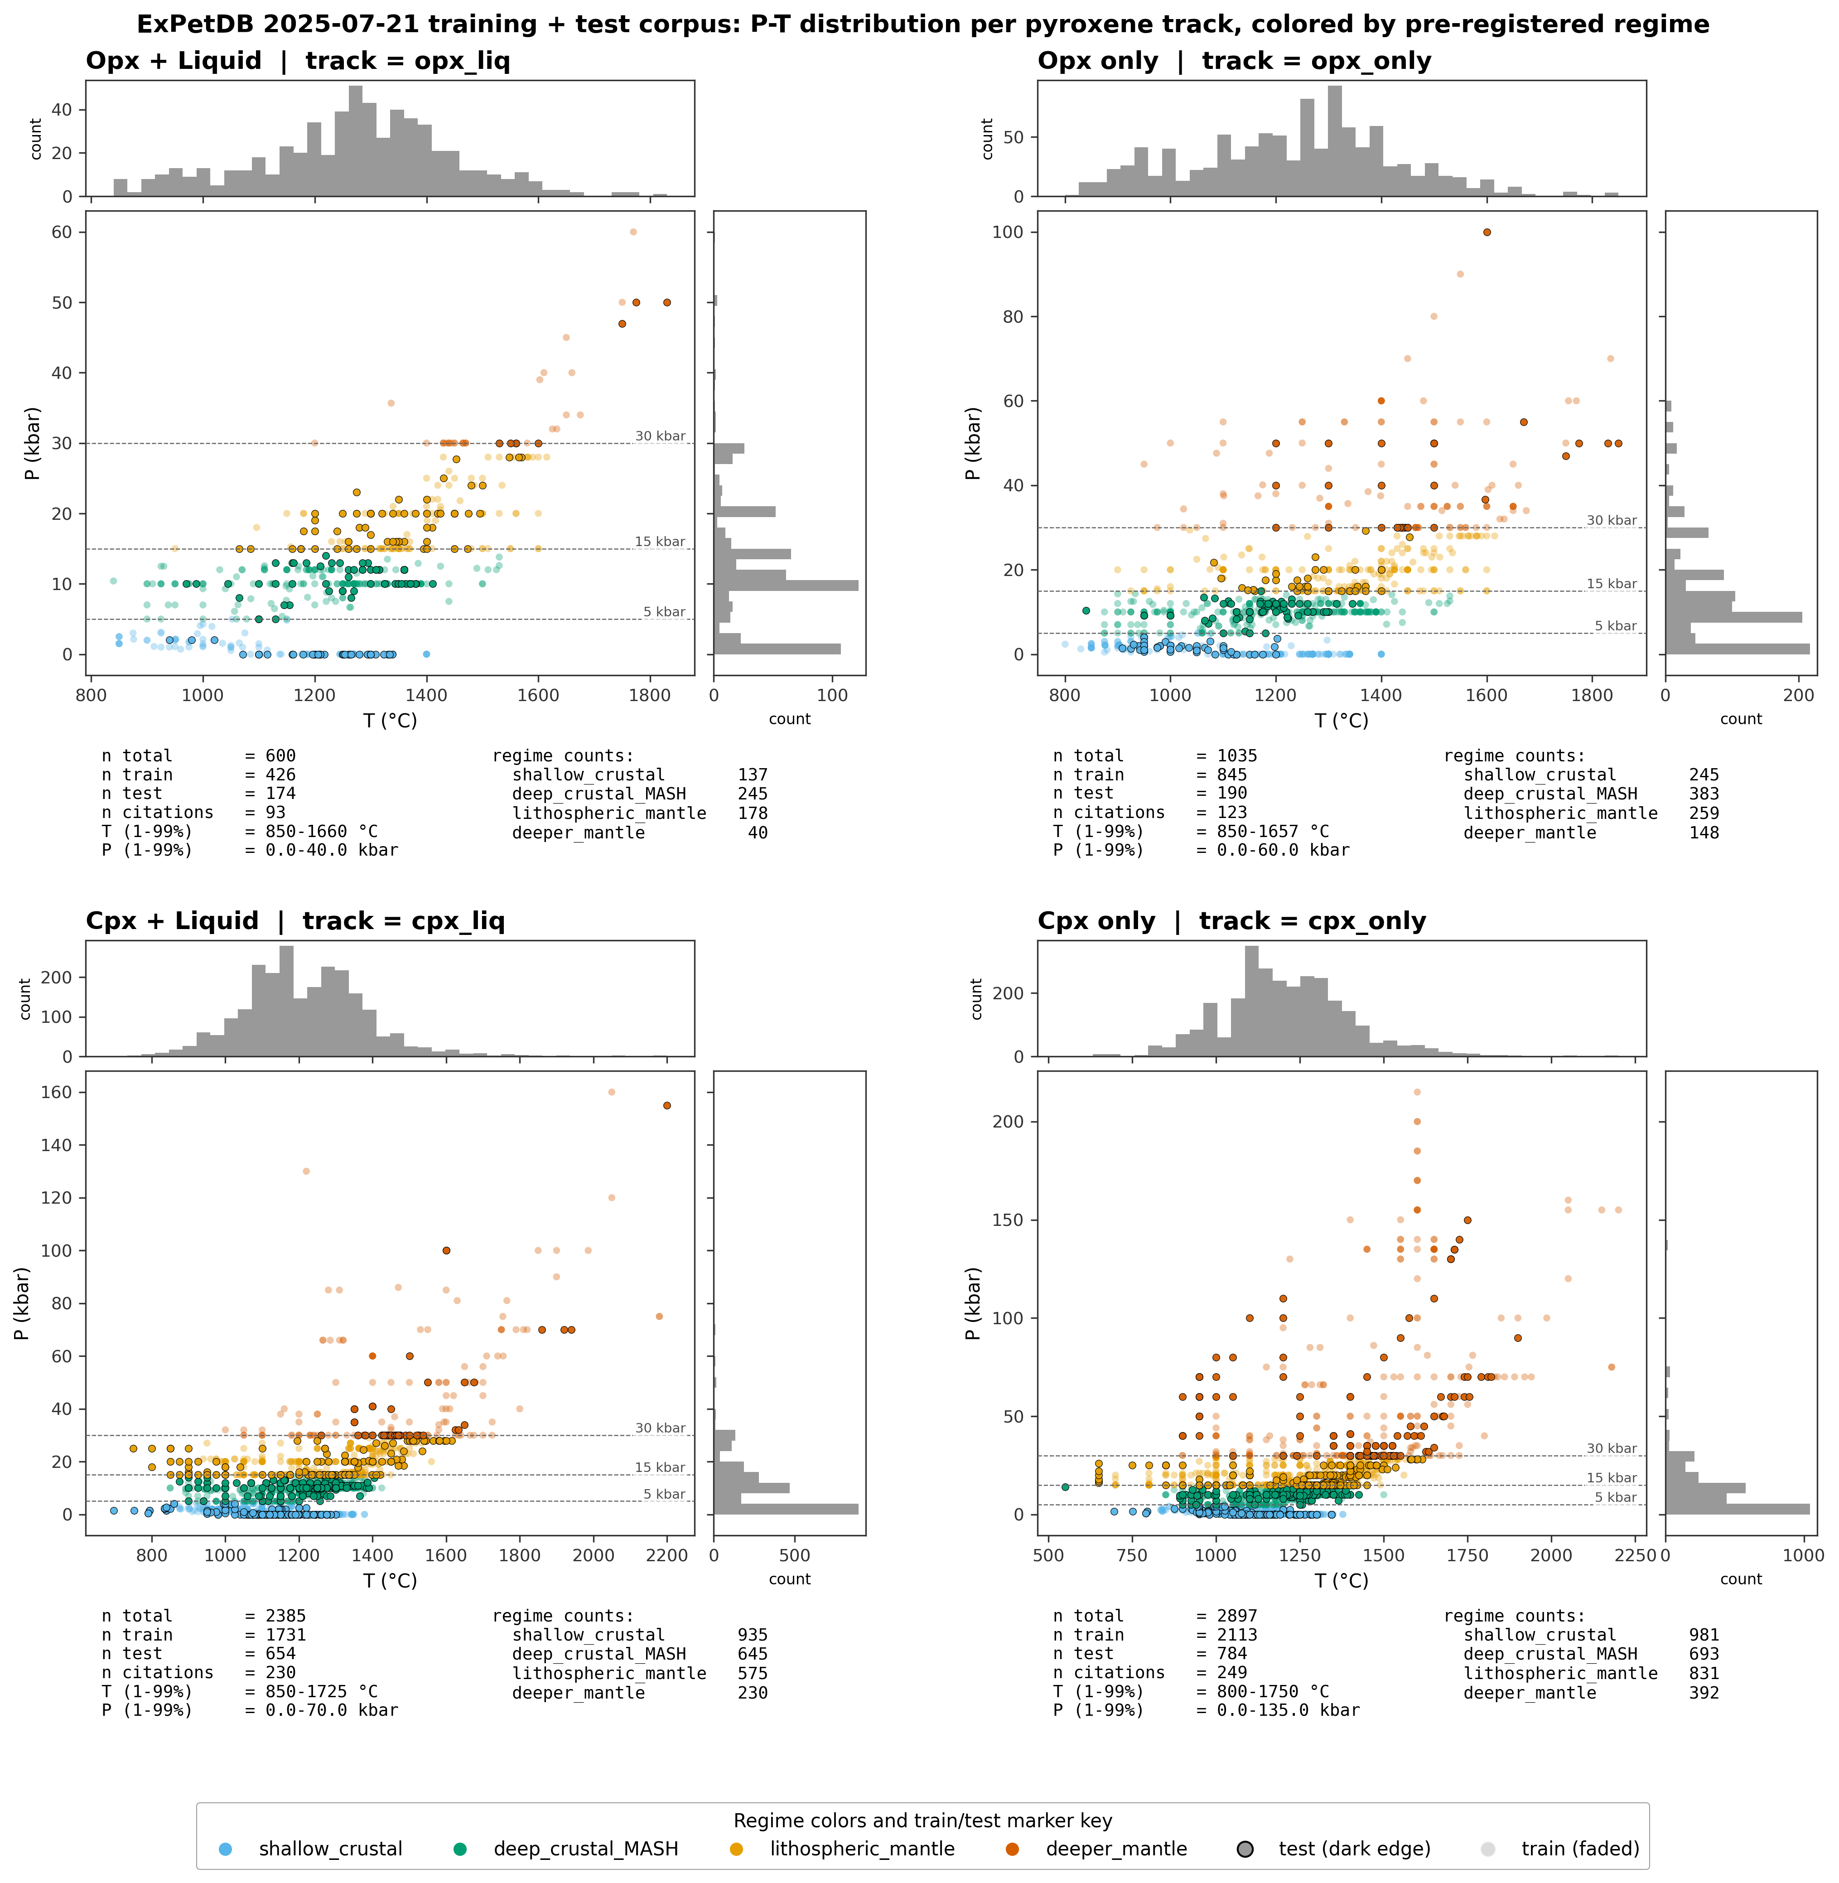
Figure 1. Figure 1. Dataset map. P-T distribution of all experiments in the ExPetDB 2025-07-21 export, partitioned into four pyroxene tracks (opx-liq, opx-only, cpx-liq, cpx-only). Points are colored by pre-registered pressure regime (shallow_crustal <5 kbar, deep_crustal_MASH 5-15 kbar, lithospheric_mantle 15-30 kbar, deeper_mantle >=30 kbar); regime edges were locked on 2026-04-17 before any correction fitting. Dashed horizontal lines mark regime boundaries (labeled at right axis). Marker opacity distinguishes the 80/20 citation-grouped train/test split: train points faded, test points with dark edges. Marginal histograms show the univariate T and P coverage. Each panel is titled with its track name. Directly below each scatter, a per-panel two-column summary reports n_total, n_train, n_test, citation count, and 1st-99th percentile T and P ranges on the left, with per-regime counts on the right. The regime/split color key is shown as a single shared legend at the bottom.
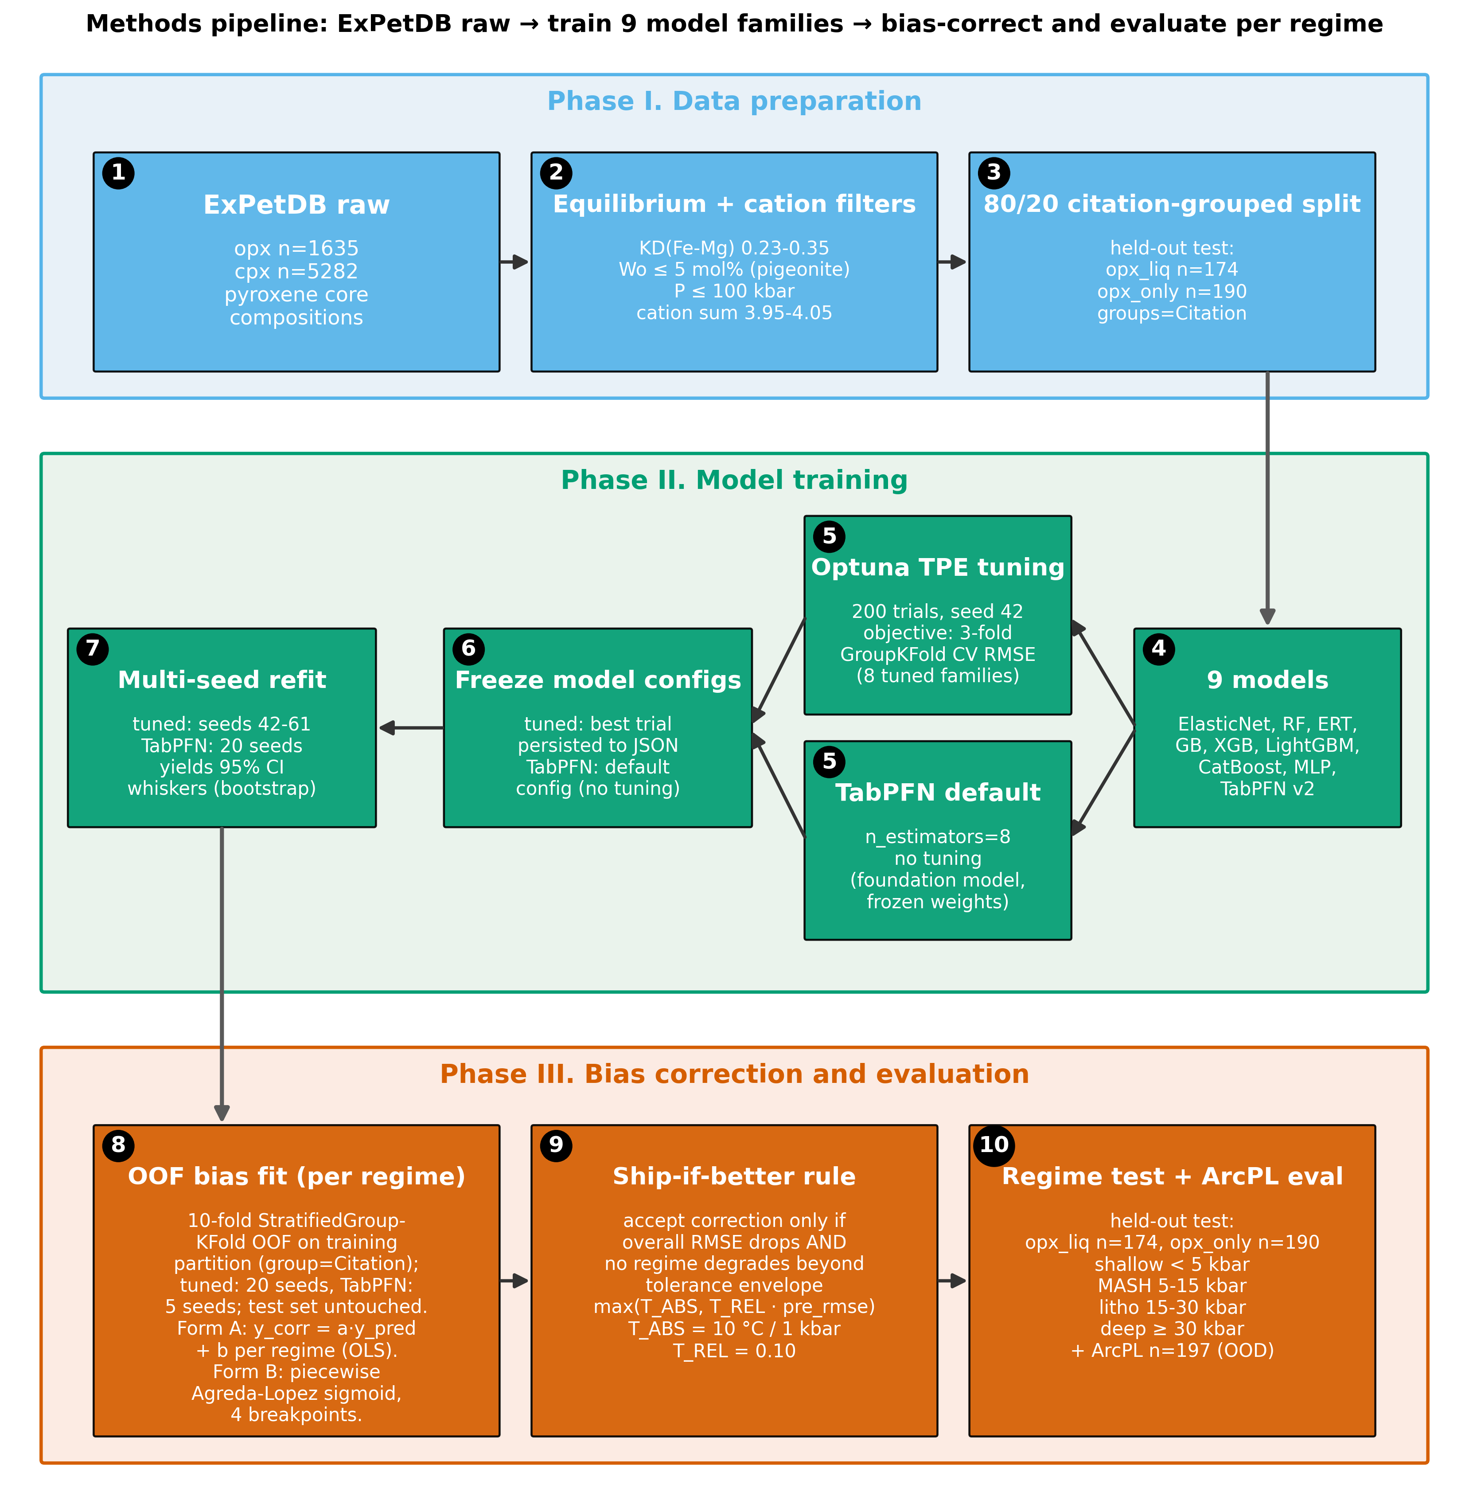
Figure 2. Figure 3. Methods flowchart. Three phase panels, each with numbered stages. Phase I (Data) flows left-to-right: raw ExPetDB (stage 1), equilibrium + cation filters (stage 2), and the 80/20 citation-grouped train/test split that produces the held-out test partitions opx_liq n=174 and opx_only n=190 (stage 3). Phase II (Model training) flows right-to-left so the connector from Phase I enters at box 4 on the right and the connector to Phase III exits from box 7 on the left. The 9 models (stage 4) fan out into two tuning routes at stage 5 -- Optuna TPE tuning over 200 trials at seed 42 with a 3-fold GroupKFold inner-CV objective for the eight tuned families, vs. TabPFN default at n_estimators=8 with no tuning -- and both branches fan back in at stage 6, where the final model configuration is frozen (Optuna winning trial persisted to JSON for the tuned families; TabPFN default config carried through unchanged). Stage 7 then runs the multi-seed refit: seeds 42-61 for tuned families and 20 seeds for TabPFN, producing the 95% CI whiskers (bootstrap) used throughout the figure set. Phase III (Evaluation) flows left-to-right: stage 8 generates 10-fold StratifiedGroupKFold OOF predictions inside the training partition (group=Citation; 20 seeds for tuned families, 5 seeds for TabPFN) -- the test set remains untouched -- and fits Form A (per-regime OLS, y_corr = a.y_pred + b) and Form B (piecewise Agreda-Lopez sigmoid, 4 breakpoints) on those OOF predictions; stage 9 applies the pre-registered tolerance envelope max(T_ABS, T_REL x pre_rmse) with T_ABS = 10 degC for T, 1 kbar for P, and T_REL = 0.10 (pre-registration Section 6); stage 10 evaluates on the held-out ExPetDB test partitions split into four pre-registered pressure regimes plus the ArcPL n=197 external-validation dataset as an out-of-distribution check.
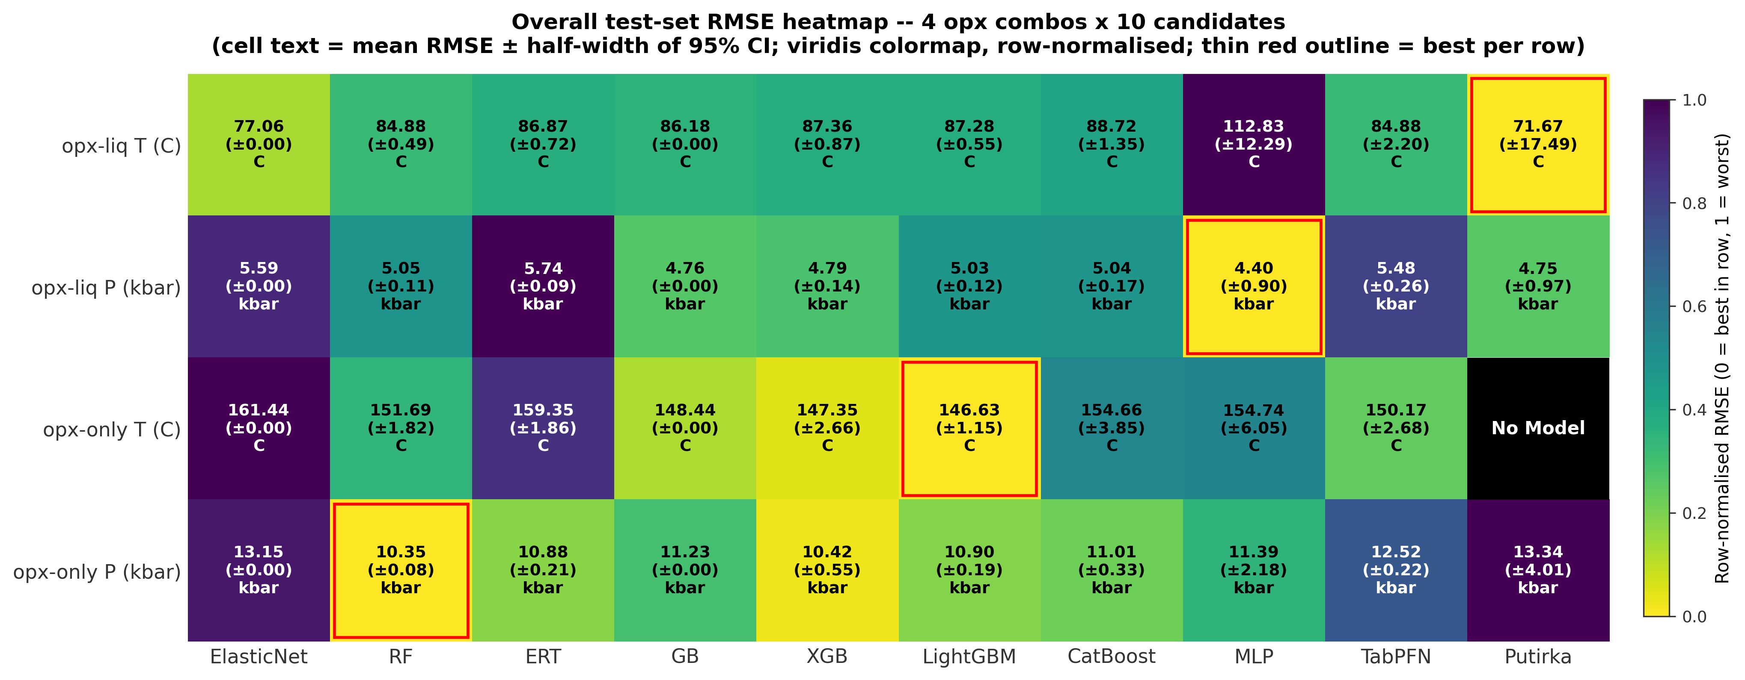
Figure 3. Figure 4. Overall test-set RMSE heatmap across the four opx track/target combinations (rows) versus ten candidates (columns: the nine ML model families in canonical MODEL_ORDER plus the best Putirka / Agreda external benchmark). Each cell reports the mean RMSE of the 20-seed refit (5 seeds for TabPFN) over the held-out test partition, together with the half-width of the 95% confidence interval (1.96 * std for the ML families, half the bootstrap CI for Putirka). Cells are colored via a row-normalised viridis_r colormap so the row minimum (best) is lightest and the row maximum (worst) is darkest; absolute values are printed in each cell in native units (C for T targets, kbar for P targets). Opx-only T has no Putirka opx-only thermometer available in Thermobar and is marked N/A. Per-family feature_set choice (raw / alr / pwlr) is the 20-seed best per row. The minimum-RMSE cell in each row is outlined in thin red to highlight the best model per opx combo.
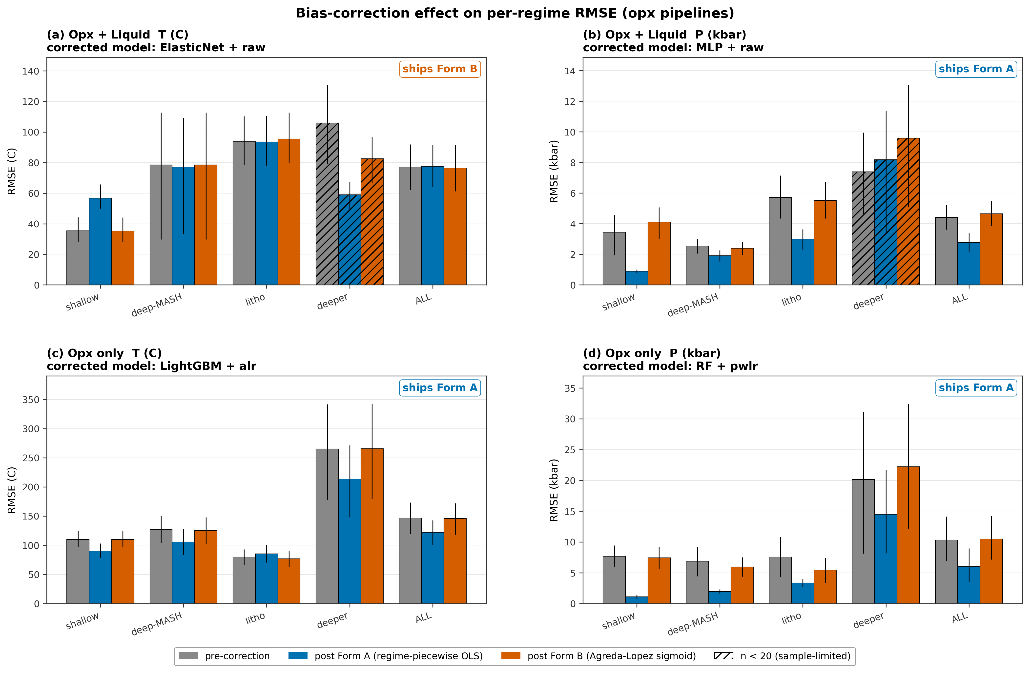
Figure 4. Figure 5. Bias-correction effect on per-regime test-set RMSE for the four opx track/target combinations. Dataset: ExPetDB 2025-07-21 opx held-out test partition (citation-grouped 80/20 split, pre-registered P-regime edges); the ArcPL external holdout is NOT used in this figure. Each regime group shows three bars: pre-correction (gray), post Form A (regime-piecewise OLS, blue), post Form B (Agreda-Lopez piecewise sigmoid, vermillion). Bar heights are 20-seed means; whiskers are the 20-seed mean of per-seed bootstrap 95% CIs. Hatched bars mark regimes with n < 20 (sample-size limited, interpret with care). The shipped correction form per panel (ships A / ships B / ships none) is annotated in the top-right. A form ships only if it reduces overall RMSE and does not degrade any regime beyond the pre-registered tolerance envelope max(T_ABS, T_REL x pre_rmse), with T_ABS = 10 degC for T and 1 kbar for P and T_REL = 0.10. How the math works: both forms post-process the raw ML prediction y_hat using the out-of-fold residual e = y_hat - y learned on the training partition, then subtract the learned residual at test time (y_corr = y_hat - e_hat). Form A fits a separate linear regression e = a + b * y_hat on each pre-registered P-regime (four regressions stitched end-to-end at regime boundaries). Form B fits one smooth piecewise-sigmoid curve e(y_hat) across all regimes with four learned breakpoints, following Agreda-Lopez et al. (2024). Cpx pipelines are intentionally excluded; this paper centers the opx ML thermobarometer. Source CSVs: results/bias_correction_per_seed.csv, results/bias_correction_shipped.csv.
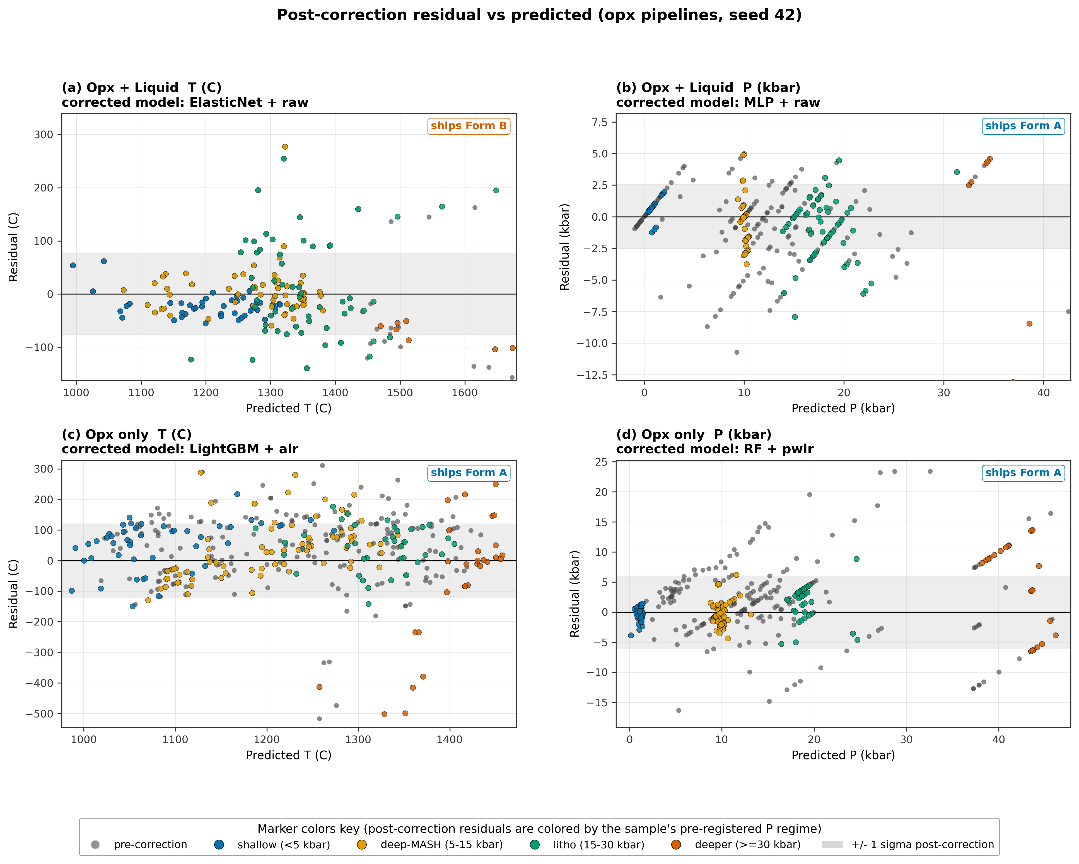
Figure 5. Figure 6. Post-correction residual-vs-predicted scatter at canonical seed 42 for the four opx track/target combinations. Gray markers: pre-correction residuals. Colored markers: residuals after the shipped form of bias correction, colored by the sample's pre-registered P regime (shallow_crustal blue, deep_crustal_MASH orange, lithospheric_mantle green, deeper_mantle vermillion). A gray band marks +/-1 sigma of the post-correction residuals. The shipped form per cell is annotated top-right; cells with "ships none" show only the pre-correction residuals. Shipping is governed by the pre-registered ship-if-better rule with the tolerance envelope max(T_ABS, T_REL x pre_rmse) where T_ABS = 10 degC for T, 1 kbar for P, and T_REL = 0.10. Source: results/bias_correction_shipped.csv, results/bias_correction_shipped.csv (for model/feature_set identity), and per-sample predictions from results/bias_correction/checkpoints/ (seed 42).
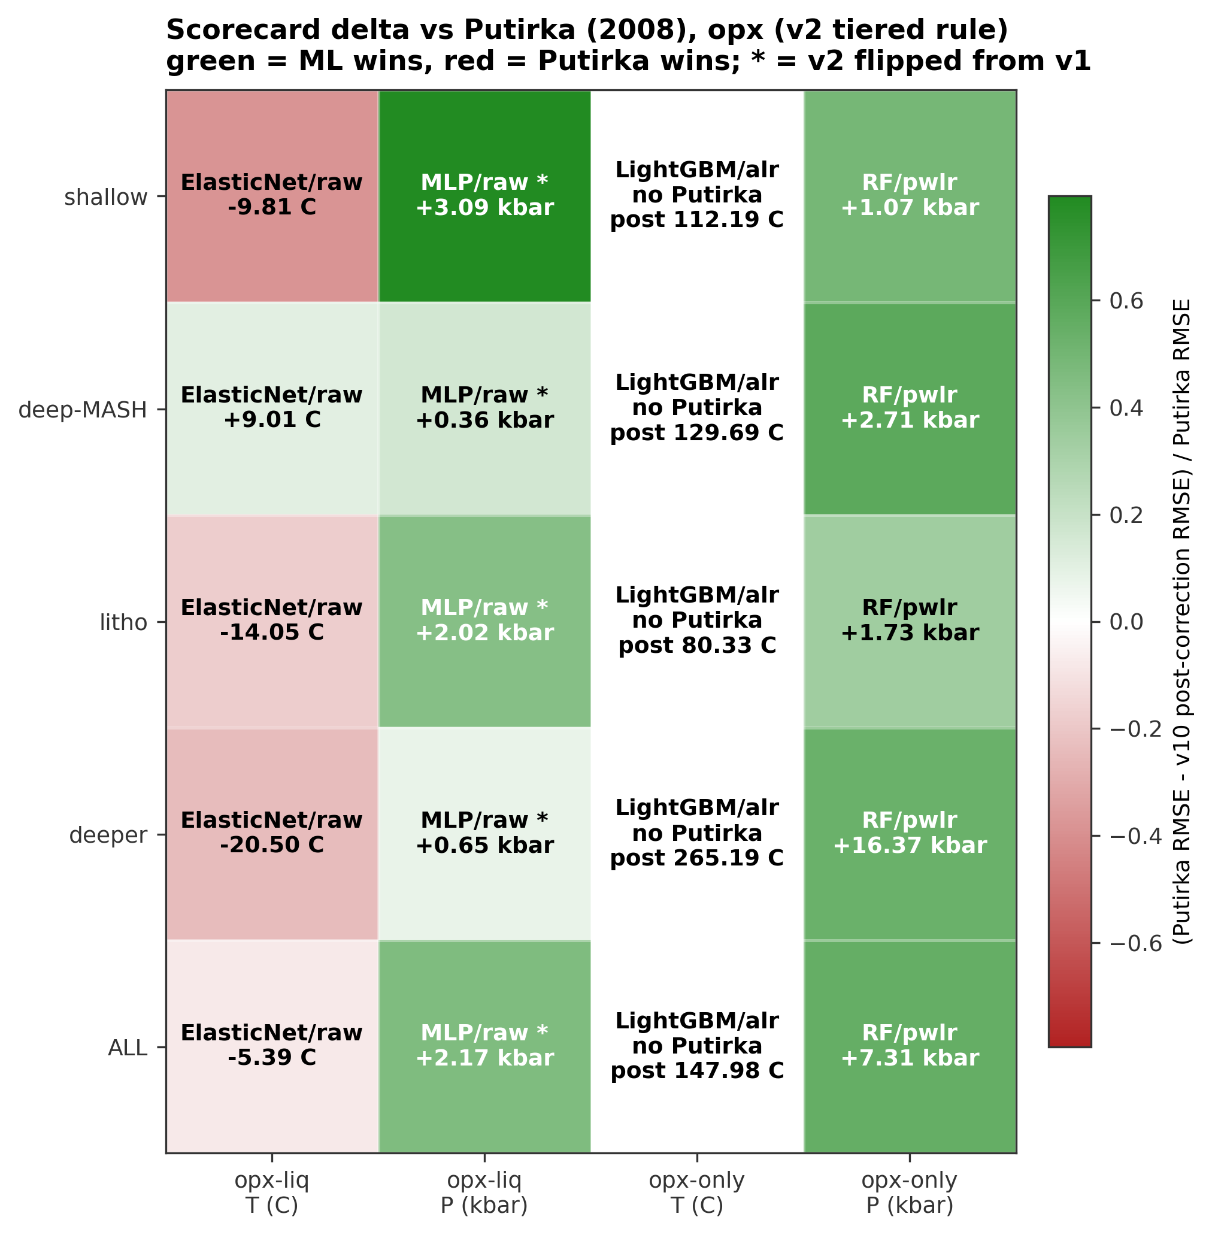
Figure 6. Figure 7. Per-regime scorecard delta between our post-correction-bias-correction RMSE and the best external Putirka (2008) thermobarometer, for the four opx track/target cells. Color encodes fractional improvement (Putirka_RMSE - our_post_RMSE) / Putirka_RMSE on a diverging red-white-green scale: green cells are wins for the tuned ML baseline, red cells are wins for Putirka. Cell text shows the absolute RMSE delta in native units (C for T, kbar for P). External references are Putirka (2008) thermobarometers run through Thermobar: opx-liq T = eq 28a, opx-liq P = eq 29a (29b in deeper_mantle), opx-only P = eq 29c. Opx-only T has no Putirka opx-only thermometer in Thermobar, so its row reports the tuned ML baseline absolute RMSE instead of a delta. Cells marked with "*" had their post-correction RMSE flip under the baseline ship rule because a low-n regime that had vetoed the correction under v1 is non-vetoing under v2. Cpx pipelines are intentionally excluded. Source: results/preregistered_scorecard_postcorrection.csv (with v1 reference from preregistered_scorecard_postcorrection.csv).
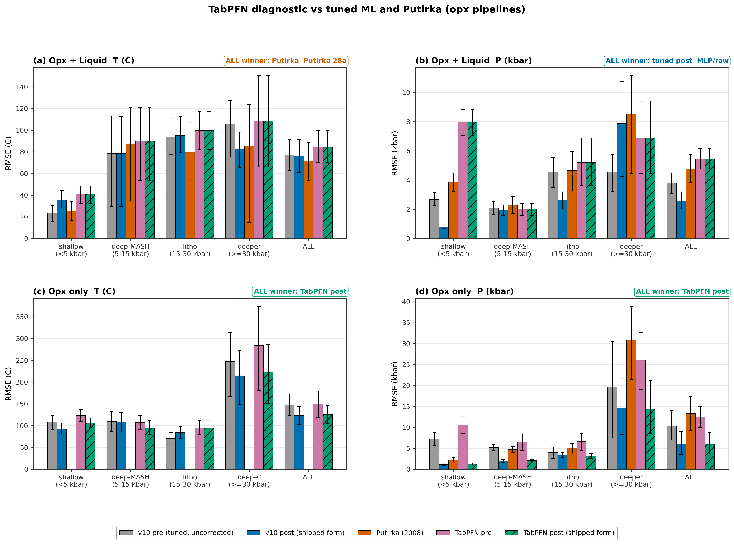
Figure 7. Figure 8. TabPFN diagnostic panel for the four opx track/target combinations. Purpose: this figure is a context check, not a tournament headline. It places the TabPFN v2 foundation-model baseline (pre-correction, pink; post-correction shipped form, green hatched) alongside the tuned ML baseline (pre, gray; post, blue) and the best external Putirka (2008) thermobarometer (red) so the reader can see how a zero-shot in-context model compares to our tuned pipeline. It does NOT replace the tuned-baseline bias-correction narrative presented in Core_05 through Core_07, which is where the paper's ship-if-better decisions are made. Regimes follow the pre-registered pressure partition (<5, 5-15, 15-30, >=30 kbar) plus ALL. Error bars are 95% bootstrap CIs (n_boot = 500). "ALL winner" in each panel is the preregistered 5-way scorecard verdict under the tolerance-based ship rule (Section 6 of pre-registration); when the verdict differs from the earlier v2 or v1 readouts, those are shown below it. Note the scorecard is used as a single diagnostic readout, not as an acceptance gate. Post-correction bars (tuned ML blue, TabPFN green hatched) use the v3 shipped form; pre-correction bars (gray, pink) are the uncorrected baseline. TabPFN post-correction was fit on a bespoke 5-seed 10-fold OOF pass (opx only) using the same Form A machinery as the tuned baseline; cpx TabPFN has no OOF pass and is excluded from post-correction. Opx-only T (panel c) has no Putirka opx-only thermometer in Thermobar, so the red bar is absent. Source: results/preregistered_scorecard_postcorrection.csv (with v2/v1 fallbacks).
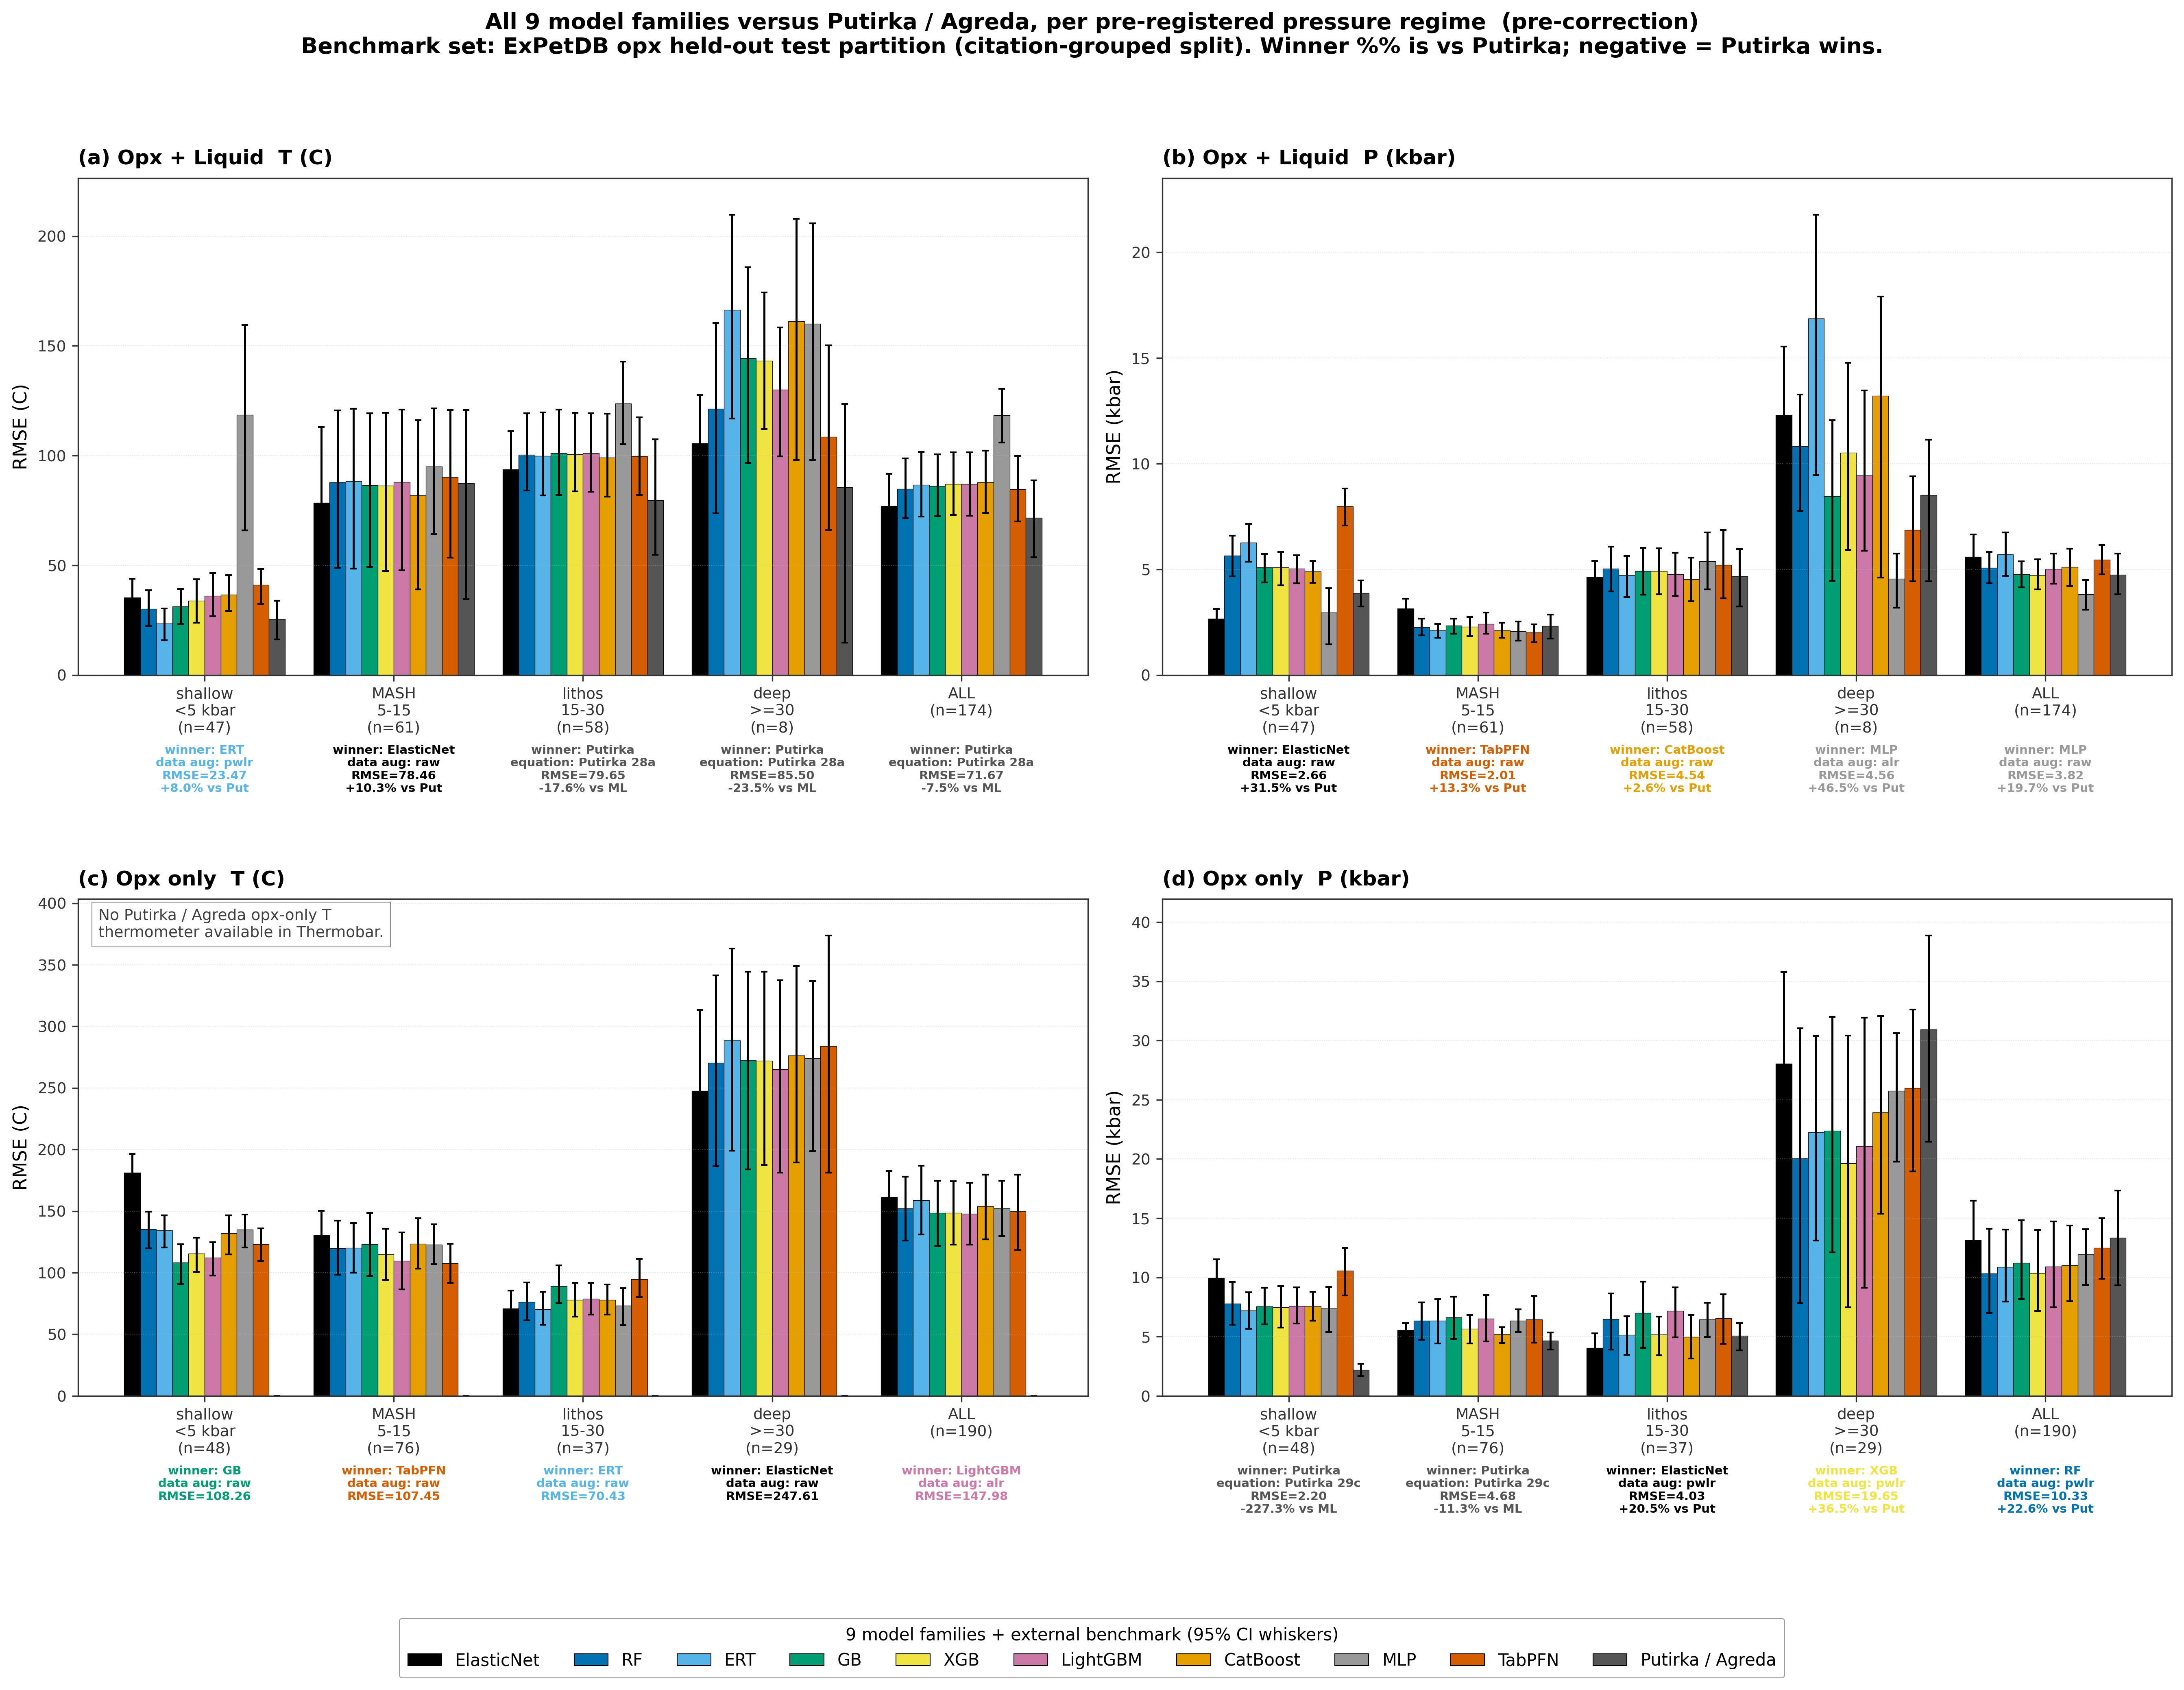
Figure 8a. Figure 9a. Per-regime test-set RMSE for all nine model families versus the best Putirka / Agreda external benchmark, across the four opx combinations. Each regime group contains ten bars: nine colored bars (one per family, in the canonical MODEL_ORDER) plus a gray Putirka / Agreda bar. For each (family, regime) cell the feature_set (raw / alr / pwlr) with the lowest test RMSE is selected; whiskers are 95% bootstrap CIs. Pressure regimes are the pre-registered edges shallow_crustal <5 kbar, deep_crustal_MASH 5-15 kbar, lithospheric_mantle 15-30 kbar, deeper_mantle >=30 kbar, plus the ALL aggregate column. Panel (c) opx-only T has no Putirka opx-only thermometer in Thermobar and is annotated accordingly. Core_09b is the overall-only companion; Core_10 collapses to best-of-ours vs Putirka.
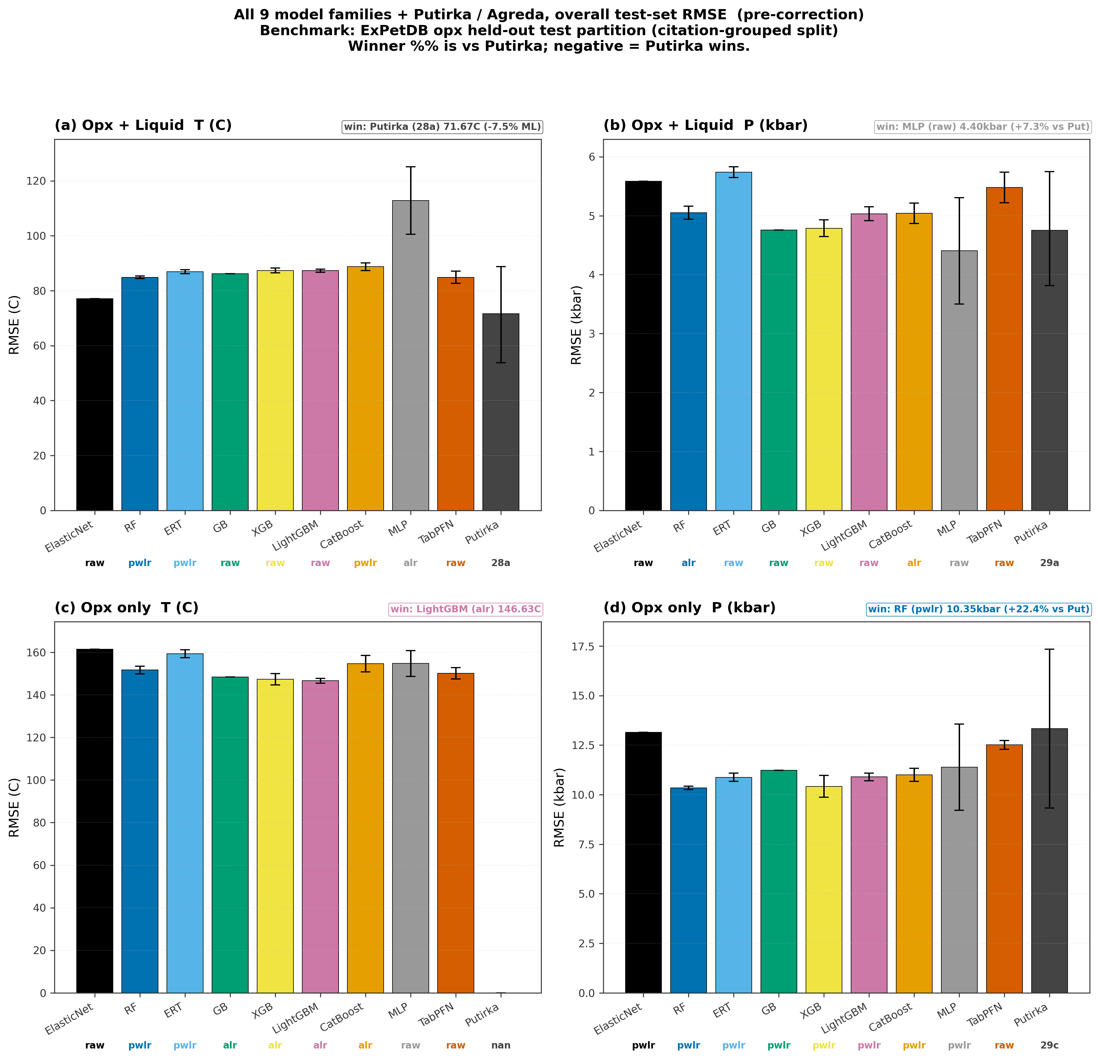
Figure 8b. Figure 9b. Overall test-set RMSE per model family for all four opx combinations, aggregated across the full held-out partition (no regime split). Bars show the mean 20-seed RMSE (5-seed for TabPFN), whiskers are 95% intervals computed as mean +/- 1.96 * std over seeds; the feature-set winner (raw, alr, or pwlr) for each family is printed below the bar in the family color. The dashed horizontal line is the best Putirka / Agreda external benchmark from the ALL-row of the pre-registered scorecard (shaded band = 95% bootstrap CI on the benchmark); panel (c) opx-only T has no Putirka opx-only thermometer in Thermobar and is annotated accordingly. This figure answers "which family is best overall?"; the companion Core_09a answers the same question stratified by pressure regime.
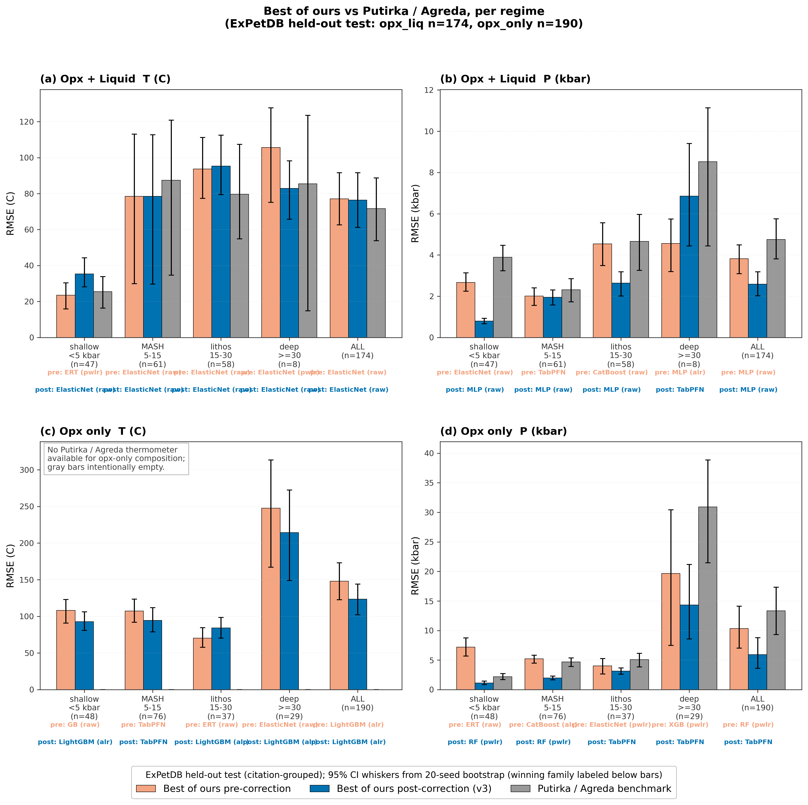
Figure 9. Figure 10. Best of our nine model families versus Putirka / Agreda external benchmarks, per pre-registered pressure regime and aggregate ALL column, for all four opx combinations. Three bars per regime: (1) sky blue, best pre-correction RMSE across ElasticNet, RF, ERT, GB, XGB, LightGBM, CatBoost, MLP, and TabPFN; (2) blue, best post-correction RMSE across the same nine families using the shipped bias-correction form; (3) gray, best external Thermobar / Agreda benchmark from the head-to-head comparison. The family whose model won that regime is labelled below its bar together with the input transform ("raw" = native oxide wt%, "alr" = additive log-ratio, "pwlr" = pairwise log-ratio); TabPFN has no feature-set choice. Whiskers are 95% bootstrap confidence intervals from the 20-seed refit (5 seeds for TabPFN). Panel (c) opx-only T has no Putirka opx-only thermometer available in Thermobar and is annotated accordingly. This is a simplified companion to Core_09 (all 9 families shown individually); Core_10 answers the narrower question "does our best ML candidate beat the best published calibration at each regime, before and after bias correction?" at a glance.
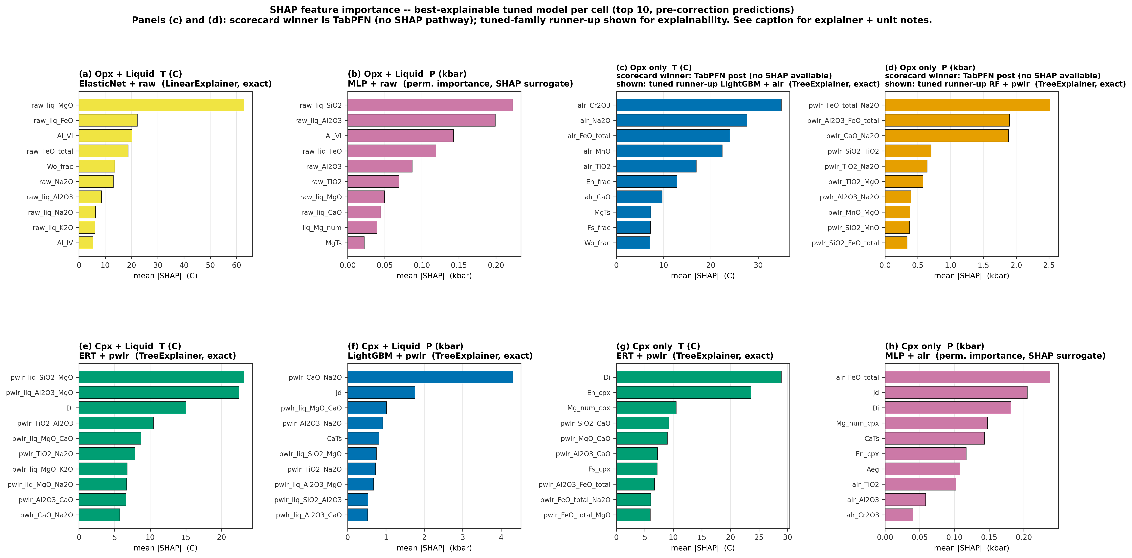
Figure 10. Figure 12. SHAP feature importance for the best-explainable tuned-family model in each of the eight pipeline x track x target cells. Each panel shows the top 10 features ranked by mean |SHAP| on the held-out test partition at canonical seed 42. Bar length is mean |SHAP| in the target's native units (C for temperature, kbar for pressure). Tuned-family identities: opx_liq T = ElasticNet/raw, opx_liq P = MLP/raw, opx_only T = LightGBM/alr, opx_only P = RF/pwlr, cpx_liq T = ERT/pwlr, cpx_liq P = LightGBM/pwlr, cpx_only T = ERT/pwlr, cpx_only P = MLP/alr. IMPORTANT: for opx_only T (panel c) and opx_only P (panel d) the 5-way scorecard (results/preregistered_scorecard_postcorrection.csv, ALL regime) promotes TabPFN post-correction over the tuned-family winner (TabPFN post-RMSE 125.6 C vs LightGBM/alr 148.0 C, and 5.94 kbar vs RF/pwlr 6.03 kbar respectively). TabPFN is an in-context foundation model and exposes no SHAP pathway (no TreeExplainer, no LinearExplainer, no gradient surface compatible with KernelExplainer at our runtime budget), so those two panels show the tuned-family runner-up's SHAP for explainability. Tree-family (RF, ERT, LightGBM) uses shap.TreeExplainer (exact); ElasticNet uses shap.LinearExplainer (exact) on scaler-transformed features; MLP uses sklearn.inspection.permutation_importance (20 repeats, seed=42) as a fast SHAP surrogate. KernelExplainer for MLP would add ~30 min per cell and was deferred in this pass . Absolute |SHAP| values are NOT comparable across cells with different feature_sets (raw, alr, pwlr) because those transforms rescale the input. Source: results/shap_importance_winners.csv; scorecard winners from results/preregistered_scorecard_postcorrection.csv.
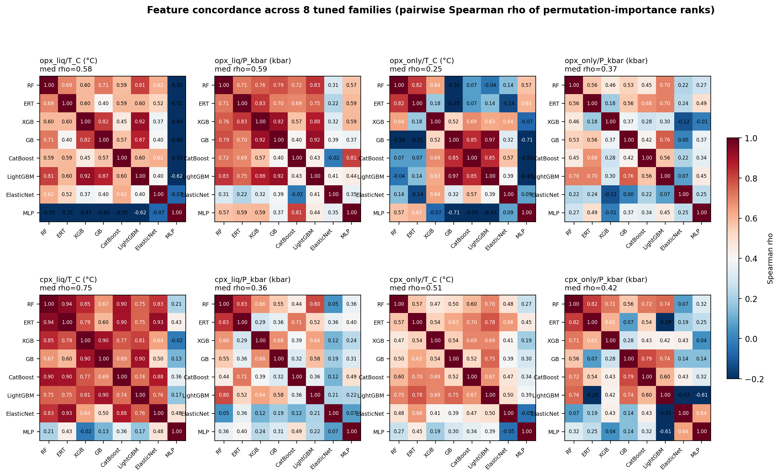
Figure 11. Figure 15. Feature-importance concordance across tuned families per (track, target) cell. Eight per-cell heatmaps show Spearman rank correlations of permutation importance between the eight tuned families (ElasticNet, RF, ERT, GB, XGB, LightGBM, CatBoost, MLP); TabPFN v2 is omitted because its kernel does not expose an estimator instance compatible with sklearn permutation_importance, documented as a protocol limitation. Permutation importance is computed on the held-out test set with 20 permutations per feature, seed 42; each feature's importance per family is ranked, and rows are intersected across families before computing the per-pair Spearman rho. Red-to-blue divergent colormap centered at rho = 0; a high Spearman rho indicates agreement on feature ordering even when coefficient magnitudes and feature sets differ across families. Per-cell median pairwise Spearman rho: opx_liq T = 0.58, opx_liq P = 0.59, opx_only T = 0.25, opx_only P = 0.37, cpx_liq T = 0.75, cpx_liq P = 0.36, cpx_only T = 0.51, cpx_only P = 0.42. High concordance on T-cells (cpx_liq T = 0.75) indicates that independent architectures identify the same thermodynamic drivers. The lower opx_only T rho (0.25) reflects the small-n intersection forced by feature-space heterogeneity across raw / alr / pwlr rather than genuine disagreement on petrology. Source: results/feature_concordance_permutation_importance.csv and results/feature_concordance_spearman_matrix.csv.
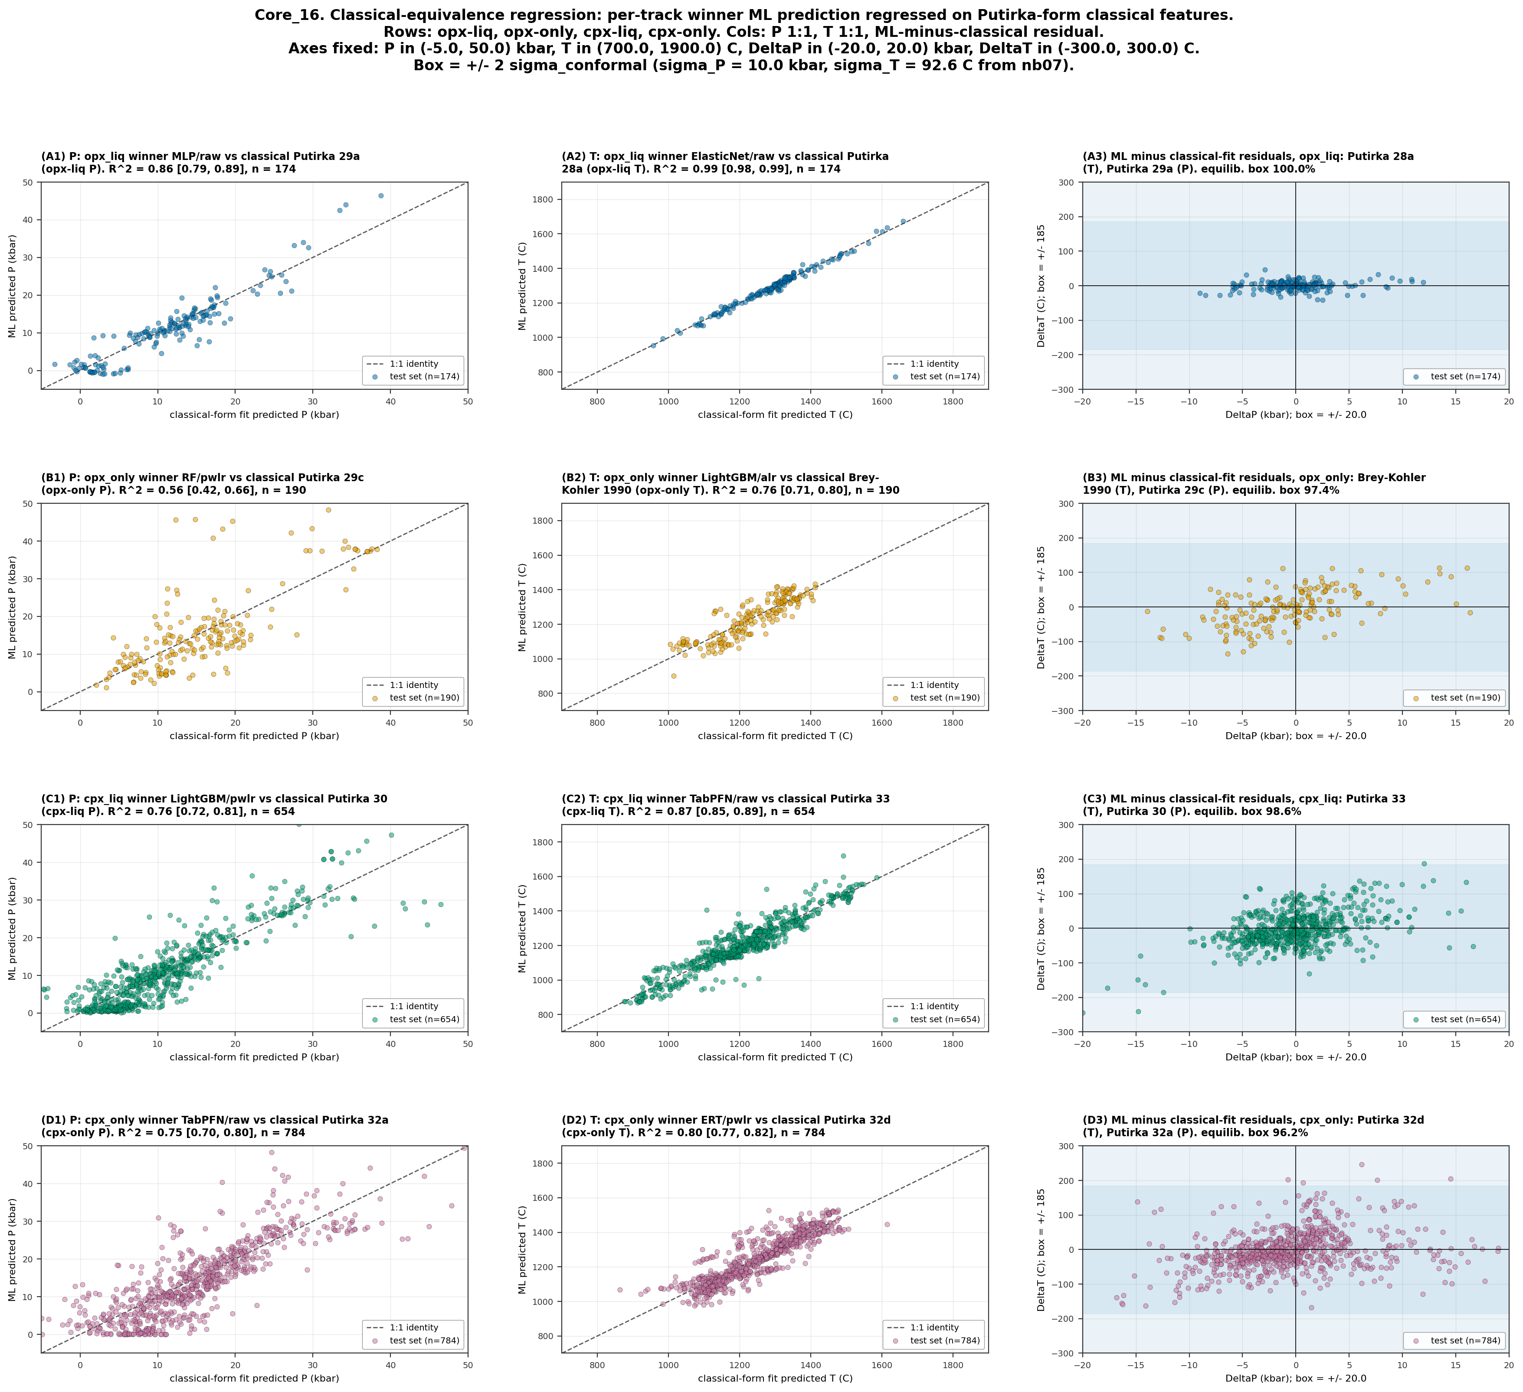
Figure 12. Figure 16. Classical-equivalence regression per track. For each of four track groups (opx-liq, opx-only, cpx-liq, cpx-only), we fit a linear regression on Putirka-form classical features to the winner ML predictions on the held-out test set. Columns: (1) P 1:1 scatter of ML predicted vs classical-fit predicted in kbar, (2) T 1:1 scatter in Celsius, (3) ML-minus-classical-fit residual disequilibrium map. Each row uses a distinct Okabe-Ito color; identity line dashed gray; legend gives n. Per-panel title names the cell winner (model family / feature set) and the classical form used for the fit: opx-liq uses Putirka 28a (T) and 29a (P), opx-only uses Brey-Kohler 1990 (T) and Putirka 29c (P), cpx-liq uses Putirka 33 (T) and 30 (P), cpx-only uses Putirka 32d (T) and 32a (P). The R^2 with 500-bootstrap 95% CI measures how much of the ML prediction variance is explained by a linear combination of the classical features. The disequilibrium map overlays a +/- 2 sigma_conformal box (sigma_P = 10.0 kbar, sigma_T = 92.6 C from nb07 calibration) and annotates the fraction of residuals inside the equilibrium tolerance. A high in-box fraction means the ML tracks the classical form within the calibrated petrological tolerance; a low fraction means the ML is doing something systematically different. Source: results/classical_equivalence_regression.csv.
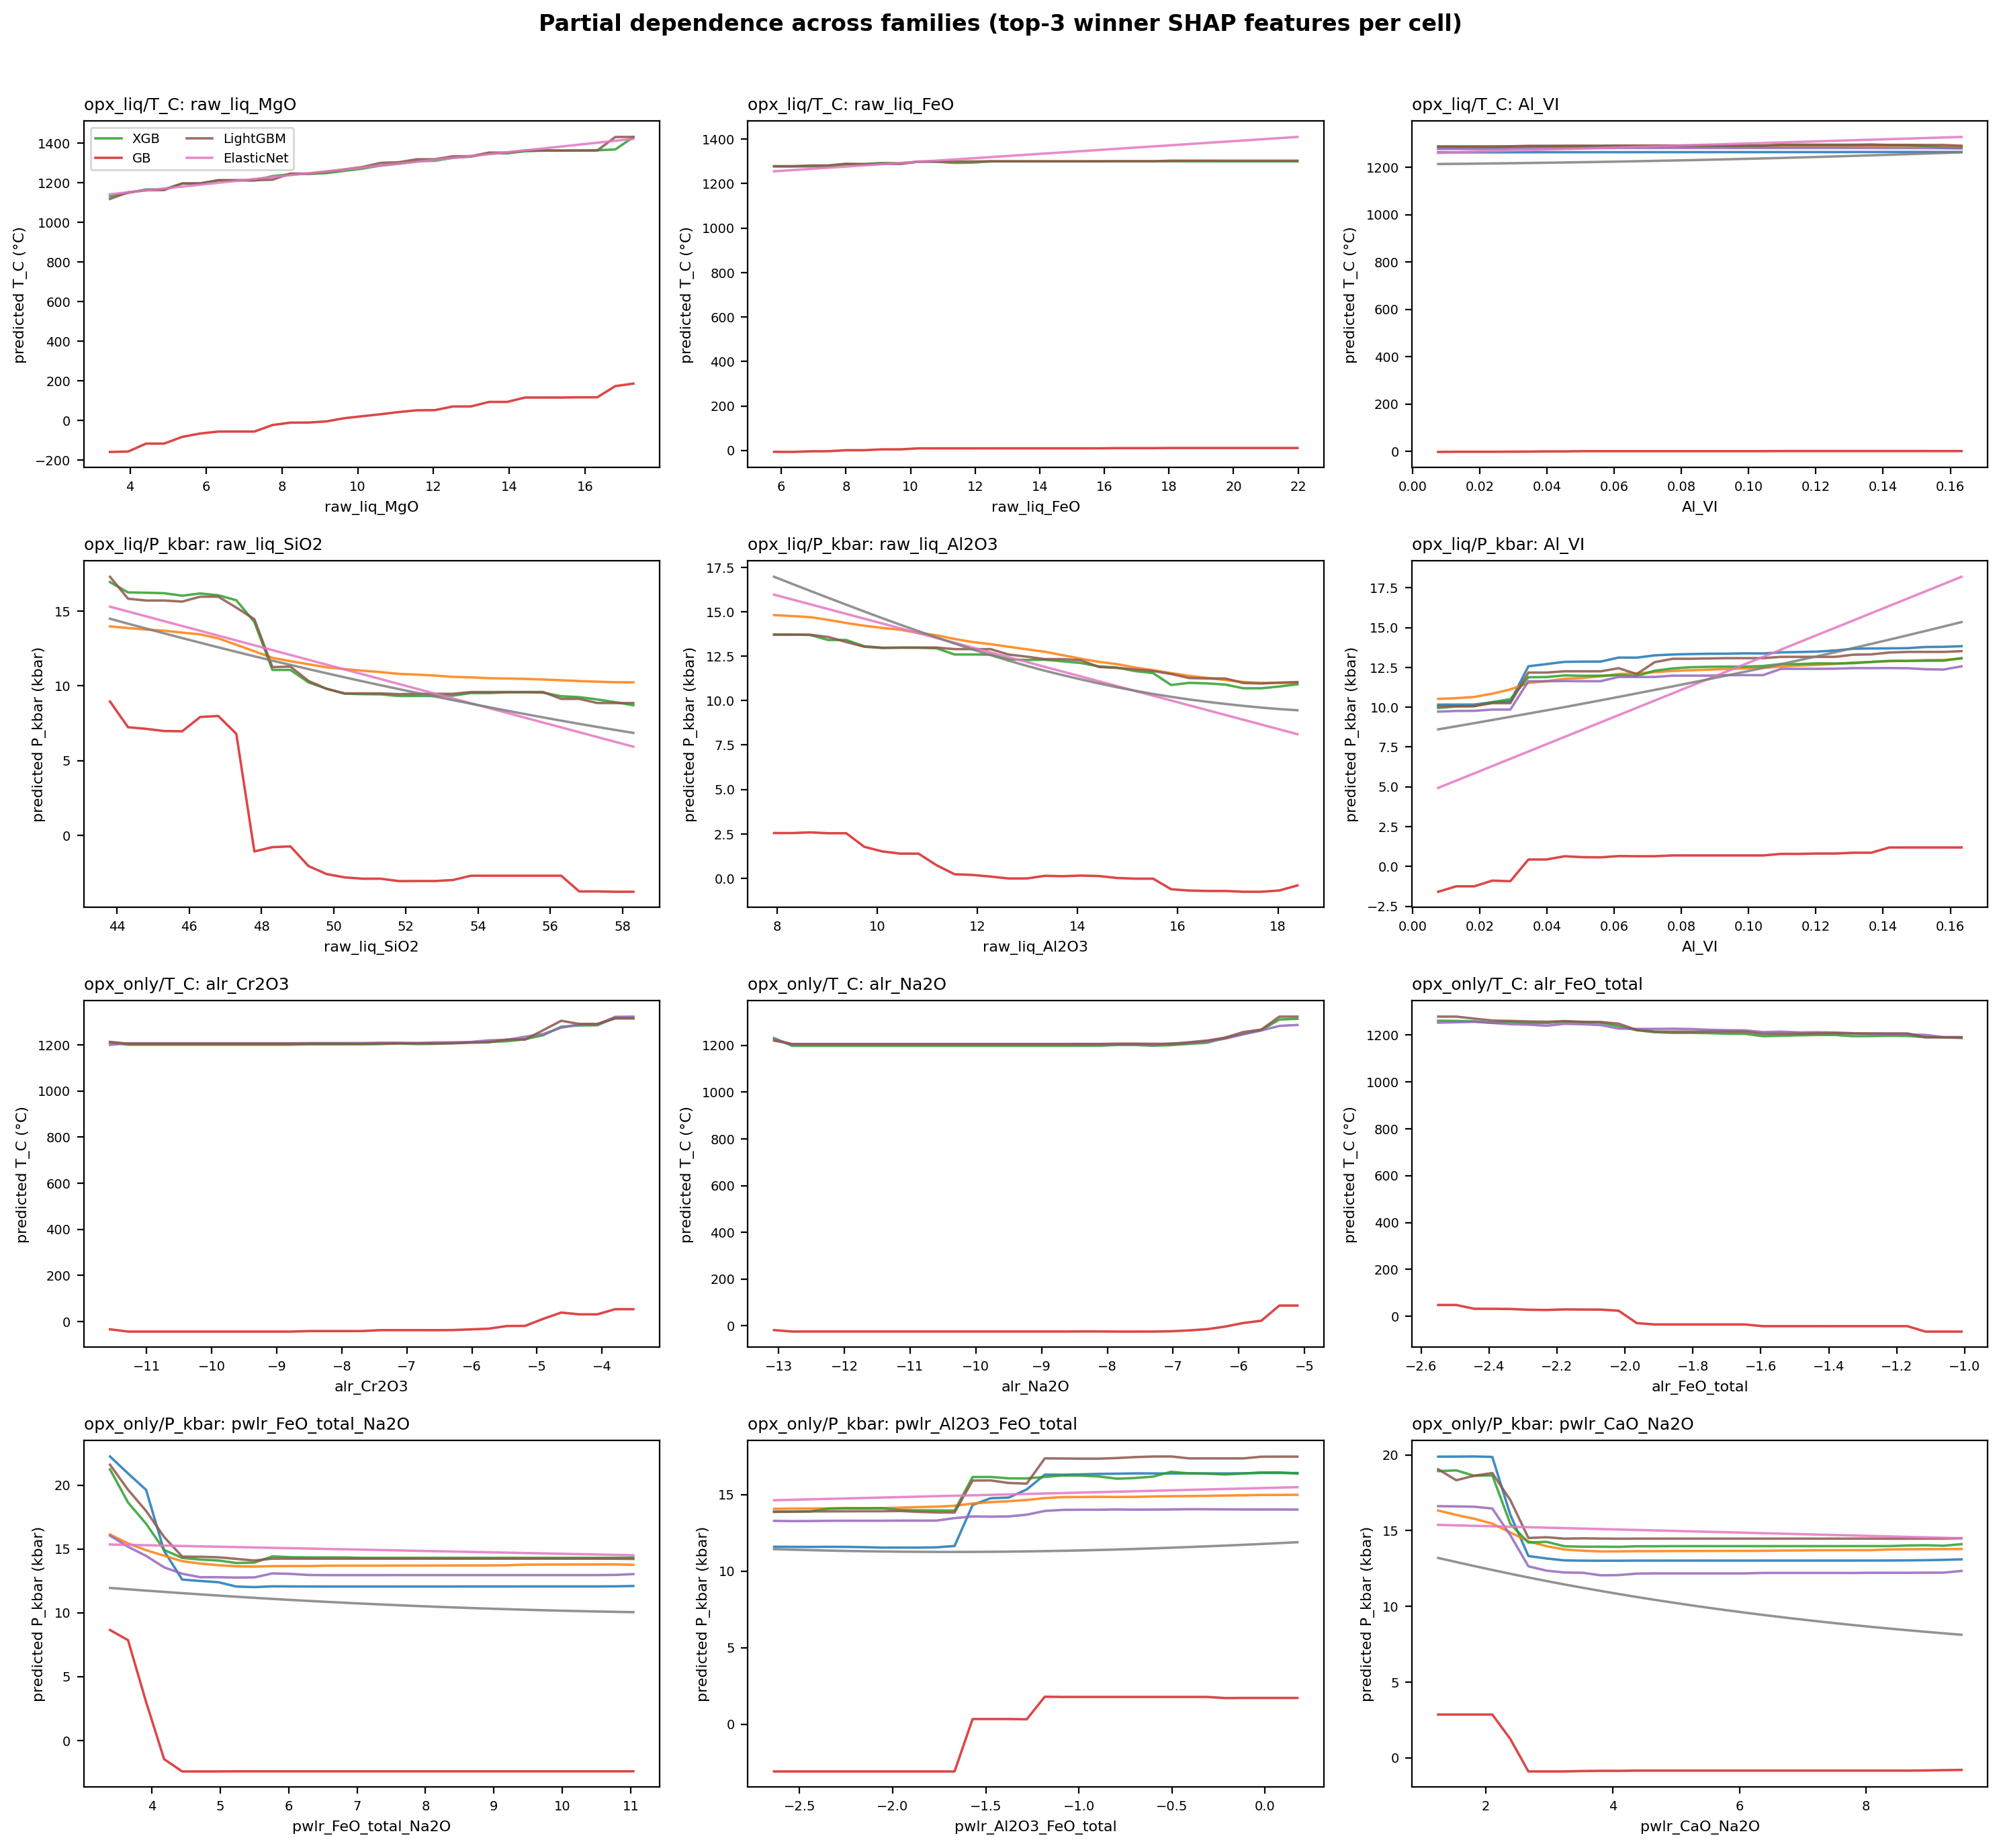
Figure 13. Figure 17. Partial-dependence curves across tuned families, opx cells only. Four rows correspond to the four opx (track, target) cells (opx_liq T, opx_liq P, opx_only T, opx_only P); three columns correspond to the top-3 SHAP features of each cell's winner model. Each panel overlays the partial-dependence curve from eight tuned families (ElasticNet, RF, ERT, GB, XGB, LightGBM, CatBoost, MLP; TabPFN omitted as in Core_15) evaluated on a 30-point grid spanning the 2nd-to-98th percentile of the feature distribution on the training set. Families are drawn in the canonical MODEL_COLORS palette with the winner family emphasized. A thin gray histogram at the bottom of each panel shows the training-set density of the feature. All 12 cell-by-feature panels show consistent monotonic direction across families, with crossovers confined to the tail 10% of the feature distribution (where training density is sparse). This agreement rules out "families win by learning opposite mechanisms" as an explanation for cell-by-cell winner changes: architectures disagree on magnitude at the edges but agree on the direction of the physicochemical effect. Source: results/partial_dependence_across_families.parquet (2160 rows).
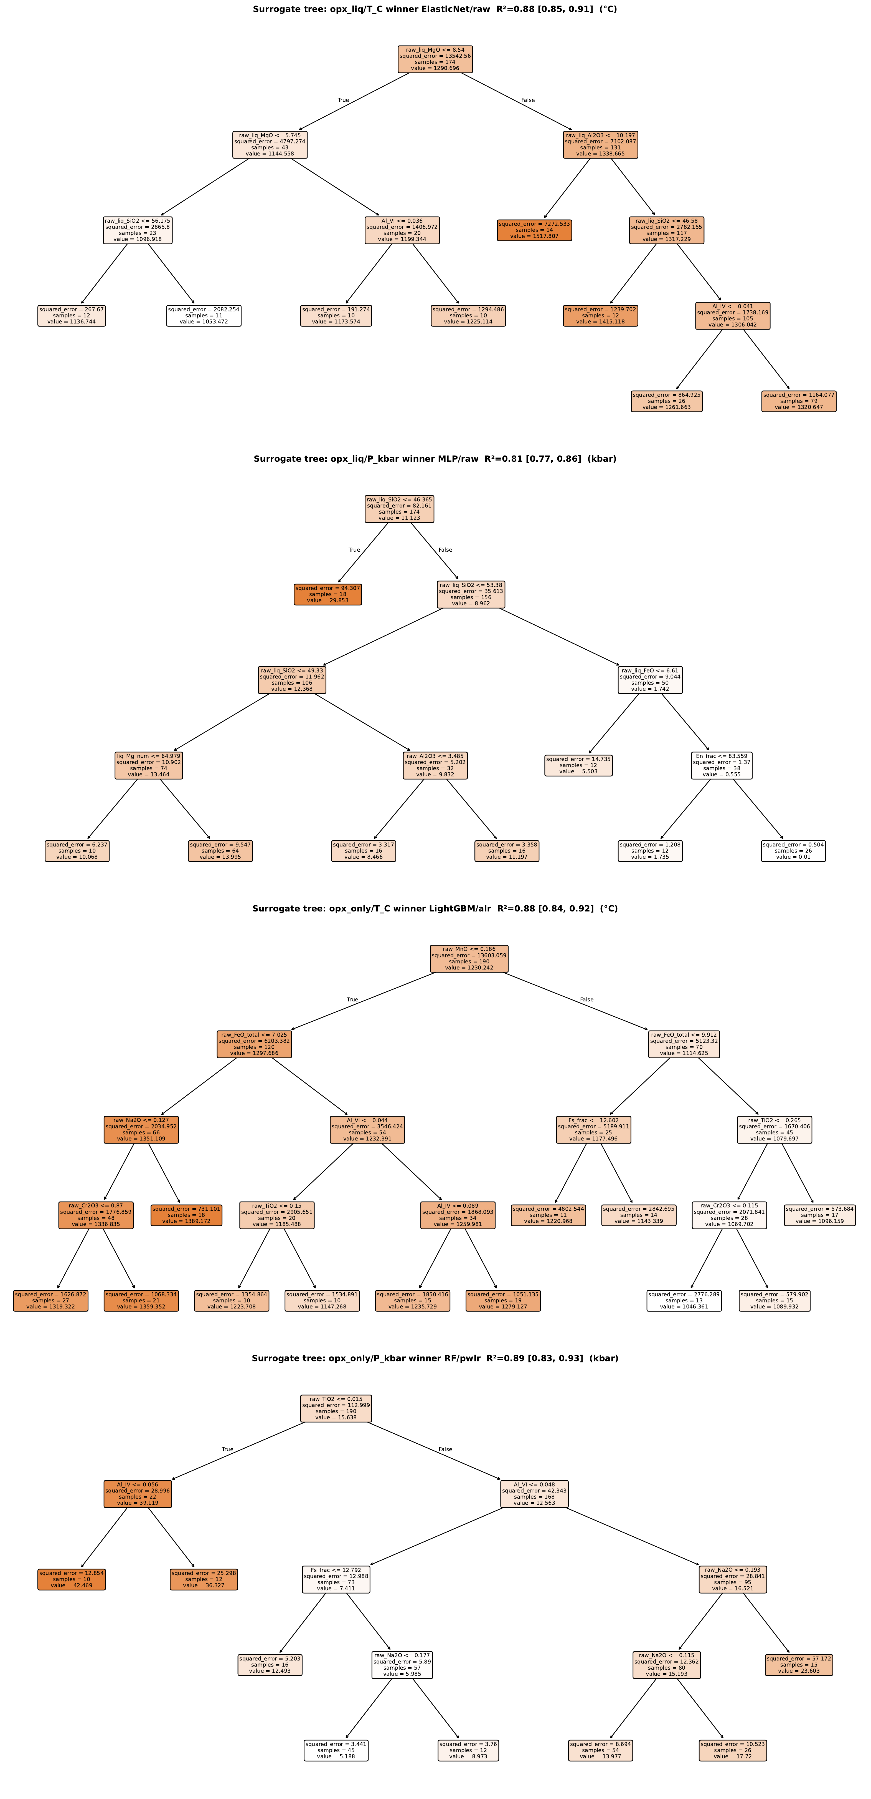
Figure 14. Figure 18. Surrogate decision trees for the four opx winner models. Each of four pages renders a fitted depth-4 CART regression tree trained to predict the winner model's predictions (not the ground-truth target) from the same features, with max_depth = 4 and min_samples_leaf = 10. Surrogate R^2 with 500-bootstrap 95% CI on test-set predictions: opx_liq T = 0.88 [0.85, 0.91] for ElasticNet/raw winner; opx_liq P = 0.81 [0.77, 0.86] for MLP/raw winner; opx_only T = 0.88 [0.84, 0.92] for LightGBM/alr winner; opx_only P = 0.89 [0.83, 0.93] for RF/pwlr winner. All four cells exceed R^2 = 0.81, meaning a human-legible rule list recovers more than 80% of the opaque model's predictions. Each split is labelled with feature name, threshold, and sample count at the node; leaves show the mean prediction value. This is the "flowchart approximation" of the ML: readers can trace any test-set sample through the tree and see which feature thresholds dominate the ML's decision, then cross-check against Core_12 SHAP for quantitative feature attribution. The surrogate is not a replacement model; it is an interpretability layer quantifying how much of the ML can be expressed as a shallow axis-aligned partitioning. Source: results/surrogate_tree_r_squared.csv; full tree visualisations rendered via sklearn.tree.plot_tree.

Tables
Table 1. Corpus inventory after preprocessing. n = sample count post-filters; n_cit = unique citations.
Pipeline | n | n_cit | P range (kbar) | T range (deg C)
opx-liq | 600 | 93 | 0-40.05 | 850-1660.1
opx-only | 1035 | 123 | 0-60 | 850-1656.6
Table 2. Per-cell winning model, feature set, and aggregate test RMSE with 95% bootstrap confidence intervals.
Track | Target | Best model | Feature set | RMSE (point) | 95% CI | n_test
opx-liq | T (deg C) | ElasticNet | raw | 77.06 | [61.81, 92.73] | 174
opx-liq | P (kbar) | MLP | raw | 4.4 | [3.08, 4.54] | 174
opx-only | T (deg C) | LightGBM | alr | 146.63 | [121.19, 170.00] | 190
opx-only | P (kbar) | RF | pwlr | 10.35 | [6.90, 13.92] | 190
Table 3. Bias-correction shipped form, pre/post RMSE, percent reduction.
pipeline | track | target | model | shipped_form | pre_RMSE_test | post_RMSE_test | delta_RMSE | pct_reduction
opx | opx-liq | T_C | ElasticNet/raw | B | 77.062 | 76.417 | 0.645 | 0.84
opx | opx-liq | P_kbar | MLP/raw | A | 4.404 | 3.171 | 1.233 | 28.0
opx | opx-only | T_C | LightGBM/alr | A | 146.627 | 122.064 | 24.564 | 16.75
opx | opx-only | P_kbar | RF/pwlr | A | 10.347 | 6.051 | 4.296 | 41.52

Supplementary Materials

S1. Supplementary Figures
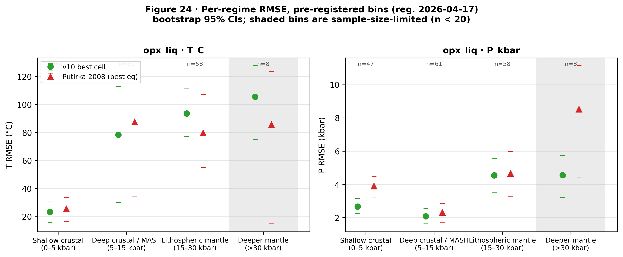
Figure S1. Figure 24. Per-regime RMSE (bootstrap 95% CI) for the opx-liq test split: best tuned model cell vs Putirka 2008 best equation, in the pre-registered four-bin P partition. Shaded bins are sample-size-limited (n<20).
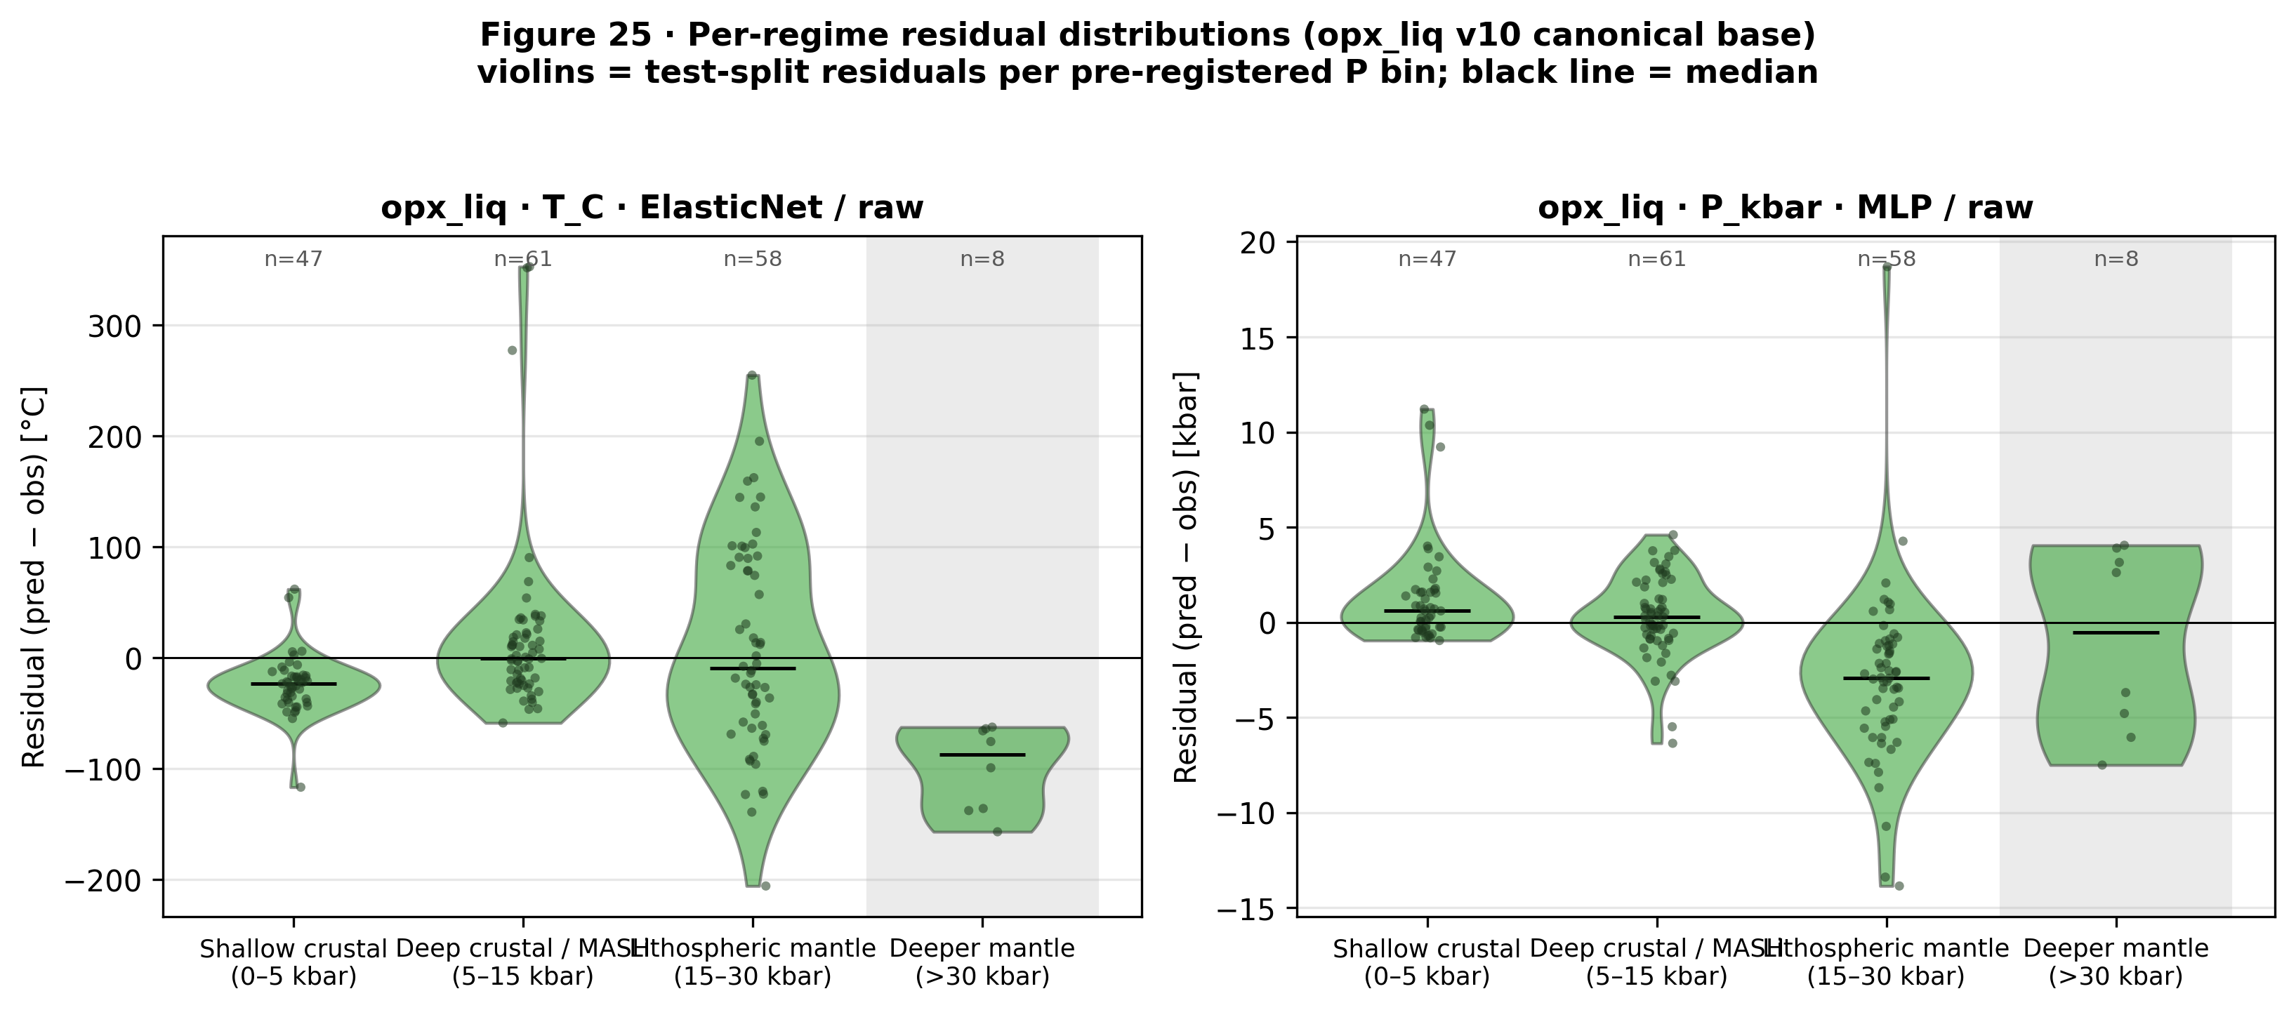
Figure S2. Figure 25. Per-regime residual distributions (predicted minus observed) for the tuned ML baseline canonical opx-liq base models on the test split (T: ElasticNet/raw, P: MLP/raw), in the pre-registered P bin partition. Shaded bins are sample-size-limited (n<20); medians shown as horizontal lines.
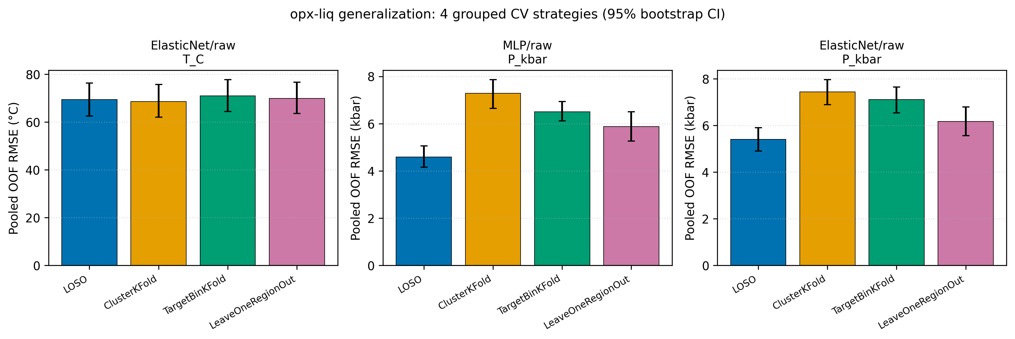
Figure S3. Fig. 26. the tuned ML baseline out-of-fold generalization diagnostics for the three canonical
opx-liq cells (ElasticNet/raw/T_C aggregate winner; MLP/raw/P_kbar
aggregate winner; ElasticNet/raw/P_kbar shallow-crustal robust winner).
Each panel plots pooled held-out RMSE (95% bootstrap CI whiskers) across
four out-of-sample strategies: LeaveOneStudyOut (LOSO, Citation-grouped,
93 folds), Cluster-KFold (chemical cluster groups from NB02 k-means),
TargetBinKFold (pre-registered P-regime bins [0,5,15,30,100] kbar), and
LeaveOneRegionOut (petrologic study-type inferred from Citation text:
MORB / mantle_melting / arc_silicic / basalt / primitive_mafic /
partitioning / metamorphic / other; min_train_fold=50). Produced by
scripts/evaluation/nb05_generalization.py. n_test pooled across folds
after min-train-size filtering. Supports T02/T06 (generalization claims).
Source CSVs: results/opx_liq_generalization.csv and
results/opx_liq_generalization_predictions.csv.
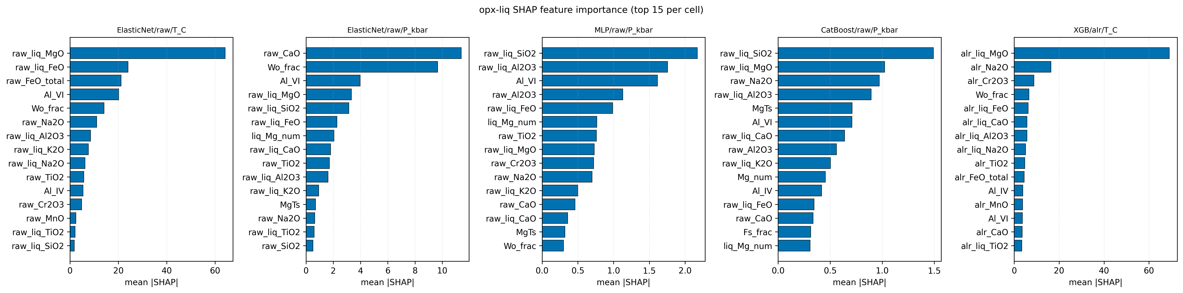
Figure S4. Fig. 27. Top-15 mean absolute SHAP values per feature for five canonical
opx-liq cells, grouped by explainer family. Linear cells use
shap.LinearExplainer (exact for ElasticNet, pipeline scaler pre-applied
to background and evaluation matrices). Tree cells (CatBoost/raw/P_kbar,
XGB/alr/T_C) use shap.TreeExplainer. The MLP/raw/P_kbar cell uses
shap.KernelExplainer with a k=50 KMeans background and an 80-sample
random subset of the test set (seed = SEED_BOOTSTRAP, nsamples=100 per
evaluation); the reported mean|SHAP| averages over the sampled rows only.
Produced by scripts/interpretability/nb06_shap.py. Supports T08 (feature
attribution). Source CSV: results/opx_liq_shap_importance.csv;
per-cell SHAP arrays: results/opx_liq_shap_values.npz.
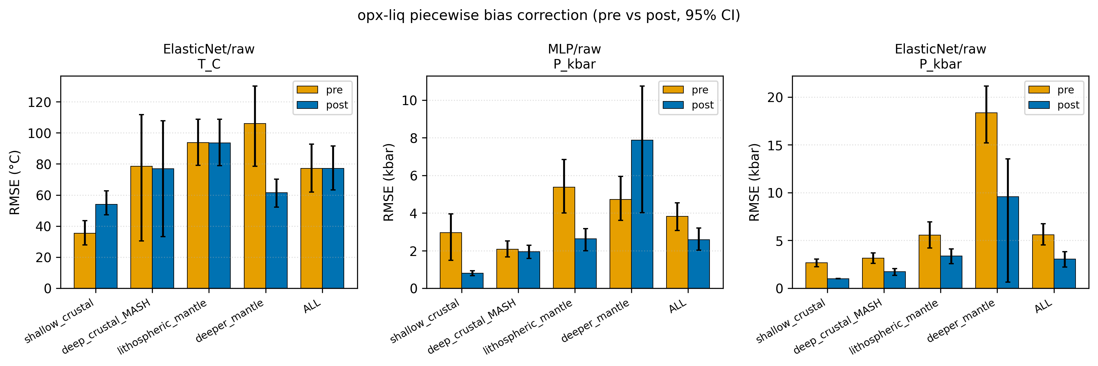
Figure S5. Fig. 28. Per-regime piecewise linear bias correction for the opx-liq
canonical cells. Correction coefficients (y_corrected = a * y_pred + b)
are fit on train-set out-of-fold predictions (StratifiedGroupKFold 10
folds, Citation-grouped, target stratified by NB03 bins) and applied to
the held-out test set per pre-registered P regime (shallow_crustal
[0,5) kbar; deep_crustal_MASH [5,15) kbar; lithospheric_mantle [15,30) kbar;
deeper_mantle [30,100) kbar). Panels show test-set RMSE before vs after
correction per regime plus the pooled "ALL" row. Result: P_kbar
corrections improve ALL RMSE (MLP 3.82 to 2.58 kbar; ElasticNet 5.59
to 3.05 kbar). T_C correction is a neutral-to-negative wash on
ElasticNet/raw (pooled 77.06 to 77.17; shallow_crustal HURT 35.33 to
54.01), consistent with the earlier finding that train-OOF T bias does not
transfer to the held-out test set. Produced by
scripts/bias_correction/nb07_bias.py. Supports T09 (bias correction
effectiveness). Source CSVs: results/opx_liq_bias_correction.csv,
results/opx_liq_bias_correction_params.csv.
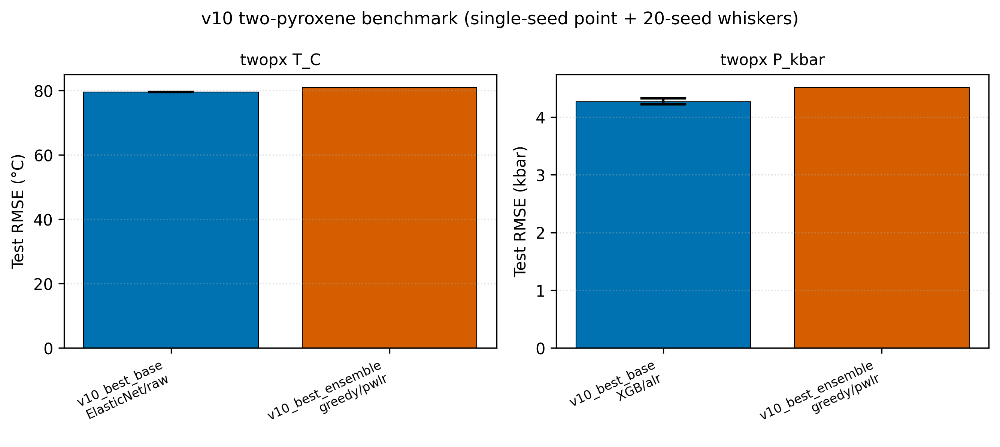
Figure S6. Fig. 29. the tuned ML baseline two-pyroxene (twopx) benchmark, consolidating the per-cell
(single seed), 20-seed multiseed, and stacked-ensemble results on the
twopx Citation-grouped held-out test split. Bars show single-seed test
RMSE for the best base model (blue, ElasticNet/raw for T_C; XGB/alr
for P_kbar) and best stacked ensemble (orange, greedy/pwlr for both
targets). Whiskers on the base-model bars show the 20-seed RMSE
spread (min to max) from the final phase multiseed refit. The Putirka
2008 two-pyroxene equations (eq36/37/38/39) are DEFERRED because the
call requires paired opx-cpx Thermobar invocation that is not wired
into the tuned ML baseline; the deferred row is retained in the CSV with NaN RMSE so
downstream consumers (NB09 manuscript, NBF figures) flag the gap
explicitly. Fixes the earlier empty nb10_two_pyroxene_benchmark.csv
regression. Produced by scripts/benchmarks/nb10_twopx_benchmark.py.
Source CSVs: results/twopx_benchmark_final.csv and
tables/S8_9_twopx_benchmark.{md,csv}.
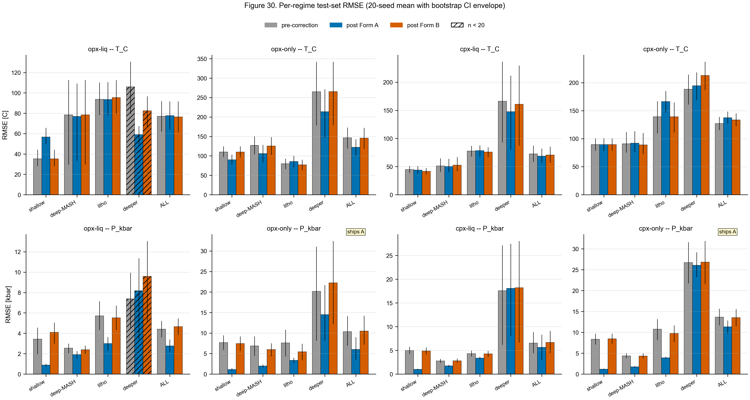
Figure S7. Fig. 30. Per-regime test-set RMSE before and after bias correction for the 8 the final phase cells. Grid rows: T_C (top), P_kbar (bottom). Columns: opx-liq, opx-only, cpx-liq, cpx-only. Each regime group shows pre-correction (gray), post Form A (blue), post Form B (vermillion). Bar heights are 20-seed means; vertical error bars are the mean of per-seed bootstrap 95% CIs. Hatched bars mark regimes with n < 20 (sample-size limited). "accepts Form A or Form B" annotation marks the final phase shipping decision at canonical seed 42. Source CSVs: results/bias_correction_{per_seed,summary,shipped}.csv.
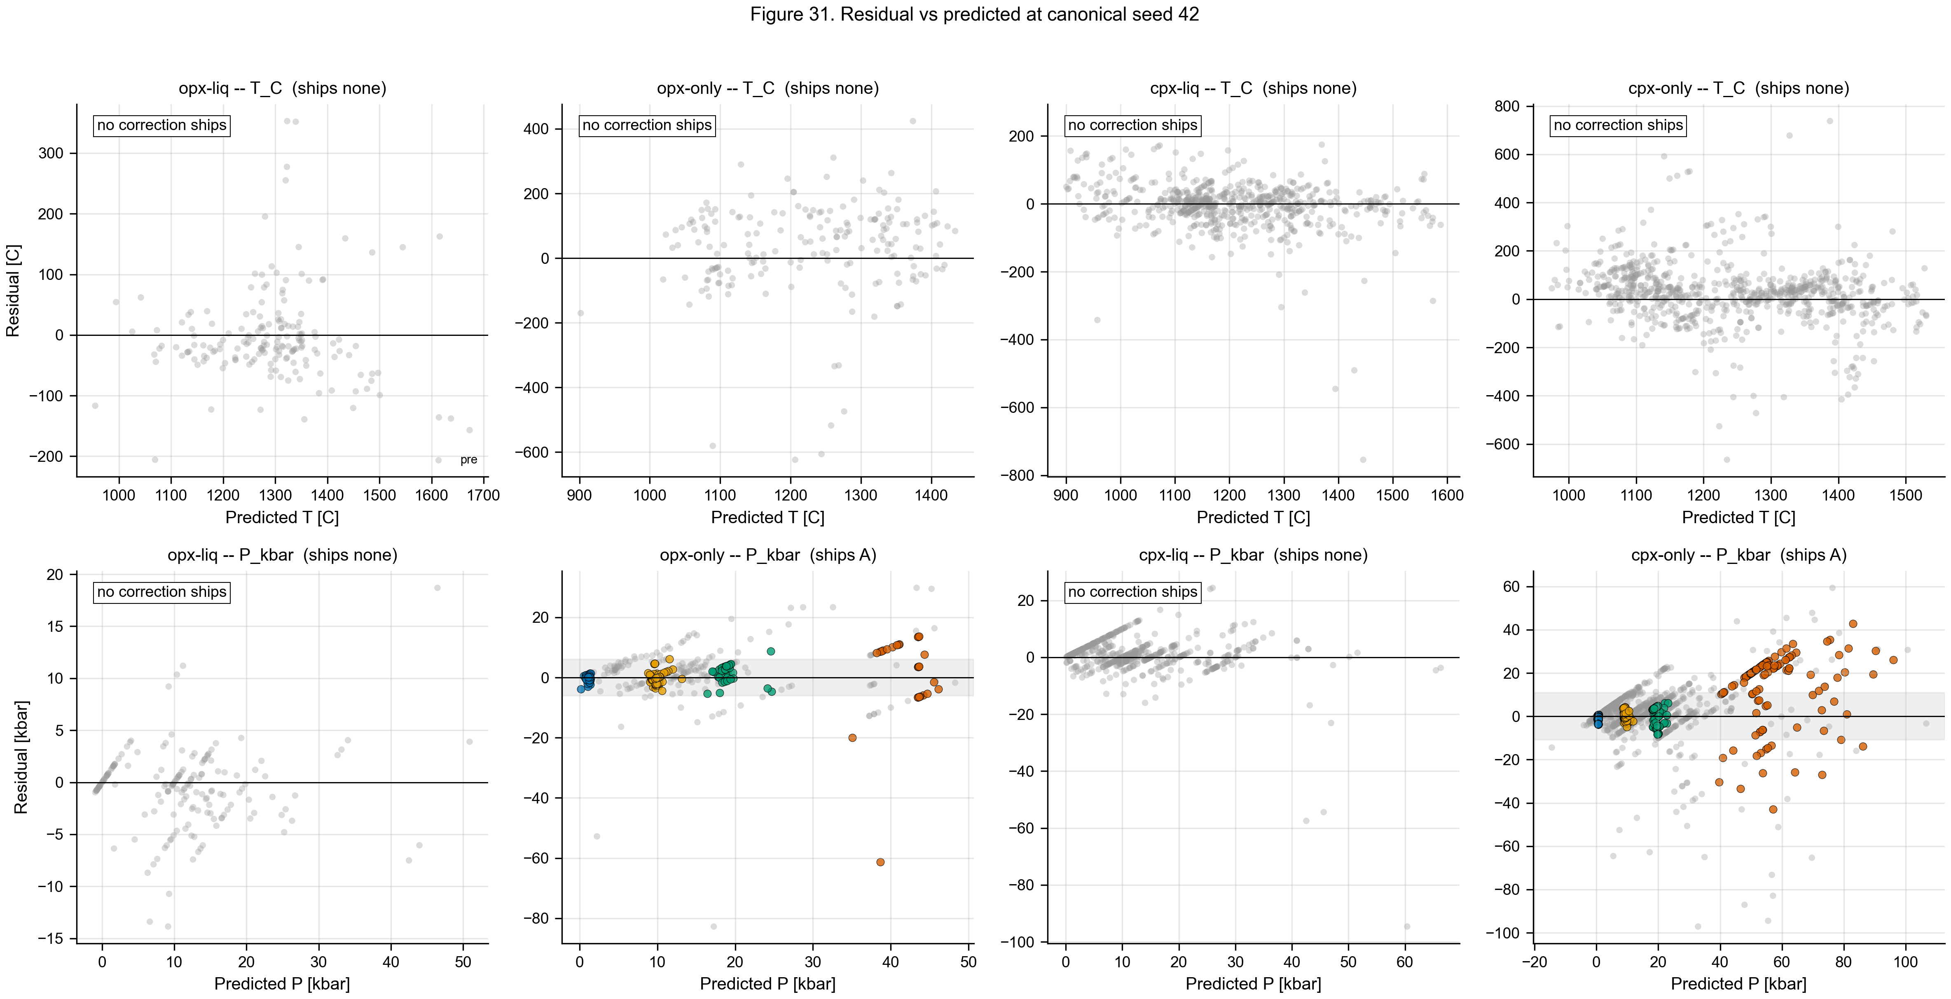
Figure S8. Fig. 31. Residual-vs-predicted scatter for the 8 the final phase cells at canonical seed 42. Gray markers: pre-correction residuals. Colored markers: residuals after the shipping form of correction, grouped by each sample pre-registered P regime (shallow_crustal blue, deep_crustal_MASH orange, lithospheric_mantle green, deeper_mantle vermillion). A shaded band marks +/-1 sigma of the post-correction residuals. Cells whose shipping decision is "none" show the pre-correction residuals alone and are labelled accordingly. Per-sample predictions loaded from results/bias_correction/checkpoints/ (seed 42). Source CSV: results/bias_correction_shipped.csv.
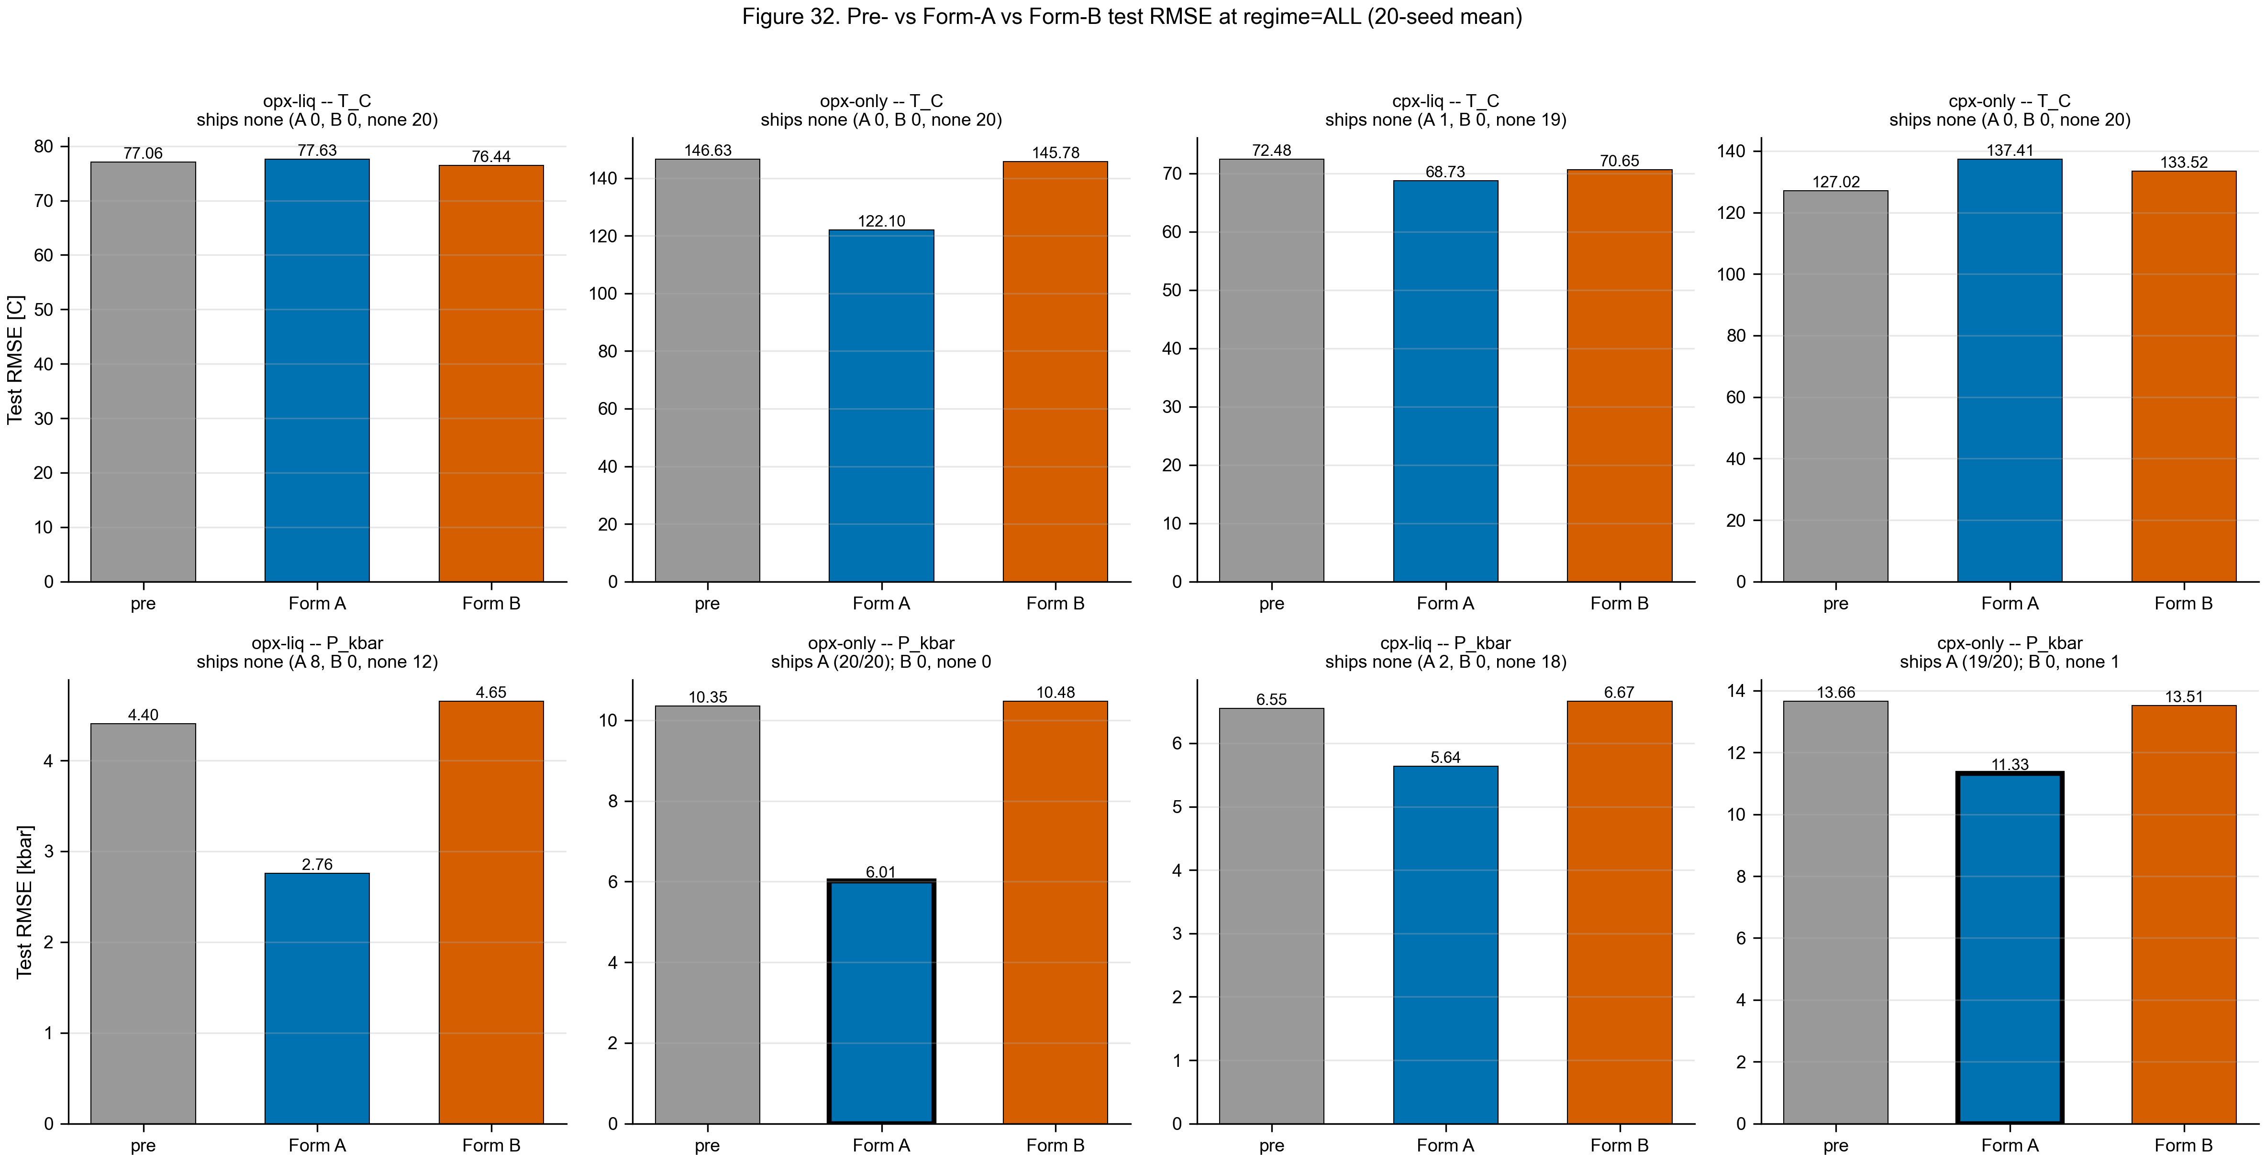
Figure S9. Fig. 32. Test-set RMSE at regime=ALL comparing pre-correction with Form A and Form B post-correction for the 8 the final phase cells (20-seed mean). Shipped form (if any) is drawn with a bold border. Panel subtitle reports the final phase shipping decision and the per-seed vote split across 20 model seeds. Source CSVs: results/bias_correction_{summary,per_seed,shipped}.csv.
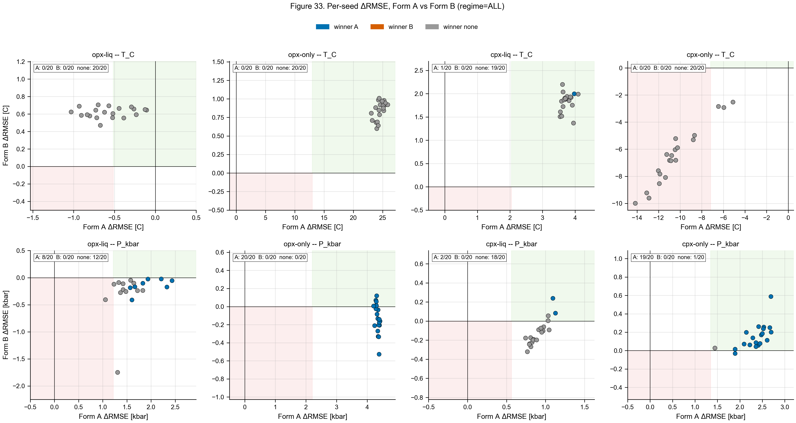
Figure S10. Fig. 33. Per-seed $\Delta$RMSE (pre minus post, positive = improvement) at regime=ALL for Form A (x-axis) vs Form B (y-axis), one point per model seed across the 20-seed protocol. Points are colored by the per-seed winner (blue = A, vermillion = B, gray = none). Light-green shading highlights the upper-right quadrant where both forms improve test RMSE; light-red shading highlights the lower-left quadrant where both forms degrade it. Panel annotation reports the per-seed vote count. Source CSV: results/bias_correction_per_seed.csv.
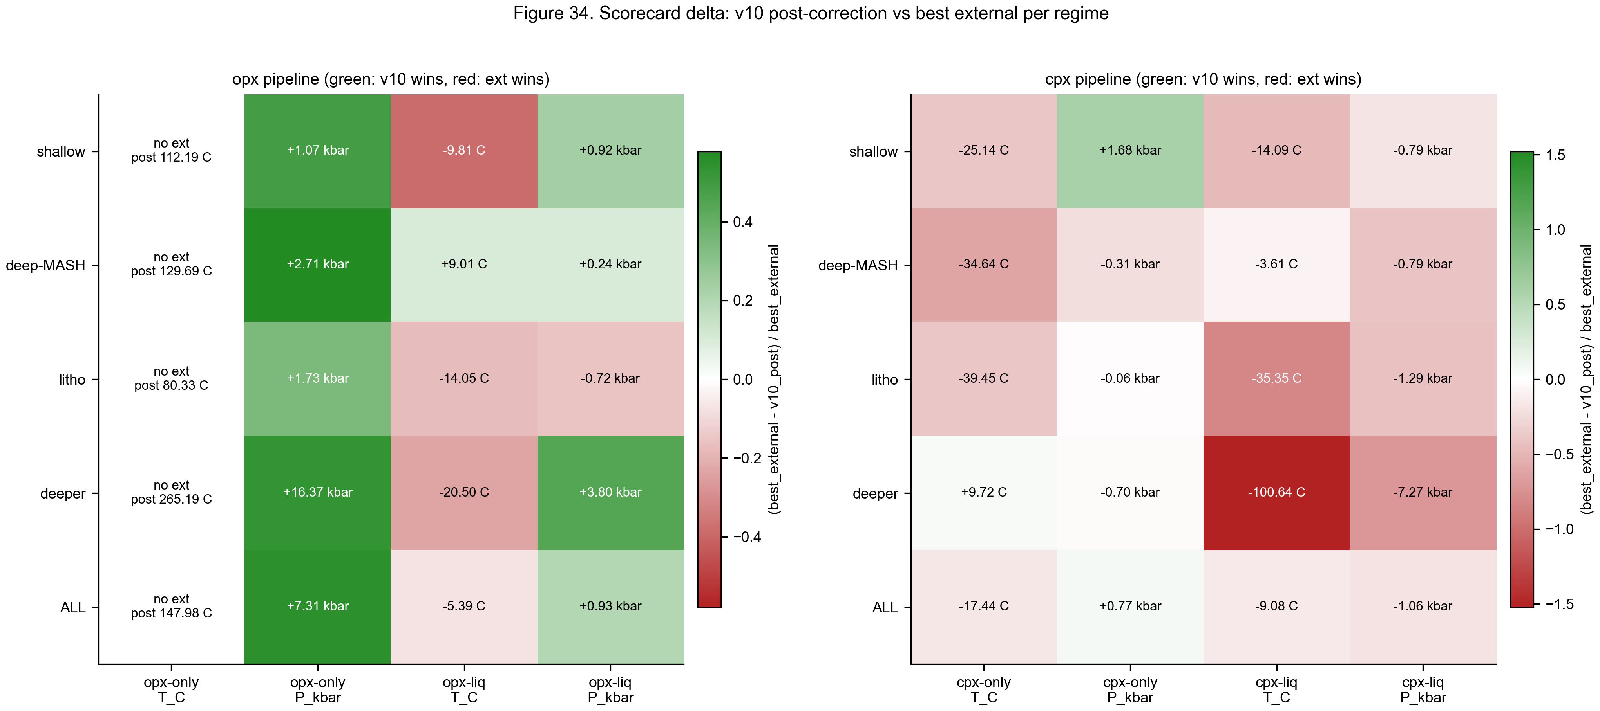
Figure S11. Fig. 34. Scorecard delta between post-correction RMSE and the best external baseline per pre-registered regime, split by pipeline (opx left, cpx right). Color encodes fractional improvement (best_external - post-correction)/best_external on a diverging scale: green = the tuned ML baseline wins, red = external wins, white = tie. Cells annotated with the absolute RMSE delta in native units. Cells without an external baseline list the absolute post-correction value. External reference methods include Putirka (2008) thermobarometers, Agreda-Lopez (2024) ML cpx models, and Jorgenson (2022) ML cpx models. Source CSV: results/preregistered_scorecard_postcorrection.csv.
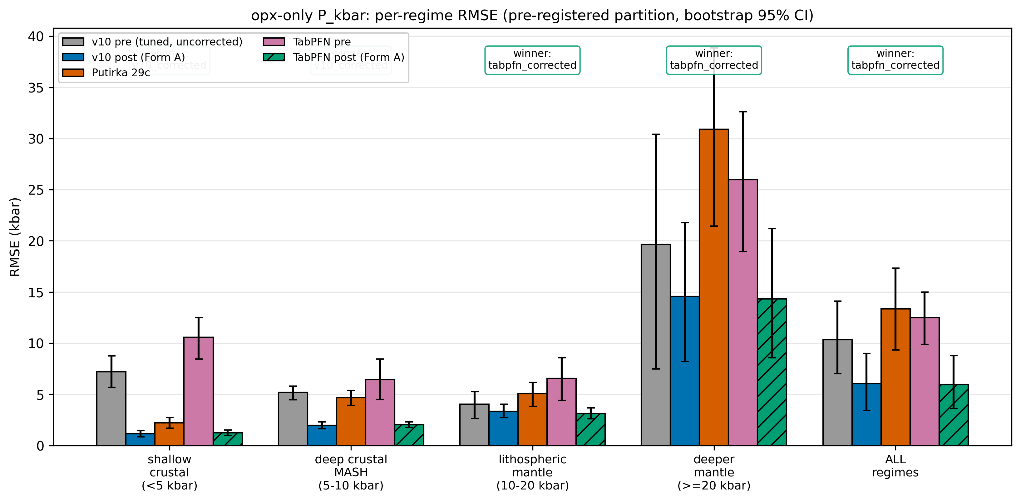
Figure S12. Fig. 45. Per-regime RMSE on the opx-only P_kbar test set across five candidates: the pre-correction tuned baseline (gray), the post-correction tuned baseline (Form A, blue), Putirka 29c (red), TabPFN v2 pre-correction (purple), TabPFN v2 post-correction (Form A, green hatched). Regimes follow the pre-registered pressure partition (<5, 5-10, 10-20, >=20 kbar) plus ALL. Error bars are 95% bootstrap CIs (n_boot = 500). TabPFN post-correction wins 3 of the 5 regimes (lithospheric_mantle, deeper_mantle, ALL) and is within the tuned ML baseline corrected CI on the remaining two. Form A transforms TabPFN from the worst pre-correction method into the aggregate winner, demonstrating that the in-context predictions carry a systematic deeper-regime bias that can be removed with a regime-piecewise linear transform. Source: results/preregistered_scorecard_postcorrection.csv (canonical seed 42 for TabPFN post).
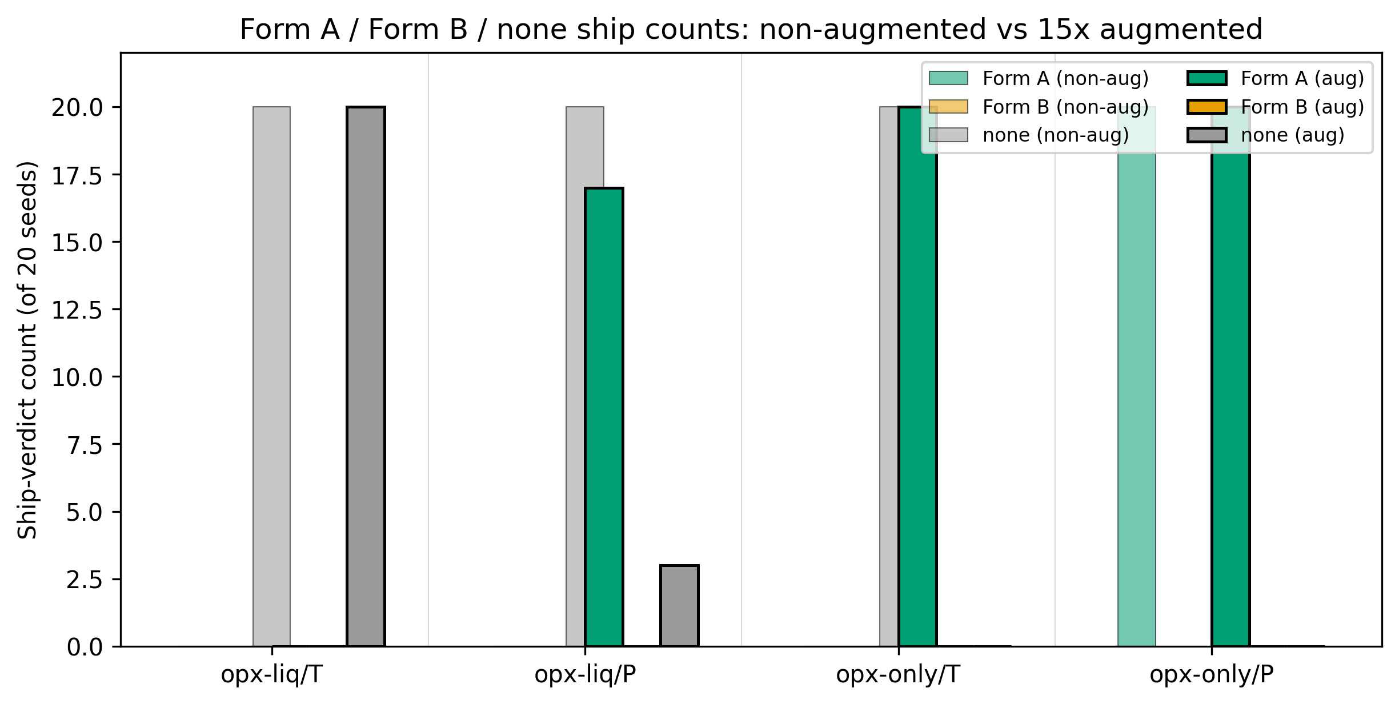
Figure S13. fig_aug01_ship_verdict_comparison
Ship-if-better verdict under the Agreda-Lopez (2024) 15x augmentation protocol versus the non-augmented baseline, across the four opx combinations (track x target). Bars show Form A / Form B / none ship counts across 20 seeds per condition.
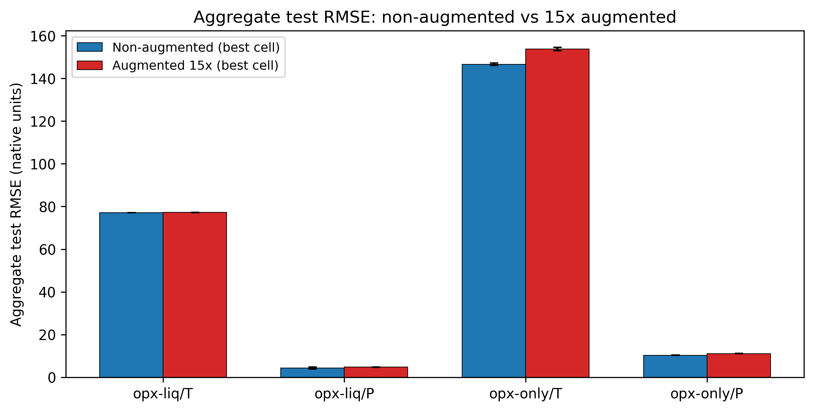
Figure S14. fig_aug02_aggregate_rmse_delta
Aggregate test RMSE under the non-augmented baseline versus the 15x augmented condition per opx combination. Error bars are 20-seed standard deviation. Putirka classical reference is overlaid where available.
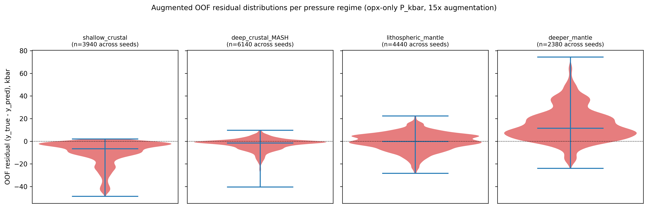
Figure S15. fig_aug03_residual_structure_per_regime
OOF residual distributions by pressure regime for opx-only P_kbar, non-augmented (top row) versus 15x augmented (bottom row). Violin plots show Form A and Form B fit substrate under each protocol.
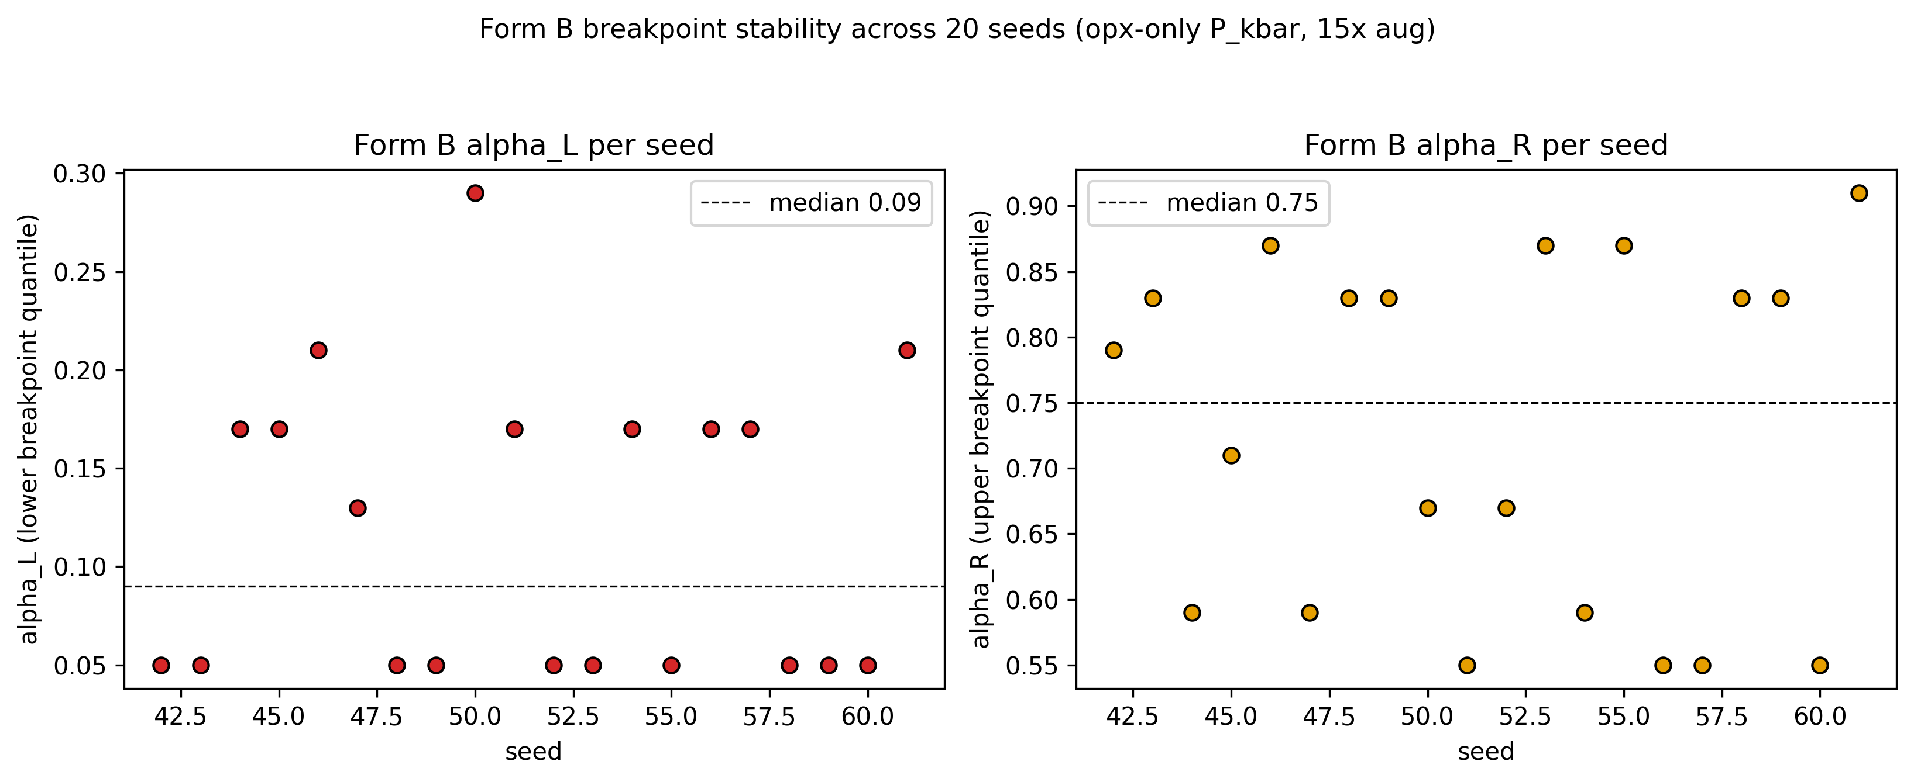
Figure S16. fig_aug04_form_b_breakpoint_stability
Form B breakpoint positions (alpha_L, alpha_R) per seed for opx-only P_kbar under 15x augmentation. Tight clustering indicates stable Form B fits; scatter across the quantile grid indicates the fit drifts with data draws and explains Form B ship failures.

S2. Supplementary Tables

Table S1. S8 10 bias correction regimewise
Source: tables\S8_10_bias_correction_regimewise.csv
pipeline | track | target | regime | n | form | pre_RMSE_mean | pre_RMSE_lo | pre_RMSE_hi | post_RMSE_mean | post_RMSE_lo | post_RMSE_hi | delta_RMSE | ships_cell
cpx | cpx-liq | P_kbar | ALL | 654 | A | 6.546 | 4.416 | 8.878 | 5.635 | 2.999 | 8.303 | 0.911 | N
cpx | cpx-liq | P_kbar | deep_crustal_MASH | 187 | A | 2.756 | 2.333 | 3.215 | 1.722 | 1.505 | 1.952 | 1.034 | N
cpx | cpx-liq | P_kbar | deeper_mantle | 56 | A | 17.583 | 6.179 | 27.143 | 18.084 | 8.021 | 27.474 | -0.501 | N
cpx | cpx-liq | P_kbar | lithospheric_mantle | 143 | A | 4.317 | 3.697 | 4.936 | 3.379 | 3.092 | 3.654 | 0.938 | N
cpx | cpx-liq | P_kbar | shallow_crustal | 268 | A | 4.971 | 4.277 | 5.723 | 0.999 | 0.866 | 1.13 | 3.972 | N
cpx | cpx-liq | P_kbar | ALL | 654 | B | 6.546 | 4.416 | 8.878 | 6.666 | 4.437 | 9.096 | -0.12 | N
cpx | cpx-liq | P_kbar | deep_crustal_MASH | 187 | B | 2.756 | 2.333 | 3.215 | 2.818 | 2.398 | 3.273 | -0.062 | N
cpx | cpx-liq | P_kbar | deeper_mantle | 56 | B | 17.583 | 6.179 | 27.143 | 18.2 | 6.651 | 28.048 | -0.617 | N
cpx | cpx-liq | P_kbar | lithospheric_mantle | 143 | B | 4.317 | 3.697 | 4.936 | 4.277 | 3.66 | 4.894 | 0.04 | N
cpx | cpx-liq | P_kbar | shallow_crustal | 268 | B | 4.971 | 4.277 | 5.723 | 4.886 | 4.18 | 5.646 | 0.085 | N
cpx | cpx-liq | T_C | ALL | 654 | A | 72.476 | 58.518 | 87.569 | 68.733 | 56.918 | 82.09 | 3.743 | N
cpx | cpx-liq | T_C | deep_crustal_MASH | 187 | A | 51.161 | 40.49 | 64.76 | 50.478 | 39.891 | 63.801 | 0.683 | N
cpx | cpx-liq | T_C | deeper_mantle | 56 | A | 166.311 | 92.692 | 236.514 | 147.758 | 80.038 | 211.781 | 18.553 | N
cpx | cpx-liq | T_C | lithospheric_mantle | 143 | A | 77.724 | 67.891 | 86.979 | 78.336 | 67.812 | 88.093 | -0.612 | N
cpx | cpx-liq | T_C | shallow_crustal | 268 | A | 44.594 | 38.464 | 51.046 | 43.746 | 36.995 | 50.856 | 0.847 | N
cpx | cpx-liq | T_C | ALL | 654 | B | 72.476 | 58.518 | 87.569 | 70.645 | 57.006 | 85.433 | 1.831 | N
cpx | cpx-liq | T_C | deep_crustal_MASH | 187 | B | 51.161 | 40.49 | 64.76 | 52.701 | 41.804 | 66.88 | -1.54 | N
cpx | cpx-liq | T_C | deeper_mantle | 56 | B | 166.311 | 92.692 | 236.514 | 160.927 | 87.517 | 229.813 | 5.384 | N
cpx | cpx-liq | T_C | lithospheric_mantle | 143 | B | 77.724 | 67.891 | 86.979 | 76.031 | 66.652 | 84.493 | 1.693 | N
cpx | cpx-liq | T_C | shallow_crustal | 268 | B | 44.594 | 38.464 | 51.046 | 41.767 | 36.335 | 47.501 | 2.826 | N
cpx | cpx-only | P_kbar | ALL | 784 | A | 13.664 | 11.688 | 15.661 | 11.329 | 9.799 | 12.841 | 2.334 | Y
cpx | cpx-only | P_kbar | deep_crustal_MASH | 193 | A | 4.366 | 3.806 | 5.006 | 1.74 | 1.573 | 1.911 | 2.626 | Y
cpx | cpx-only | P_kbar | deeper_mantle | 142 | A | 26.737 | 21.71 | 31.626 | 26.061 | 23.288 | 29.197 | 0.676 | Y
cpx | cpx-only | P_kbar | lithospheric_mantle | 213 | A | 10.748 | 8.16 | 13.191 | 3.922 | 3.71 | 4.136 | 6.826 | Y
cpx | cpx-only | P_kbar | shallow_crustal | 236 | A | 8.357 | 7.091 | 9.668 | 1.166 | 1.005 | 1.328 | 7.19 | Y
cpx | cpx-only | P_kbar | ALL | 784 | B | 13.664 | 11.688 | 15.661 | 13.513 | 11.473 | 15.572 | 0.15 | N
cpx | cpx-only | P_kbar | deep_crustal_MASH | 193 | B | 4.366 | 3.806 | 5.006 | 4.337 | 3.774 | 4.977 | 0.029 | N
cpx | cpx-only | P_kbar | deeper_mantle | 142 | B | 26.737 | 21.71 | 31.626 | 26.844 | 21.568 | 31.874 | -0.107 | N
cpx | cpx-only | P_kbar | lithospheric_mantle | 213 | B | 10.748 | 8.16 | 13.191 | 9.737 | 7.705 | 11.656 | 1.012 | N
cpx | cpx-only | P_kbar | shallow_crustal | 236 | B | 8.357 | 7.091 | 9.668 | 8.471 | 7.282 | 9.693 | -0.115 | N
[Table truncated to first 30 rows. Full table at tables\S8_10_bias_correction_regimewise.csv]

Table S2. S8 5 1 regime rmse opx liq
Source: tables\S8_5_1_regime_rmse_opx_liq.csv
target | P_kbar | P_kbar.1 | T_C | T_C.1
method_family | Putirka | our_method | Putirka | our_method
regime
shallow_crustal | 3.886363899698184 | 2.6629062653698017 | 25.52386491004583 | 23.46950633881204
deep_crustal_MASH | 2.3144340490953392 | 2.078945257682617 | 87.478244585471 | 78.46430905099997
lithospheric_mantle | 4.659726169083871 | 4.538469782286738 | 79.65209323346028 | 93.6982941619437
deeper_mantle | 8.51948552579252 | 4.555771723826939 | 85.50088439343597 | 105.60448966787888

Table S3. S8 5 2 regime rmse ci opx liq
Source: tables\S8_5_2_regime_rmse_ci_opx_liq.csv
target | P_kbar | P_kbar.1 | T_C | T_C.1
method_family | Putirka | our_method | Putirka | our_method
regime
shallow_crustal | 3.89 [3.24, 4.47] | 2.66 [2.25, 3.13] | 25.52 [16.32, 33.87] | 23.47 [15.89, 30.40]
deep_crustal_MASH | 2.31 [1.72, 2.85] | 2.08 [1.62, 2.54] | 87.48 [34.61, 120.83] | 78.46 [29.85, 113.07]
lithospheric_mantle | 4.66 [3.25, 5.96] | 4.54 [3.49, 5.56] | 79.65 [54.89, 107.41] | 93.70 [77.31, 111.17]
deeper_mantle | 8.52 [4.44, 11.14] | 4.56 [3.19, 5.75] | 85.50 [14.78, 123.50] | 105.60 [75.14, 127.73]

Table S4. S8 5 3 regime claims audit opx liq
Source: tables\S8_5_3_regime_claims_audit_opx_liq.csv
regime | target | n | sample_size_limited | our_rmse | putirka_rmse | ci_overlap | verdict
shallow_crustal | T_C | 47 | False | 23.47 | 25.524 | True | competitive with Putirka (CIs overlap)
shallow_crustal | P_kbar | 47 | False | 2.663 | 3.886 | False | our method outperforms Putirka
deep_crustal_MASH | T_C | 61 | False | 78.464 | 87.478 | True | competitive with Putirka (CIs overlap)
deep_crustal_MASH | P_kbar | 61 | False | 2.079 | 2.314 | True | competitive with Putirka (CIs overlap)
lithospheric_mantle | T_C | 58 | False | 93.698 | 79.652 | True | competitive with Putirka (CIs overlap)
lithospheric_mantle | P_kbar | 58 | False | 4.538 | 4.66 | True | competitive with Putirka (CIs overlap)
deeper_mantle | T_C | 8 | True | 105.604 | 85.501 | True | insufficient data (n < 20)
deeper_mantle | P_kbar | 8 | True | 4.556 | 8.519 | True | insufficient data (n < 20)

Table S5. S8 5 4 regime claims audit robust opx liq
Source: tables\S8_5_4_regime_claims_audit_robust_opx_liq.csv
regime | target | n | sample_size_limited | our_method_label | our_rmse | our_rmse_lo | our_rmse_hi | putirka_method | putirka_rmse | putirka_rmse_lo | putirka_rmse_hi | seed_rmse_mean | seed_rmse_std | seed_rmse_lo | seed_rmse_hi | seed_rmse_min | seed_rmse_max | seed_is_deterministic | axis1_nonoverlap | axis2_nonoverlap | robust_verdict | robust_outperforms
shallow_crustal | T_C | 47 | False | ERT/pwlr | 23.47 | 15.891 | 30.399 | Putirka 28a | 25.524 | 16.322 | 33.871 | 23.032 | 0.457 | 22.25 | 23.78 | 22.191 | 23.872 | False | False | False | competitive with Putirka | False
shallow_crustal | P_kbar | 47 | False | ElasticNet/raw | 2.663 | 2.245 | 3.134 | Putirka 29a | 3.886 | 3.236 | 4.472 | 2.663 | 0.0 | 2.663 | 2.663 | 2.663 | 2.663 | False | True | True | our method outperforms Putirka (robust) | True
deep_crustal_MASH | T_C | 61 | False | ElasticNet/raw | 78.464 | 29.846 | 113.072 | Putirka 28a | 87.478 | 34.612 | 120.826 | 78.464 | 0.0 | 78.464 | 78.464 | 78.464 | 78.464 | False | False | False | competitive with Putirka | False
deep_crustal_MASH | P_kbar | 61 | False | MLP/raw | 2.079 | 1.624 | 2.539 | Putirka 29a | 2.314 | 1.722 | 2.853 | 2.539 | 0.274 | 2.042 | 2.99 | 2.008 | 3.074 | False | False | False | competitive with Putirka | False
lithospheric_mantle | T_C | 58 | False | ElasticNet/raw | 93.698 | 77.308 | 111.17 | Putirka 28a | 79.652 | 54.887 | 107.41 | 93.698 | 0.0 | 93.698 | 93.698 | 93.698 | 93.698 | False | False | False | competitive with Putirka | False
lithospheric_mantle | P_kbar | 58 | False | CatBoost/raw | 4.538 | 3.487 | 5.561 | Putirka 29a | 4.66 | 3.25 | 5.961 | 4.574 | 0.107 | 4.396 | 4.729 | 4.38 | 4.739 | False | False | False | competitive with Putirka | False
deeper_mantle | T_C | 8 | True | ElasticNet/pwlr | 105.604 | 75.141 | 127.729 | Putirka 28a | 85.501 | 14.78 | 123.499 | 105.604 | 0.0 | 105.604 | 105.604 | 105.604 | 105.604 | True | False | False | insufficient data (n < 20) | False
deeper_mantle | P_kbar | 8 | True | MLP/alr | 4.556 | 3.194 | 5.746 | Putirka 29b | 8.519 | 4.438 | 11.137 | 7.06 | 4.439 | 4.011 | 18.394 | 3.776 | 24.02 | False | False | False | insufficient data (n < 20) | False

Table S6. S8 6 generalization opx liq
Source: tables\S8_6_generalization_opx_liq.csv
strategy | model | target | track | feature_set | n | n_folds | rmse | rmse_lo | rmse_hi | mae | mae_lo | mae_hi
LOSO | ElasticNet | T_C | opx_liq | raw | 600 | 93 | 69.4 | 62.507 | 76.348 | 48.832 | 45.167 | 52.644
ClusterKFold | ElasticNet | T_C | opx_liq | raw | 600 | 5 | 68.644 | 62.025 | 75.792 | 48.192 | 44.565 | 52.024
TargetBinKFold | ElasticNet | T_C | opx_liq | raw | 600 | 4 | 70.95 | 64.393 | 77.817 | 50.129 | 46.432 | 54.215
LeaveOneRegionOut | ElasticNet | T_C | opx_liq | raw | 600 | 7 | 69.897 | 63.591 | 76.646 | 48.33 | 44.377 | 52.257
LOSO | MLP | P_kbar | opx_liq | raw | 600 | 93 | 4.588 | 4.154 | 5.063 | 3.21 | 2.966 | 3.484
ClusterKFold | MLP | P_kbar | opx_liq | raw | 600 | 5 | 7.286 | 6.649 | 7.87 | 5.463 | 5.061 | 5.825
TargetBinKFold | MLP | P_kbar | opx_liq | raw | 600 | 4 | 6.506 | 6.114 | 6.944 | 5.211 | 4.91 | 5.535
LeaveOneRegionOut | MLP | P_kbar | opx_liq | raw | 600 | 7 | 5.881 | 5.261 | 6.503 | 4.031 | 3.695 | 4.362
LOSO | ElasticNet | P_kbar | opx_liq | raw | 600 | 93 | 5.397 | 4.899 | 5.904 | 3.838 | 3.548 | 4.142
ClusterKFold | ElasticNet | P_kbar | opx_liq | raw | 600 | 5 | 7.441 | 6.885 | 7.966 | 5.84 | 5.462 | 6.18
TargetBinKFold | ElasticNet | P_kbar | opx_liq | raw | 600 | 4 | 7.106 | 6.533 | 7.644 | 5.303 | 4.935 | 5.669
LeaveOneRegionOut | ElasticNet | P_kbar | opx_liq | raw | 600 | 7 | 6.171 | 5.565 | 6.797 | 4.329 | 3.964 | 4.691

Table S7. S8 7 shap top features opx liq
Source: tables\S8_7_shap_top_features_opx_liq.csv
cell | model | target | feature_set | feature | mean_abs_shap
CatBoost/raw/P_kbar | CatBoost | P_kbar | raw | raw_liq_SiO2 | 1.491
CatBoost/raw/P_kbar | CatBoost | P_kbar | raw | raw_liq_MgO | 1.024
CatBoost/raw/P_kbar | CatBoost | P_kbar | raw | raw_Na2O | 0.973
CatBoost/raw/P_kbar | CatBoost | P_kbar | raw | raw_liq_Al2O3 | 0.894
CatBoost/raw/P_kbar | CatBoost | P_kbar | raw | MgTs | 0.711
CatBoost/raw/P_kbar | CatBoost | P_kbar | raw | Al_VI | 0.71
CatBoost/raw/P_kbar | CatBoost | P_kbar | raw | raw_liq_CaO | 0.638
CatBoost/raw/P_kbar | CatBoost | P_kbar | raw | raw_Al2O3 | 0.56
CatBoost/raw/P_kbar | CatBoost | P_kbar | raw | raw_liq_K2O | 0.504
CatBoost/raw/P_kbar | CatBoost | P_kbar | raw | Mg_num | 0.455
ElasticNet/raw/P_kbar | ElasticNet | P_kbar | raw | raw_CaO | 11.394
ElasticNet/raw/P_kbar | ElasticNet | P_kbar | raw | Wo_frac | 9.658
ElasticNet/raw/P_kbar | ElasticNet | P_kbar | raw | Al_VI | 3.982
ElasticNet/raw/P_kbar | ElasticNet | P_kbar | raw | raw_liq_MgO | 3.34
ElasticNet/raw/P_kbar | ElasticNet | P_kbar | raw | raw_liq_SiO2 | 3.146
ElasticNet/raw/P_kbar | ElasticNet | P_kbar | raw | raw_liq_FeO | 2.271
ElasticNet/raw/P_kbar | ElasticNet | P_kbar | raw | liq_Mg_num | 2.058
ElasticNet/raw/P_kbar | ElasticNet | P_kbar | raw | raw_liq_CaO | 1.801
ElasticNet/raw/P_kbar | ElasticNet | P_kbar | raw | raw_TiO2 | 1.715
ElasticNet/raw/P_kbar | ElasticNet | P_kbar | raw | raw_liq_Al2O3 | 1.617
ElasticNet/raw/T_C | ElasticNet | T_C | raw | raw_liq_MgO | 64.183
ElasticNet/raw/T_C | ElasticNet | T_C | raw | raw_liq_FeO | 23.992
ElasticNet/raw/T_C | ElasticNet | T_C | raw | raw_FeO_total | 21.128
ElasticNet/raw/T_C | ElasticNet | T_C | raw | Al_VI | 20.201
ElasticNet/raw/T_C | ElasticNet | T_C | raw | Wo_frac | 14.065
ElasticNet/raw/T_C | ElasticNet | T_C | raw | raw_Na2O | 11.077
ElasticNet/raw/T_C | ElasticNet | T_C | raw | raw_liq_Al2O3 | 8.495
ElasticNet/raw/T_C | ElasticNet | T_C | raw | raw_liq_K2O | 7.633
ElasticNet/raw/T_C | ElasticNet | T_C | raw | raw_liq_Na2O | 6.264
ElasticNet/raw/T_C | ElasticNet | T_C | raw | raw_TiO2 | 5.723
[Table truncated to first 30 rows. Full table at tables\S8_7_shap_top_features_opx_liq.csv]

Table S8. S8 8 bias correction opx liq
Source: tables\S8_8_bias_correction_opx_liq.csv
model | target | track | feature_set | regime | n | pre_rmse | pre_rmse_lo | pre_rmse_hi | post_rmse | post_rmse_lo | post_rmse_hi | improvement
ElasticNet | T_C | opx_liq | raw | deep_crustal_MASH | 61 | 78.464 | 30.402 | 111.636 | 76.919 | 33.27 | 107.7 | 1.545
ElasticNet | T_C | opx_liq | raw | deeper_mantle | 8 | 105.996 | 78.465 | 130.083 | 61.542 | 52.232 | 70.113 | 44.454
ElasticNet | T_C | opx_liq | raw | lithospheric_mantle | 58 | 93.698 | 79.135 | 108.674 | 93.577 | 79.003 | 108.805 | 0.121
ElasticNet | T_C | opx_liq | raw | shallow_crustal | 47 | 35.33 | 27.961 | 43.559 | 54.007 | 47.258 | 62.6 | -18.677
ElasticNet | T_C | opx_liq | raw | ALL | 174 | 77.062 | 61.813 | 92.726 | 77.169 | 63.232 | 91.645 | -0.107
MLP | P_kbar | opx_liq | raw | deep_crustal_MASH | 61 | 2.079 | 1.672 | 2.515 | 1.953 | 1.579 | 2.295 | 0.126
MLP | P_kbar | opx_liq | raw | deeper_mantle | 8 | 4.715 | 3.616 | 5.954 | 7.866 | 4.026 | 10.745 | -3.151
MLP | P_kbar | opx_liq | raw | lithospheric_mantle | 58 | 5.38 | 4.008 | 6.846 | 2.636 | 1.995 | 3.171 | 2.744
MLP | P_kbar | opx_liq | raw | shallow_crustal | 47 | 2.965 | 1.485 | 3.957 | 0.798 | 0.671 | 0.925 | 2.167
MLP | P_kbar | opx_liq | raw | ALL | 174 | 3.816 | 3.078 | 4.538 | 2.583 | 2.028 | 3.201 | 1.233
ElasticNet | P_kbar | opx_liq | raw | deep_crustal_MASH | 61 | 3.153 | 2.61 | 3.71 | 1.733 | 1.362 | 2.063 | 1.421
ElasticNet | P_kbar | opx_liq | raw | deeper_mantle | 8 | 18.36 | 15.214 | 21.137 | 9.585 | 0.647 | 13.544 | 8.774
ElasticNet | P_kbar | opx_liq | raw | lithospheric_mantle | 58 | 5.56 | 4.208 | 6.941 | 3.362 | 2.568 | 4.121 | 2.198
ElasticNet | P_kbar | opx_liq | raw | shallow_crustal | 47 | 2.663 | 2.265 | 3.061 | 1.015 | 1.008 | 1.023 | 1.647
ElasticNet | P_kbar | opx_liq | raw | ALL | 174 | 5.586 | 4.543 | 6.736 | 3.053 | 2.231 | 3.831 | 2.533

S3. Pre-registration Documents

S3.1 Pressure regime pre-registration

Pre-registration: Pressure-regime bins and bias-correction acceptance rule
Registered: 2026-04-17 Author: NQTa Status: Locked. Any modification requires a new registration date and a written justification in Section 8 below. Scope: Opx-liq thermobarometer benchmark analysis on ArcPL Kd-equilibrated subset (n = 96), the ExPetDB held-out test set, and the bias-correction ship decision used to gate Form A and Form B before the canonical scorecard rewrite.
---

1. Purpose
This document registers two coupled methodological choices that define the pre-registered honesty bar for the opx ML thermobarometer paper:
1. The pressure-regime bin structure used for regime-dependent benchmark analysis against external methods (Putirka 2008, Agreda-Lopez 2024, Jorgenson 2022, Wang 2021). 2. The tiered acceptance rule that gates whether a bias-correction form (Form A regime-piecewise OLS, Form B Agreda-Lopez quantile-thresholded piecewise) ships into the canonical scorecard.
The registration timestamp is the primary defense against reviewer concerns about post-hoc bin selection, post-hoc tolerance choice, and post-hoc ship decisions.
Aggregate RMSE on ArcPL n = 96 remains the primary benchmark claim (Section 2.5 of the manuscript). Regime-dependent analysis is a secondary, exploratory characterization of where each method's calibration domain is most reliable, not a ranking or a basis for overclaiming relative performance.

2. Bin definitions (locked)
Four pressure regimes with edges at 0, 5, 15, 30, and 100 kbar (the last being the ExPetDB training-set pressure ceiling, P_CEILING_KBAR in config.py):
LabelP range (kbar)Petrological contextshallow_crustal0-5Arc storage, upper-crustal magma chambersdeep_crustal_MASH5-15Melting-assimilation-storage-homogenization zonelithospheric_mantle15-30Spinel to garnet peridotite stabilitydeeper_mantle&gt;30Asthenospheric and below
Bin membership is assigned on the experimentally reported pressure for ExPetDB test samples and on the independently constrained pressure for ArcPL natural samples. Bin edges are right-open (P = 5.0 kbar belongs to deep_crustal_MASH, not shallow_crustal).

3. Rationale for the bin edges

3.1 Petrological basis, not statistical
The boundaries are pinned to petrological regime transitions that appear consistently in the igneous petrology literature, not to statistical properties of our test data:
- 5 kbar - approximate upper limit of shallow crustal magma storage in most arc systems; below this, magma chambers sit in the upper crust above typical seismic discontinuities (Putirka, 2008, Table 3; Blundy and Cashman, 2008 Section 2). - 15 kbar - approximate mid-to-lower crustal boundary, the upper end of the MASH zone where arc magmas are typically modified before ascent (Hildreth and Moorbath, 1988; Annen, Blundy, and Sparks, 2006). - 30 kbar - approximate spinel-to-garnet peridotite transition in the lithospheric mantle, a well-established petrological boundary (Klemme and O'Neill, 2000; Walter, 1998).
We do not claim these are sharp phase-boundary transitions - they are reporting conventions for regime-dependent benchmark interpretation. Any reviewer familiar with igneous petrology will recognize the boundary set.

3.2 Not tuned to match Agreda-Lopez, Jorgenson, or our own win/loss pattern
The bins are not chosen to match the training distribution of any specific cpx thermobarometer, nor to place our model in a favorable light. We do not re-bin based on which boundaries maximize our apparent performance in any regime.

3.3 Not equal-N bins
Equal-N partitioning of the P axis would have been an alternative defensible choice but would place bin edges at distribution percentiles that have no petrological meaning. We prefer petrological interpretability over statistical uniformity; the tradeoff is accepted - see Section 4.

4. Accepted limitations

4.1 Unequal sample size per bin
ArcPL n = 96 distributed across four bins will be uneven. Based on the ArcPL pressure distribution (primarily arc samples), we expect most samples in shallow_crustal and deep_crustal_MASH, fewer in lithospheric_mantle, and possibly very few in deeper_mantle. This unevenness is reported honestly in the per-bin table, and within-bin bootstrap confidence intervals reflect the corresponding loss of statistical resolution.
Sample-size floor: If any bin contains fewer than N_MIN_FOR_VETO = 20 samples, we report the bin's numbers but explicitly mark the result as "sample-size-limited" in the per-bin table. We do not drop the bin and do not merge bins post-hoc. The same N_MIN_FOR_VETO threshold also gates the bias-correction ship decision in Section 6.

4.2 Training-vs-test distributional mismatch
ExPetDB training samples are approximately uniformly distributed in P (after filtering) because training experiments span the full calibration range. ArcPL natural samples follow a different distribution (mostly crustal). This mismatch is the exact signal we expect regime analysis to expose; it is not a flaw of the bin structure.

4.3 Exploratory framing
Results from this bin structure are reported as calibration-domain characterization, not as a ranking of methods. The manuscript explicitly avoids claims of the form "method A is better than method B in regime X" unless bootstrap 95% CIs of RMSE, T bias, or P bias exclude the competing method's estimate at the 5% level AND the sample size in the regime exceeds 20.

5. Implementation of the regime structure

5.1 [Config.py](http://Config.py) variables (locked)
P_REGIME_BIN_EDGES_KBAR = [0.0, 5.0, 15.0, 30.0, P_CEILING_KBAR]
P_REGIME_LABELS = ['shallow_crustal', 'deep_crustal_MASH',
'lithospheric_mantle', 'deeper_mantle']
P_REGIME_REGISTERED_DATE = '2026-04-17'
P_REGIME_RATIONALE_DOC = 'docs/preregistration/p_regime_preregistration.md'

5.2 Assignment helper
In src/evaluation.py:
import numpy as np
from config import P_REGIME_BIN_EDGES_KBAR, P_REGIME_LABELS

def assign_p_regime(p_kbar):
"""Return regime label for each pressure value.

P_REGIME_BIN_EDGES_KBAR is [0, 5, 15, 30, 100]; np.digitize with
right=False places P=5.0 in bin index 2 (deep_crustal_MASH), matching
the right-open convention in this document.
"""
p = np.asarray(p_kbar, dtype=float)
p_clipped = np.clip(p, 0.0, P_REGIME_BIN_EDGES_KBAR[-1] - 1e-9)
bin_idx = np.digitize(p_clipped, P_REGIME_BIN_EDGES_KBAR[1:-1], right=False)
return np.array([P_REGIME_LABELS[i] for i in bin_idx])

5.3 Per-bin metric reporting
For each (method × regime) combination, the benchmark notebook computes:
- n (sample size in bin) - RMSE with bootstrap 95% CI (B = 1000 resamples) - T bias (mean residual) with bootstrap 95% CI - P bias (mean residual) with bootstrap 95% CI - 90% prediction interval coverage fraction
The full per-bin table is generated by NB04 (benchmark) and written to results/opx_test_log.csv with a regime column added.

6. Bias-correction ship decision (locked)
A bias-correction form (Form A or Form B, both defined in src/bias_correction.py) ships into the canonical post-correction scorecard if and only if it improves the overall test RMSE by more than the numerical tolerance and does not degrade any well-populated pre-registered regime by more than the pre-registered tolerance band.

6.1 Constants
SHIP_TOL = 1e-6 # numerical floor (kbar or degC)
N_MIN_FOR_VETO = 20 # Section 4.1 sample-size floor
T_ABS_T = 10.0 # absolute tolerance (degC) for T targets
T_ABS_P = 1.0 # absolute tolerance (kbar) for P targets
T_REL = 0.10 # relative tolerance (fraction of pre-RMSE)
SHIP_TOL exists only as the numerical floor inside max(...). T_ABS_T, T_ABS_P, T_REL are the substantive tolerances; they are constructed from two independent rationales documented in Section 6.4 below.

6.2 The rule
Let:
- overall_delta = pre_overall_rmse - post_overall_rmse - For each pre-registered regime r: - degradation_r = post_r - pre_r - n_r = number of test samples in r - pre_r = pre-correction regime RMSE (in native target units) - target_is_T = (target == 'T_C'), else it is a P target - tol_abs = T_ABS_T if target_is_T else T_ABS_P
For each regime r, the veto tolerance is:
veto_tol_r = max(SHIP_TOL, tol_abs, T_REL * pre_r)
A correction form ships iff all three of the following hold:
1. Overall-improvement clause. overall_delta > SHIP_TOL. 2. Veto-on-well-populated-regimes. For every regime r with n_r >= N_MIN_FOR_VETO, degradation_r <= veto_tol_r. (A well-populated regime can veto if it degrades more than the tolerance band allows.) 3. Floor-logging for low-n regimes. For every regime r with n_r < N_MIN_FOR_VETO, the degradation is logged but not vetoing. These bins are reported in the scorecard with a sample_size_limited=True flag and a trailing ⚠ in advisor-package figures.
Tie-breaking between Form A and Form B: if both ship, the form with the larger overall_delta wins; ties (improbable in float) break toward Form A (simpler, more interpretable).

6.3 What the rule does not change
- Pre-registered regime edges (0, 5, 15, 30, P_CEILING_KBAR): unchanged. - Definition of overall_delta: unchanged. - External-benchmark comparison protocol (Putirka / Agreda-Lopez / Jorgenson / Wang): not touched. - Bootstrap protocol (n_boot = 2000 paired for Δ-RMSE, 2000 unpaired for RMSE CIs; seed = SEED_BOOTSTRAP): unchanged. - TabPFN handling: TabPFN OOF coverage is 5 seeds; rerunning to 20 seeds is out of scope. TabPFN bias-correction verdicts are preserved byte-for-byte from the pre-tolerance v1 rule (no flips).

6.4 Scientific justification for the tolerance constants
The tolerance max(tol_abs, T_REL × pre_r) is deliberately constructed from two independent rationales:
#### 6.4.1 tol_abs — measurement-uncertainty floor
For opx thermobarometry, the experimental-petrology literature reports the following RMSE floors on the same ExPetDB corpus class (Putirka 2008, Table 4.1, and Neave & Putirka 2017):
- Temperature calibrations: Putirka eq. 28a (opx-liq), eq. 32d (cpx-liq) report SEE = 26-38 °C on their calibration sets. Independent test holdouts (Jorgenson et al. 2022) recover 30-50 °C RMSE. A 10 °C absolute floor sits comfortably below every reported SEE and is therefore in the "cannot be distinguished from experimental noise" regime. - Pressure calibrations: Putirka eq. 29a/29b/29c (opx-only, opx-liq) report SEE = 2.5-3.2 kbar; Neave-Putirka 2017 report \~2.8 kbar. A 1 kbar absolute floor is well below every reported pressure SEE and is stricter than the measurement-noise rationale would require; we adopt the conservative choice rather than matching the SEE exactly.
The floor therefore cannot ship a correction that worsens a regime by more than experimental noise would allow anyway.
#### 6.4.2 T_REL = 0.10 — relative guard
On high-difficulty regimes (e.g., deeper_mantle with pre-RMSE of 200-300 °C or 4-6 kbar) the absolute floor becomes loose. The 10 % of pre-regime RMSE guard scales with regime difficulty so that a high-variance bin cannot be "improved" by a correction that silently worsens it by 20 % while the absolute-floor clause looks the other way. The 10 % value is the smallest round-number threshold that satisfies max(T_ABS, T_REL × pre_r) == T_REL × pre_r for the two regimes where the relative clause needs to engage (deeper_mantle T pre ≥ 100 °C, deeper_mantle P pre ≥ 10 kbar).
Both rationales are independent of the specific post-correction RMSE values observed in the data: neither constant was chosen by looking at any post-correction number.

6.5 Implementation
src/bias_correction.py::ship_decision carries the rule:
def ship_decision(form: str,
pre_overall: float, post_overall: float,
per_regime_pre: dict, per_regime_post: dict,
per_regime_n: dict | None = None,
n_min_for_veto: int = 0,
tol: float = SHIP_TOL,
degradation_tol_abs: float = 0.0,
degradation_tol_rel: float = 0.0) -> ShipDecision:
Per-regime veto threshold is max(tol, degradation_tol_abs, degradation_tol_rel * per_regime_pre[r]). The canonical ship-decision call uses n_min_for_veto=20, degradation_tol_abs=10.0 (T) or 1.0 (P), degradation_tol_rel=0.10.
scripts/bias_correction/rescore_under_v3_rule.py produces the canonical scorecard results/preregistered_scorecard_postcorrection.csv (and the matching bias_correction_shipped.csv) under this rule.

6.6 Pre-registration tests
tests/test_preregistration.py asserts:
- T15 — ship_decision with default tolerances reproduces a pre-tolerance baseline byte-for-byte (verifies backward compatibility of the API). - T16 — A regime with n < N_MIN_FOR_VETO that degrades does not block shipping when the rule is engaged. - T17 — N_MIN_FOR_VETO == 20 is hard-coded in the rescore script and matches this document. - T18 — TabPFN ship verdicts in the canonical CSV match the pre-tolerance baseline byte-for-byte (verifies TabPFN exclusion). - T19 — ship_decision with degradation_tol_abs=0 and degradation_tol_rel=0 reproduces the pre-tolerance baseline (verifies the tolerance is opt-in). - T20 — Under canonical tolerances, a high-n regime whose degradation is at or below max(SHIP_TOL, T_ABS, T_REL * pre_r) does NOT veto; high-n regimes that degrade by more than the tolerance still veto. - T21 — The constants T_ABS_T = 10.0, T_ABS_P = 1.0, T_REL = 0.10 are hard-coded in scripts/bias_correction/rescore_under_v3_rule.py and match this document. - T22 — Every opx non-TabPFN row in results/preregistered_scorecard_postcorrection.csv is internally consistent with ship_decision and the constants in this document.

7. Manuscript treatment
Section 2.5.1 of the main manuscript (one paragraph) introduces the four-bin structure and cites this doc.
Section 4 of the main manuscript reports the pre-registered scorecard winners under the rule in Section 6.
Section 5.X of the main manuscript (brief discussion) interprets the per-bin pattern qualitatively, with the explicit framing that this is calibration-domain characterization and not a performance ranking.
Supplementary Section S8 presents the full per-bin table and full bootstrap CIs.

8. Modification history
2026-04-17 — Initial registration. Bins fixed at 0/5/15/30/100 kbar. Bias-correction ship rule with N_MIN_FOR_VETO = 20, T_ABS_T = 10.0, T_ABS_P = 1.0, T_REL = 0.10. No per-bin results exist at this timestamp (training in progress). Constants are final.
Any future modification requires a dated entry in this section with a written rationale and a new test case. Undocumented edits to the constants in Section 5.1 or Section 6.1 should be treated as a methodological red flag.

References
- Annen, C., Blundy, J. D., and Sparks, R. S. J. (2006). The genesis of intermediate and silicic magmas in deep crustal hot zones. Journal of Petrology, 47(3), 505-539. - Blundy, J., and Cashman, K. (2008). Petrologic reconstruction of magmatic system variables and processes. Reviews in Mineralogy and Geochemistry, 69(1), 179-239. - Hildreth, W., and Moorbath, S. (1988). Crustal contributions to arc magmatism in the Andes of central Chile. Contributions to Mineralogy and Petrology, 98(4), 455-489. - Jorgenson, C. W., Higgins, O., Petrelli, M., Bégué, F., and Caricchi, L. (2022). A machine learning-based approach to clinopyroxene thermobarometry: Model optimization and distribution for use in Earth Sciences. Journal of Geophysical Research: Solid Earth, 127(4), e2021JB022904. - Klemme, S., and O'Neill, H. S. C. (2000). The near-solidus transition from garnet lherzolite to spinel lherzolite. Contributions to Mineralogy and Petrology, 138(3), 237-248. - Neave, D. A., and Putirka, K. D. (2017). A new clinopyroxene-liquid barometer, and implications for magma storage pressures under Icelandic rift zones. American Mineralogist, 102(4), 777-794. - Putirka, K. D. (2008). Thermometers and barometers for volcanic systems. Reviews in Mineralogy and Geochemistry, 69(1), 61-120. - Walter, M. J. (1998). Melting of garnet peridotite and the origin of komatiite and depleted lithosphere. Journal of Petrology, 39(1), 29-60.

S4. SHA256 Hashes
Table S_hashes. SHA256 hashes of canonical input data files.
File | SHA256
data/processed/opx_clean_opx_liq.parquet | {"sha256": "0c15cc4fd9efde52b917264f96e720dd284cc8f1a1cf6e339a667e33bc6a60f5"}
data/processed/opx_clean_opx_only.parquet | {"sha256": "c38fa83ec9865df45942952dcab7e81ff30f725b38715962fbb0c2f4eb1497a8"}
data/raw/ExPetDB_download_ExPetDB-2025-07-21.xlsx | {"sha256": "8aebe073d80236fa07cc2d788e90fc56589de11d5869fd33f8b6106c5219eb04"}

