Jaycar End of Day Automation

Table of contents

* Document version
* Introduction
* Features
* Instructions
  + Setup
  + At EOD
* Features of Autofill workbook
* troubleshooting
* Known issues
* Future development ideas

Document Version

|  |  |  |
| --- | --- | --- |
| Date | Version | Description |
| 31/01/2020 | V0.1 | Draft documentation |
| 1/02/2020 | V0.2 | Added images |
|  |  |  |

Introduction

**Notice:**

This software has not been officially approved or authorised by Jaycar nor the IT department; and as such, may contains bugs or issues. Whilst every attempt has been made to prevent this with verification and notifications, there is still the potential for error. Use at your own risk.

Features

Currently Implemented:

* Copies salesperson stats into correct date/under correct person in Friedman.
* Copies stats into EOD.
* Alerts if salesperson date is incorrect.
* Alerts if nerd perks/door count is empty.
* Alerts if sales go under “Other Store Refunds”.
* Keeps a backup of files for a week.
* Erases EOD document every Monday.
* Verifies that EOD/monthly document adds up to the correct amount.
* Uploads salesperson stats and EOD into a default email to send to area manager at EOD.
* At end of the month it also uploads the monthly document to the email.

To be Implemented:

* Automatic copying of daily door count.
* At end of month moves current monthly document into an archive folder and replaces it with a new blank document. (Implemented but deactivated atm)

Instructions

**Setup:**

1. Copy the EOD excel document and Monthly stats document into the folder containing “Auto-fill.xlsm”
2. Rename EOD document to “EOD report.xlsx”
3. Rename Monthly document to “Current Monthly Master Stats.xlsm”
4. Open Back Office IN Remote Desktop

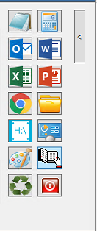

1

Fig 1: Remote Desktop shortcuts

1. Go to Reports Module
2. Go to Sales
3. Go to Sales by Salesperson
4. Change “Output” from “window” or “printer” to “File”

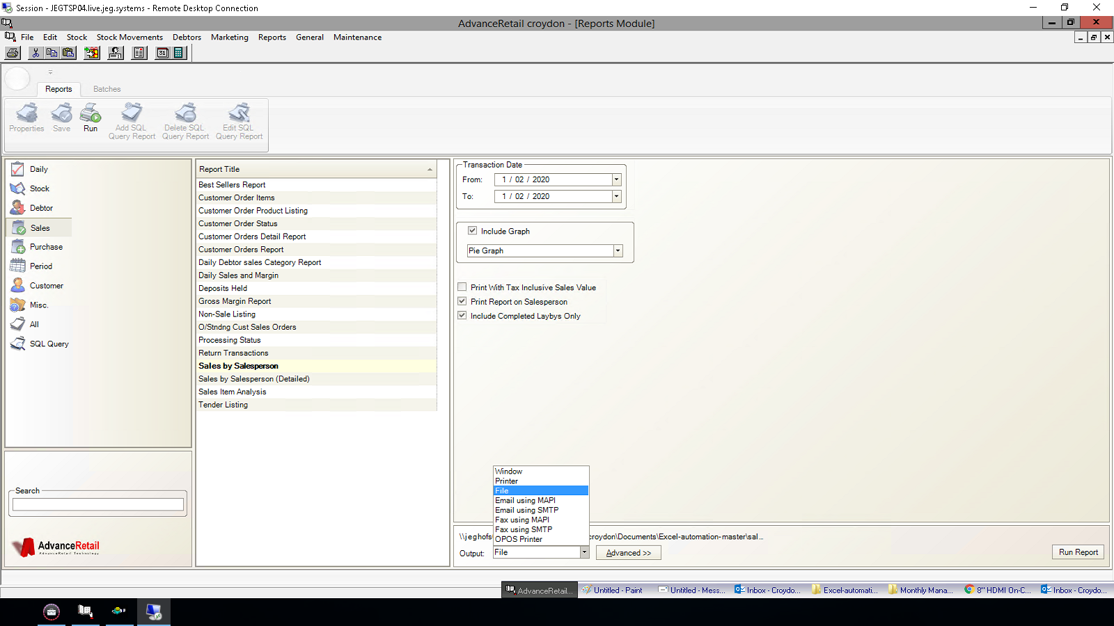Fig 2: Remote Desktop Back Office

2

3

4

5

1. In advanced:
   1. Change file type to “Excel” “.XLS”
   2. Change the save location to the folder containing “Auto-fill.xlsm”

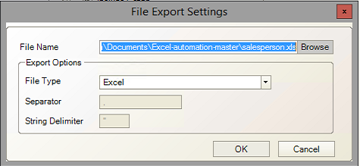

6.b

6.a

Fig 3: Advanced

1. Run the report.

7



Fig 4: Back office; run report

1. Open AutoFill.xlsm
2. Press “Refresh Friedman Names”. This will populate the “Friedman Name” column will all the regular staff at your store.

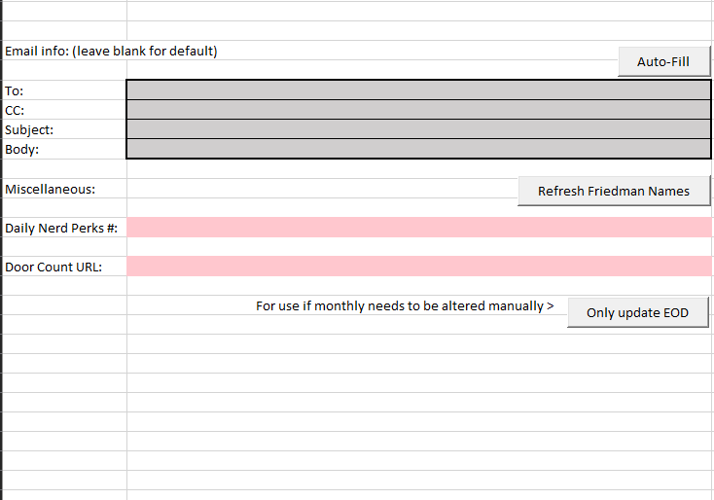

9

Fig: 5 AutoFill.xlsm

1. In “Salesperson name” fill in the corresponding name with the FULL salesperson name that appears in either Salesperson.xls or the F10 “change salesperson” window in the POS.

This is to allow you to keep having abbreviated names in Friedman.

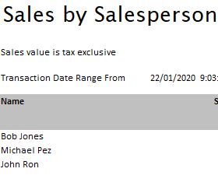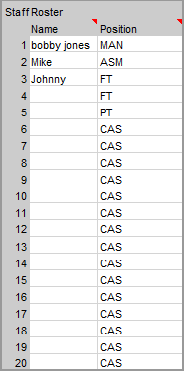

Fig 6: Monthly stats “Store Details” Fig 7: Salesperson.xls

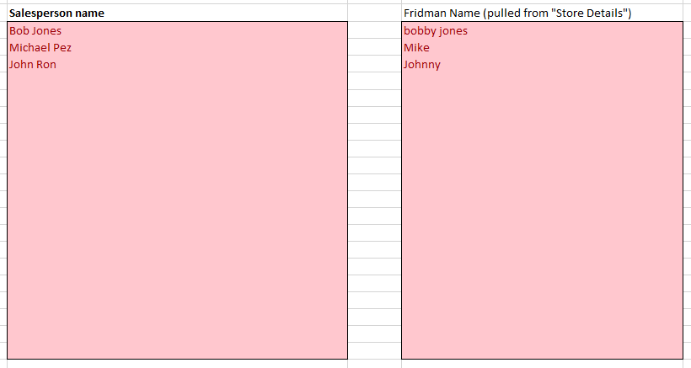

9

10 

Fig 8: AutoFill.xlsm

Fig 6: contains the current months staff. This will be directly copied over into “Friedman Name” (Fig 8) after pressing “Refresh Friedman Names”.

Fig 7: Are the actual staff names that the sales go under. Under “SalesPerson name” in Fig 8, the names need to be copied over exactly into their respective slots.

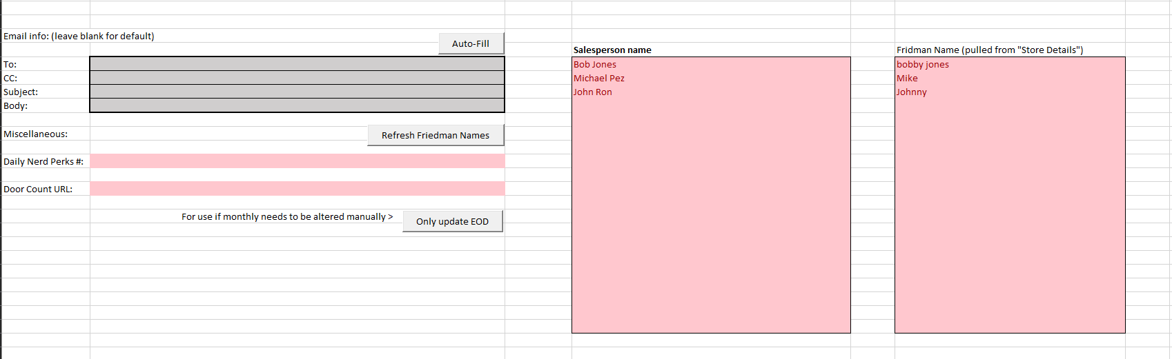This is to ensure that sales under “Bob Jones” still go under “Bob Jones” in the Friedman document despite the Friedman document using an Alias.

Fig 8: AutoFIll.xlsm

**End of setup.**

**After setup, at EOD:**

Now that the files and salesperson data has been established, you don’t have to do it again. Now at the EOD all you have to do is:

1. Open Back Office in Remote desktop; change date and run report. *(Must be done in desktop Back Office as regular Back Office can’t save the file.)*
2. Open “Auto-fill.xlsm”
3. Press “Auto-Fill”

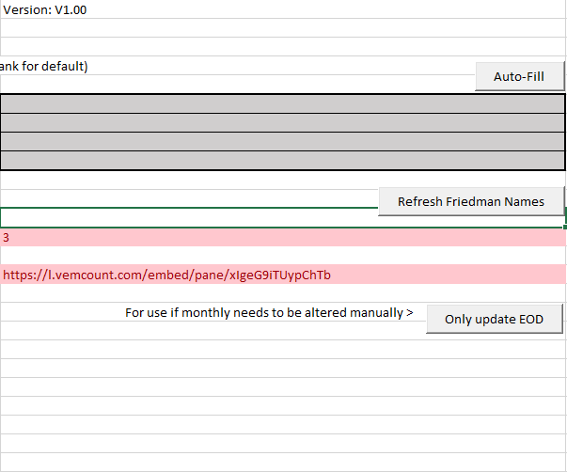

2

1. Wait
2. Send email to AM

**End of EOD:**

Features of AutoFill Workbook

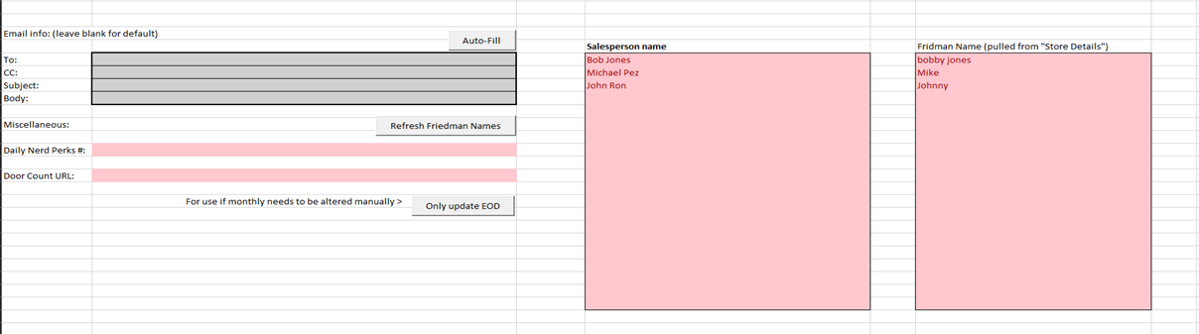

5

6

4

3

2

1

1. Email information: Type a custom message to override the default configurations.  
   - *To:* Leave blank for program to assume email address. Make sure “Area Manager” in “Store Details” has first and last name.

* *CC:* Blank normally. Add your own email to see how your store is going or for when the AM is on leave
* *Subject:* By default will format the message as “EOD Report <STORE NAME> <CURRENT DATE>” so e.g. EOD report Croydon 1/02/2020”
* *Body:* Blank by default. Add a custom message to be sent to the AM.

1. Auto-Fill: Automatically collects relevant information and places it in EOD report and monthly sales document.
2. Nerd Perks: Add todays nerd perks to be automatically added to EOD when “Auto-fill” is run.
3. Refresh Friedman Names: Automatically run when “Auto-Fill” is pressed but press it again if Staff Roster is updated.
4. Only update EOD: If something goes wrong with monthly stats and you have to fix it manually, run this to only update EOD document.
5. Door Count URL: Add the website URL of the door count to be added to Monthly document. (Not implemented atm)

Troubleshooting

*Email address is not correct:*

* Either add the area managers email address in “To:” of “Auto-fill.xlsm” or in “Store Details” or the monthly document. Change the area manager to the first and last name of the area manager.

*Message box stating SalesPerson date is incorrect*

* Check that the salesperson sheet is being saved to the correct folder and that back office is set to the right date

*Message box stating Monthly or EOD or Blank Monthly not found*

* Make sure:
  + Monthly is called: “Current Monthly Master Stats.xlsm”
  + EOD is called: “EOD report.xlsx”
* Make sure both files are in the same folder as “Auto-fill.xlsm”

*Message box stating Validation failed*

* Manually check that the correct people got the correct values in the monthly sheet
* Make sure “other store refunds” is filled in correctly if applicable.
* Make sure other casuals have the correct values if applicable.

*Message box stating Nerd Perks empty*

* Manually add nerd perks number

*Message box stating door Count empty*

* Manually add door count

*Salesperson going under “Other store refunds”*

* Make sure the salesperson’s name is exactly the same as what it appears in POS/salesperson sales sheet.