Jaycar End of Day Automation

V1.08

Table of contents

* Document version
* Introduction
* Features
* Instructions
  + Setup
  + At EOD
* Features of Autofill workbook
* Other features
* Troubleshooting
* Version changes

Document Version

|  |  |  |
| --- | --- | --- |
| Date | Version | Description |
| 31/01/2020 | V0.1 | Draft documentation |
| 1/02/2020 | V0.2 | Added images |
| 2/02/2020 | V0.3 | Added version changes |
| 3/02/2020 | V0.4 | Explained more features |

Introduction

**Notice:**

This software has not been officially approved or authorised by Jaycar nor the IT department; and as such, may contains bugs or issues. Whilst every attempt has been made to prevent this with verification and notifications, there is still the potential for error. Use at your own risk.

Features

Currently Implemented:

* Copies salesperson stats into correct date/under correct person in Friedman.
* Copies stats into EOD.
* Alerts if salesperson date is incorrect.
* Alerts if nerd perks/door count is empty.
* Alerts if sales go under “Other Store Refunds”.
* Keeps a backup of files for a week.
* Erases EOD document every Monday.
* Verifies that EOD/monthly document adds up to the correct amount.
* Uploads salesperson stats and EOD into a default email to send to area manager at EOD.
* At end of the month it also uploads the monthly document to the email.
* At end of month moves current monthly document moves into an archive folder and replaces it with a new blank document.
* Every Sunday, start week in Store Details is changed to the next Monday.

Instructions

**Setup:**

1. Copy the EOD excel document and Monthly stats document into the folder containing “Auto-fill.xlsm”
2. Rename EOD document to “EOD report.xlsx”
3. Rename Monthly document to “Current Monthly Stats.xlsm”
4. Open Back Office IN Remote Desktop

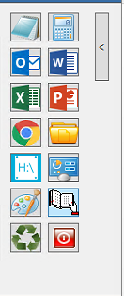

1

Fig 1: Remote Desktop shortcuts

1. Go to Reports Module
2. Go to Sales
3. Go to Sales by Salesperson
4. Change “Output” from “window” or “printer” to “File”

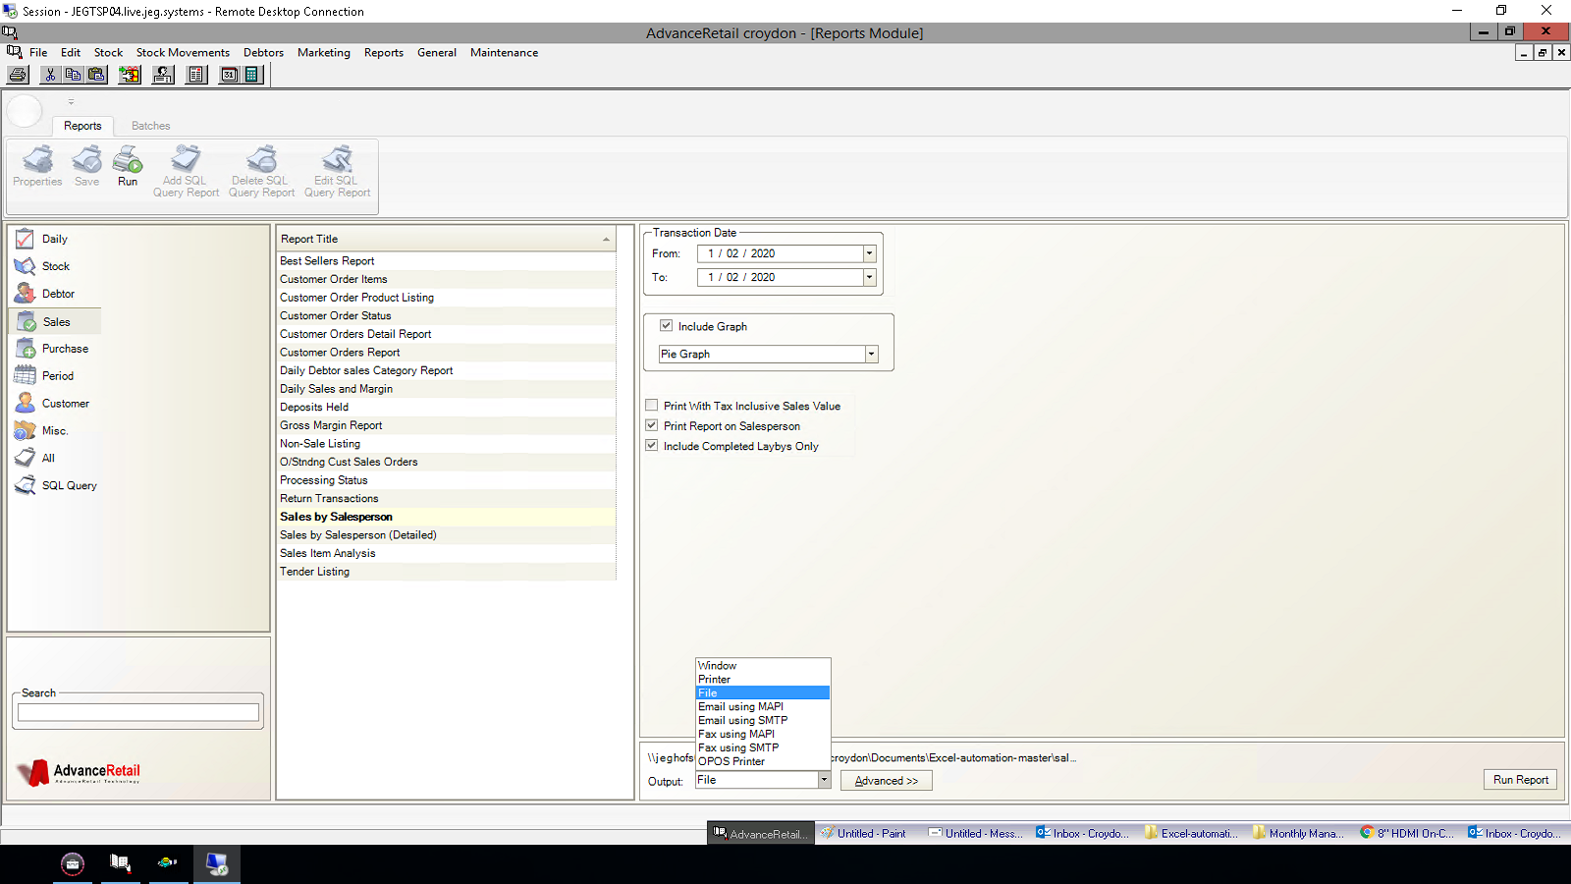Fig 2: Remote Desktop Back Office

2

3

4

5

1. In advanced:
   1. Change file type to “Excel” “.XLS”
   2. Change the save location to the folder containing “Auto-fill.xlsm”

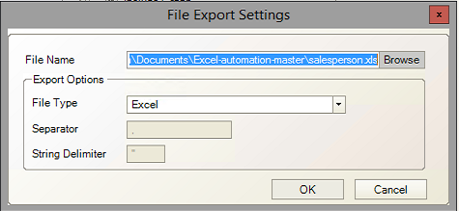

6.b

6.a

Fig 3: Advanced

1. Run the report.

7



Fig 4: Back office; run report

1. Open AutoFill.xlsm
2. Press “Refresh Friedman Names”. This will populate the “Friedman Name” column will all the regular staff at your store.

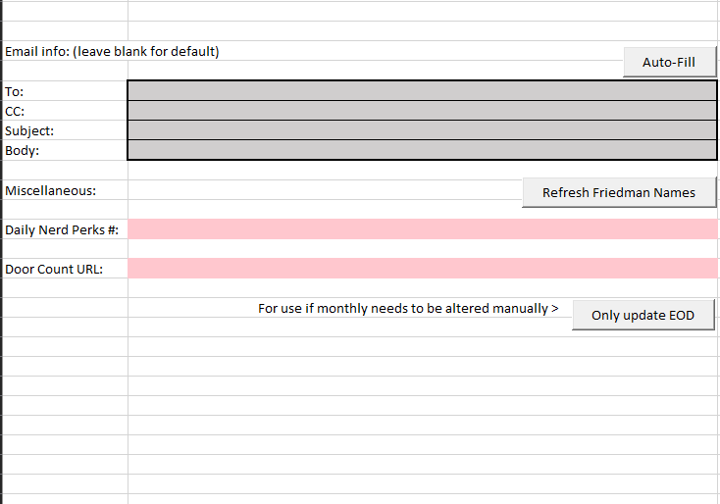

9

Fig: 5 AutoFill.xlsm

1. In “Salesperson name” fill in the corresponding name with the FULL salesperson name that appears in either Salesperson.xls or the F10 “change salesperson” window in the POS.

This is to allow you to keep having abbreviated names in Friedman.

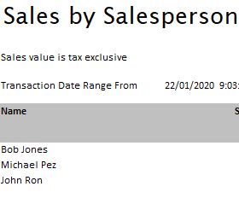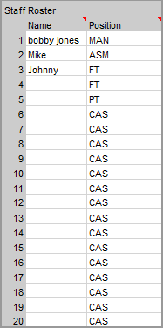

Fig 6: Monthly stats “Store Details” Fig 7: Salesperson.xls

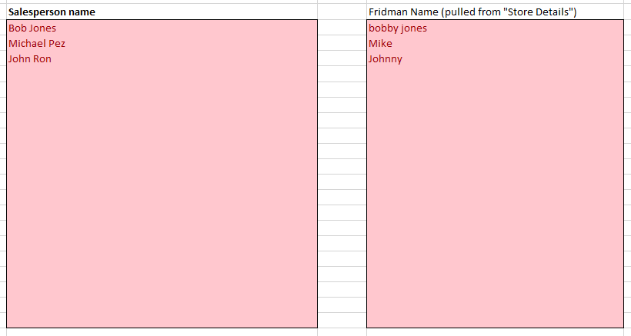

9

10 

Fig 8: AutoFill.xlsm

Fig 6: contains the current months staff. This will be directly copied over into “Friedman Name” (Fig 8) after pressing “Refresh Friedman Names”.

Fig 7: Are the actual staff names that the sales go under. Under “SalesPerson name” in Fig 8, the names need to be copied over exactly into their respective slots.

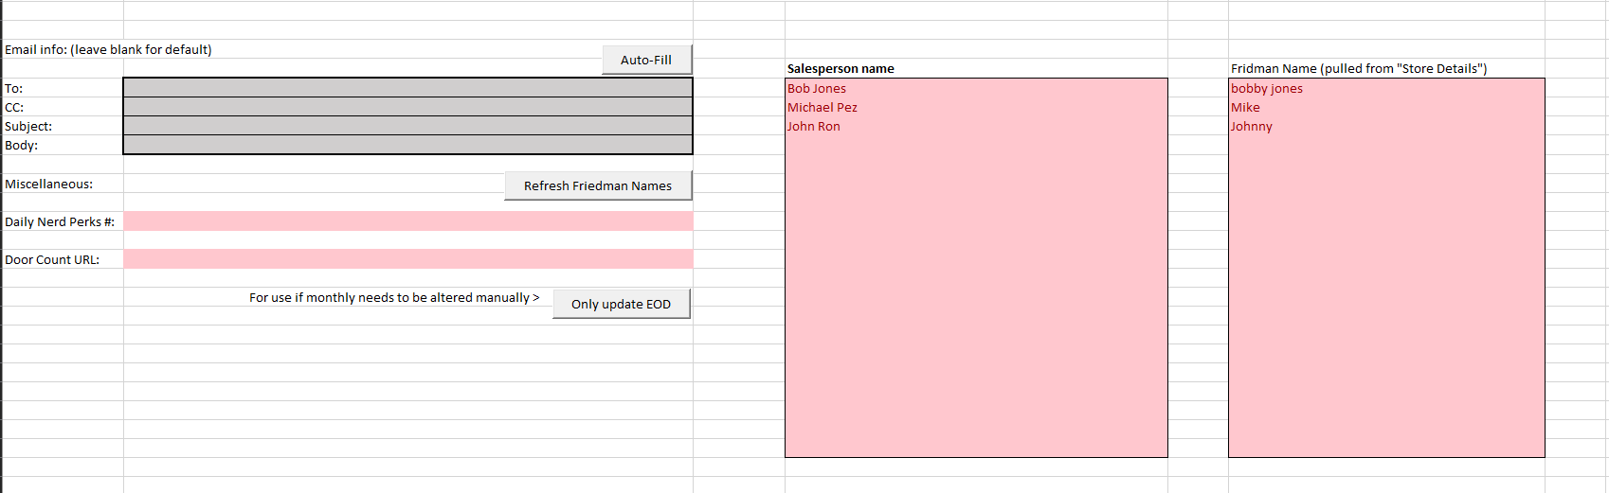This is to ensure that sales under “Bob Jones” still go under “Bob Jones” in the Friedman document despite the Friedman document using an Alias.

Fig 8: AutoFIll.xlsm

**End of setup Part 1.**

**Part 2:**

In “Blank documents” place in the blank monthly master stats. Rename the file to “Blank Monthly Master Stats.xlsm”

At the end of the month, this will be used to replace the “Current Monthly master Stats.xlsm” with a fresh document.

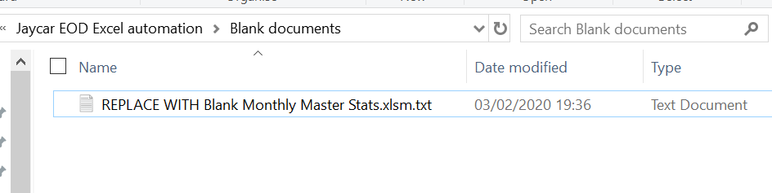

Fig 9: Before replacing

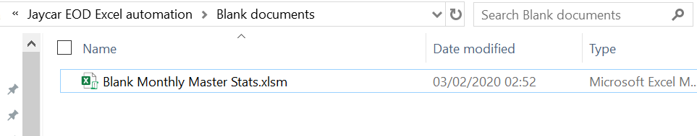

Fig 10: After replacing

**NOTE:** When a new version of Monthly Stats is released. Replace the “Blank Monthly Master Stats.xlsm” with that, ensuring to change the name as well. There is no guarantee the code will still operate correctly but it’s unlikely that the new versions will affect the code but ideally, double check everything is going into the correct places for the first day.

**After setup, at EOD:**

Now that the files and salesperson data has been established, you don’t have to do it again. Now at the EOD all you have to do is:

1. Open Back Office in Remote desktop; change date and run report. *(Must be done in desktop Back Office as regular Back Office can’t save the file.)*
2. Open “Auto-fill.xlsm”
3. Press “Auto-Fill”

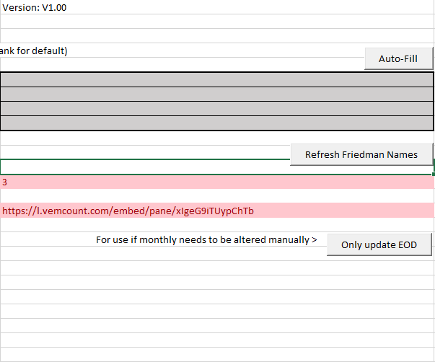

2

Fig 11: Autofill daily use

1. Wait
2. Send email to AM

**End of EOD:**

Features of AutoFill Workbook

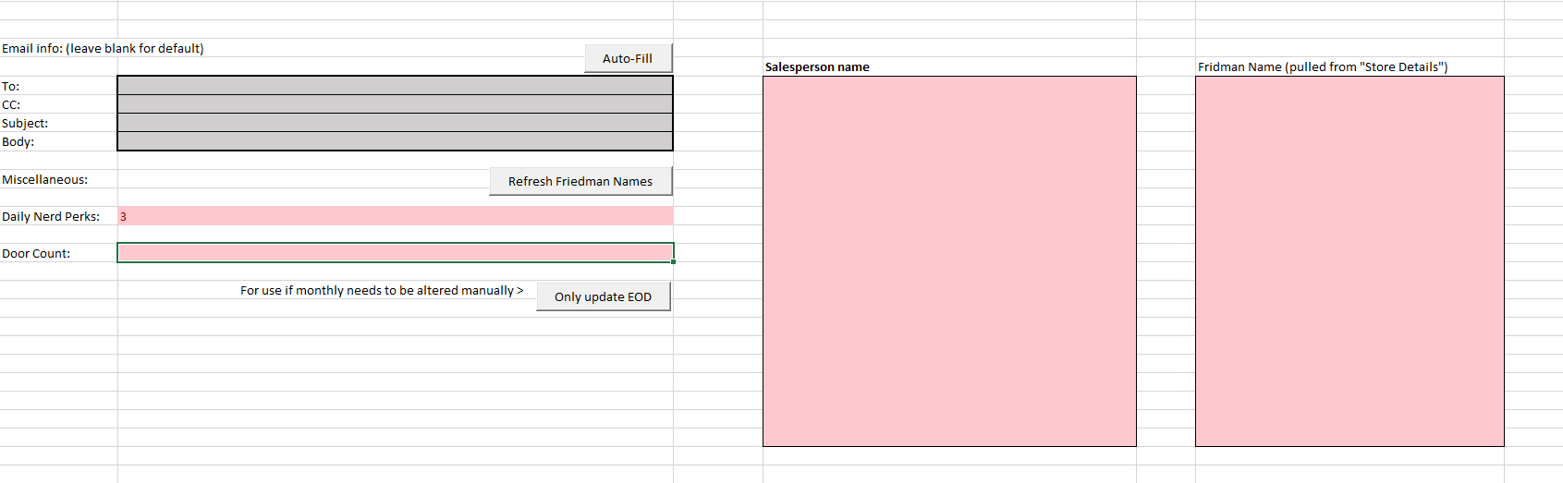

7

8

5

6

4

3

2

1

Fig 12: whole Autofill guide

1. Email information: Type a custom message to override the default configurations.  
   - *To:* Leave blank for program to assume email address. Make sure “Area Manager” in “Store Details” has first and last name.

* *CC:* Blank normally. Add your own email to see how your store is going or for when the AM is on leave
* *Subject:* By default, will format the message as “EOD Report <STORE NAME> <CURRENT DATE>” so e.g. EOD report Croydon 1/02/2020”
* *Body:* Blank by default. Add a custom message to be sent to the AM.

1. Auto-fill: Automatically collects relevant information and places it in EOD report and monthly sales document.
2. Nerd Perks: Add todays nerd perks to be automatically added to EOD when “Auto-fill” is run.
3. Refresh Friedman Names: Automatically run when “Auto-Fill” is pressed but press it again if Staff Roster is updated.
4. Only update EOD: If something goes wrong with monthly stats and you have to fix it manually, run this to only update EOD document.
5. Door Count: Type in today’s door count.
6. Salesperson Names: Insert the *Full* salesperson name here. Can be found using the “F10” change salesperson menu in POS or through the salesperson data found in Back Office.
7. Friedman name: Is automatically populated when **#4** (Refresh Friedman Names)is pressed. **Note:** This can not be edited through the autofill document.

Other features

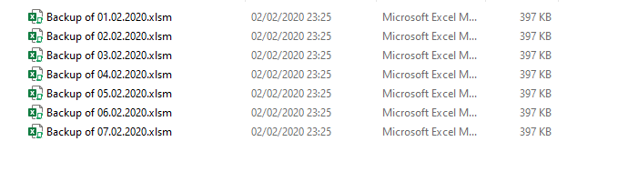

Fig 13: Backup Feature

When “Auto-Fill” is pressed, a backup is created and put in the “Backup” folder. If this is the first time, the folder will be created.

**NOTE:** Anything in this folder will be deleted after 7 days.

**END of MONTH:**

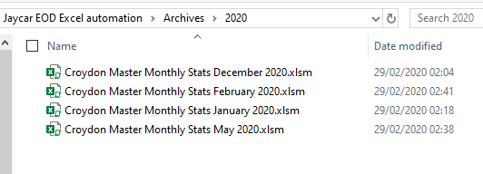

Fig 14: e.g. Archive

* On the last day of the month, the program will automatically save “Current Monthly Master Stats.xlsm” into the respective archival folder, under the correct year. The name will be changed to the stores name, the date set in the monthly report’s “Store Details”.
* This will then be uploaded in the email being sent to the Area Manager, along with the usual EOD report and salesperson data.
* The Staff Roster and Area Managers name are copied over into the new blank current monthly stats.

**EOD REPORT:**

When autofill is finished processing, it’ll automatically change the name of “EOD Report.xlsm” to “<YOUR STORE NAME> EOD Report.xlsm”

START DATE:

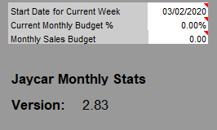

Fig 15:

The program will automatically change the start week to the next week’s Monday when a new week occurs or on the Sunday of the current week.



Fig 16:

*Version:* The current version of the software. Use to know if you have the latest version.

*Monthly Stats Compatibility Version:* Shows the latest version of the Monthly Stats that was tested working.

Troubleshooting

*Email address is not correct:*

* Either add the area managers email address in “To:” of “Auto-fill.xlsm” or in “Store Details” or the monthly document. Change the area manager to the first and last name of the area manager.

*Message box stating Salesperson date is incorrect*

* Check that the salesperson sheet is being saved to the correct folder and that back office is set to the right date

*Message box stating Monthly or EOD or Blank Monthly not found*

* Make sure:
  + Monthly is called: “Current Monthly Master Stats.xlsm”
  + EOD is called: “EOD report.xlsx”
* Make sure both files are in the same folder as “Auto-fill.xlsm”

*Message box stating Validation failed*

* Manually check that the correct people got the correct values in the monthly sheet
* Make sure “other store refunds” is filled in correctly if applicable.
* Make sure other casuals have the correct values if applicable.

*Message box stating Nerd Perks empty*

* Manually add nerd perks number

*Message box stating door Count empty*

* Manually add door count

*Salesperson going under “Other store refunds”*

* Make sure the salesperson’s name is **exactly** the same as what it appears in POS/salesperson sales sheet.

Version changes

*V1.00: (31/01/2020)*

* First release.

*V1.01: (01/02/2020)*

* Updated autofill to accept Door count.
* Fix bug where workbooks would be reopened every time “Auto-Fill” was pressed.

*V1.02: (02/02/2020)*

* Speed optimisations.
* Files in “Backup” are now deleted after seven days.
* Fixed a significant bug.
* At end of month, current document is sent to an archive and replaced with a new one.

*V1.03: (03/02/2020)*

* Changed EOD filename to include store name. I.E. <STORENAME> EOD Report.xlsm

*V1.04: (03/02/2020)*

* Fixed bug where you’d still be given a message about Nerd Perks spot being empty.
* Current Staff Roster and Area managers name will be copied over to the blank document at end of month
* Code will automatically change Week start over to next week on either new week or Sundays.

*V1.05:* (04/02/2020)

* Fixed bug where door count would be lost if monthly wasn’t manually saved after pressing autofill
* Every Sunday, monthly stats are saved as “<STORE NAME> Master Monthly Stats <MONTH> <YEAR>” and uploaded as a separate email.

*V1.06:* (11/03/2020)

* Changed name so that “Monthly Master Stats” is now just “Monthly Stats”
* Added code so that major sales would be automated, along with past monthly major sales.

*V1.07:* (17/03/2020)

* Added past years major sales button.
* Fixed End of Month routine so that it saves with the correct name.

V1.07a-c: (19-20/03/2020)

* Fixed bug where major sales button wouldn’t include decimal values.
* Changed formatting of major sales description to lower case.
* Fixed bug where EOD report would show up daily.
* Added compensation for back office major sales unpredictable date formatting.

*V1.08* (22/03/2020):

* Added feature where at end of month the last days of the friedman stats will be copied over into the new current friedman stats to fill in the days from the Monday to the first day of the new month.

*V1.10* (5/04/2020):

* Code optimisations
* Added backup and notifications to end of month
* Door count is wiped at file closure
* Email files wiped after 7 days

V1.14 (6/04/2020):

* Bug fixes
* Finalised VBA side door count
* Added fault tolerance in case salesperson data is saved to the default location