Brief Summary of Final Project Results
Project 12: Data-driven method application for PDE identification and dynamic prediction using PDEBench data
Team: Balakin Egor; Prochukhan Daria; Ismailov Magomedrashad; Egorov Vitaliy. Repository: https://github.com/Nojatij/data_driven_project

Project title
Data-driven method application for PDE identification and dynamic prediction using PDEBench data.

Project team
- Balakin Egor - core code, experiment pipeline, HDF5 loading, and DMD implementation.
- Prochukhan Daria - source synthesis, visualization narrative, and final presentation structure.
- Ismailov Magomedrashad - mathematical formulation, SINDy/PDE-FIND candidate library, and coefficient interpretation.
- Egorov Vitaliy - baseline evaluation, metric design, runtime comparison, and result tables.

Background and objective
The project was not treated as a direct reproduction of one paper. Instead, PDEBench was used as a controlled source of PDE simulation data for testing several data-driven approaches on the same spatiotemporal fields. The work covers the required pipeline: data parsing and visualization, dynamic prediction with Dynamic Mode Decomposition (DMD), sparse PDE identification with SINDy/PDE-FIND, comparison with a compact machine-learning baseline inspired by Fourier Neural Operators, and evaluation by accuracy and runtime metrics.
Two one-dimensional PDEBench datasets were used. The main case is Burgers' equation with nu = 0.01, where the expected structure is u_t = -u u_x + nu u_xx. The secondary case is linear advection with beta = 0.4, where the expected structure is u_t = -beta u_x. The original HDF5 tensors have shape 10000 x 201 x 1024. To keep the experiment reproducible on an ordinary computer, the notebook uses 64 samples and spatial stride 4, giving a working tensor of 64 x 201 x 256 for each PDE.

Methods and experimental design
The data are read from HDF5 using the PDEBench keys tensor, x-coordinate, and t-coordinate. The time axis is split into training and forecast intervals with train_fraction = 0.65. Four methods are compared: a persistence baseline, rank-24 DMD, PDE-FIND/SINDy, and a compact FNO-style neural model. The persistence baseline repeats the last training state and is included to make the prediction task non-trivial.
DMD fits a low-rank linear evolution operator between consecutive snapshots. It is expected to work especially well for linear transport because the dynamics are close to a translation operator. PDE-FIND/SINDy estimates u_t and spatial derivatives by finite differences, builds a candidate library {1, u, u^2, u^3, u_x, u_xx, u_xxx, u u_x, u u_xx, u^2 u_x}, and solves a sparse regression problem. The neural baseline uses spectral convolution in Fourier space, one-step autoregressive training, 16 Fourier modes, width 48, and 20 epochs. This is intentionally smaller than the full official PDEBench baselines, but it provides a fair local ML comparison.
Metrics include RMSE, normalized RMSE (nRMSE), MAE, MAPE with epsilon stabilization, maximum error, boundary RMSE, conserved-value RMSE, Fourier low/mid/high frequency errors, and training/prediction time. The discussion below focuses on nRMSE, RMSE, MAE, and total runtime because these are the most transparent for a short final report.

Result summary
The main numerical result is that the best method depends on the PDE type. DMD is the strongest method on the linear advection case, while the compact FNO-style model gives the lowest nRMSE on the nonlinear Burgers case. PDE-FIND/SINDy is most valuable as an equation-identification tool: it recovers the physically important terms, but its explicit rollout is less stable than DMD or the neural baseline.
Table 1. Forecast accuracy and runtime on the selected PDEBench subsets.
Dataset | Method | RMSE | nRMSE | MAE | Total time, s
Advection beta=0.4 | DMD | 0.0211 | 0.0300 | 0.00663 | 0.477
Advection beta=0.4 | FNO-style ML | 0.5738 | 0.8165 | 0.2617 | 18.510
Advection beta=0.4 | Persistence | 0.6542 | 0.9308 | 0.4511 | 0.000
Advection beta=0.4 | PDE-FIND/SINDy | 1.6539 | 2.3532 | 1.0207 | 2.957
Burgers nu=0.01 | FNO-style ML | 0.0593 | 0.1111 | 0.0371 | 18.669
Burgers nu=0.01 | DMD | 0.0737 | 0.1379 | 0.0458 | 0.464
Burgers nu=0.01 | Persistence | 0.0910 | 0.1703 | 0.0518 | 0.000
Burgers nu=0.01 | PDE-FIND/SINDy | 0.3915 | 0.7328 | 0.0829 | 3.035
For advection, DMD reaches nRMSE = 0.030 in less than half a second, which is consistent with the fact that the equation describes a linear transport process. The neural baseline is much slower and less accurate here, most likely because a compact one-step model trained for only 20 epochs is not competitive with the nearly exact linear structure captured by DMD. For Burgers, the FNO-style model is best (nRMSE = 0.111), while DMD remains close (nRMSE = 0.138) and much faster. This reflects the trade-off between nonlinear approximation power and computational cost.
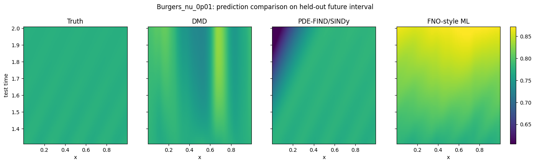
Figure 1. Burgers forecast comparison on the held-out interval: ground truth, DMD, PDE-FIND/SINDy, and compact FNO-style baseline.
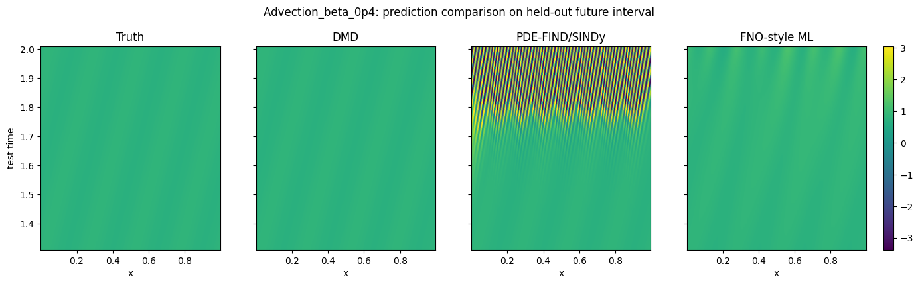
Figure 2. Advection forecast comparison on the held-out interval. DMD follows the linear transport dynamics most closely.

PDE identification
The PDE-FIND/SINDy coefficients should be interpreted separately from the rollout errors. The sparse regression step recovers the expected advection term almost exactly: the coefficient of u_x is -0.400047 versus the theoretical -0.4. For Burgers, the main nonlinear convection term u u_x is also recovered with the correct sign and close magnitude (-0.928976 versus -1.0). The diffusion coefficient u_xx is identified as 0.003553 instead of 0.01, indicating that this term is more sensitive to spatial downsampling, finite-difference error, and thresholding.
Table 2. Main physically expected PDE-FIND/SINDy coefficients.
Dataset | Term | Expected | Identified | Interpretation
Advection beta=0.4 | u_x | -0.400000 | -0.400047 | Recovered almost exactly
Burgers nu=0.01 | u u_x | -1.000000 | -0.928976 | Correct sign and close magnitude
Burgers nu=0.01 | u_xx | +0.010000 | +0.003553 | Correct sign, underestimated magnitude

Conclusion and limitations
The project goals were achieved: the notebook parses PDEBench HDF5 files, visualizes the data, implements DMD prediction, applies PDE-FIND/SINDy for interpretable PDE recovery, trains a compact FNO-style baseline, and compares all methods using accuracy and runtime. The results show a clear pattern rather than a single universal winner. DMD is extremely efficient and strong for linear transport; the neural baseline is more useful for the nonlinear Burgers dynamics; and SINDy/PDE-FIND gives the clearest physical interpretation but requires careful numerical differentiation and more stable integration for long rollouts.
The main limitation is that the experiment uses a manageable subset and a compact neural baseline rather than the full official PDEBench training setup. This was a deliberate design choice: the final code is lightweight enough for local execution while still satisfying the methodological requirements of the project. The most direct improvements would be a derivative-smoothing study for PDE-FIND, a more stable rollout integrator, hyperparameter sweeps for the sparse threshold and DMD rank, and comparison with the official pretrained PDEBench baselines when available.

Deliverables
- Executable notebook: notebooks/PDEBench_DMD_SINDy_Project.ipynb
- Generated outputs: results/metrics_table.csv, results/pdefind_coefficients.csv, results/final_summary.md, and figures after running the notebook.
- Repository: https://github.com/Nojatij/data_driven_project

References
[1] Makoto Takamoto, Timothy Praditia, Raphael Leiteritz, Dan MacKinlay, Francesco Alesiani, Dirk Pfluger, and Mathias Niepert. PDEBENCH: An Extensive Benchmark for Scientific Machine Learning. NeurIPS 2022 Datasets and Benchmarks Track / arXiv:2210.07182. https://arxiv.org/abs/2210.07182
[2] PDEBench GitHub repository. Code, data utilities, and baseline training/evaluation scripts. https://github.com/pdebench/PDEBench
[3] Makoto Takamoto et al. PDEBench Datasets. DaRUS, version 8.0, doi:10.18419/DARUS-2986. https://darus.uni-stuttgart.de/dataset.xhtml?persistentId=doi:10.18419/DARUS-2986
[4] Peter J. Schmid. Dynamic mode decomposition of numerical and experimental data. Journal of Fluid Mechanics, 656, 5-28, 2010. https://doi.org/10.1017/S0022112010001217
[5] Steven L. Brunton, Joshua L. Proctor, and J. Nathan Kutz. Discovering governing equations from data: Sparse identification of nonlinear dynamical systems. PNAS, 113(15), 3932-3937, 2016. https://doi.org/10.1073/pnas.1517384113
[6] Samuel H. Rudy, Steven L. Brunton, Joshua L. Proctor, and J. Nathan Kutz. Data-driven discovery of partial differential equations. Science Advances, 3(4), e1602614, 2017. https://doi.org/10.1126/sciadv.1602614
[7] Zongyi Li, Nikola Kovachki, Kamyar Azizzadenesheli, Burigede Liu, Kaushik Bhattacharya, Andrew Stuart, and Anima Anandkumar. Fourier Neural Operator for Parametric Partial Differential Equations. arXiv:2010.08895. https://arxiv.org/abs/2010.08895
[8] Project repository submitted for this work. https://github.com/Nojatij/data_driven_project

