**Nokuvimba Natalie**

**Lab4**

1. Return all actors whose last names are ALLEN from the actor table.

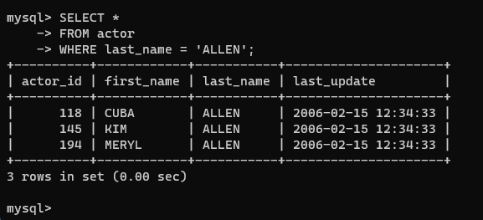

2. Return all the actors who’s last_name column has a value DAVIS, and the row’s first_name has a value SUSAN.

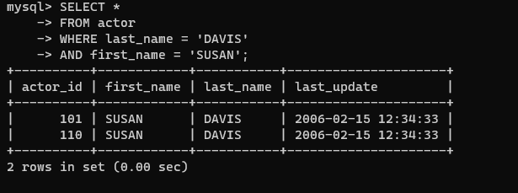

3. Return all actors where last_name column has a value ALLEN or DAVIS.

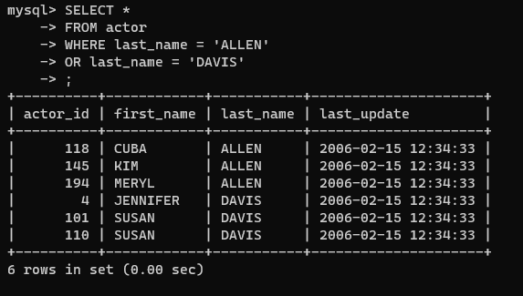

4. Return the number of categories which have a name that does not start with the letter A.

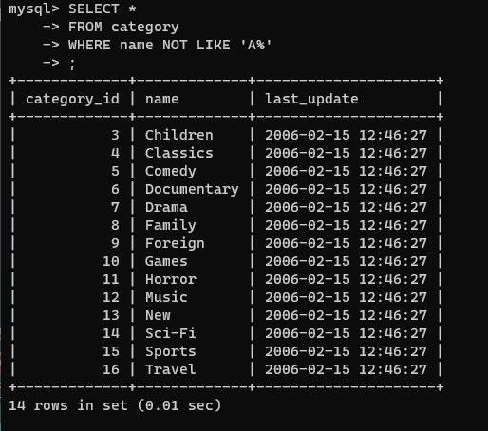

5. Return all actor names and the name of each film title they were in.

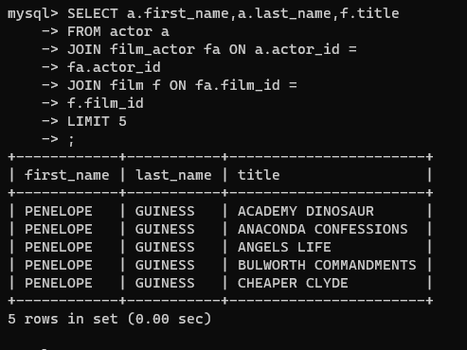

6. Return the title, release year, and category of all movies.

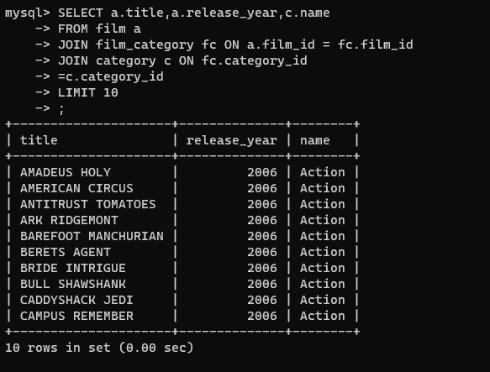

7. Return how much JOHNNY TURPIN has spent on movie rentals.

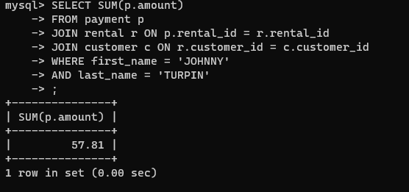

8. Return the name of the customer that has spent the most of movie rentals, include the amount they have spent.

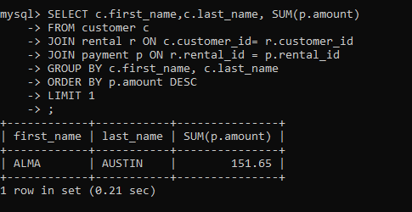

9. Return all movie title, release year, actor name and category where the actor first_name is ‘Sean’

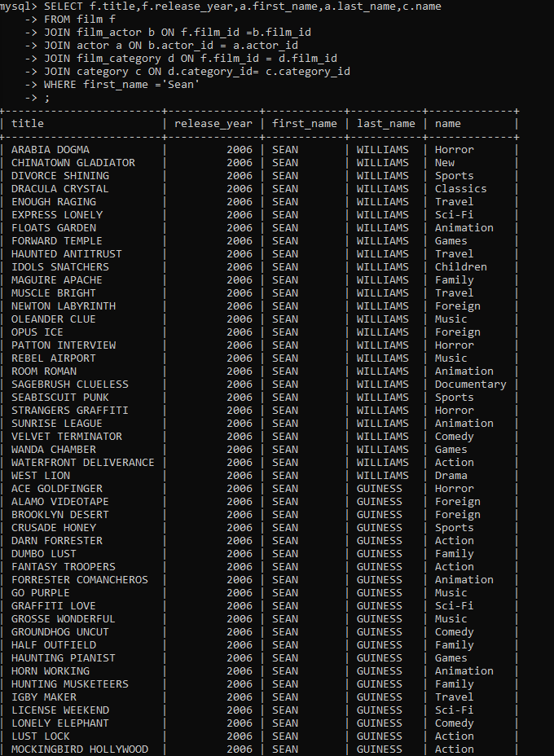

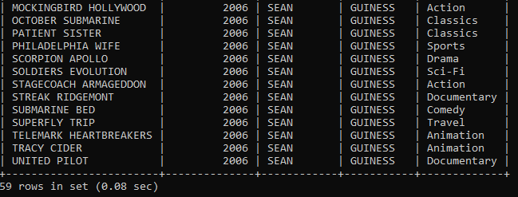

=10. Explore the database and create ten more challenging SQL statement, something different to the above. (Just Select, no create, update or delete statements)

1. Return all customer names that spent on rentals with a limit of 10.

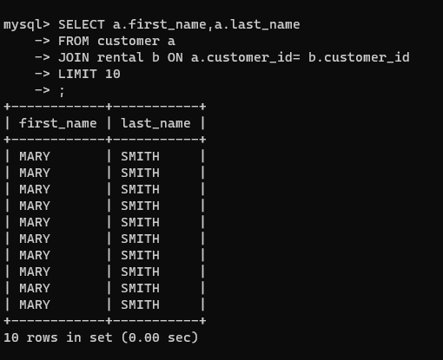

1. Return the country, city and Address of Mary Smith

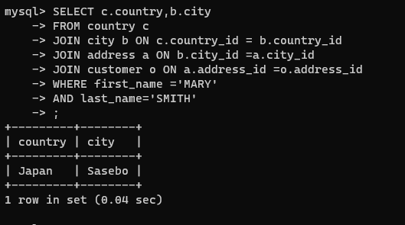

1. Return the name of the customers that spent their expenses on rentals in Zimbabwe 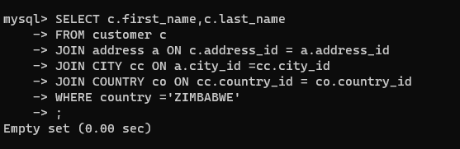
2. Return the name of staff, the store id and address where the highest payment on rentals was made.

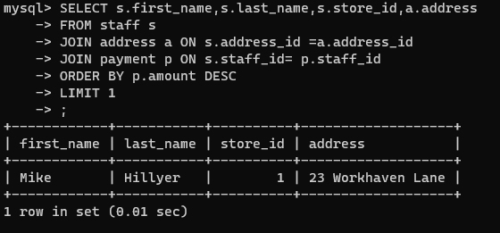

1. State the first 5 titles of the films and with the highest rental payment amount.

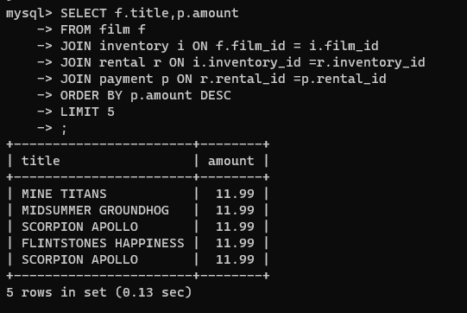

1. Return 10 names of the staff whose first_name starts with A.

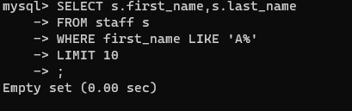

1. Return 5 names of customers that spent their expenses on rentals, and the title of the film they spent on.

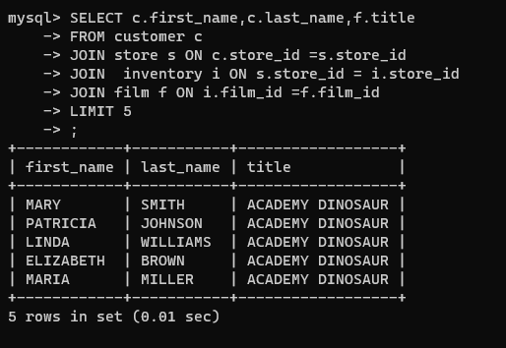

1. Return 15 countries and their cities

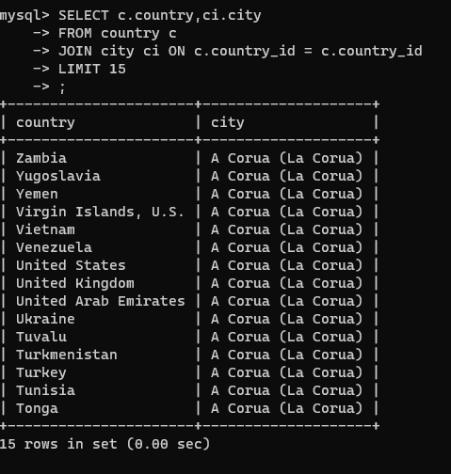

1. Return at least 20 languages used in the films



j.Return the name of customer, title of film and the last update made on the film.

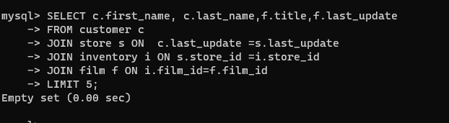

k. Return names of the staff.

