**Nokuvimba Natalie**

**Lab5**

1. Creating a database



2. Creating tables

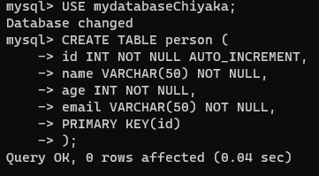

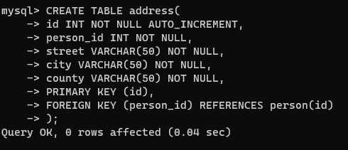

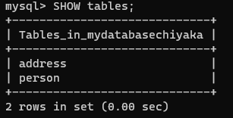

3. Write an sql statement to select all the people details from the person and address table where county is “Somecounty”.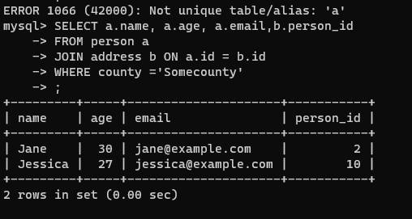

4. How to update a table

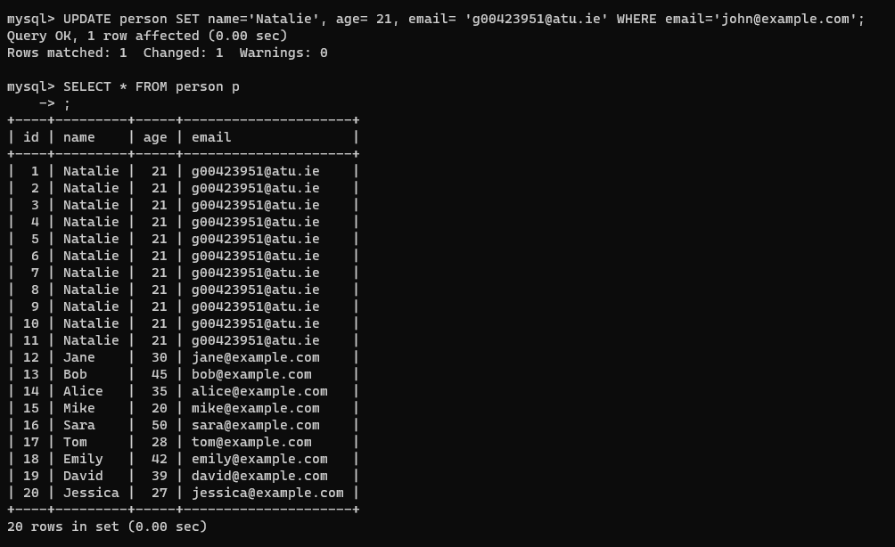

5. Using Transactions

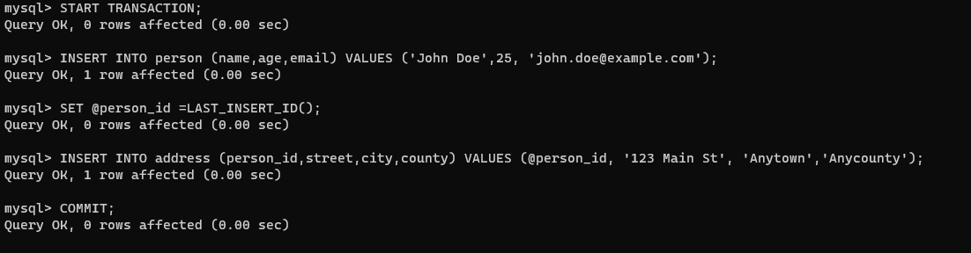

6. Deleting data

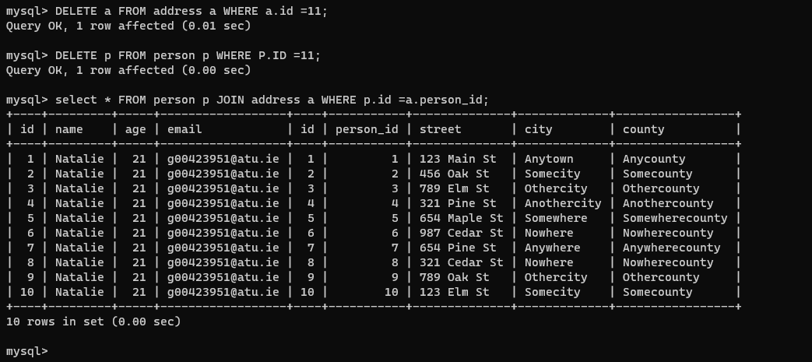

7. Using MySQL Workbench. To back up my database

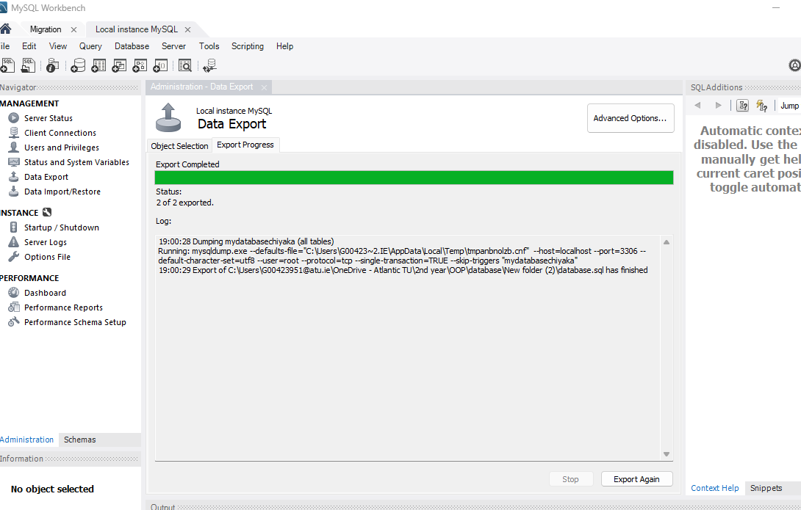

8.Importing saved database:

