New York University - Shanghai Probability and Statistics
Problem set 2: Probabilities MATH-SHU 235
Fall 2025

Exercise 1. Problem 2.1.

Exercise 2. Problem 2.2.
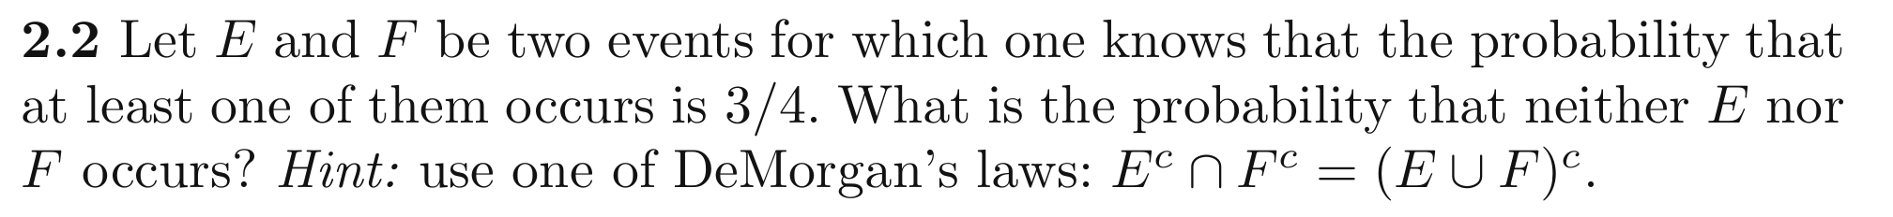

Exercise 3. Problem 2.3.

Exercise 4. Problem 2.5.
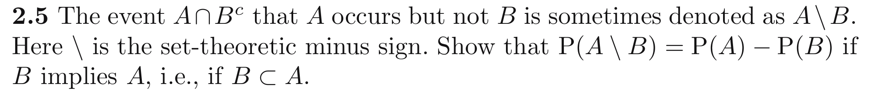

Exercise 5. Problem 2.6.
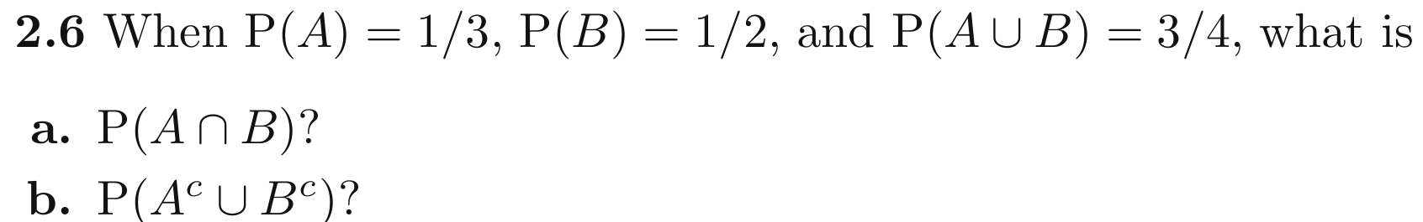

Exercise 6. Problem 2.7.

Exercise 7. Problem 2.15.
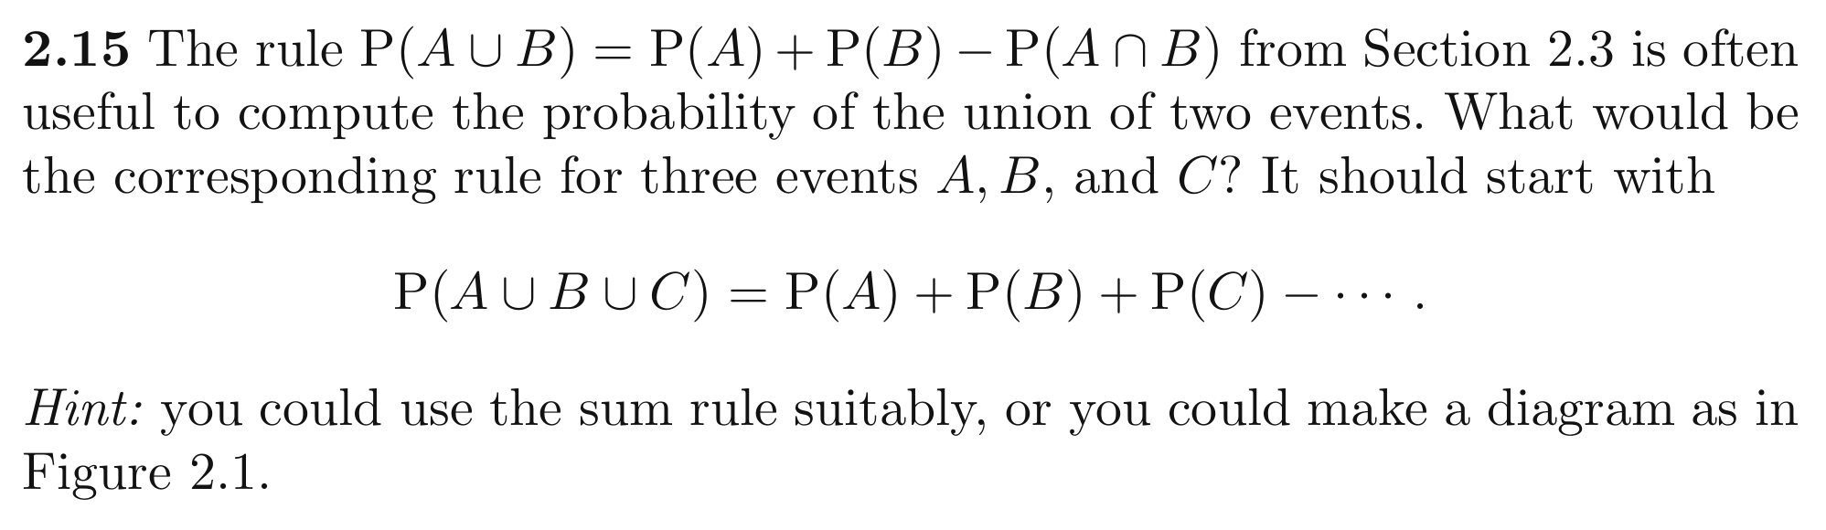

Exercise 8. Problem 2.18.
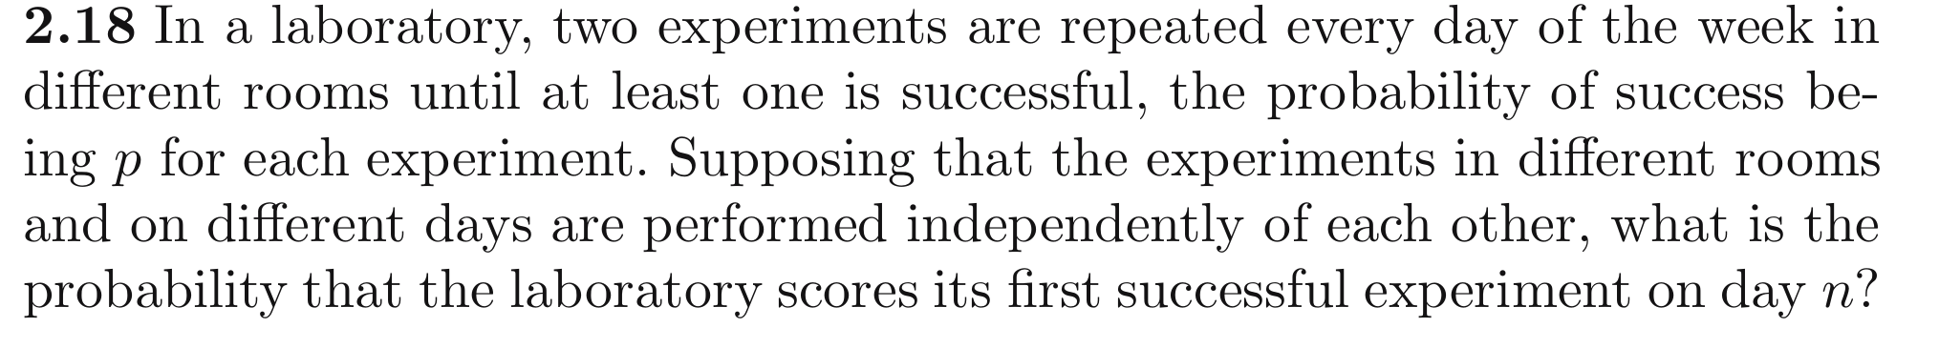

Exercise 9. Problem 2.19.
