New York University - Shanghai Probability and Statistics
Problem set 1: Sample spaces. Events MATH-SHU 235
Fall 2025

In this and subsequent homework sets, problem numbers refer to those of the textbook A Modern Introduction to Probability and Statistics by Dekking, Kraaikamp, Lopuhaa and Meester.

Exercise 1. Do problem 2.9.
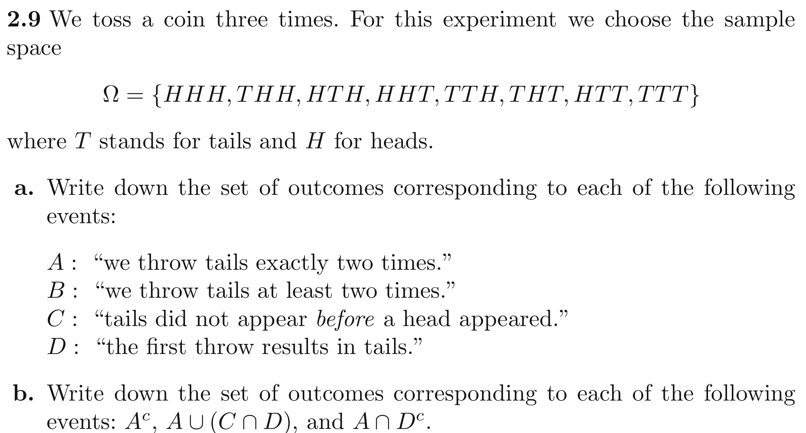

Exercise 2. Do problem 2.10.
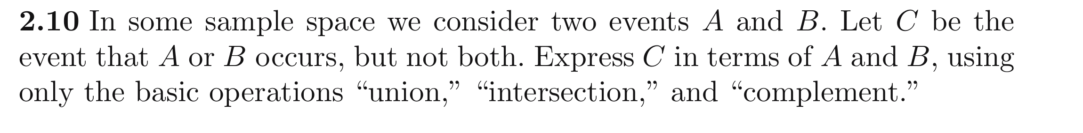

Exercise 3. Do problem 2.17.
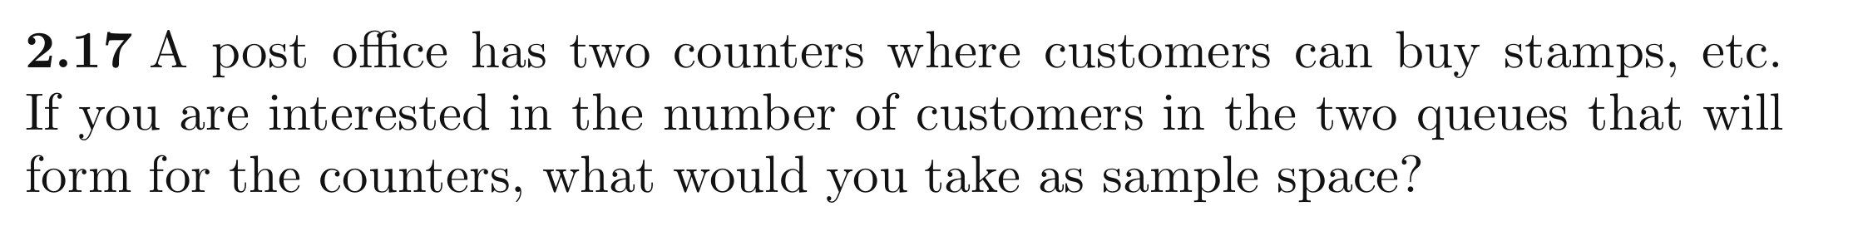

Exercise 4. Determine the sample space for the following experiments:
- Flip two coins.

- Flip a coin twice.

- Flip a coin and throw a die.

- A monkey types a letter per second during a minute.

- Height of one person.

- Height and weight of a person.

- Height of a sample of 45 persons.

- Height and weight of a sample of 45 persons.

Exercise 5. A roulette is turned 5 times. Let B_{n}, n =1,...5, be the event that the n-th turn results in an odd number. Write the following events in terms of the B_{n}’s, using unions, intersections and complements:
- Odd numbers appear at the 2nd and 4th turns.

- Odd numbers appear only at the 2nd and 4th turns.

- The first odd number appears at the 3rd turn.

- The last odd number appears at the 3rd turn.

Exercise 6. A die is thrown 100 times.
- Determine the sample space.

- Let A_{n} be the event that the number 6 comes out for the first time at the n-th throw. Write the following events in terms of the A_{n}’s, using unions, intersections and complements:
  - A 6 eventually comes out.
  - No throw produces a 6.

- Let B_{k} be the event that the number 6 comes out at the k-th attempt. Write A_{n} in terms of the
B_{k}’s.

