Java-QAP3

- How many hours did it take you to complete this assessment?
Problem 1: 45 minutes
Problem 2: 45 minutes
Problem 3: 1 hour
Problem 4: 30 minutes
Total: 3-4 hours

- What online resources did you use?
All that was needed were the occasional google search to verify my understanding.

- Did you get help from any classmates?
I did not require help from classmates.

- Did you ask for help from an instructor?
I did not require help from an instructor.

- Rate the difficulty of each problem and your confidence in solving similar problems in the future.
I felt strong in my understanding of the concepts used in this assessment. It was a great review of the topics done so far. I feel confident in solving problems similar to these in the future.

Output Photos
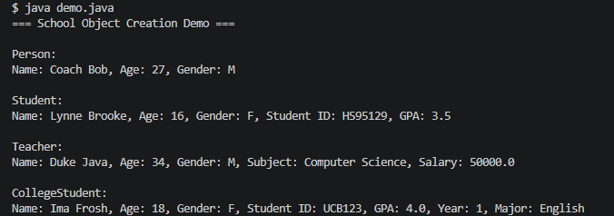
1.

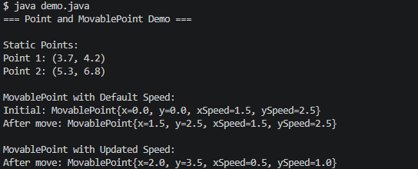
2.

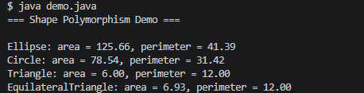
3.

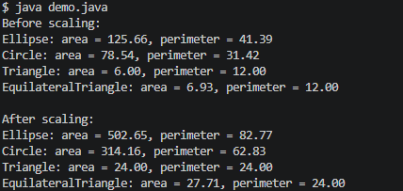
4.

