Group 17 Design Record

## Benjamin Lokanc, Nolan Litwin, Benjamin Krett

**RTL Schematic:**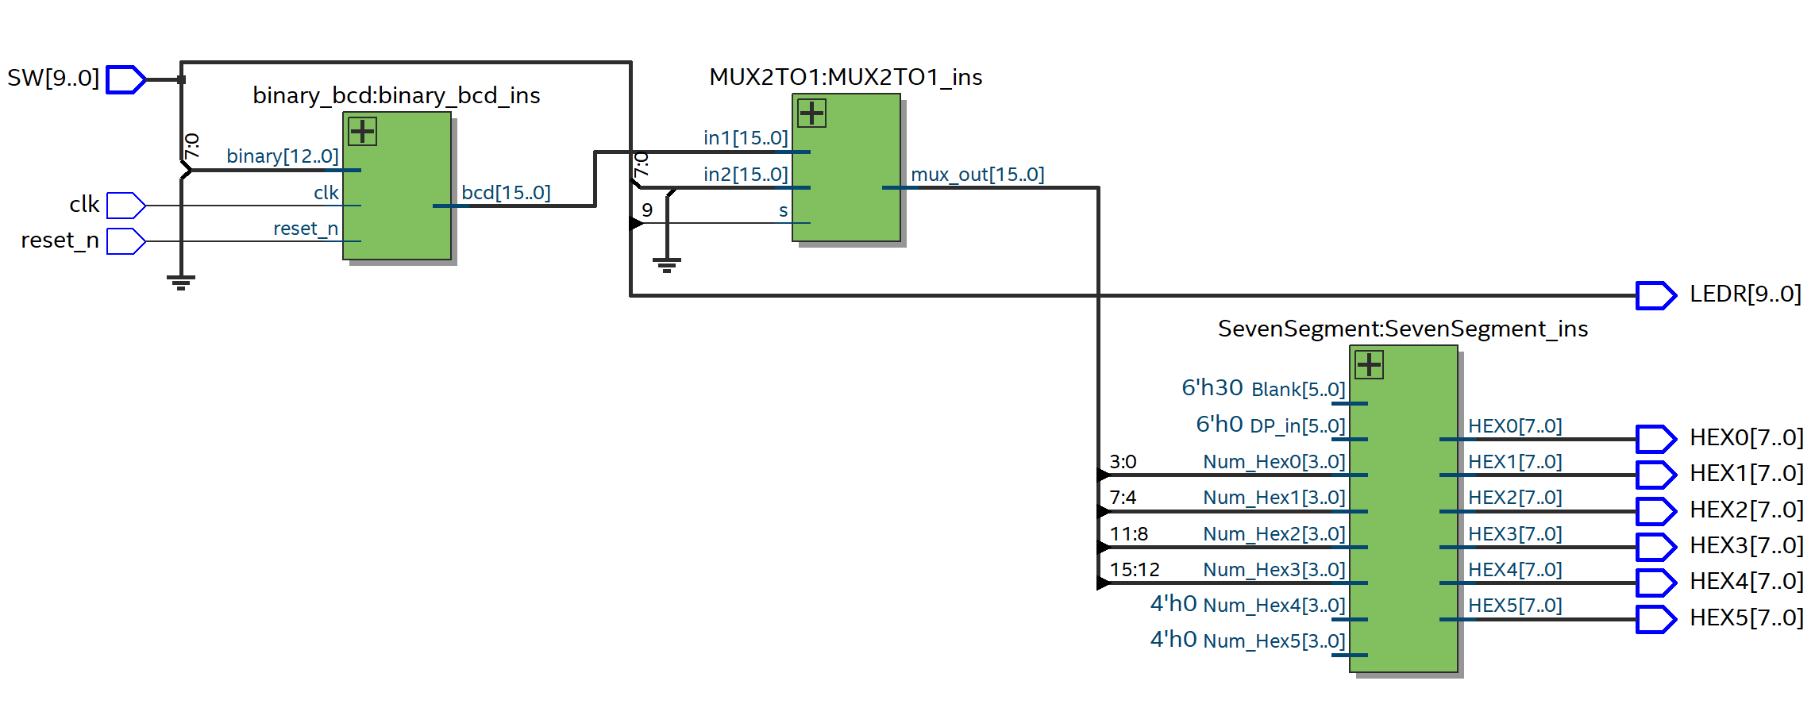

**Fmax Summary:**

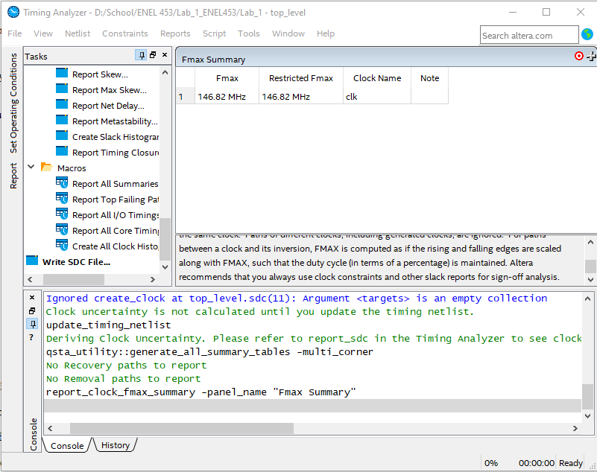

**Messages Window (3 images):**

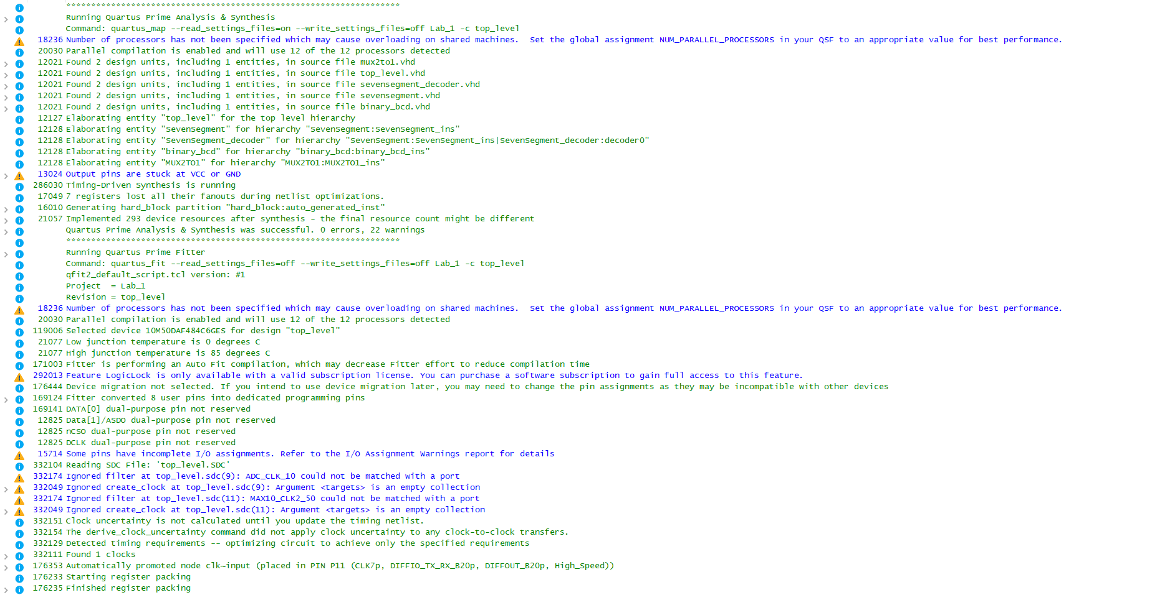

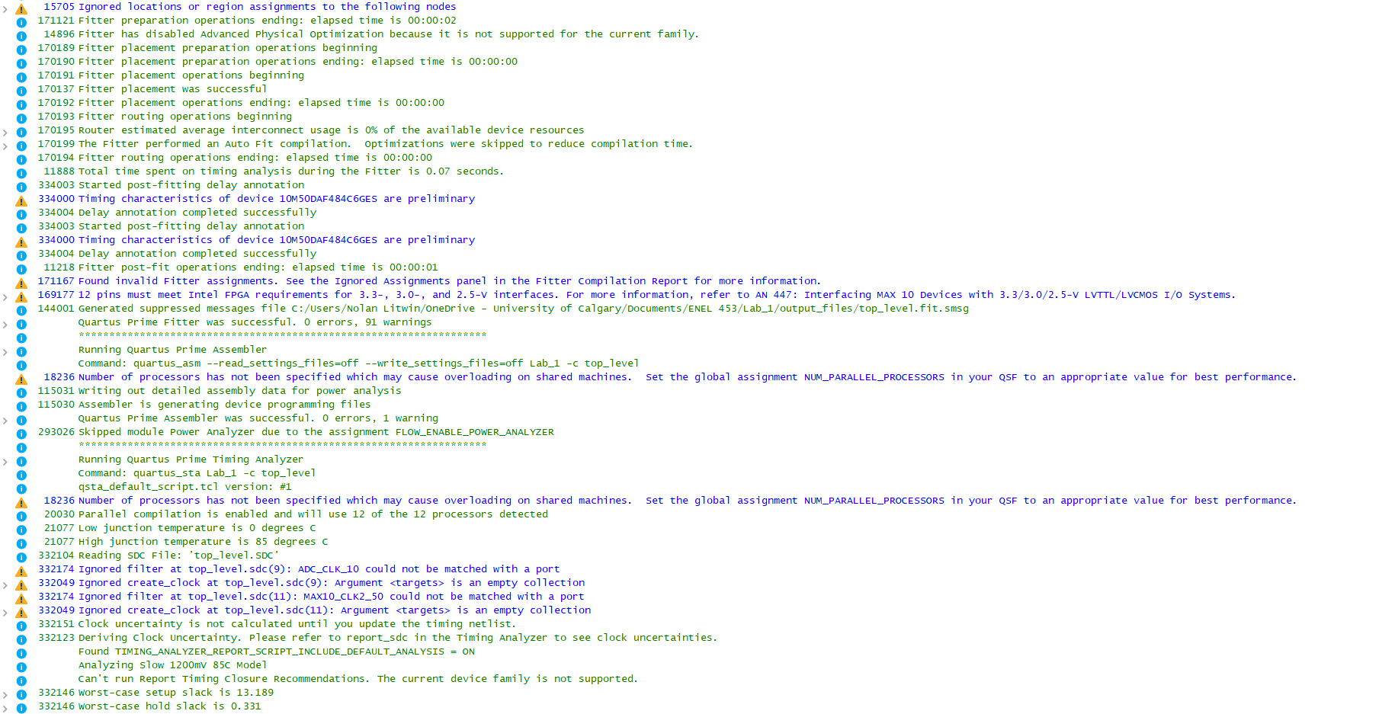

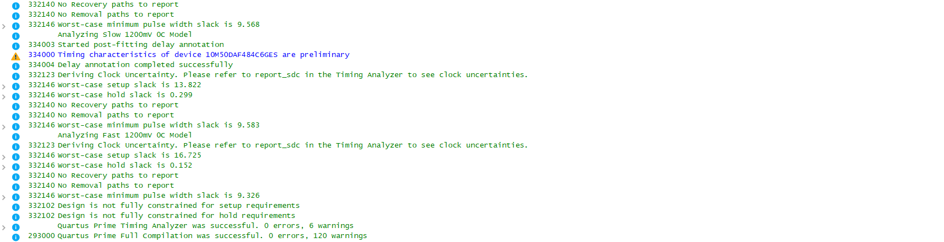

**MUX2TO1 Simulation Waveforms:**

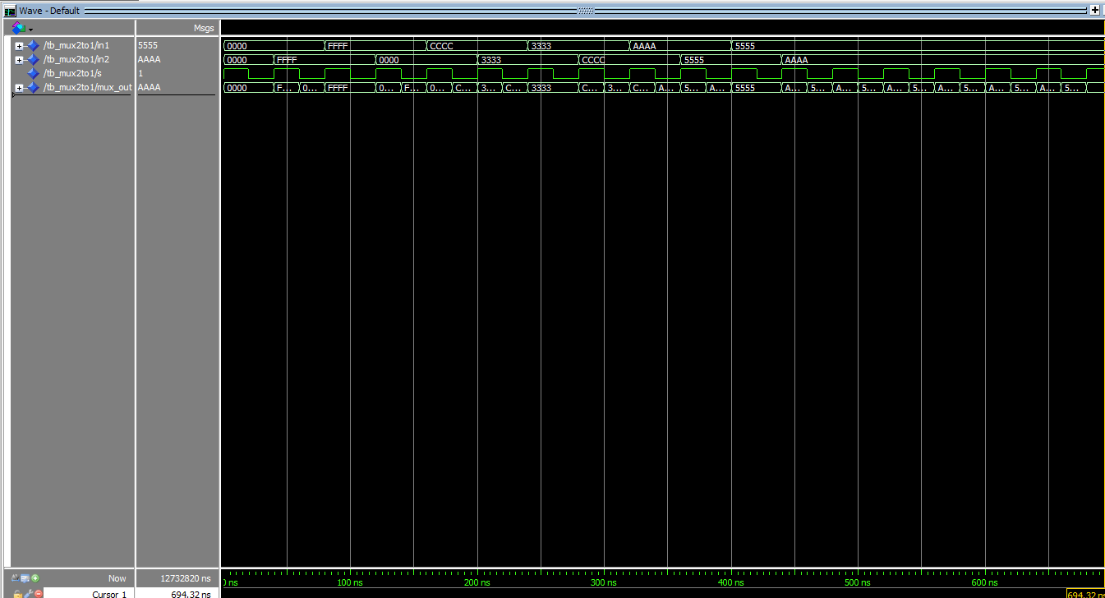

**top_level Simulation Waveforms:**

