CS 8540: Big Data Project
Spark and Ray-Based Forecasting of Stock-Market Twitter Activity
Nolan Rink
Phase 2 Final Report
Spring 2026
Table of Contents
1. Introduction........................................................2
2. Technical Description.............................................2 - 4
3. Implementation....................................................5 - 8
4. Experiments and Analysis of Results........................9 - 12
5. Conclusions and Future Work................................13 - 14

Introduction
This project uses Spark and Ray to process and analyze stock-market Twitter data. The system cleans raw tweets, extracts hashtags and cashtags, saves the processed data in Parquet format, builds forecasting features, trains machine learning models with Ray, and creates visualizations. The main task is predicting the next-day popularity of selected hashtags and cashtags.
The project includes the main parts of a Big Data workflow: distributed data processing, storage, machine learning, evaluation, runtime tracking, and visualization. Apache Spark is used to clean, store, retrieve, and aggregate the tweet data. Ray is used to run machine learning models.
The final results compare a simple baseline, classical machine learning models run with Ray, and a Ray Train PyTorch MLP model trained on the forecasting features.

Technical Description
The project uses a stock-market tweets dataset with 923,673 tweets from April through July 2020. The raw dataset has three main columns: `id`, `created_at`, and `text`. These columns are enough for a time-based Twitter analysis because the tweet text includes hashtags like `#stocks` and cashtags like `$AAPL`.
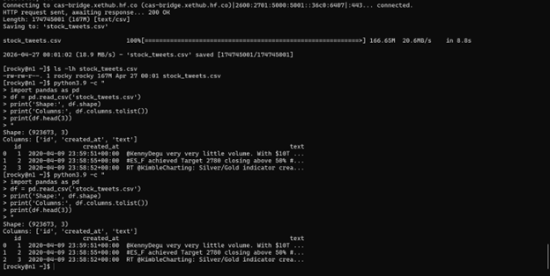
Figure 1: Raw stock-market tweet dataset inspection showing the downloaded CSV shape, columns, and sample rows before Spark processing.
The overall system architecture follows a Spark-to-Ray workflow:
Raw tweets
-> Spark cleaning and hashtag/cashtag extraction
-> Spark Parquet outputs
-> Ray feature table construction
-> Classical Ray model comparison
-> Ray Train MLP forecasting
-> Evaluation metrics and visualizations

Dataset and Extracted Signals
The dataset is useful for Big Data analysis because it shows social media activity about the stock market over time. Hashtags show general topics like investing, trading, and market discussion. Cashtags show attention toward specific companies or market symbols, such as `$AAPL`, `$AMZN`, and `$SPX`.
One limitation is that the dataset only covers a short time period. The final forecasting data covers April 9, 2020 to July 16, 2020. This is enough for a class project and short-term forecasting test, but it means the models are only evaluated on a limited amount of history.

Spark Pipeline Overview
The Spark pipeline reads the raw stock_tweets.csv file, removes tweets with missing text, removes duplicate tweet text, extracts hashtags and cashtags, creates daily and weekly date fields, and saves the processed data in Parquet format.
The main Spark outputs are:
• cleaned_tweets.parquet - cleaned tweet text with extracted hashtags and cashtags
• daily_hashtag_counts.parquet - daily hashtag counts by date and tag
• daily_cashtag_counts.parquet - daily cashtag counts by date and tag
• weekly_hashtag_counts.parquet - weekly hashtag counts by week and tag
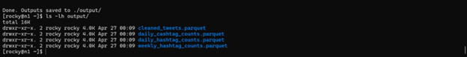
Figure 2: Spark output directory showing the cleaned tweets and daily/weekly tag-count Parquet outputs.
The pipeline uses Spark DataFrame operations and user-defined functions to extract and count tags. The Spark part of the project handles distributed storage, retrieval, cleaning, feature extraction, and aggregation.

Ray Forecasting Overview
The Ray portion of the project turns the Spark daily count outputs into a forecasting problem. Each selected hashtag or cashtag becomes a daily time series. The target is target_next_count, which means the next-day count for the same tag. This lets the system test whether recent tag activity can predict future tag popularity.
The Ray work has two main parts. First, a classical Ray workflow trains several scikit-learn models in parallel using Ray remote tasks. Second, a Ray Train workflow trains a small PyTorch MLP forecasting model and uses GPU support on FABRIC.

Implementation

Spark Implementation
The Spark implementation starts by creating a SparkSession and reading stock_tweets.csv with headers and inferred schema. After loading the data, the pipeline removes rows with missing tweet text and removes duplicate tweet text. Hashtags are extracted with a regular expression and converted to lowercase. Cashtags are extracted with a separate regular expression and converted to uppercase.
The Spark pipeline then creates a date field from created_at and a week field using date_trunc. The hashtag and cashtag arrays are exploded so Spark can group by date or week and count tag activity. The final outputs are saved in Parquet format.
The Spark run reported top hashtags such as #stocks and #stockmarket. It also reported top cashtags such as $SPX, $AAPL, and $AMZN. These high-volume tags support the decision to build a forecasting dataset using the top hashtags and cashtags.
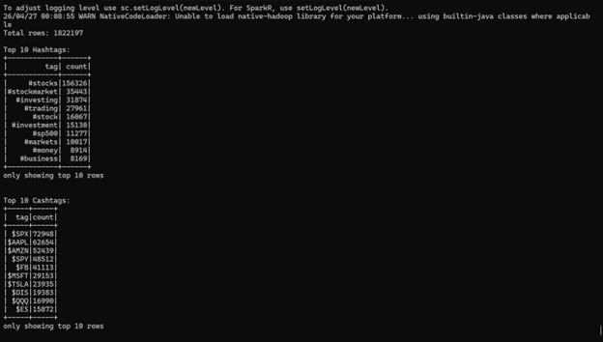
Figure 3: Spark terminal output showing successful processing and the most frequent hashtags and cashtags.

Spark Exploratory Visualizations
The Spark visualization script created charts from the Spark Parquet outputs. These charts included a top 20 hashtag bar chart, a top 10 cashtag pie chart, a daily trend line for the top five hashtags, and a weekly hashtag heatmap. These visualizations helped confirm that the Spark outputs contained useful tag activity before the Ray forecasting work began.
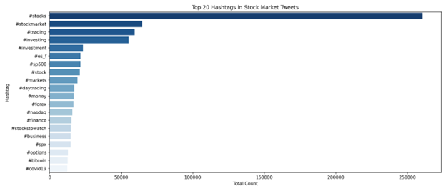
Figure 4: Top 20 hashtags in the stock-market tweets, with #stocks clearly dominating the discussion.
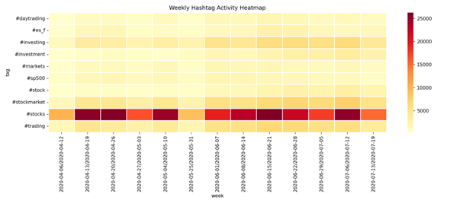
Figure 5: Weekly hashtag activity heatmap showing how the top hashtags changed over time.

Feature Table Construction
The forecasting feature table is built from daily_hashtag_counts.parquet and daily_cashtag_counts.parquet. The script selects the top 15 hashtags and top 15 cashtags that appear on at least 60 days. The selected tags are expanded into a daily panel, so missing tag/date combinations are filled with a count of zero.
The feature table has 2,310 total rows. This represents 30 selected tags across 77 dates. The modeling-ready split contains 1,440 training rows, 330 validation rows, and 300 test rows.

Feature table item | Value
Total rows | 2,310
Selected tags | 30 total: 15 hashtags and 15 cashtags
Date range | 2020-04-09 to 2020-07-16
Training rows | 1,440
Validation rows | 330
Test rows | 300
Target variable | target_next_count

The main input features are current count, lagged counts, rolling means, rolling standard deviations, one-day count difference, one-day percent change, tag identity, and tag type. One limitation is that the model only uses the selected top tags, not every tag in the full dataset.

Classical Ray Forecasting Implementation
The classical Ray workflow is implemented in run_ray_forecasting.py. This script loads the feature table, evaluates simple baselines, and trains pooled scikit-learn models in parallel with Ray remote tasks. The learned models include linear regression, ridge regression, random forest, and histogram gradient boosting.
Ray is useful here because each model training job is submitted as a separate Ray task. This allows multiple model types to train and evaluate in parallel. The script saves predictions, overall metrics, by-tag metrics, by-tag-type metrics, and training-time results.

Ray MLP Implementation
The neural forecasting workflow is implemented in train_ray_mlp_forecaster.py. This script uses Ray Train TorchTrainer to train a small PyTorch MLP regressor on the count-only feature table. The model predicts target_next_count using count-history features and one-hot encoded tag and tag_type features.
The MLP has two hidden linear layers with ReLU activations and dropout. The model trains with SmoothL1Loss on a standardized target. The MLP does not train directly on raw tweet text. It trains on the derived forecasting table created from Spark daily count outputs. This is important because Spark turns raw Twitter activity into structured time-series features, and Ray Train uses those features for supervised learning.
Ray Train setting | Final run value
Workers | 1
GPU requested | true
Device used | cuda
Epochs | 100
Batch size | 64
Best epoch | 55
Training time | 197.93 seconds

Experiments and Analysis of Results

Evaluation Metrics
The project uses MAE, RMSE, sMAPE, and training time to evaluate the forecasting workflow. MAE reports the average absolute prediction error in tag-count units. RMSE penalizes larger errors more strongly. sMAPE is useful because hashtags and cashtags can have different count scales. Training time measures the computational cost of each machine learning approach.

Baseline and Classical Ray Results
The official baseline is baseline_last_value. This baseline predicts that tomorrow's count will be the same as today's count. It is a reasonable baseline for short-term forecasting because many tags have similar activity from one day to the next.
The best classical model by validation sMAPE was random_forest_pooled. On the test set, the random forest improved over the last-value baseline on all main metrics.
Model | Test MAE | Test RMSE | Test sMAPE
baseline_last_value | 132.20 | 260.08 | 30.43
random_forest_pooled | 106.68 | 190.43 | 24.78

This result shows that the engineered count-history features were useful. It also shows that a classical tree-based model worked well for this small structured forecasting dataset.

Ray MLP Results
The Ray MLP added a neural forecasting model with GPU-capable training. The final run used CUDA and trained for 197.93 seconds. The model beat the last-value baseline on the test set, but it did not beat the best classical random forest by test sMAPE.
Split | MAE | RMSE | sMAPE
validation | 113.44 | 209.73 | 36.52
test | 104.44 | 182.18 | 25.73

This is still a useful result. It shows that adding a neural model does not automatically improve performance on a short, structured time-series panel.
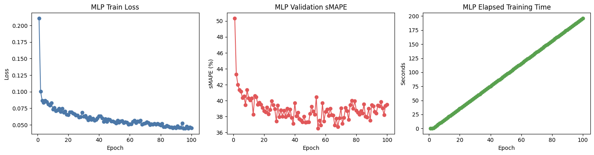
Figure 6: Ray Train MLP learning curves showing training loss, validation sMAPE, and elapsed training time over 100 epochs.

Hashtag and Cashtag Performance
The tag-type results show that hashtags and cashtags were not equally easy to forecast. For the MLP test set, hashtag prediction was easier than cashtag prediction based on sMAPE. This may be because hashtags often represent broader topics, while cashtags can be more event-driven and more volatile.
Tag type | Test MAE | Test RMSE | Test sMAPE
cashtag | 131.39 | 193.04 | 30.74
hashtag | 77.50 | 170.62 | 20.73

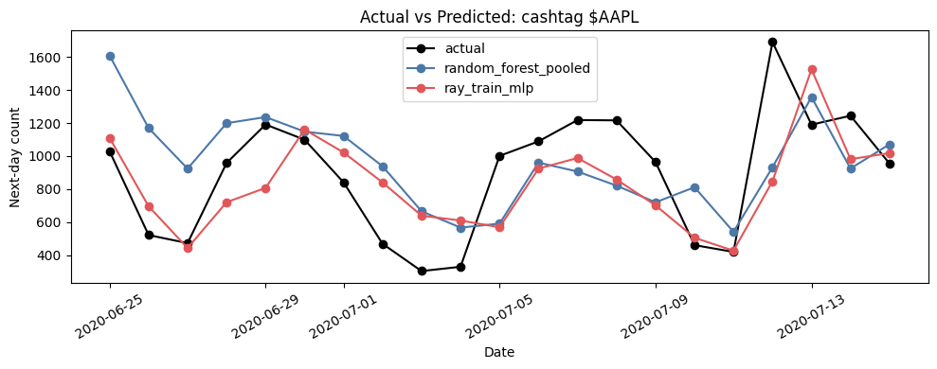
Figure 7: Actual versus predicted next-day counts for cashtag $AAPL using the random forest and Ray Train MLP models.
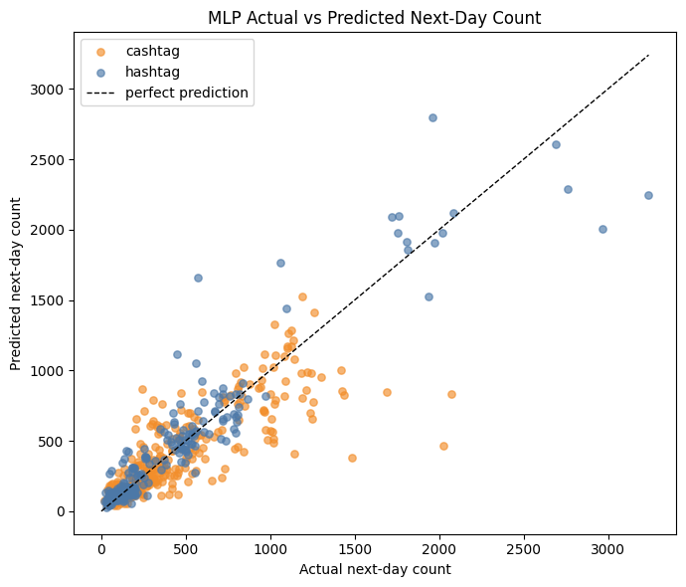
Figure 8: MLP actual-versus-predicted scatterplot. The dashed diagonal line represents perfect prediction.

Runtime and Training-Time Analysis
Training time was saved for both the classical Ray models and the Ray MLP. This helps show the systems side of the project because the report can discuss both accuracy and how long the machine learning tasks took to finish.
The classical Ray models are faster and run on CPU. The MLP adds a GPU training workflow. The MLP training time was 197.93 seconds. Since the MLP did not beat the random forest by test sMAPE, the extra neural training time was not justified by accuracy alone. However, it was still useful because it demonstrated Ray Train and GPU-based training.
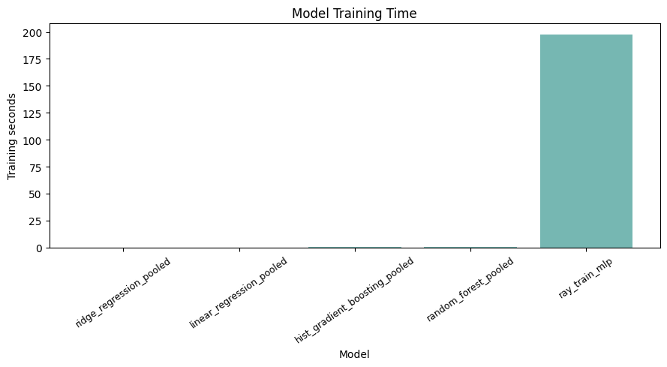
Figure 9: Training-time comparison showing the much higher computational cost of the Ray Train MLP compared with the classical Ray models.

Testing and Reproducibility
The project was tested by running each part of the final Phase 2 workflow in order from the command line. First, the required Spark output files were checked to make sure the daily hashtag and cashtag Parquet outputs were available under phase2/data/spark_output/output/. Necessary Libraries were installed using requirements-phase2.txt
The final workflow uses three main scripts. The feature table script creates top_tags_daily_features.parquet from the Spark daily count outputs. The classical Ray script trains and evaluates the baseline and scikit-learn forecasting models using the count-only feature table. The Ray Train script runs the final GPU-based PyTorch MLP forecasting job with one Ray Train worker.
After each script finished, the expected output files were checked. These included the feature table, prediction files, overall metrics, by-tag metrics, by-tag-type metrics, training-time files, MLP training history, and JSON run summaries.

The main commands used to reproduce the final workflow were:
python3 phase2/scripts/build_feature_table.py
python3 -u phase2/scripts/run_ray_forecasting.py
python3 -u phase2/scripts/train_ray_mlp_forecaster.py

Conclusions and Future Work
This project shows an end-to-end Big Data workflow for stock-market Twitter analysis. Spark was used to clean, store, retrieve, and aggregate tweet data, while Ray was used to train and evaluate models for next-day hashtag and cashtag forecasting. Ray also added a GPU-supported PyTorch neural training workflow.
The best forecasting result came from the classical Ray random forest model. It improved test sMAPE from 30.43 for the last-value baseline to 24.78. The Ray Train MLP reached a test sMAPE of 25.73, which beat the baseline but did not beat the random forest. This shows that a neural model is not always better than a strong classical model for a small forecasting task.Overall, the project meets the main goal of combining Spark processing and Ray machine learning.

