CUAD Final Report

Nolan Rink

Spring 2026

Masters Project

Github

5/8/2026

Table of Contents
1. Abstract And Contributions
2. Introduction And Research Question
3. Dataset And Task Definition
4. Why CUAD Extraction Is Difficult
5. Preprocessing And Output Schema
6. Main Method: Fine-Tuned Structured Generation
7. Baselines
8. Evaluation Metrics
9. Quantitative Results
10. Category-Level And Qualitative Error Analysis
11. Limitations And Future Work
12. Reproducibility And Conclusion
Appendix: Implementation And Evaluation Details
References

1. Abstract And Contributions
This report asks: "Can LoRA-based parameter-efficient fine-tuning of a small open instruction model improve structured CUAD contract clause extraction compared with zero-shot prompting and a simple extractive QA baseline?" The project treats CUAD as a structured extraction task over (contract chunk, CUAD category) records. Each model output must contain category, found, normalized_answer, and evidence_text, so the task tests both clause detection and answer extraction rather than free-form legal summary.
The main method fine-tunes TinyLlama/TinyLlama-1.1B-Chat-v1.0 with LoRA and compares it with a simple extractive QA baseline and zero-shot TinyLlama prompting. In final whole-set evaluation, fine-tuned structured generation performs best among the three evaluated methods: found accuracy 0.9122 and normalized-answer token F1 0.6798, compared with 0.8170 and 0.6216 for extractive QA. Zero-shot generation is limited mainly by output reliability, with parsed JSON rate 0.1644.
The result supports the thesis that LoRA-based fine-tuning improves structured CUAD extraction in this evaluated chunk/category setup. The conclusion remains bounded: TinyLlama is a practical single-GPU model choice, not the strongest possible model; the task is not full-contract retrieval; positive-only extraction remains difficult; and the system is an experimental pipeline, not a tool for real legal use.
The report makes three contributions:
A reproducible single-GPU CUAD preprocessing, training, evaluation, and reporting pipeline.
A structured-generation fine-tuning setup that trains a small open instruction model to produce parseable CUAD JSON outputs.
A final three-way evaluation comparing fine-tuned structured generation, extractive QA, and zero-shot generation with whole-set metrics, per-category results, and qualitative examples.

2. Introduction And Research Question
Legal contract review often requires specific clause extraction rather than broad document summary [1], [2]. In CUAD, the useful output is not just whether a legal topic appears somewhere; the system must decide whether a particular clause category appears in a given contract context and, when it does, return the answer and supporting evidence.
This project sits between contract-understanding work and small-model adaptation. CUAD and the Atticus Project provide the contract-review task context [1], [2]. TinyLlama and LoRA make the experiment practical in a constrained single-GPU setting by adapting a small open instruction model with parameter-efficient adapters [3], [4], [8].
The original CUAD benchmark reports span-extraction metrics such as AUPR and precision at fixed recall using confidence-ranked span predictions and a Jaccard-overlap match rule [1]. Those results are useful related-work context, but they are not directly comparable to this report's chunk/category structured-generation evaluation. This system emits JSON fields, counts invalid JSON as task failure, and reports whole-set found and text-overlap metrics on preprocessed chunks. For that reason, the report does not claim direct numerical comparison to published CUAD benchmark scores; its claims are limited to the controlled comparison among fine-tuned structured generation, extractive QA, and zero-shot generation.
The research question is: "Can LoRA-based parameter-efficient fine-tuning of a small open instruction model improve structured CUAD contract clause extraction compared with zero-shot prompting and a simple extractive QA baseline?" The completed evaluation answers yes within this scope. The fine-tuned structured model reaches whole-set found accuracy of 0.9122 and normalized-answer token F1 of 0.6798, compared with 0.8170 and 0.6216 for extractive QA. Zero-shot prompting performs poorly under whole-set scoring, with parsed JSON rate 0.1644.
The scope is intentionally narrow. This is a experimental pipeline, not a production legal system. The evaluation is chunk/category level, not full-contract retrieval, and future work such as Qwen, broader model sweeps, or long-context retrieval is not treated as completed work.

3. Dataset And Task Definition
This project uses CUAD as a supervised legal clause extraction task. Each example pairs one contract chunk with one CUAD category and asks the model to return a structured answer for that category in that chunk. The evaluation unit is therefore a chunk/category record, not an entire contract.
The required output is a JSON object with four fields: category, found, normalized_answer, and evidence_text. If the category is present, found should be true and the answer/evidence fields should contain the extracted content. If the category is absent, found should be false and both answer fields should be null. This schema makes no-answer behavior and machine-parseable output part of the task.
The preprocessed dataset contains 41 CUAD categories in each split. Splits are contract-level rather than chunk-level, which reduces the risk of testing on chunks from contracts whose wording, parties, dates, or boilerplate were already seen during training.
Table 1. Dataset split summary.
Split | Total records | Contracts | Chunks | Positive records | No-answer records | Brief note
Train | 51,704 | 367 | 11,123 | 31,751 | 19,953 | Used for model fitting; contract-level split from the raw training contracts
Validation | 5,568 | 41 | 1,105 | 3,321 | 2,247 | Used for validation during development and model selection
Test | 8,493 | 102 | 2,617 | 4,366 | 4,127 | Held-out evaluation split and primary source for final reported metrics

No-answer records are part of the supervised task. The test split contains 4,366 positive records and 4,127 no-answer records, so a useful extractor must learn both when to answer and when to abstain.

4. Why CUAD Extraction Is Difficult
CUAD extraction combines detection, extraction, normalization, and strict formatting. For each (contract chunk, CUAD category) pair, the model must decide whether the category is present, produce the normalized answer when it is present, provide evidence text, and return a valid JSON object.
The first difficulty is context length. The project uses 2,200-character chunks with 1,600-character stride to keep training feasible on a single GPU, but this means the model sees a local contract window rather than the whole agreement. Some clauses depend on surrounding definitions, parties, dates, headings, or exceptions outside the chunk.
The second difficulty is no-answer behavior. Nearly half of the test set is no-answer records. A model that always extracts text would create many false positives, while a model that abstains too often would miss real clauses. This is why the evaluation separates answer-present recall from no-answer accuracy.
The third difficulty is contract language itself. Repeated boilerplate, party labels, date-like fields, and header metadata can look relevant without answering the queried category. Multi-entity categories such as Parties also require complete normalization, not just detection of one plausible name.
Strict JSON output adds another burden for generative models. The zero-shot sample file includes outputs that begin with Contract chunk: instead of parseable JSON, and the zero-shot metric report confirms that invalid JSON is a major failure mode. For this project, a plausible answer still fails if it cannot be parsed into the required schema.

5. Preprocessing And Output Schema
Preprocessing turns the raw CUAD files into consistent records for all three methods. The path starts from train_separate_questions.json and test.json. The held-out CUAD test contracts remain the test split, while validation is created from the raw training contracts using contract-level assignment. The verified summary reports 408 raw training contracts and 102 raw test contracts; after validation holdout, the final splits contain 367 training contracts, 41 validation contracts, and 102 test contracts.
Each contract is converted into overlapping 2,200-character windows with a 1,600-character stride. Chunks are then paired with CUAD categories. A record is positive when the answer is visible in the chunk; otherwise it can become a no-answer record. The setting max_negative_chunks_per_category = 1 keeps no-answer examples without allowing negative records to grow without control.
Table 2. Preprocessing settings.
Setting | Value | Source | Why it matters
Raw train file | train_separate_questions.json | data/cuad_preprocessed_main/summary.json | Source for train/validation contracts
Raw test file | test.json | data/cuad_preprocessed_main/summary.json | Source for held-out test contracts
Validation contract fraction | 0.1 | data/cuad_preprocessed_main/summary.json | Creates validation split from raw training contracts
Split seed | 13 | data/cuad_preprocessed_main/summary.json | Makes contract-level validation assignment reproducible
Chunk size | 2,200 characters | data/cuad_preprocessed_main/summary.json | Defines local contract window length
Chunk stride | 1,600 characters | data/cuad_preprocessed_main/summary.json | Creates overlapping windows
Max negative chunks per category | 1 | data/cuad_preprocessed_main/summary.json | Limits sampled no-answer records per absent category
Number of categories | 41 | data/cuad_preprocessed_main/summary.json | Defines category coverage in each split
Output schema fields | category, found, normalized_answer, evidence_text | AGENTS.md | Defines the structured generation target

The generation target is the same four-field JSON schema used throughout the report. Positive records use found: true with a normalized answer and evidence text. No-answer records use found: false with null answer fields. The same preprocessed task supports fine-tuned structured generation, extractive QA, and zero-shot prompting, which keeps the later comparison aligned.
This preprocessing makes the task feasible but also narrows it. The results measure structured extraction from prepared chunks, not retrieval or full-contract legal review.

6. Main Method: Fine-Tuned Structured Generation
The main method fine-tunes TinyLlama/TinyLlama-1.1B-Chat-v1.0 to produce the JSON schema from a contract chunk and category [3], [8]. TinyLlama was chosen because it is practical for single-GPU FABRIC work, not because it is the strongest possible CUAD model. The project contribution is the structured fine-tuning and evaluation setup, not a new model architecture or broad model sweep.
Training uses LoRA rather than full-model fine-tuning [4]. The approved training summary reports LoRA enabled for q_proj, k_proj, v_proj, o_proj, gate_proj, up_proj, and down_proj. This parameter-efficient setup adapts the model to the task while keeping the run feasible on one GPU.
Table 3. Method/training setup.
Item | Value | Source | Why it matters
Base model | TinyLlama/TinyLlama-1.1B-Chat-v1.0 | artifacts/cuad_train_summary_full.json | Small open instruction model used for the main method
Fine-tuning method | LoRA enabled | artifacts/cuad_train_summary_full.json | Parameter-efficient adaptation for the single-GPU setting
LoRA target modules | down_proj, gate_proj, k_proj, o_proj, q_proj, up_proj, v_proj | artifacts/cuad_train_summary_full.json | Documents adapted model components
Model context window | 2048 | artifacts/cuad_train_summary_full.json | Sets prompt and target context budget
Maximum source length | 1024 | artifacts/cuad_train_summary_full.json | Caps tokenized prompt/chunk input
Maximum target length | 192 | artifacts/cuad_train_summary_full.json | Keeps JSON targets compact
Completed steps | 3,000 | artifacts/cuad_train_summary_full.json | Confirms a completed full run
Best eval loss | 0.029317 at step 2,400 | artifacts/cuad_train_summary_full.json | Identifies best validation checkpoint

The prompt asks the model to read a contract chunk and return JSON only, using exactly the four expected keys. The run completed 3,000 steps, selected the best checkpoint by validation loss, and stopped after no further improvement. The best evaluation loss was 0.029317 at step 2,400.

7. Baselines
Baselines make the research question comparative. This project uses one main simple baseline, extractive QA, plus a lightweight zero-shot prompting comparison.
The extractive QA baseline uses deepset/bert-base-cased-squad2 [5], [6], [7]. It is meaningful because CUAD often resembles span extraction: if an answer appears in a chunk, a span model may be able to select it directly. The comparison is not perfectly symmetric, because extractive QA predicts spans or no-answer decisions rather than naturally producing the same JSON object with normalized answer and evidence fields.
The zero-shot baseline uses the same TinyLlama base model without task-specific fine-tuning. It tests whether prompting alone is enough to make the model follow the schema. Its approved evaluation shows that this is not enough: only 1,396 of 8,493 predictions parse as valid JSON, for parsed JSON rate 0.1644.
Table 4. Baseline setup.
Baseline | Model/method | Input/output style | Key settings | Purpose in the comparison
Extractive QA Baseline | deepset/bert-base-cased-squad2 | Question plus contract chunk in; answer span or no-answer decision out | Max sequence length 384; 6,800 completed training steps; best eval loss 1.1411 | Main simple comparison for span-style CUAD extraction
Zero-Shot Generative Baseline | TinyLlama/TinyLlama-1.1B-Chat-v1.0 without fine-tuning | Chunk/category prompt in; requested JSON output out | Context window 2048; max source length 1024; max new tokens 192; parse rate 0.1644 | Lightweight prompting comparison for schema following

Together, the baselines provide a useful comparison set without expanding the project into a larger model sweep.

8. Evaluation Metrics
Whole-set metrics are the primary evidence. For generative methods, invalid JSON stays in the denominator and counts as failure where appropriate. This is the fair headline comparison because malformed JSON is a real task failure for a structured extractor.
Parsed-only metrics are still useful diagnostically, but they are optimistic because they exclude invalid generations. Positive-only metrics answer a different question: they isolate cases where the reference contains an answer, so they better reflect answer-present extraction quality.
Table 5. Evaluation metric definitions.
Metric | What it measures | Field(s) involved | Caveat / interpretation note
Parse rate / invalid JSON count | Whether generated output can be parsed into the expected structured record | Full generated output | Invalid JSON counts as failure in whole-set metrics
Whole-set found accuracy | Present/absent accuracy over all test records | found | Primary detection metric because it includes invalid JSON failures
Answer-present recall | Recovery of records where the reference category is present | found | Low values mean real answer-bearing records are missed
No-answer accuracy | Correct abstention on records where the category is absent | found | Important because no-answer records are a central part of the task
Normalized token F1 | Token overlap for normalized answer text | normalized_answer | Whole-set values mix extraction quality with correct no-answer behavior
Positive-only normalized token F1 | Answer text quality restricted to positive references | normalized_answer | Best headline view of answer extraction difficulty
Evidence token F1 | Token overlap for supporting contract text | evidence_text | Checks whether evidence aligns with the reference support text
Per-category found accuracy | Found accuracy broken out by CUAD category | category, found | Reveals uneven behavior hidden by aggregate metrics

The metric design separates schema reliability, found/not-found detection, no-answer behavior, answer overlap, evidence overlap, and category-level performance. It also avoids direct CUAD-paper AUPR or precision-at-recall comparisons, because this project does not produce confidence-ranked span predictions under the original benchmark protocol.

9. Quantitative Results
The final whole-set comparison supports the research question. Fine-tuned structured generation is strongest overall, extractive QA is competitive but weaker, and zero-shot prompting is limited mainly by invalid JSON.
Table 6. Final method comparison.
Method | Parse rate | Whole-set found accuracy | Answer-present recall | No-answer accuracy | Normalized token F1 | Positive-only normalized token F1 | Main interpretation
Fine-tuned structured generation | 0.9408 | 0.9122 | 0.8619 | 0.9654 | 0.6798 | 0.4098 | Strongest overall; improves schema following and detection, but answer extraction remains imperfect
Extractive QA baseline | N/A | 0.8170 | 0.6683 | 0.9743 | 0.6216 | 0.2883 | Competitive main baseline; strong abstention, weaker answer-present recovery
Zero-shot generation baseline | 0.1644 | 0.0714 | 0.0989 | 0.0422 | 0.0247 | 0.0082 | Lightweight prompting comparison; mostly fails because outputs are often invalid JSON

The fine-tuned model combines high parse reliability with the strongest found accuracy and answer overlap. It reaches parse rate 0.9408, found accuracy 0.9122, answer-present recall 0.8619, no-answer accuracy 0.9654, normalized-answer token F1 0.6798, and positive-only normalized token F1 0.4098.
The extractive QA baseline is meaningful but weaker overall. It reaches found accuracy 0.8170 and normalized-answer token F1 0.6216, with strong no-answer accuracy of 0.9743 but lower answer-present recall of 0.6683 and positive-only token F1 of 0.2883.
Zero-shot prompting performs poorly under whole-set scoring. Its parse rate is 0.1644, with 7,097 invalid JSON outputs out of 8,493. Whole-set found accuracy is 0.0714 and positive-only normalized-answer token F1 is 0.0082.
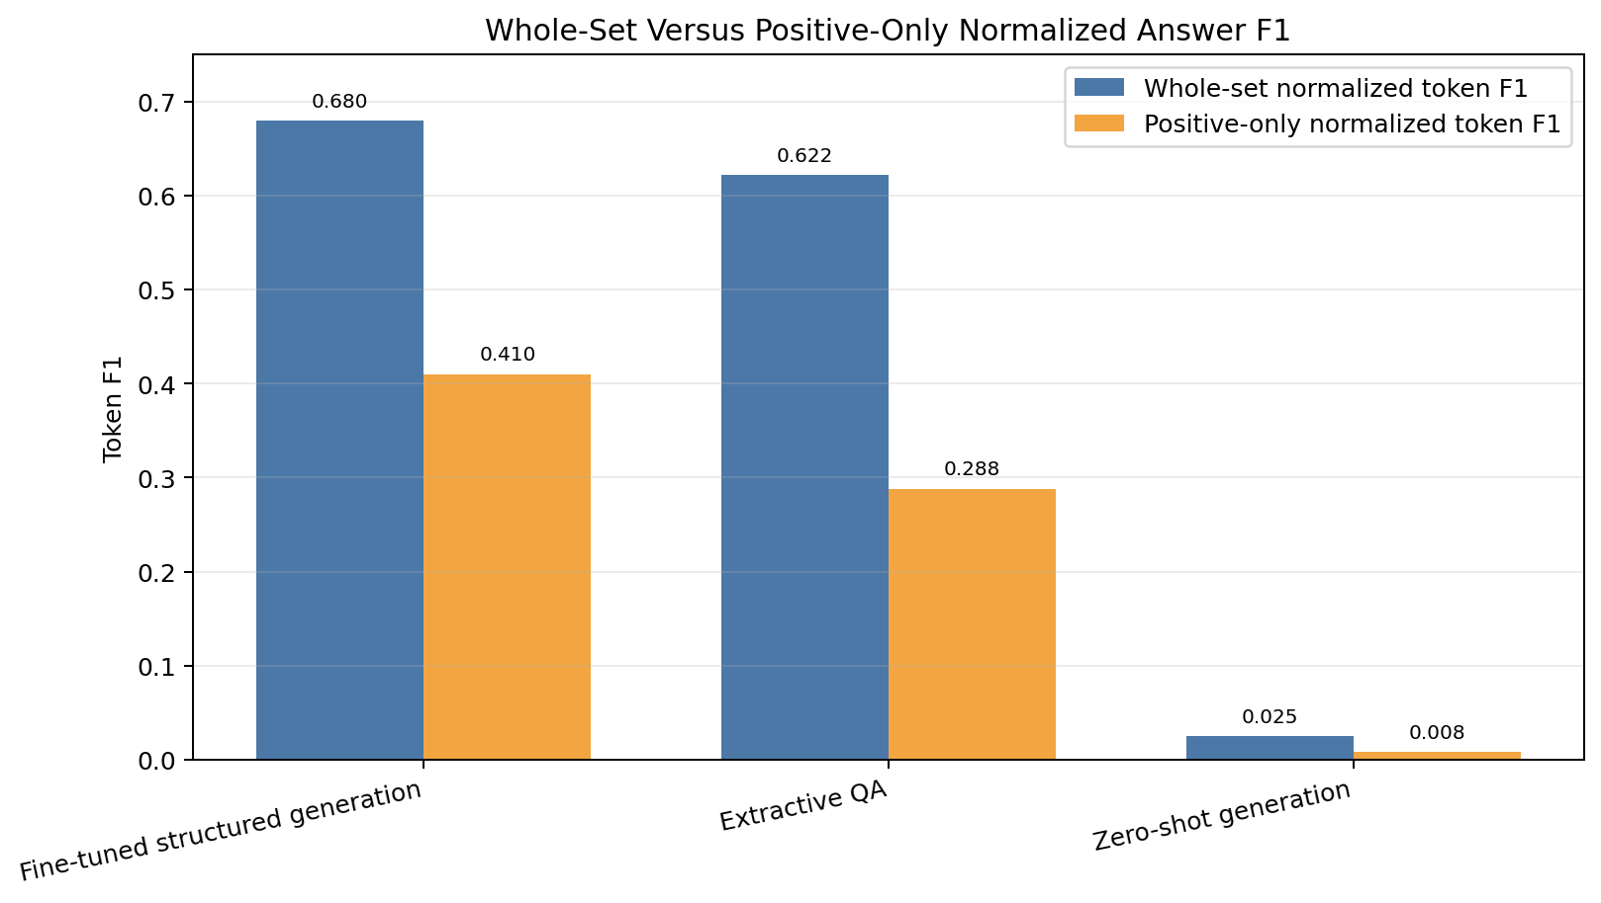
Figure 1. Whole-set and positive-only normalized answer token F1 for fine-tuned structured generation, extractive QA, and zero-shot generation. The gap shows that no-answer handling contributes to whole-set scores, while answer-present extraction remains harder for all methods.
Figure 1 clarifies that whole-set and positive-only F1 answer different questions. Whole-set F1 includes no-answer handling and parse failures; positive-only F1 isolates answer-present extraction. The lower positive-only scores preserve the main caveat: fine-tuning improves the structured task, but answer extraction is still not solved.
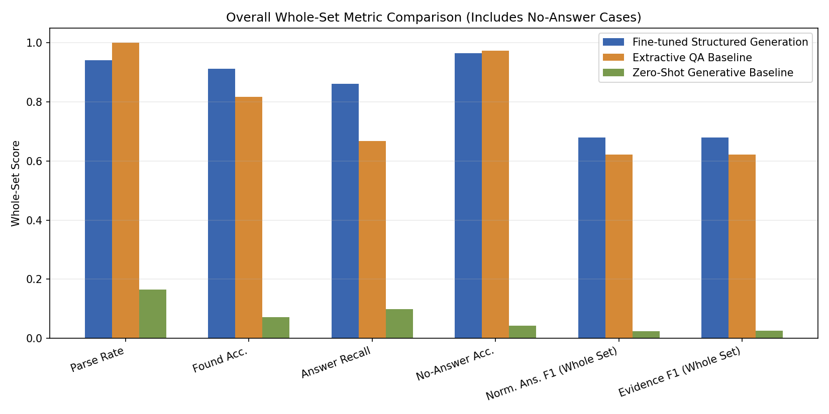
Figure 2. Overall whole-set CUAD metrics for fine-tuned structured generation, extractive QA, and zero-shot generation. The figure shows the main method comparison and supports the headline result that fine-tuned structured generation is strongest overall, while zero-shot generation is weak under whole-set scoring.
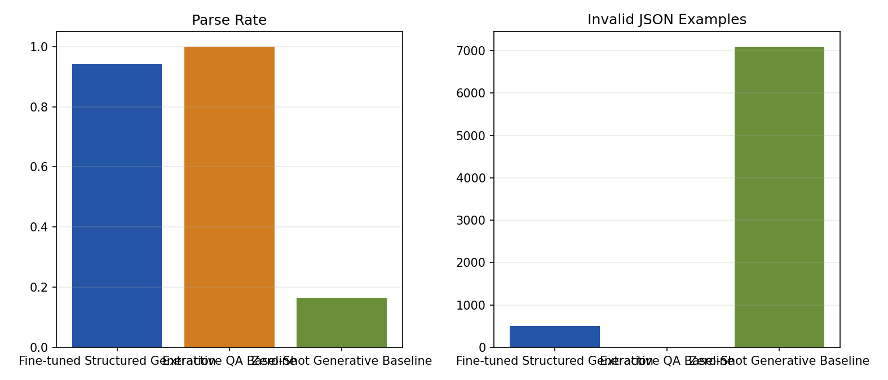
Figure 3. Parse reliability and invalid JSON counts for the generative methods. The figure shows that fine-tuning greatly improves JSON reliability over zero-shot prompting, but does not eliminate invalid outputs.
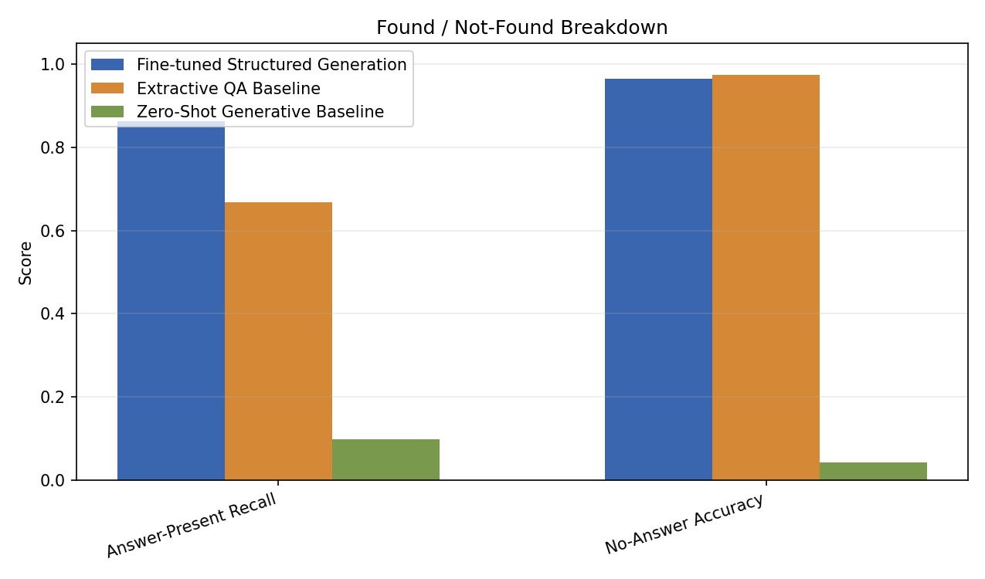
Figure 4. Found/not-found breakdown for the evaluated methods. The figure separates answer-present recall from no-answer accuracy, making clear that strong abstention and strong positive-case recovery are different behaviors.
Figures 2-4 show the same pattern visually: fine-tuned structured generation is strongest overall, fine-tuning greatly improves JSON reliability compared with zero-shot prompting, and answer-present recall should be read separately from no-answer accuracy.

10. Category-Level And Qualitative Error Analysis
Aggregate metrics hide category-level variation. Some categories are relatively direct when the relevant text is explicit in the chunk. For example, the fine-tuned model reaches whole-set found accuracy 0.9184 and normalized-answer token F1 0.8420 on Document Name, and 0.9581 found accuracy with 0.9326 normalized-answer token F1 on Governing Law.
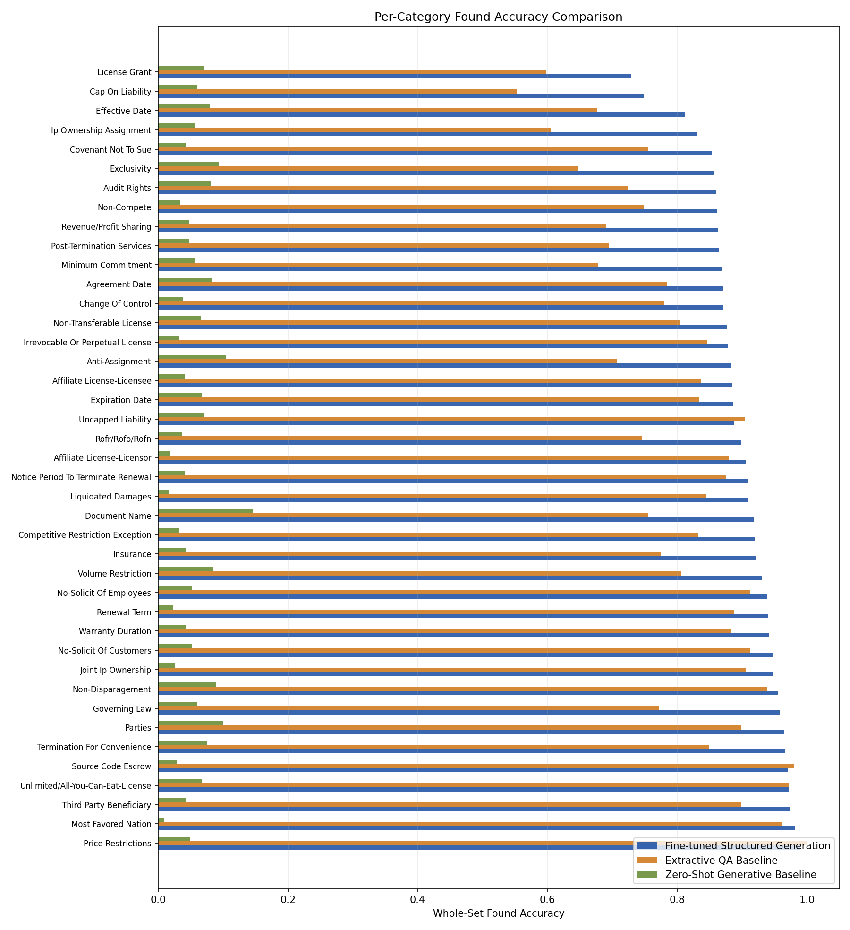
Figure 5. Per-category whole-set found accuracy across CUAD categories. The figure shows that aggregate performance is uneven by category, so the overall comparison should be interpreted together with category-level and qualitative analysis.
Other categories remain harder. Parties has high found accuracy but much lower normalized-answer quality, showing that the model can detect a category while incompletely normalizing a multi-entity answer. License Grant and Cap On Liability also have lower answer-present recall, which suggests that dense clause language remains difficult.
Qualitative examples make these errors concrete. The fine-tuned model correctly predicts SUPPLY CONTRACT for a Document Name example, but it also produces a partial Parties answer and a Parties false positive with Seller. The extractive QA baseline can add boundary tokens or return plausible but under-normalized spans. Zero-shot generation often fails before content scoring because the output is not valid JSON.
Date and header-like fields create a related failure mode. The fine-tuned sample file includes an Agreement Date no-answer record where the model selects nearby buyer/end-user text instead of abstaining. This does not define the whole category, but it shows why qualitative review is useful: contract headers often place titles, dates, parties, and administrative fields close together.
Table 7. Qualitative example summary.
Method | Category | Example type | Reference summary | Prediction summary | Takeaway
Fine-tuned structured generation | Document Name | Success | Reference identifies SUPPLY CONTRACT | Prediction also identifies SUPPLY CONTRACT | Explicit titles are handled well when the answer is local and direct
Fine-tuned structured generation | Parties | Partial answer | Reference includes seller plus buyer/end-user information | Prediction keeps only Shenzhen LOHAS Supply Chain Management Co., Ltd. | Multi-entity categories can be detected but incompletely normalized
Fine-tuned structured generation | Parties | False positive | Reference is no-answer | Prediction marks found with Seller | Generic legal labels can trigger plausible but wrong positives
Fine-tuned structured generation | Agreement Date | False positive | Reference is no-answer | Prediction selects buyer/end-user text | Nearby header metadata can confuse date/category decisions
Extractive QA baseline | Document Name | Boundary issue | Reference is SUPPLY CONTRACT | Prediction is SUPPLY CONTRACT Contract | Span extraction can add extra boundary tokens
Extractive QA baseline | Parties | Partial answer | Reference contains fuller party information | Prediction is Buyer and Seller | Span-style answers can be plausible but under-normalized
Zero-shot generation | Multiple | Invalid JSON / raw-contract output | Expected structured JSON | Output begins with Contract chunk: and copied text | Prompting alone often fails the output contract

These examples are illustrative, not statistically representative. They explain the metric pattern: fine-tuning improves structured behavior, but positive-only extraction, multi-entity normalization, span boundaries, and invalid JSON remain important failure modes.

11. Limitations And Future Work
The results support the main thesis, but only within the evaluated setup. The project tests one small LoRA-tuned instruction model, one extractive QA baseline, and one zero-shot prompting baseline on preprocessed chunk/category records.
The first limitation is model capacity. TinyLlama was practical for single-GPU FABRIC work, but it is not presented as the strongest possible CUAD model. Future work should test stronger instruction models, including Qwen2.5-7B-Instruct LoRA or QLoRA if access and compute allow. That is future work, not completed evidence.
The second limitation is context. Chunking makes the task feasible, but it does not test full-contract retrieval or long-context reasoning. Some clauses may depend on definitions, parties, dates, or exceptions outside the local chunk.
The third limitation is reliability and extraction quality. Fine-tuning raises parse rate to 0.9408, but 503 fine-tuned outputs are still invalid JSON. Positive-only normalized-answer token F1 remains 0.4098, so answer-present extraction is not solved even though found accuracy is high.
Table 8. Limitations and future-work responses.
Limitation | Evidence/source | Effect on interpretation | Future-work response
TinyLlama is practical, not the strongest possible model | artifacts/cuad_train_summary_full.json; Section 6 | Results support the evaluated TinyLlama LoRA setup, not a general best-model claim | Run Qwen2.5-7B-Instruct LoRA/QLoRA as future work if access and compute allow
The task uses chunk/category inputs | Sections 3-5; AGENTS.md | Results measure prepared extraction examples, not complete contract search | Consider retrieval or full-document extraction only after the core story is stable
JSON reliability is improved but imperfect | artifacts/cuad_eval_metrics_full_report.json | 503 fine-tuned outputs are still invalid JSON and count as whole-set failures | Test schema-constrained decoding or transparent validation/repair
Positive-only answer extraction remains difficult | artifacts/cuad_eval_metrics_full_report.json; Section 9 | High found accuracy does not mean answer normalization is solved | Try stronger models, better prompts, and targeted category analysis
Baseline set is intentionally limited | Sections 7 and 9; approved baseline artifacts | The comparison answers the current research question but is not a model sweep | Add stronger QA and model-choice baselines only after the core report is stable

Future work should build outward from this evidence: stronger models, stronger QA baselines, schema-constrained decoding or transparent validation, retrieval or full-document extraction, and focused ablations on chunk size, stride, prompt format, and negative sampling. The project should remain framed as an experimental pipeline, not a legal advice system.

12. Reproducibility And Conclusion
The report is supported by reproducibility artifacts rather than one-off notebook output. The notebook was used for inspection, metrics debugging, final plots, tables, and qualitative examples. train_cuad.py holds the reproducible command path for preprocessing, training, evaluation, saved predictions, scoring, and plotting.
Table 9. Artifact map.
Artifact family | Example files | Report role | Caveat / notes
Preprocessed data summary | data/cuad_preprocessed_main/summary.json | Supports dataset counts, split construction, chunk settings, and category count | Use this instead of ignored local preprocessing outputs
Fine-tuned structured-generation training | artifacts/cuad_train_summary_full.json | Documents TinyLlama LoRA setup, completed steps, checkpoint choice, and training settings | *_full* is the approved structured-generation family
Fine-tuned structured-generation evaluation | artifacts/cuad_eval_metrics_full_report.json; artifacts/cuad_eval_prediction_samples_full.jsonl | Supports main-method metrics and qualitative examples | Whole-set metrics remain primary
Extractive QA baseline | artifacts/cuad_extractive_train_summary_final.json; artifacts/cuad_extractive_eval_metrics_final_report.json; artifacts/cuad_extractive_eval_prediction_samples_final.jsonl | Supports the main baseline setup, metrics, and sample errors | *_final* is the approved extractive family
Zero-shot baseline | artifacts/cuad_zero_shot_eval_metrics_main_report.json; artifacts/cuad_zero_shot_eval_prediction_samples_main.jsonl | Supports the lightweight prompting comparison and JSON-failure analysis | *_main* is the approved zero-shot family
Final result summary and plots | artifacts/cuad_final_results_summary.json; artifacts/cuad_final_results_*.png; artifacts/additional_visualizations/cuad_whole_set_vs_positive_only_norm_f1.png | Supports final tables, figures, and headline comparison | Final figures are included in the DOCX; manual Word/PDF visual inspection remains useful.

The artifact families define the conclusion. The fine-tuned structured-generation model is strongest in the final whole-set comparison, the extractive QA baseline is competitive but weaker, and zero-shot prompting is limited by poor JSON reliability.
The answer to the research question is yes within this evaluated setup: LoRA-based fine-tuning improved structured CUAD extraction compared with zero-shot prompting and the simple extractive QA baseline. The final claim remains bounded by the limitations above: whole-set metrics are primary, positive-only extraction remains difficult, TinyLlama is a practical single-GPU model choice, and full-contract retrieval or production legal use is outside scope.

Appendix: Implementation And Evaluation Details
Table 10 collects the main implementation and evaluation settings that support reproducibility.
Table 10. Implementation and evaluation details.
Setting | Value | Source/evidence | Why it matters
Evaluation unit | One chunk/category test record | data/cuad_preprocessed_main/summary.json; Sections 3-5 | Keeps all method comparisons on the same task unit
Structured-generation model | TinyLlama/TinyLlama-1.1B-Chat-v1.0 | artifacts/cuad_train_summary_full.json; [8] | Identifies the exact small open model used
Fine-tuning method | LoRA enabled; target modules down_proj, gate_proj, k_proj, o_proj, q_proj, up_proj, v_proj | artifacts/cuad_train_summary_full.json | Documents the parameter-efficient adapter setup
Generation context and budgets | Context window 2048; source length 1024; target/new tokens 192 | artifacts/cuad_train_summary_full.json; artifacts/cuad_eval_metrics_full_report.json | Bounds structured prompt and JSON output length
Fine-tuned training run | 3,000 completed steps; best eval loss 0.0293 at step 2,400 | artifacts/cuad_train_summary_full.json | Identifies the completed run and selected checkpoint
Extractive QA baseline | deepset/bert-base-cased-squad2; max sequence length 384; 6,800 steps; best eval loss 1.1411 | artifacts/cuad_extractive_train_summary_final.json | Documents the main simple baseline configuration
Zero-shot baseline | Same TinyLlama model source; evaluation mode zero_shot_base_model; max new tokens 192 | artifacts/cuad_zero_shot_eval_metrics_main_report.json | Documents the prompting-only comparison
Whole-set scoring rule | Malformed or invalid-JSON predictions count as incorrect | approved metric reports | Makes schema reliability part of the headline evaluation

References
[1] Dan Hendrycks, Collin Burns, Anya Chen, and Spencer Ball. "CUAD: An Expert-Annotated NLP Dataset for Legal Contract Review." NeurIPS 2021 Datasets and Benchmarks Track; arXiv:2103.06268. https://doi.org/10.48550/arXiv.2103.06268
[2] The Atticus Project. "Contract Understanding Atticus Dataset (CUAD)." https://www.atticusprojectai.org/cuad/ Accessed May 4, 2026.
[3] Peiyuan Zhang, Guangtao Zeng, Tianduo Wang, and Wei Lu. "TinyLlama: An Open-Source Small Language Model." arXiv:2401.02385, 2024. https://doi.org/10.48550/arXiv.2401.02385
[4] Edward J. Hu, Yelong Shen, Phillip Wallis, Zeyuan Allen-Zhu, Yuanzhi Li, Shean Wang, Lu Wang, and Weizhu Chen. "LoRA: Low-Rank Adaptation of Large Language Models." arXiv:2106.09685, 2021. https://doi.org/10.48550/arXiv.2106.09685
[5] Jacob Devlin, Ming-Wei Chang, Kenton Lee, and Kristina Toutanova. "BERT: Pre-training of Deep Bidirectional Transformers for Language Understanding." arXiv:1810.04805, 2018. https://doi.org/10.48550/arXiv.1810.04805
[6] Pranav Rajpurkar, Robin Jia, and Percy Liang. "Know What You Don't Know: Unanswerable Questions for SQuAD." ACL 2018; arXiv:1806.03822. https://doi.org/10.48550/arXiv.1806.03822
[7] deepset. "deepset/bert-base-cased-squad2." Hugging Face model card. https://huggingface.co/deepset/bert-base-cased-squad2 Accessed May 4, 2026.
[8] TinyLlama. "TinyLlama/TinyLlama-1.1B-Chat-v1.0." Hugging Face model card. https://huggingface.co/TinyLlama/TinyLlama-1.1B-Chat-v1.0 Accessed May 4, 2026.

