DWI RD Project
##Setup
library(tidyverse)
Warning: package 'lubridate' was built under R version 4.5.2
── Attaching core tidyverse packages ──────────────────────── tidyverse 2.0.0 ──
✔ dplyr 1.1.4 ✔ readr 2.1.5
✔ forcats 1.0.1 ✔ stringr 1.5.2
✔ ggplot2 4.0.0 ✔ tibble 3.3.0
✔ lubridate 1.9.5 ✔ tidyr 1.3.1
✔ purrr 1.1.0
── Conflicts ────────────────────────────────────────── tidyverse_conflicts() ──
✖ dplyr::filter() masks stats::filter()
✖ dplyr::lag() masks stats::lag()
ℹ Use the conflicted package (<http://conflicted.r-lib.org/>) to force all conflicts to become errors
library(fixest)
Warning: package 'fixest' was built under R version 4.5.2

Load dataset
load("data/DWI_data.rdata")
ls()
[1] "dwi"

Data checks (structure + required variables)
Before creating the RDD variables, I check that the dataset loaded correctly and contains the key fields.
# Quick structure check
glimpse(dwi)
Rows: 214,558
Columns: 11
$ Date <chr> "30jul2007", "20feb2007", "18mar2003", "17dec2006", "07apr1…
$ Alcohol1 <dbl> 0, 0, 0, 0, 0, 0, 0, 0, 0, 0, 0, 0, 0, 0, 0, 0, 0, 0, 0, 0,…
$ Alcohol2 <dbl> 0, 0, 0, 0, 0, 0, 0, 0, 0, 0, 0, 0, 0, 0, 0, 0, 0, 0, 0, 0,…
$ male <dbl> 1, 1, 1, 1, 1, 1, 1, 0, 0, 1, 0, 1, 1, 1, 1, 1, 0, 1, 0, 1,…
$ white <dbl> 1, 1, 0, 1, 1, 1, 0, 0, 1, 0, 1, 1, 1, 1, 1, 1, 0, 1, 1, 1,…
$ recidivism <dbl> 1, 0, 0, 0, 0, 0, 1, 0, 0, 0, 0, 0, 0, 0, 0, 0, 0, 0, 0, 0,…
$ acc <dbl> 0, 0, 0, 0, 0, 1, 0, 0, 0, 1, 0, 1, 0, 0, 0, 0, 1, 0, 0, 1,…
$ aged <dbl> 48, 51, 68, 51, 22, 49, 63, 49, 21, 39, 26, 33, 24, 50, 43,…
$ year <dbl> 2007, 2007, 2003, 2006, 1999, 2003, 2004, 2005, 1999, 2007,…
$ bac1 <dbl> 0, 0, 0, 0, 0, 0, 0, 0, 0, 0, 0, 0, 0, 0, 0, 0, 0, 0, 0, 0,…
$ bac2 <dbl> 0, 0, 0, 0, 0, 0, 0, 0, 0, 0, 0, 0, 0, 0, 0, 0, 0, 0, 0, 0,…
# Confirm the required variables exist
required_vars <- c("bac1", "bac2", "recidivism", "male", "white", "aged", "acc")
missing_vars <- setdiff(required_vars, names(dwi))
if (length(missing_vars) > 0) {
stop("Missing required variables: ", paste(missing_vars, collapse = ", "))
} else {
cat("All required variables are present.\n")
}
All required variables are present.

Key RDD variables (running variable and cutoffs)
Each driver has two BAC tests (bac1 and bac2). To create one running variable for the RDD, I use the minimum of the two tests (bac_min). I then create indicators for being at/above the two policy thresholds (0.08 and 0.15).
dwi <- dwi %>%
mutate(
bac_min = pmin(bac1, bac2, na.rm = TRUE),
above_08 = as.integer(bac_min >= 0.08),
above_15 = as.integer(bac_min >= 0.15)
)
# Sanity checks
summary(dwi$bac_min)
Min. 1st Qu. Median Mean 3rd Qu. Max.
0.0000 0.1030 0.1360 0.1393 0.1730 0.4350
table(dwi$above_08, useNA = "ifany")
0 1
24807 189751
table(dwi$above_15, useNA = "ifany")
0 1
128603 85955

Initial exploration (BAC distribution and baseline recidivism)
I begin with basic exploration to understand- (i) the distribution of the running variable (bac_min), (ii) how much data lies near each policy cutoff, (iii) the overall baseline recidivism rate.
ggplot(dwi, aes(x = bac_min)) +
geom_density(fill = "deepskyblue3", alpha = 0.45, linewidth = 1) +
geom_vline(xintercept = 0.08, linewidth = 1.1, linetype = "dashed", colour = "firebrick3") +
geom_vline(xintercept = 0.15, linewidth = 1.1, linetype = "dashed", colour = "darkorange3") +
coord_cartesian(xlim = c(0, 0.30)) +
labs(
title = "BAC distribution (minimum of two tests)",
subtitle = "Dashed lines mark policy thresholds at 0.08 (red) and 0.15 (orange)",
x = "BAC (bac_min)",
y = "Density"
) +
theme_minimal(base_size = 12) +
theme(plot.title = element_text(face = "bold"))
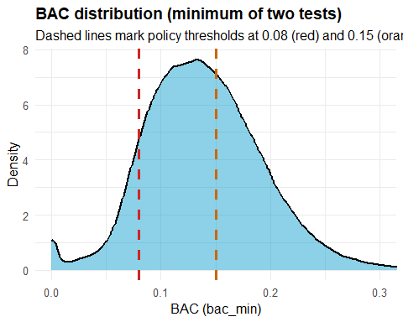

BAC distribution near the 0.08 cutoff
To check for unusual “bunching” right at the legal threshold, I zoom in on a narrow window around BAC = 0.08.
dwi_008 <- dwi %>%
filter(bac_min >= 0.03, bac_min <= 0.13)
ggplot(dwi_008, aes(x = bac_min)) +
geom_density(fill = "deepskyblue3", alpha = 0.45, linewidth = 1) +
geom_vline(xintercept = 0.08, linewidth = 1.2, linetype = "dashed", colour = "firebrick3") +
labs(
title = "BAC distribution near the 0.08 cutoff",
subtitle = "Density plot for bac_min in [0.03, 0.13]; dashed red line at 0.08",
x = "BAC (bac_min)",
y = "Density"
) +
theme_minimal(base_size = 12) +
theme(plot.title = element_text(face = "bold"))
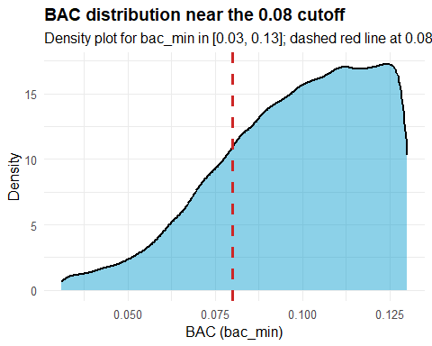

BAC distribution near the 0.15 cutoff
I also zoom in around BAC = 0.15, which corresponds to an additional increase in punishment severity. This helps assess whether there is any unusual bunching or discontinuity in the running variable near the second threshold.
dwi_015 <- dwi %>%
filter(bac_min >= 0.10, bac_min <= 0.20)
ggplot(dwi_015, aes(x = bac_min)) +
geom_density(fill = "darkorange2", alpha = 0.40, linewidth = 1) +
geom_vline(xintercept = 0.15, linewidth = 1.2, linetype = "dashed", colour = "firebrick3") +
labs(
title = "BAC distribution near the 0.15 cutoff",
subtitle = "Density plot for bac_min in [0.10, 0.20]; dashed red line at 0.15",
x = "BAC (bac_min)",
y = "Density"
) +
theme_minimal(base_size = 12) +
theme(plot.title = element_text(face = "bold"))
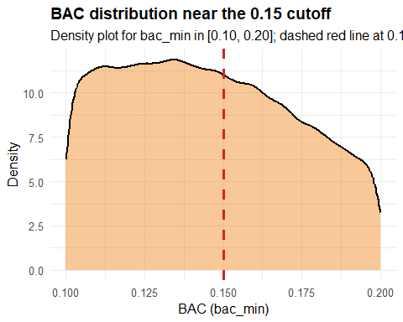

Baseline recidivism rate
As a reference point, I compute the overall recidivism rate in the full sample.
dwi %>%
summarise(
n = n(),
recidivism_rate = mean(recidivism, na.rm = TRUE)
)
n recidivism_rate
1 214558 0.1176325

Missingness check
Before making any data-cleaning decisions, I report how much ‘missingness’ exists in the key analysis variables.
key_vars <- c("bac1", "bac2", "bac_min", "recidivism", "male", "white", "aged", "acc", "year")
dwi %>%
summarise(across(all_of(key_vars), ~ mean(is.na(.)))) %>%
pivot_longer(everything(), names_to = "variable", values_to = "missing_share") %>%
arrange(desc(missing_share))
# A tibble: 9 × 2
variable missing_share
<chr> <dbl>
1 bac1 0
2 bac2 0
3 bac_min 0
4 recidivism 0
5 male 0
6 white 0
7 aged 0
8 acc 0
9 year 0

Quick near-cutoff comparison
As an initial descriptive check, I compare observations just below vs just above each cutoff within a narrow window (±0.02 BAC). This is not the final regression discontinuity estimate, but it provides an early sense of whether outcomes and co-variates look similar near the threshold.
w <- 0.02 # window size (±0.02)
summary_near <- function(cutoff) {
dwi %>%
filter(bac_min >= cutoff - w, bac_min <= cutoff + w) %>%
mutate(above = as.integer(bac_min >= cutoff)) %>%
group_by(above) %>%
summarise(
n = n(),
recid_rate = mean(recidivism),
male_share = mean(male),
white_share = mean(white),
mean_age = mean(aged),
acc_share = mean(acc),
.groups = "drop"
) %>%
mutate(cutoff = cutoff) %>%
relocate(cutoff, above)
}
bind_rows(
summary_near(0.08),
summary_near(0.15)
) %>%
arrange(cutoff, above)
# A tibble: 4 × 8
cutoff above n recid_rate male_share white_share mean_age acc_share
<dbl> <int> <int> <dbl> <dbl> <dbl> <dbl> <dbl>
1 0.08 0 14584 0.115 0.784 0.846 34.5 0.0902
2 0.08 1 25790 0.0989 0.792 0.852 33.9 0.0899
3 0.15 0 32208 0.116 0.791 0.863 34.3 0.133
4 0.15 1 28376 0.117 0.788 0.870 34.9 0.162
At 0.08, recidivism is lower just above the cutoff (≈ 0.0989) than just below (≈ 0.1147). At 0.15, recidivism is very similar (slightly higher above).

Interim takeaways from initial exploration
At this stage, I have- (i) created the running variable for the regression discontinuity design (bac_min, defined as the minimum of the two BAC tests), (ii) checked basic data quality.
The distribution of bac_min looks smooth overall and around both policy cutoffs (0.08 and 0.15) based on the density plots. ‘Missingness’ is effectively zero in the key variables used in later analysis, so no sample exclusions are required for missing data.
As an initial descriptive comparison within ±0.02 of each cutoff, recidivism appears lower just above 0.08 than just below, while around 0.15 the difference is small. These comparisons are descriptive and do not yet isolate the causal effect; they mainly motivate the formal RDD analysis in the next stage.

Difference summary table
near_tbl <- bind_rows(
summary_near(0.08),
summary_near(0.15)
)
near_tbl %>%
group_by(cutoff) %>%
summarise(
diff_recid = recid_rate[above == 1] - recid_rate[above == 0],
diff_male = male_share[above == 1] - male_share[above == 0],
diff_white = white_share[above == 1] - white_share[above == 0],
diff_age = mean_age[above == 1] - mean_age[above == 0],
diff_acc = acc_share[above == 1] - acc_share[above == 0],
.groups = "drop"
)
# A tibble: 2 × 6
cutoff diff_recid diff_male diff_white diff_age diff_acc
<dbl> <dbl> <dbl> <dbl> <dbl> <dbl>
1 0.08 -0.0158 0.00735 0.00596 -0.606 -0.000356
2 0.15 0.00128 -0.00277 0.00775 0.516 0.0294

Causal Logic
The problem with estimating whether harsher punishments reduce recidivism is that BAC level affects the punishment the driver receives and their likelihood of re-offending. This creates a back door where drivers with higher BAC levels are not just receiving harsher punishments, but also may be differing in other characteristics, like risk tolerance, poor judgment, or alcoholism, that may affect whether they re-offend. Because of this, we cannot simply compare low BAC and high BAC drivers.
This problem can be addressed with the usage of a regression discontinuity design. Washington State has two BAC thresholds at 0.08 and 0.15, which when crossed trigger different punishments. Because drivers cannot control their BAC reading when being pulled over, those that land just above and just below the cutoff are essentially identical people who happened to have slightly different BAC readings. The only material difference between these two groups is the punishment that they received. Because of this, it means that any difference in recidivism observed near the cutoff can be attributed to the punishment rather than any other differences in the drivers. Now that we have established this logic, we can now test whether the key assumptions of the design actually hold in the data.

Checking Data for Lumping
Now that the data has been cleaned and the causal logic has been explained, we need to test whether the assumptions of the RDD design are present in the data. Before we can begin performing our RDD analysis, we need to make sure that there is no manipulation of BAC that influences whether the drivers end up on one side of the cutoff or the other. This will be achieved with a lumping test. Next, we need to ensure that the drivers just above and below the cutoff are materially similar to each other. We will achieve this by performing placebo regressions.
We need to check that there is no manipulation in the running variable around the cutoff point. To do this, we will graphically look at the data, by creating bins, and check to see if there is a jump at the cutoff in the number of observations.
#Check lumping at the 0.08 cutoff
dwi_bin_count <- dwi %>%
filter(bac_min >= 0.03, bac_min <= 0.13) %>%
mutate(bac_bins = cut(bac_min, breaks = 3:13/100)) %>%
group_by(bac_bins) %>%
count()
#Create plot to visualize the data
ggplot(dwi_bin_count, aes(x = bac_bins, y = n)) +
geom_col() +
geom_vline(xintercept = 5.5,
color = "red", linetype = "dashed") +
labs(title = "Observation counts near 0.08 BAC cutoff",
x = "BAC bin", y = "Count") +
theme_minimal() +
theme(axis.text.x = element_text(angle = 45, hjust = 1))
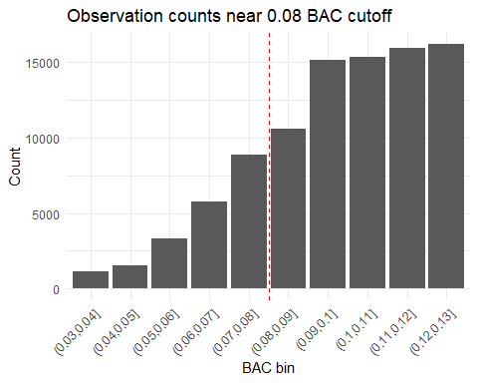
#Check for lumping at the 0.15 cutoff
dwi_bin_count_0.15 <- dwi %>%
filter(bac_min >= 0.10, bac_min <= 0.20) %>%
mutate(bac_bins = cut(bac_min, breaks = 10:20/100)) %>%
group_by(bac_bins) %>%
count()
#Create plot to visualize the data
ggplot(dwi_bin_count_0.15, aes(x = bac_bins, y = n)) +
geom_col() +
geom_vline(xintercept = 5.5,
color = "red", linetype = "dashed") +
labs(title = "Observation counts near 0.15 BAC cutoff",
x = "BAC bin", y = "Count") +
theme_minimal() +
theme(axis.text.x = element_text(angle = 45, hjust = 1))
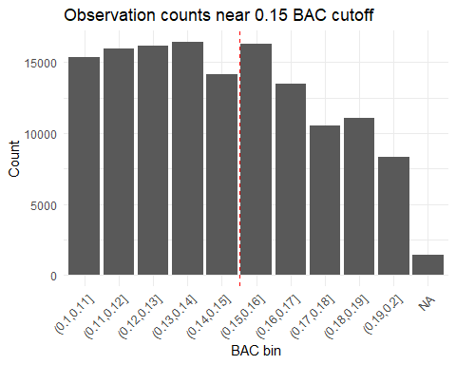
Both of the bar charts above show that there is no obvious peak just beneath the 0.08 or 0.15 cutoff. This means that there is no indication that BAC levels have been manipulated to land on one side of the cutoff or the other. Both charts show a relatively consistent shape of the data, which means that we can trust that there is no manipulation in the running variable. We can now proceed with our placebo testing.

Run Placebo Tests
The second part of reviewing the data is to run placebo tests. We do this because we need to ensure that the other key RDD assumption is true, meaning that the only thing that changes at the cutoff is the punishment. To perform this test, we will re-run the RDD regressions but swap out recidivism with our other variables (male, white, aged, acc). If this key assumption holds, we should not expect to see any jump at the cutoff for any of these variables. If we do see a jump at the cutoff in any of these variables, then that would suggest that our two groups (above and below the threshold BAC level) differ in other ways, thus making our comparison invalid. We will perform this check for both the 0.08 BAC cutoff and the 0.15 BAC cutoff.
#Create centered variable for BAC at 0.08 cutoff
dwi <- dwi %>%
mutate(bac_centered_08 = bac_min - 0.08)
#Run regression for placebo tests at 0.08 cutoff
p1 <- feols(male ~ above_08*bac_centered_08, data = dwi %>% filter(abs(bac_centered_08) < 0.05))
p2 <- feols(white ~ above_08*bac_centered_08, data = dwi %>% filter(abs(bac_centered_08) < 0.05))
p3 <- feols(aged ~ above_08*bac_centered_08, data = dwi %>% filter(abs(bac_centered_08) < 0.05))
p4 <- feols(acc ~ above_08*bac_centered_08, data = dwi %>% filter(abs(bac_centered_08) < 0.05))
etable(p1, p2, p3, p4)
p1 p2
Dependent Var.: male white
Constant 0.7853*** (0.0044) 0.8478*** (0.0039)
above_08 0.0057 (0.0055) 0.0038 (0.0048)
bac_centered_08 -0.1752 (0.2321) 0.0552 (0.2029)
above_08 x bac_centered_08 0.2947 (0.2567) 0.0488 (0.2244)
__________________________ __________________ __________________
S.E. type IID IID
Observations 92,158 92,158
R2 6.05e-5 8.86e-5
Adj. R2 2.8e-5 5.6e-5
p3 p4
Dependent Var.: aged acc
Constant 33.92*** (0.1265) 0.0825*** (0.0033)
above_08 -0.1647 (0.1573) -0.0022 (0.0041)
bac_centered_08 -66.52*** (6.622) -1.044*** (0.1730)
above_08 x bac_centered_08 73.75*** (7.324) 1.901*** (0.1914)
__________________________ _________________ __________________
S.E. type IID IID
Observations 92,158 92,158
R2 0.00232 0.00163
Adj. R2 0.00229 0.00160
---
Signif. codes: 0 '***' 0.001 '**' 0.01 '*' 0.05 '.' 0.1 ' ' 1
When looking at the above table, we can see that the coefficients on the above_08 variable are insignificant in all four of the placebo tests. This means that gender, race, age and whether there was an accident do not jump at the 0.08 cutoff. Because of this, we can confidently say that drivers above and below the BAC threshold and essentially identical for our purposes.
#Create centered variable for BAC at 0.15 cutoff
dwi <- dwi %>%
mutate(bac_centered_15 = bac_min - 0.15)
#Run regression for placebo tests as 0.15 cutoff
p5 <- feols(male ~ above_15*bac_centered_15, data = dwi %>% filter(abs(bac_centered_15) < 0.05))
p6 <- feols(white ~ above_15*bac_centered_15, data = dwi %>% filter(abs(bac_centered_15) < 0.05))
p7 <- feols(aged ~ above_15*bac_centered_15, data = dwi %>% filter(abs(bac_centered_15) < 0.05))
p8 <- feols(acc ~ above_15*bac_centered_15, data = dwi %>% filter(abs(bac_centered_15) < 0.05))
etable(p5, p6, p7, p8)
p5 p6
Dependent Var.: male white
Constant 0.7891*** (0.0029) 0.8646*** (0.0025)
above_15 -0.0013 (0.0042) 0.0044 (0.0036)
bac_centered_15 -0.1876. (0.1008) 0.2457** (0.0852)
above_15 x bac_centered_15 0.2263 (0.1558) -0.1774 (0.1317)
__________________________ __________________ __________________
S.E. type IID IID
Observations 138,308 138,308
R2 6.65e-5 0.00037
Adj. R2 4.48e-5 0.00035
p7 p8
Dependent Var.: aged acc
Constant 34.51*** (0.0821) 0.1438*** (0.0025)
above_15 0.0560 (0.1191) 0.0068. (0.0037)
bac_centered_15 15.39*** (2.829) 0.9704*** (0.0868)
above_15 x bac_centered_15 9.989* (4.372) 0.2671* (0.1342)
__________________________ _________________ __________________
S.E. type IID IID
Observations 138,308 138,308
R2 0.00249 0.00865
Adj. R2 0.00247 0.00863
---
Signif. codes: 0 '***' 0.001 '**' 0.01 '*' 0.05 '.' 0.1 ' ' 1
When looking at the above table for the results of our 0.15 BAC placebo tests, we can say the same thing. The coefficients on the above_15 variable are not significant for gender, race, age, or whether there was an accident either. This means that there are no indications that other variables outside of the treatment or the outcome are jumping at the cutoff. We can proceed with running our regressions on the data.

Run Regressions
Now that we have checked the key assumptions in our data set, we can proceed with the main analysis. We want to determine whether crossing the BAC threshold, and receiving a harsh punishment, causes a decrease in recidivism. First, we will center the running variable around each cutoff point, create a treatment indicator for being above the threshold and then interact these two variables. The coefficient on the treatment indicator shows the jump in recidivism at the cutoff, which is our estimate of the effect of a harsher punishment. We will run three different variations for each cutoff: 1) a wider window of 0.05, 2) a narrower window of 0.02, and 3) a wide window with our additional variables added as controls. We will compare our results among these three variations to see if our results are stable.
r1 <- feols(recidivism ~ above_08 * bac_centered_08,
data = dwi %>% filter(abs(bac_centered_08) < 0.05))
etable(r1)
r1
Dependent Var.: recidivism
Constant 0.1123*** (0.0034)
above_08 -0.0188*** (0.0042)
bac_centered_08 -0.2613 (0.1772)
above_08 x bac_centered_08 0.6904*** (0.1960)
__________________________ ___________________
S.E. type IID
Observations 92,158
R2 0.00054
Adj. R2 0.00051
---
Signif. codes: 0 '***' 0.001 '**' 0.01 '*' 0.05 '.' 0.1 ' ' 1
Based on the results of the above table for our first variation where we use a window of 0.05, the coefficient on above_08 is -0.0188 and higly significant at p < 0.001. This means that drivers above the 0.08 threshold had a recidivism rate of about 1.9 percentage points lower than drivers below the cutoff. Since the overall recidivism rate is 11.8%, this decrease shows a significant drop in repeat offenders.
r2 <- feols(recidivism ~ above_08 * bac_centered_08,
data = dwi %>% filter(abs(bac_centered_08) < 0.02))
etable(r2)
r2
Dependent Var.: recidivism
Constant 0.1074*** (0.0045)
above_08 -0.0133* (0.0062)
bac_centered_08 -0.8974* (0.4543)
above_08 x bac_centered_08 1.262* (0.5789)
__________________________ __________________
S.E. type IID
Observations 38,962
R2 0.00083
Adj. R2 0.00075
---
Signif. codes: 0 '***' 0.001 '**' 0.01 '*' 0.05 '.' 0.1 ' ' 1
When we narrow the window from 0.05 to 0.02, the coefficient on above_08 is -0.0133 and still significant at p < 0.05. This result is smaller than our wider window of 0.05, nonetheless it still aligns with our result when we used the wider window.
r3 <- feols(recidivism ~ above_08 * bac_centered_08 + male + white + aged,
data = dwi %>% filter(abs(bac_centered_08) < 0.05))
etable(r3)
r3
Dependent Var.: recidivism
Constant 0.1019*** (0.0054)
above_08 -0.0192*** (0.0042)
bac_centered_08 -0.3129. (0.1770)
male 0.0331*** (0.0025)
white 0.0157*** (0.0029)
aged -0.0009*** (8.82e-5)
above_08 x bac_centered_08 0.7427*** (0.1958)
__________________________ ____________________
S.E. type IID
Observations 92,158
R2 0.00360
Adj. R2 0.00353
---
Signif. codes: 0 '***' 0.001 '**' 0.01 '*' 0.05 '.' 0.1 ' ' 1
When we add our demographic variables as controls, the coefficient on above_08 at -0.0192 is very similar to our initial regression and equally significant at p< 0.001. We have included these controls (male, white, aged) because they can affect recidivism, for example a young male driver is more likely to be a repeat offender. However it is important to note that they do not jump at the cutoff which we confirmed in our placebo tests. We do not include the acc variable as whether there was an accident or not can be influenced by the BAC variable, which would introduce bias into the model. Given that our coefficients on above_08 have generally remained stable across the three variations, it improves our confidence that the effect is real.
We will now repeat our analysis from our first regression, using a wide window of 0.05, but not at the 0.15 threshold. If it is true that harsher punishments decrease drunk driving, we would expect to see a further drop in recidivism for drivers that receive the most severe punishments.
r4 <- feols(recidivism ~ above_15 * bac_centered_15,
data = dwi %>% filter(abs(bac_centered_15) < 0.05))
etable(r4)
r4
Dependent Var.: recidivism
Constant 0.1206*** (0.0023)
above_15 -0.0075* (0.0033)
bac_centered_15 0.3643*** (0.0795)
above_15 x bac_centered_15 0.0634 (0.1228)
__________________________ __________________
S.E. type IID
Observations 138,308
R2 0.00059
Adj. R2 0.00057
---
Signif. codes: 0 '***' 0.001 '**' 0.01 '*' 0.05 '.' 0.1 ' ' 1
At the 0.15 threshold using a wide window of 0.05, the coefficient on above_15 is -0.0075 and significant at p < 0.05. This means that drivers above the 0.15 threshold had a recidivism rate of 0.75 percentage points lower than drivers below the cutoff. Although the effect is smaller than the one estimated at the 0.08 cutoff, it still supports the belief that harsher punishments decrease recidivism.
r5 <- feols(recidivism ~ above_15 * bac_centered_15,
data = dwi %>% filter(abs(bac_centered_15) < 0.02))
etable(r5)
r5
Dependent Var.: recidivism
Constant 0.1247*** (0.0037)
above_15 -0.0103* (0.0052)
bac_centered_15 0.8516** (0.3099)
above_15 x bac_centered_15 -0.5693 (0.4542)
__________________________ __________________
S.E. type IID
Observations 60,584
R2 0.00014
Adj. R2 9.1e-5
---
Signif. codes: 0 '***' 0.001 '**' 0.01 '*' 0.05 '.' 0.1 ' ' 1
When we narrow to a 0.02 window, the coefficient on above_15 is -0.0103 and significant at p < 0.05. Similar to our result of the narrow window on the above_08 cutoff, this estimate is somewhat noisier, however the direction and significance still align with our other results.
r6 <- feols(recidivism ~ above_15 * bac_centered_15 + male + white + aged,
data = dwi %>% filter(abs(bac_centered_15) < 0.05))
etable(r6)
r6
Dependent Var.: recidivism
Constant 0.1183*** (0.0044)
above_15 -0.0075* (0.0033)
bac_centered_15 0.3799*** (0.0794)
male 0.0292*** (0.0021)
white 0.0055* (0.0025)
aged -0.0007*** (7.56e-5)
above_15 x bac_centered_15 0.0651 (0.1227)
__________________________ ____________________
S.E. type IID
Observations 138,308
R2 0.00265
Adj. R2 0.00260
---
Signif. codes: 0 '***' 0.001 '**' 0.01 '*' 0.05 '.' 0.1 ' ' 1
When we add demographic controls, the coefficient on above_15 is -0.0075 (the same as our first estimate for the 0.15 cutoff) and is significant at p < 0.05. Just like our regression with controls at the 0.08 cutoff, the addition of these controls do not materially change our results, which is what we would expect to see given the results of our placebo tests.
Putting it all together, the above results show us similar effects. Crossing the first cutoff of 0.08 reduces recidivism by about 1.9 percentage points, and crossing the 0.15 cutoff reduces recidivism by an additional 0.75 percentage points. Both of these effects are statistically significant and remain consistent across different window sizes and the addition of demographic controls. Therefore, we can say that harsher punishments do reduce the likelihood of re-offending.

