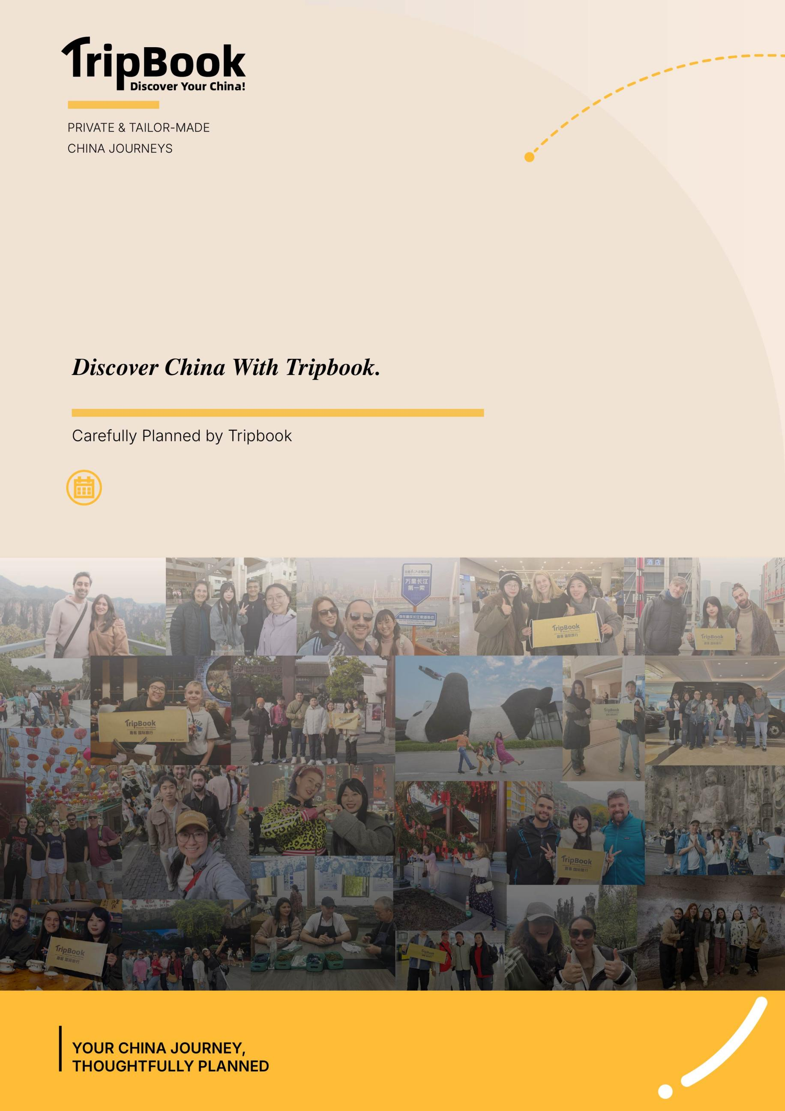
September 14 - September 19,2026
6 Days
The Guest Traveler Family
China Journey 2026
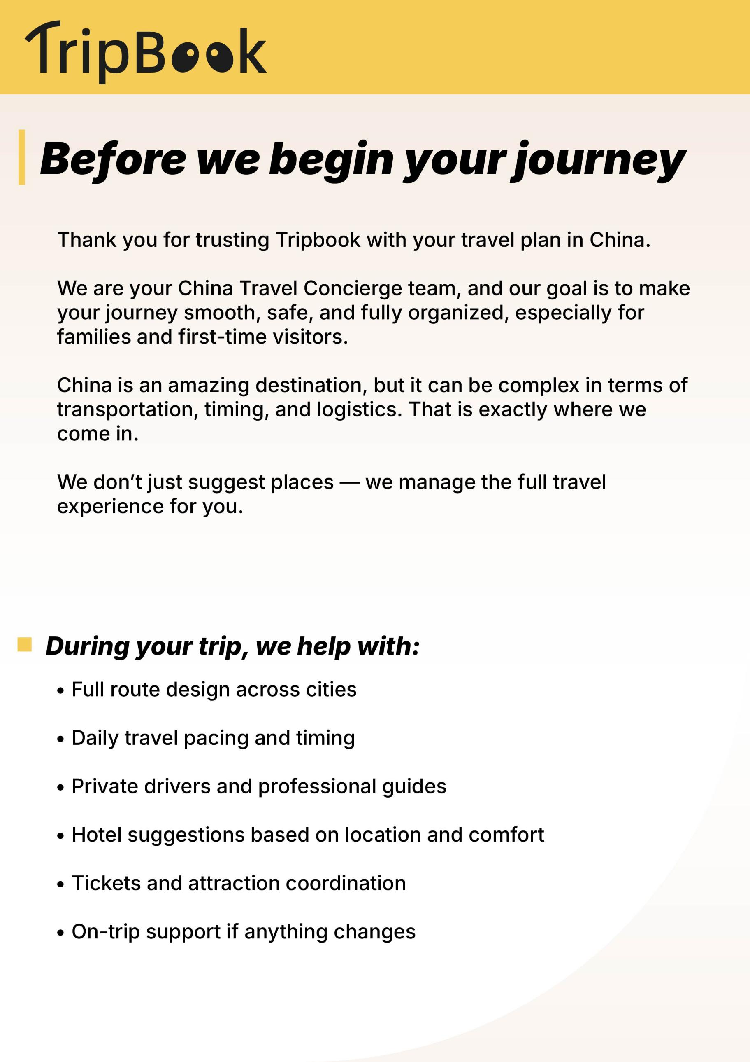

Guest Traveler’s China Discovery Journey

Client Information:
* Name: Guest Traveler
* Number of travelers: 6 travelers (6 adults)
* Travel dates: September 14 - September 19
*Total Travel Duration: 6 Days, including arrival and departure dates
*Destination: Shanghai, Xi'an, Zhangjiajie

What happens next
Once you review this plan, we will take care of the next steps for you.
• We refine details based on your feedback
• We finalize drivers, guides, and all logistics on the ground
• We prepare every part of your journey before your arrival in China
Everything will be coordinated in advance, so your trip feels smooth and fully organized from the moment you land.

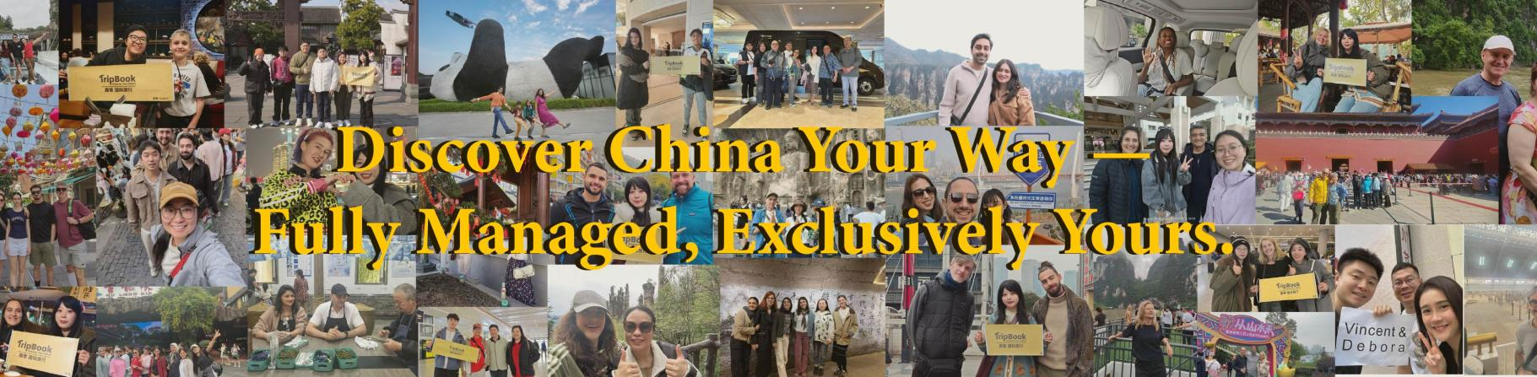

Day 1 ｜ September 14 ｜ Shanghai
Private Transfer: Yes (Full-day private vehicle)
Guide: No

Morning ｜ No Activities
The day is focused on arrival, with no sightseeing scheduled for the morning.

Afternoon ｜ Arrive in Shanghai — Maglev Train — Jing'an Temple
Upon arriving at Shanghai Pudong or Hongqiao Airport, your private driver will meet you. You can experience riding the Maglev Train into the city, then head to Jing'an Temple for a visit. Tucked away in the middle of the bustling city, the golden-roofed temple creates a striking contrast with the surrounding office towers. Step inside to see the main hall and the bronze pagoda.

Evening ｜ Huangpu River Night Cruise
In the evening, take a night cruise on the Huangpu River to see the lights on both banks and the Bund's architectural ensemble from the water. The boat is comfortable and a relaxing way to unwind after your arrival.

Day 2 ｜ September 15 ｜ Shanghai → Xi'an
Private Transfer: Yes (Full-day private vehicle, airport drop-off)
Guide: Yes

Morning ｜ The Bund — Nanjing Road Pedestrian Street
After breakfast, your driver and guide will meet you at the hotel and take you to the Bund for a walk along the river to see the colonial-era architecture ensemble and the Lujiazui skyline across the water. Then continue on foot into Nanjing Road Pedestrian Street, from traditional department stores to modern shopping malls, and stroll along the way.

Afternoon ｜ Yu Garden — City God Temple
In the afternoon, head to the Yu Garden and City God Temple area. Yu Garden is a classical Jiangnan garden from the Ming Dynasty — compact in size but intricately laid out, featuring rockeries, ponds, winding corridors, and pavilions. The nearby City God Temple area is home to many traditional snacks and time-honored shops — try some Nanxiang xiaolongbao (soup dumplings).

Evening ｜ Transfer to Shanghai Airport — Night Flight to Xi'an
In the evening, depending on the flight schedule, your driver will transfer you to the Shanghai airport to board a night flight to Xi'an. Rest on the flight. Upon arrival, a local driver will meet you and transfer you to the hotel for check-in.

Day 3 ｜ September 16 ｜ Xi'an
Private Transfer: Yes (Full-day private vehicle)
Guide: Yes

Morning ｜ Terracotta Army Museum
After breakfast, your driver and guide will take you to the Terracotta Army Museum in Lintong. Start with Pit No. 1 to see the largest military formation, then visit Pits No. 2 and 3 to see different military units and excavated artifacts. Your guide will explain the excavation process and the military system of the Qin Dynasty.

Afternoon ｜ Huaqing Palace
After the Terracotta Army, head to Huaqing Palace, a Tang Dynasty imperial hot spring retreat. View the bathing pool ruins including the Lotus Pool and Begonia Pool, as well as the Five-Room Hall, site of the Xi'an Incident. In the afternoon, stroll through the garden area at the foot of Mount Li.

Evening ｜ Great Tang All Day Mall
In the evening, head to the Great Tang All Day Mall, a pedestrian street featuring Tang Dynasty-inspired architecture. Once the lights come on, parades and street performances fill the area. Stroll along and enjoy the sights — the roly-poly performer is one of the most popular attractions that draws crowds.

Day 4 ｜ September 17 ｜ Xi'an → Zhangjiajie
Private Transfer: Yes (Full-day private vehicle, airport drop-off + airport pick-up)
Guide: Yes

Morning ｜ Early Flight to Zhangjiajie
After breakfast, your driver will transfer you to the Xi'an airport to board an early flight to Zhangjiajie. Upon arrival, a local driver and guide will meet you at the airport.

Afternoon ｜ Tianmen Mountain
In the afternoon, head to Tianmen Mountain and take the cable car up, overlooking the city and the winding mountain road on the way. On the mountain, walk along the cliffside path and visit Tianmen Mountain Temple, with views extending to distant ridgelines.

Evening ｜ Furong Town
In the late afternoon, head to Furong Town to see the waterfall night view and the illuminated stilted houses. The ancient town is built above a waterfall, and once the lights come on at night, the layered scenery is stunning. After the visit, return to your hotel in Zhangjiajie and rest.

Day 5 ｜ September 18 ｜ Zhangjiajie
Private Transfer: Yes (Full-day private vehicle)
Guide: Yes

Morning ｜ Zhangjiajie National Forest Park
After breakfast, enter Zhangjiajie National Forest Park through the Forest Park ticket gate and walk along Golden Whip Stream to see quartz sandstone pillar forests and streams on both sides. Morning light filtering through the gorge makes for a pleasant walk.

Afternoon ｜ Zhangjiajie National Forest Park
In the afternoon, take the park shuttle up the mountain and view the full panorama of the pillar forest from various lookout points. Your guide will take you to the best vantage points. There is a fair amount of mountain walking, so feel free to go at your own pace.

Evening ｜ Hotel Rest — Pack
Return to the hotel, rest, and pack for tomorrow's departure to Beijing.

Day 6 ｜ September 19 ｜ Zhangjiajie → Beijing
Private Transfer: Yes (Station drop-off)
Guide: No

Morning ｜ Early Train to Beijing
After breakfast, your driver will transfer you to the station to board an early train to Beijing. The journey is fairly long — rest on the train.

Afternoon ｜ Arrive in Beijing — Hotel Check-in
Upon arrival in Beijing, transfer to the hotel for check-in. The afternoon is for resting and adjusting to the pace of the city, recharging for the days ahead.

