Proposed Robot Design
Overall idea: The robot should be easy to CAD, manufacture, assemble, test, and modify within the available lab time. The design is based on a simple two-layer acrylic robot structure, a bit similar to my Term 2 group robot
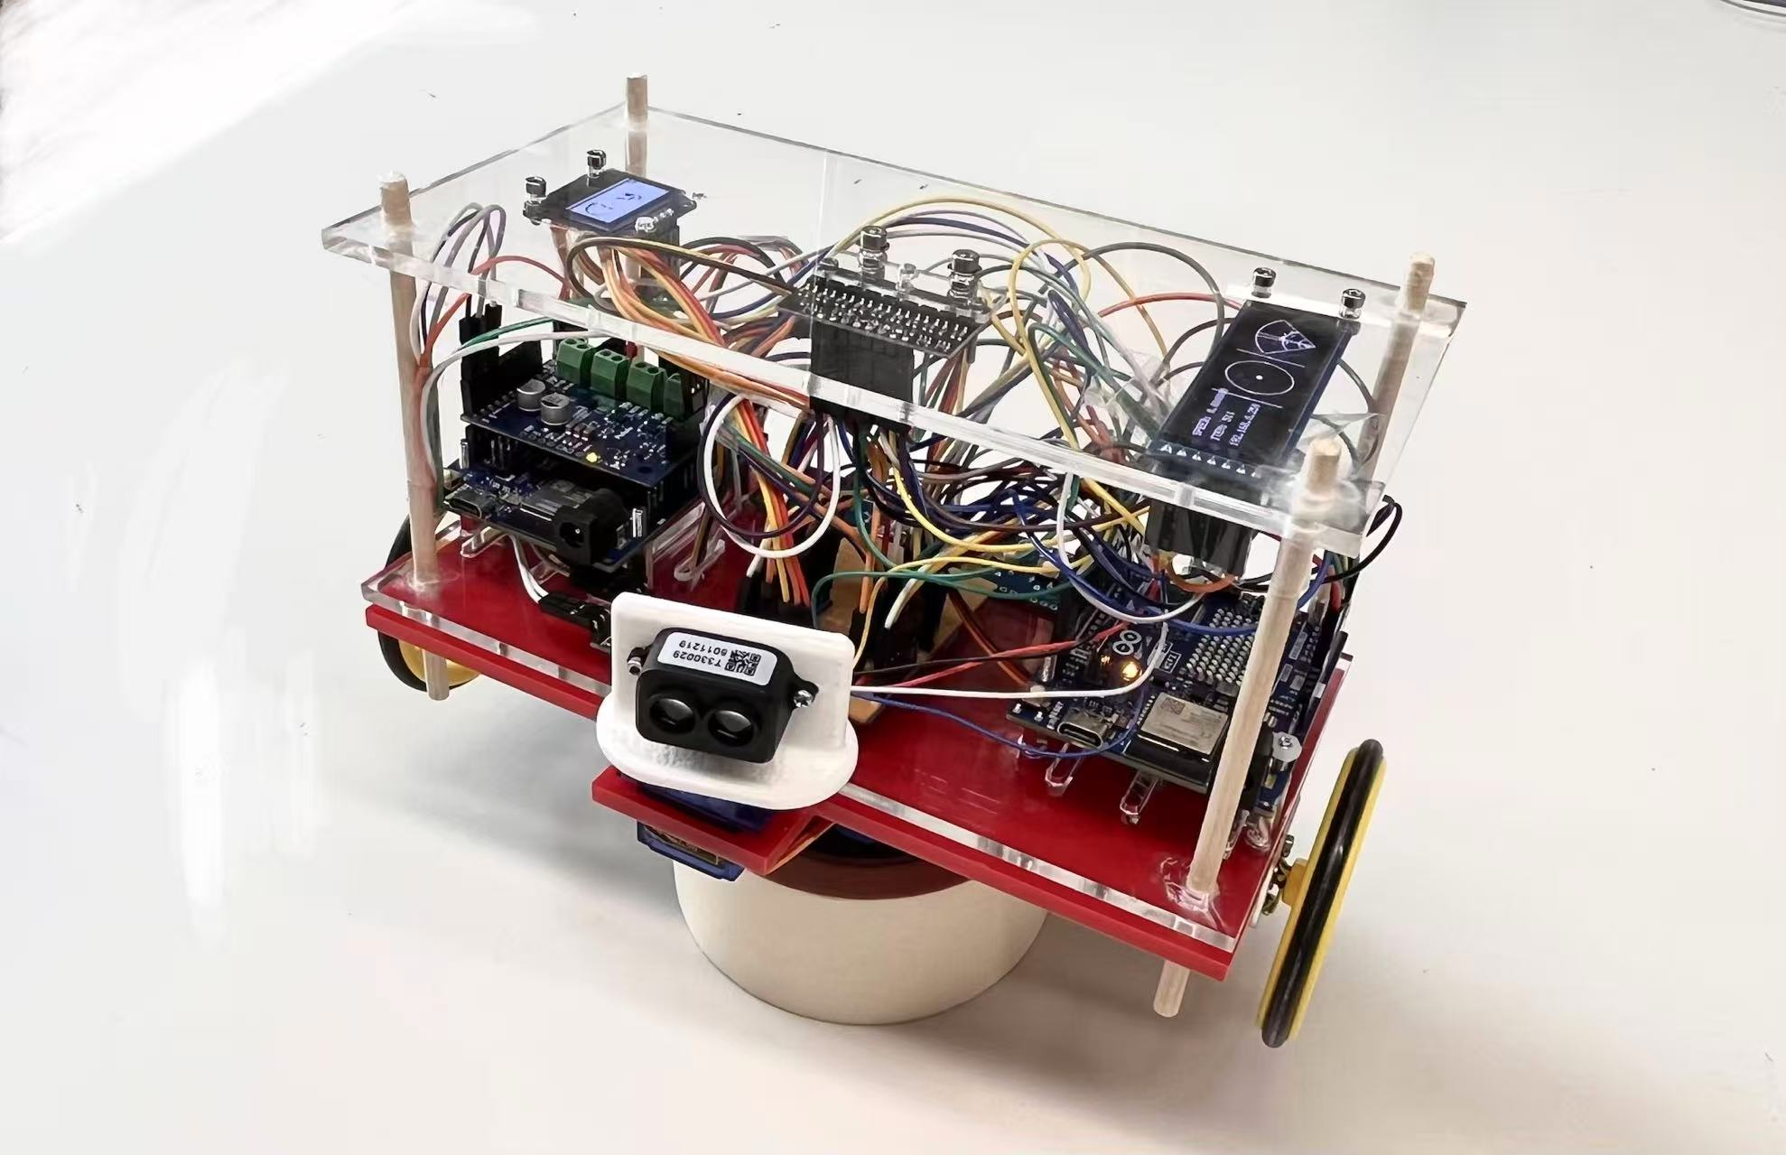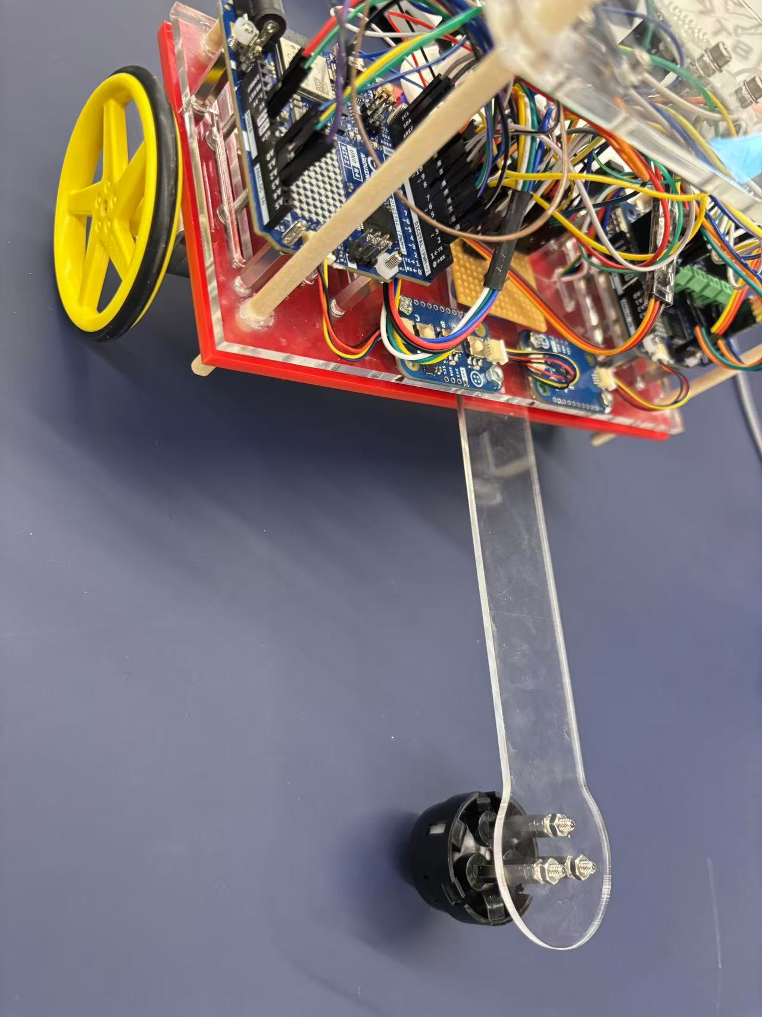

Quick Design Summary
Subsystem | Proposed design
Drivetrain | Two-wheel differential drive + rear caster wheel / ball caster
Chassis | Two-layer laser-cut acrylic chassis with standoffs
Controller | Arduino GIGA R1 WiFi on the upper deck
Motor driver | Motoron M3S550 motor driver board on the upper deck
Line following | Front-bottom reflectance sensor array, height-adjustable
Distance sensing | Front ToF distance sensor; optional side ToF if time allows
RFID | Bottom-mounted RFID reader close to the seed outlet
Planting | Low-profile angled 5-seed hopper + SG90 servo gate
Reviving | Wide front bumper button + top red/green LED
Safety | Top hardware kill switch + WiFi software kill switch
Target size | Approximately 190 mm x 170 mm x 130-140 mm

1. Drivetrain
I think we should make the robot a two-wheel differential-drive car, with one rear caster wheel or ball caster for support. This would be similar to the robot my group built in Term 2.
The reason for this choice is that it is simple and realistic for us to build. It is easy to control, has a small turning radius, saves material, and works well for line following. It also means we do not need a complicated steering mechanism. From the software side, we only need to control the speed of the left and right motors.

2. Chassis Design
I think we should use a two-layer acrylic chassis.
The lower layer can hold the motors, battery, RFID reader, reflectance line sensor, seed outlet, and some of the wiring.
The upper layer can hold the Arduino GIGA, Motoron motor driver board, hardware kill switch, LED, and the support structure for the planting mechanism.
This layout should make the robot easier to manufacture, assemble, debug, and modify later.

3. Electronics Placement
The Arduino GIGA R1 WiFi and the Motoron M3S550 should be mounted on the upper acrylic plate.(not sure because I don’t know the exact weight)
The battery should be mounted on the lower layer and placed as close to the centre of the robot as possible.
The reason is that the Arduino and Motoron need to be easy to access for wiring, debugging, and replacement. The battery is relatively heavy, so placing it low and central will lower the centre of gravity. This should make the robot more stable when turning, going through the tunnel, or moving on small ramps.

4. Reflectance Line Sensor
The reflectance sensor array should be mounted at the front bottom of the robot, as close to the ground as possible.
The suggested height is around 3-8 mm above the ground.
Its job is to detect the black lines on the floor so the robot can follow them.
The reason for placing it at the front is that the robot can detect the line earlier and correct its direction before it drifts too much. If the sensor is too far back, the robot may already be off the line before it reacts.
From my Term 2 experience, this kind of sensor can be unreliable if the height is not correct. So I think the sensor bracket should be height-adjustable, because the reflectance sensor is sensitive to both distance from the ground and lighting conditions. We may need to fine-tune it during testing.

5. Distance Sensor
I think we should add a ToF distance sensor at the front of the robot.
It should face forward and be placed above the reflectance sensor array.
Its purpose is to detect the distance to walls, detect the airlock door position, prevent the robot from crashing, detect obstacles or other robots in front, and help with emergency return if we need to follow another robot without hitting it.
If we have time, we could also add a side ToF sensor for wall following. However, the front ToF sensor should be the priority, because it is more directly useful for stopping and obstacle detection.
For obstacle avoidance, I have not fully decided on the final strategy yet, but using a ToF distance sensor seems like the most realistic option.

6. RFID Reader
The RFID reader should be mounted underneath the robot, near the front-middle area, and as close as possible to the seed outlet.
The reason is that each planting hole in the main arena has an RFID tag underneath it. When the robot reads a tag, it sends the tag ID to the server through WiFi and asks whether that location is fertile or infertile. If the location is fertile, the robot plants one seed.
If the RFID reader and the seed outlet are far apart, the robot would need to move again after reading the tag, which could introduce positioning errors. If we keep the RFID reader and seed outlet close together, the robot can almost plant in place after reading a valid tag, which should improve accuracy.

7. Planting Mechanism
For the planting mechanism, I suggest using a low-profile angled seed hopper(because height limit is 15cm), an SG90 servo gate, and a bottom seed outlet.
The seed diameter is about 12.7 mm, so the internal diameter or width of the hopper should be around 14-16 mm.
The hopper should hold up to 5 seeds. The seeds can sit in an angled tube or channel, with the lowest seed near the outlet. When the robot needs to plant, the SG90 servo opens a small gate, releases one seed, and then closes again.
The reason for using an angled hopper is that it is lower than a vertical tube, so it is less likely to exceed the 15 cm height limit. It also keeps the centre of gravity lower, which makes the robot more stable. The structure is simple, easy to 3D print or make with a tube, and the SG90 servo is cheap, common, and easy to control with Arduino. We only need two positions: closed(0 degree of servo) and open(90 degree of servo).
The main risk is releasing more than one seed at a time. To avoid this, the outlet should ideally have a small single-seed pocket, so only one seed can reach the outlet at a time.

8. Seed Outlet Position
The seed outlet should be on the bottom of the robot and close to the RFID reader.
The reason is that the planting position depends on the RFID tag. If the RFID reader detects the correct tag but the seed outlet is far away, the seed may miss the hole. Keeping the RFID reader and seed outlet close together reduces alignment error and should improve planting accuracy.

9. Revive Mechanism
The robot needs a mechanical revive button or bumper at the front.
I suggest using a wider front bumper plate with a push button or micro switch behind it.
When another robot touches or pushes the front bumper, the button will be pressed, and the top LED should change from red to green.
The reason is that a small button may be difficult for another robot to press accurately. A wider bumper gives a larger contact area and makes the revive mechanism easier to trigger during the actual challenge.

10. Top LED
We need a red/green LED indicator on the top of the robot.
The default state should be red. After the front revive button is pressed, it should turn green.
This makes it easy for people and the judges to see whether the robot has been revived. The LED should be placed on top so it is visible, but we still need to make sure the total height stays under 15 cm.

11. Kill Switches
The robot needs two kill switches: a top hardware kill switch and a WiFi software kill switch.
The hardware kill switch should be on the top of the robot, ideally as a clear red button. It is for safety, so someone can stop the robot quickly.
The software kill switch will be implemented through WiFi and code. If the server sends a stop command, the Arduino should immediately stop the motors.
So mechanically, we need to leave space and mounting holes for the top hardware kill switch. In software, we need to include the WiFi kill switch in the robot state machine.

12. Overall Layout Summary
The robot should include the following main elements:
- a two-layer acrylic chassis
- left and right drive wheels
- one rear caster wheel or ball caster
- Arduino GIGA R1 WiFi as the main controller
- Motoron M3S550 motor driver for motor control
- front-bottom reflectance sensor array for line following
- front ToF distance sensor for wall distance and obstacle detection
- bottom RFID reader for identifying planting locations
- low-mounted battery compartment for better stability
- front revive button / bumper
- top red/green LED indicator
- top hardware kill switch
- simple angled seed hopper for up to 5 seeds
- SG90 servo gate to release one seed at a time
- bottom seed outlet close to the RFID reader
Target dimensions: approximately 190 mm x 170 mm x 130-140 mm. This keeps the robot safely under the maximum size limit of 20 x 20 x 15 cm.

13. Suggested Physical Layout
Front: revive bumper button, ToF distance sensor, reflectance sensor array.
Bottom / front-middle: RFID reader, seed outlet.
Middle: left and right motors, left and right drive wheels, low-mounted battery.
Upper layer: Arduino GIGA, Motoron M3S550, hardware kill switch, red/green LED, tidy wiring.
Rear or rear-side: low-profile angled seed hopper, SG90 servo gate.
Rear bottom: caster wheel or ball caster.

This is the image from gpt5.5, which is not accurate and there are some mistakes. You guys can have a look because the words are abstract, I think image is better to understand.