# Instruction

## Software Installation and Environment Configuration

1. Download **Java SE Development Kit 8**, and install it on your laptop based on the instruction.
2. Go to the **Environmental Variable** configuration on your laptop, create a variable called **JAVA_HOME** and value should be the installation path of your jdk
3. And then add following strings to end of the system variable - **CLASSPATH** %JA V A_HOME%\lib;%JA V A_HOME%\lib\dt.jar;%JA V A_HOME%\lib\to ols.jar;%TOMCAT_HOME%\lib\servlet-api.jar;
4. Download **Eclipse** IDE (Version: Mars Release 1 (4.5.0)) on your laptop; Select the right version for your computer (Mac or Windows)
5. Specify the folder where you want Eclipse to be installed. The default folder will be in your User directory.
6. Select the ‘Install’ button to begin the installation.
7. Once the installation is complete you can now launch Eclipse.

## Import Project

1. Open Eclipse, click on “File” button on top menu 🡪 “Import..” 🡪 “Existing Projects into Workspace” 🡪 “Next” 🡪 select the root directory of my project on your computer 🡪 “Next”

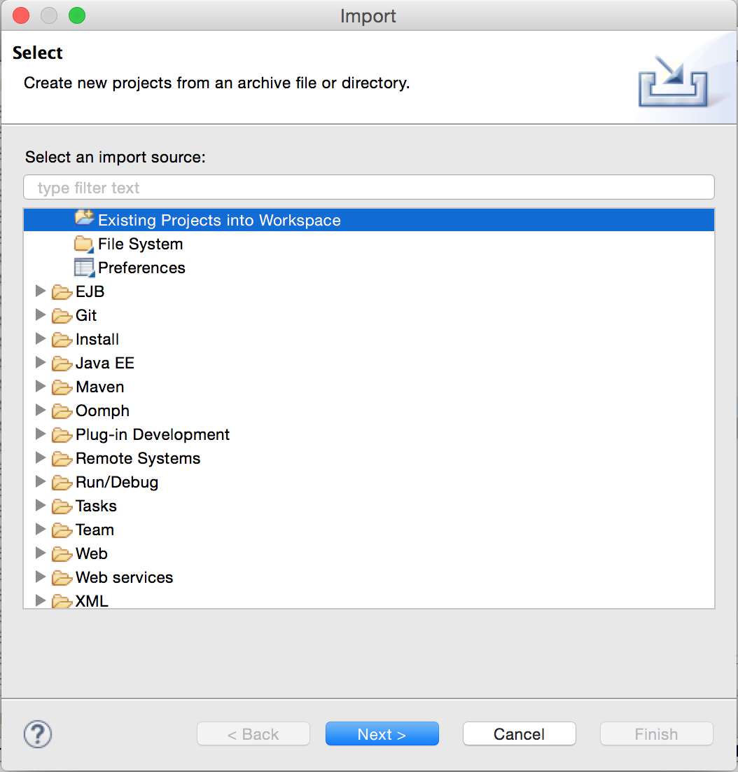

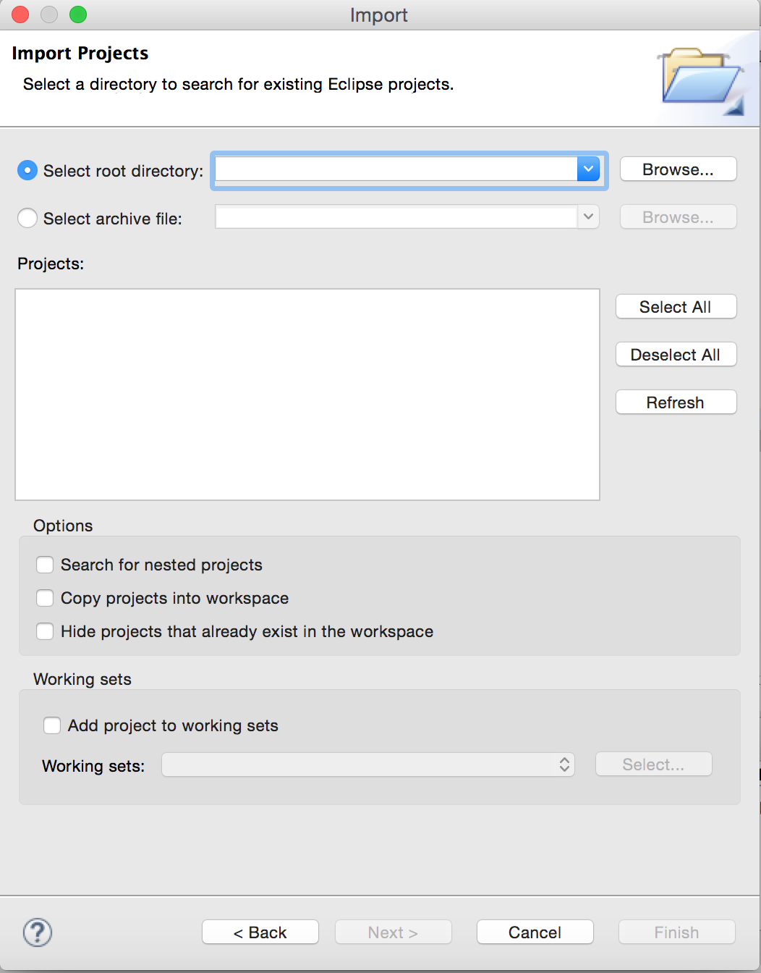

1. Once done, you’ll see the whole project on your package explorer on the left side

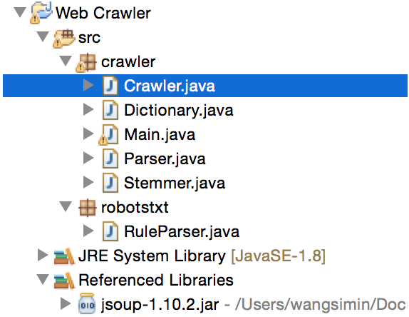

1. Since I import an external library “jsoup-1.10.2.jar” to my project, if you can’t find it in your project, you can download from <https://jsoup.org/download> and import it

## Compilation and Execution

## Once successfully import my project, click on the “Main.java” File, the input of the program is an Integer number, the limit on the number of pages to receive, and a list of stop words to exclude; you can modify the parameters by hand (later I may put all words in a file and read from the file)

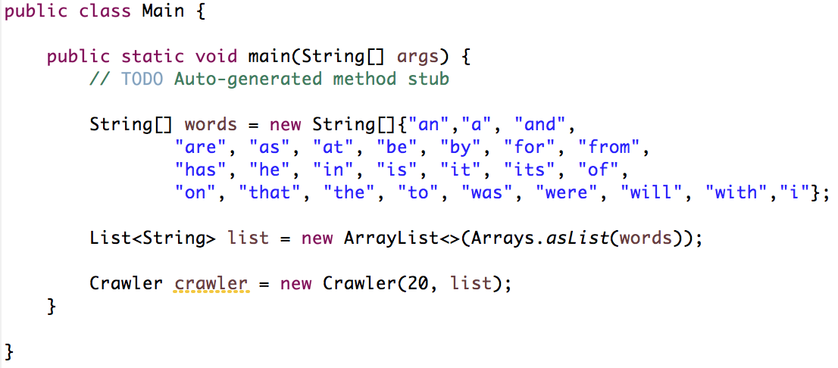

1. If you want to add synonyms in the thesaurus, click on the “thesaurus.txt” file under *src* directory and manually insert at the end for each term.

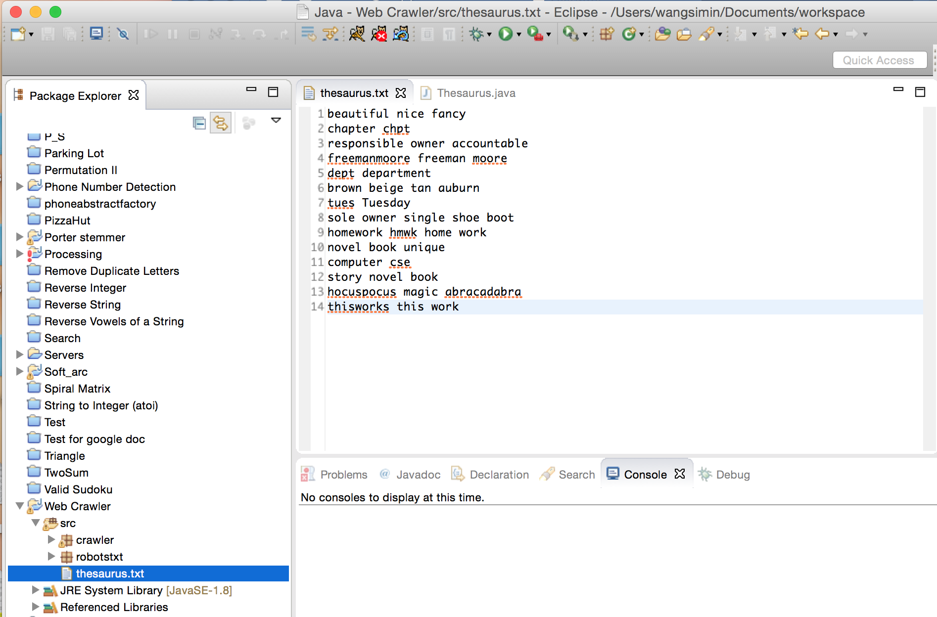

1. Run the Main.java as Java Application

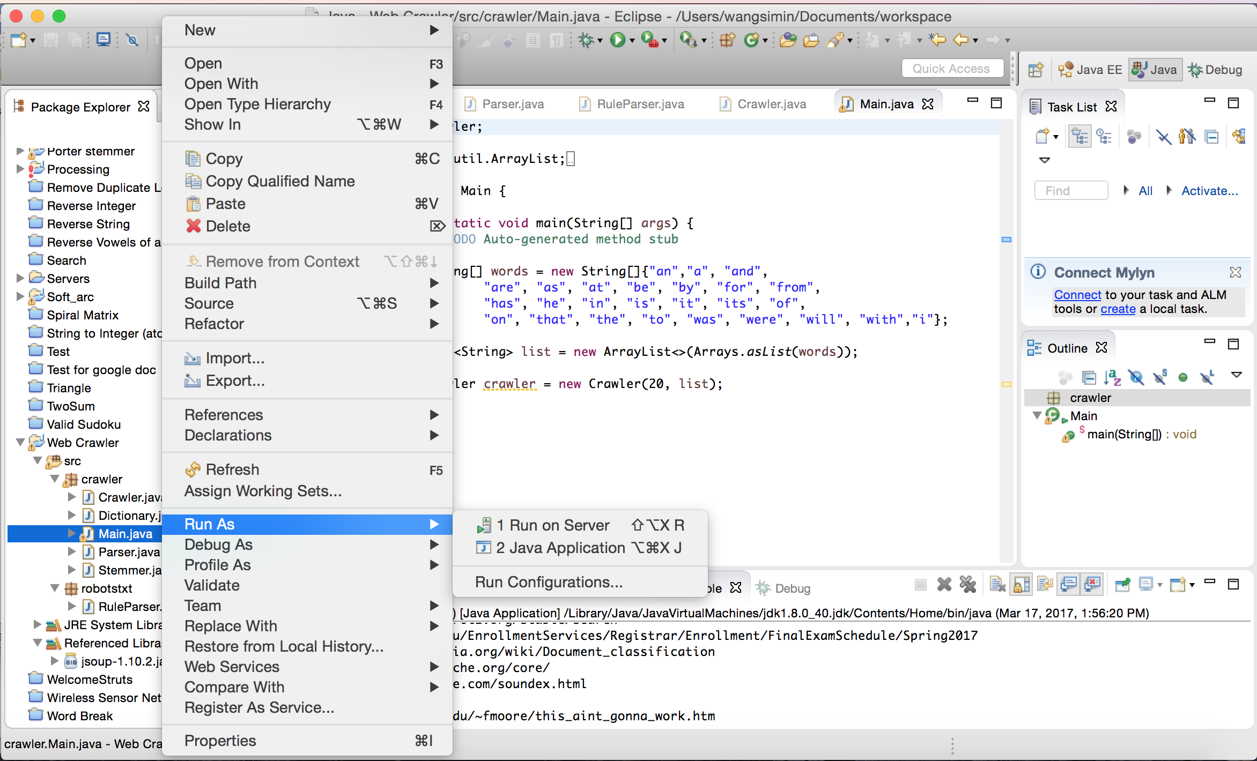

1. Finish the execution and display the output