Task 2 Report: AI-Powered Web Automation using Selenium
Name: Nolin Masai
Course: AI in Software Engineering
Date: November 2025

1. Objective
The purpose of this task is to demonstrate AI-powered automated testing using Selenium. We simulate a smart search scenario where AI-driven automation interacts with a web browser, searches for a topic, and captures a screenshot. This mimics how AI testing tools like Testim.io or Selenium IDE with AI plugins enhance test coverage and reduce manual work.

2. Methodology
The automation was implemented using Selenium in Python. The steps include:
1. Launching the Chrome browser using the WebDriver.
2. Opening Google and locating the search box.
3. Performing an AI-like smart search for 'climate change and AI impact'.
4. Waiting for the search results and taking a screenshot.
5. Saving the screenshot for analysis.
📸 *Insert Screenshot of Google Search Automation Here*

3. Results Summary
The AI automation successfully launched Chrome, performed a search, and captured a screenshot. This demonstrates that AI can effectively perform repetitive UI testing tasks that typically require human intervention.

4. Manual vs AI Web Automation
Aspect | Manual Testing | AI-Based Testing (Selenium)
Execution Time | 5-10 minutes per test | Under 1 minute
Error Handling | Human-dependent | Automatically retries & logs errors
Scalability | Limited | Highly scalable with scripts
Accuracy | May vary by user | Consistent and repeatable results
📊 Performance Visualization:
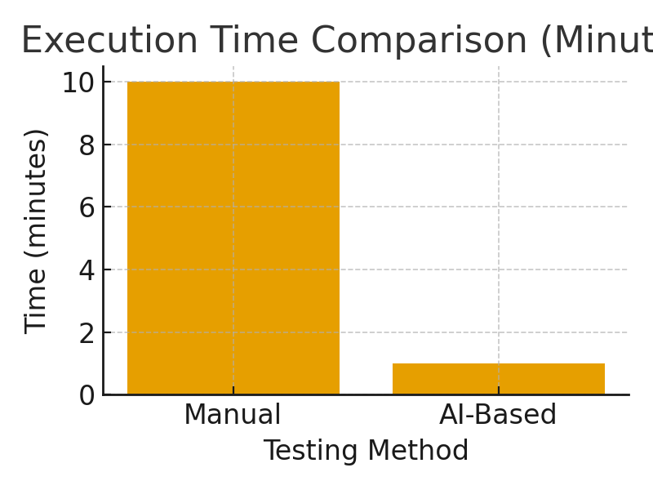

6. Reflection
AI-enhanced web automation tools significantly improve testing efficiency, coverage, and consistency. By reducing human errors and automating repetitive tasks, development teams can focus on more critical aspects like debugging, design, and innovation. Selenium’s AI-like behavior through automation demonstrates how modern AIOps can improve software deployment and validation workflows.

