PROPOSAL 1
WEDE PART 1
ST10521269
lehlogonolo mgiba
noloron

Table of Content
Table of Contents
1. Organisation Overview 2
2.Website Goals and Objectives 2
3. Current Website Analysis 3
4. Proposed Website Features and Functionality 3
6. Technical Requirements 5

1. Organisation Overview
Name: Noloron
Brief History:
Noloron is a fictional South African technology solutions company established to provide organisations with practical, secure and reliable technology solutions. The company initially focuses on software development, cybersecurity and hardware/IT infrastructure, with a long-term vision of expanding into areas such as animation, architecture and real estate.
Mission:
To design secure, innovative and reliable technology solutions that help organisations solve real business problems, improve efficiency and achieve sustainable growth.
Vision:
To become one of Africa's trusted technology companies by providing secure, innovative and reliable solutions that empower organisations to grow.
Target Audience:
Small and medium-sized businesses, start-ups, educational organisations, financial institutions, non-profit organisations and other organisations requiring technology solutions.
Core Services:
- Software development
- Web development
- Cybersecurity
- Hardware and IT infrastructure
- IT support and maintenance
Brand Slogan:
Built to Solve.

2.Website Goals and Objectives
Goal:
To establish Noloron's professional online presence and provide potential clients with a central platform to learn about its services and contact the organisation.
Objectives:
- Clearly communicate Noloron's services.
- Build credibility and trust.
- Generate potential client enquiries.
- Provide accessible company information.
- Create a foundation for showcasing future projects.
Key Performance Indicators (KPIs):
KPI | Target
Monthly website visits | 500+ within 6 months
Monthly enquiries | 20+
Average sessions duration | 2+ Minutes
Completed enquiry forms | 10+ per month
Mobile usability | 95%+

3. Current Website Analysis
Existing Website:
Noloron currently does not have an official website as it is a newly established organisation.
Weaknesses:
- No central online presence.
- Limited ability to showcase services.
- No online enquiry platform.
- No digital portfolio.
- Limited opportunity to establish online credibility.
Areas for Improvement:
The proposed website will address these weaknesses by providing a professional, responsive platform containing company information, services, portfolio content and contact functionality.

Market/Competitor Consideration:
Noloron operates in a competitive South African IT market alongside established providers such as BCX, Gijima and Datacentrix. Unlike these larger providers, Noloron will focus on being an accessible, client-focused technology partner, combining software, cybersecurity and infrastructure se

4. Proposed Website Features and Functionality
Homepage:
Introduces Noloron, its value proposition, major services and calls-to-action.
About Us:
Provides the company's history, mission, vision, values and philosophy.
Services:
Explains Noloron's software development, web development, cybersecurity, infrastructure and IT support services.
Portfolio:
Showcases completed projects, demonstrations and future case studies.
Contact:
Provides company contact information and an enquiry form for potential clients.
Navigation:
A consistent navigation menu will allow users to move easily between the main sections of the website.
Future Functionality:
The website can later be expanded with client portals, online consultations, support systems, authentication and other advanced fu

5. Design and User Experience.
Colour Scheme:
- Midnight Navy – professionalism, trust and security.
- Electric Blue – technology and innovation.
- White – simplicity and clarity.
- Light Grey – supporting backgrounds.
- Emerald Green – reliability and success.
Typography:
A modern sans-serif font such as Inter, Poppins or Montserrat will be used. Large, bold headings will establish hierarchy, while regular-weight body text will prioritize readability.
Sitemap

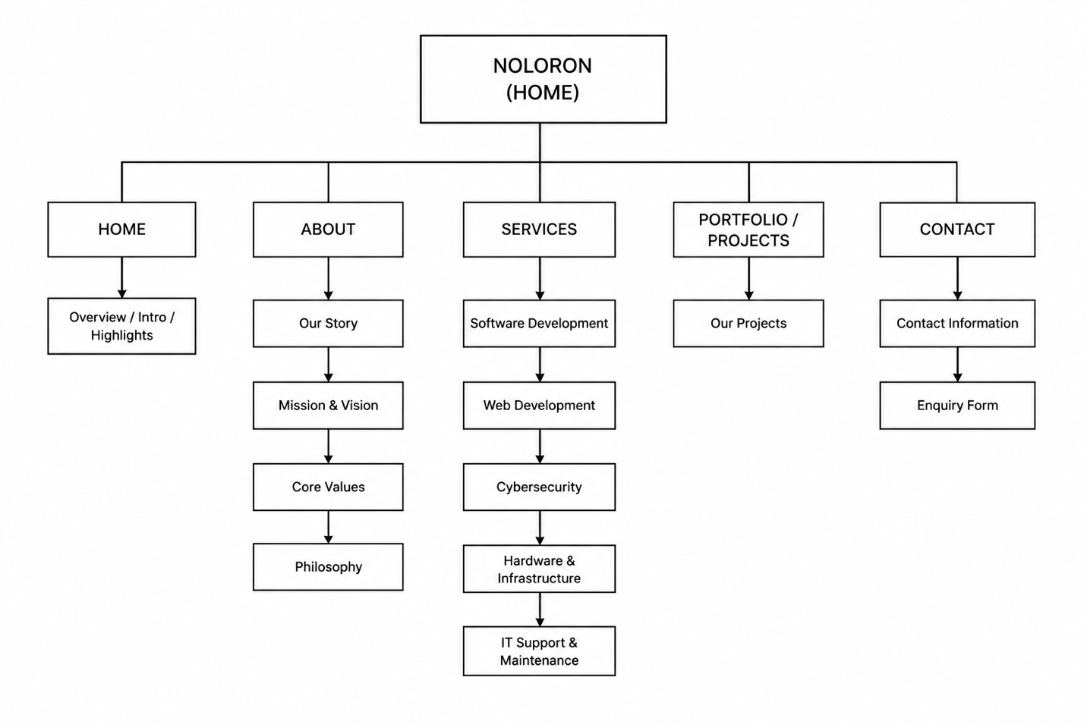

Layout and Design:
The website will use a clean, modern and minimalist technology aesthetic with consistent spacing, clear sections, cards and strong calls-to-action.
User Experience:
The website will prioritize simple navigation, responsive layouts, readable typography, accessible colour contrast and clear information hierarchy. Visitors should be able to find information about Noloron and its services quickly.
Wireframes:
Low-fidelity wireframes will be developed to demonstrate the proposed layout and information hierarchy before development.

-NOLORON
-Home
-About
Our Story
Mission & Vision
Core Values
Philosophy

-Services
Software Development
Web Development
Cybersecurity
Hardware & Infrastructure
IT Support & Maintenance
-Portfolio / Projects
-Contact
Contact Information
Enquiry Form

6. Technical Requirements
Programming Languages:
- HTML5
- CSS3
- JavaScript
Development Tools:
- Visual Studio Code,
- Git/GitHub
- MAC OS M1 or higher, 16gb ram minimum
- Netlify, reCAPTCHA
- Canva

Domain:
A professional domain such as noloron.co.za will be investigated, subject to availability.
Hosting:
A reliable web-hosting service capable of supporting a responsive corporate website will be required.
Additional Requirements:
- Responsive design.
- Modern browser compatibility.
- Semantic HTML.
- Accessibility considerations.
- Performance optimization.
- HTTPS/security for the deployed website.

7. Timeline and Milestones
3 days- Research, requirements proposal.
2 days -Sitemap and low fidelity wireframes.
2 days-HTML structure and content
1 week CSS styling and responsive design
1 week- java-script Functionality
1 week-Testing, debugging and final improvements

8. Budget
Item | Estimated cost:
Website design & dev | R8000
Web hosting | +-R1500/year
maintenance | +-R500/year
Domain registration | +-R250/year
Estimated initial cost: | +-R9,750.00
9.References
- Sitemap image created by lehlogonolo mgiba through Canva
- Noloron logo created by lehlogonolo mgiba in canva

