Project 3 Report

Introduction
For this project, the Federal Highway Administration tasked us with studying and analyzing Transportation systems in the United States. We were given two datasets: the National Household Travel Survey (NHTS), and the Next Generation Simulation Data (NGSIM). Our objectives were to create a bar chart, histogram, box plot, and two additional time-series plots to visualize the data. The variables chosen were to be relevant and informative, providing a clear understanding of transportation trends and driving behavior in the US.
We were also asked to run a simulation using the Intelligent Driver Model and plot the trajectories and accelerations of lead, following, and simulated following cars. Finally, we made a time sheet to document time spent on each aspect of the project. This would help our firm analyze how much time Python could save for future projects.

Methods
For the bar chart, we chose to plot number of vehicles by fuel type. This highlights the fact that most vehicles still use traditional gas, with notable minorities being electric and diesel. We used “plt.figure” to code all plots for the project, and the “ax.text” to format the graph to show the actual count of vehicles for each fuel type.
Our histogram then displayed a distribution of vehicle age, separated by urban and rural. This underlines the difference between how urban and rural populations use vehicles, while also giving a clear picture of how vehicle age is distributed overall. To distinguish between rural and urban, we coded separate histograms and then combined them with different colors assigned to each.
Our boxplot showed vehicle age by vehicle make. This plot was the most effective way to compare age distribution between brands and provides insight into which brands tend to last the longest. To code this we used several tools including show fliers, whisker props, and median props to assemble the plots.

We then chose to plot a line graph of follower speed over time, which showed all the data and the average between it. This not only showed the speed pattern of all cars measured, but also when the most variation of speed occurred. We plotted another line graph of lead and follower car speed over time, which better displayed the behavior of the follower car being in response to changes in speed of the lead car. The code for this was straightforward, using “sns.lineplot” and coding the formatting from there.
Results and Discussion
Our results from the boxplot show that gas powered vehicles dominate the dataset with 13,485 vehicles while all other fuel types are much lower. Hybrids and diesel are the next most common but are still small, and electric, plug-in hybrid, and alternative fuels make up a small portion. This indicates the U.S. transportation system is still heavily reliant on gasoline, which is important for planners analyzing current usage trends. The low share of electric and hybrid vehicles highlights opportunities for future growth, helping guide decisions on infrastructure, sustainability initiatives, and policy development.
Our results from the histogram show urban areas have a higher number of vehicles across most age ranges, with a concentration of newer vehicles. Rural areas show fewer vehicles overall and tend to have relatively older vehicles, with a more spread-out age distribution. This suggests that urban areas may adopt newer vehicle technologies faster, while rural areas rely more on older vehicles. For transportation planning, this is important when considering maintenance needs, emissions policies, and where to focus on investments in newer vehicle infrastructure like electric charging stations.
Our results from the boxplot show vehicle age varies by make with some brands having older vehicles on average and others showing newer. There is also a widespread age for many makes indicating a mix of both new and older vehicles. This is useful for understanding differences in vehicle longevity and usage across brands. It can help transportation planners and manufacturers identify trends in durability or incentives to replace older vehicles to improve safety and reduce emissions.
Our results from the line graph show that vehicle speeds change over time with clear patterns of acceleration and deceleration, especially during congestion periods. The follower vehicle closely tracks the leader’s speed with slight delays, and the simulated model produces behavior that closely matches the real-world follower data in both speed and position. These findings are important for understanding traffic flow and driver behavior. The close match between simulated and real data suggests that models like IDM can be used to predict traffic patterns, improve roadway design, and support the development of automated driving systems and traffic management strategies.

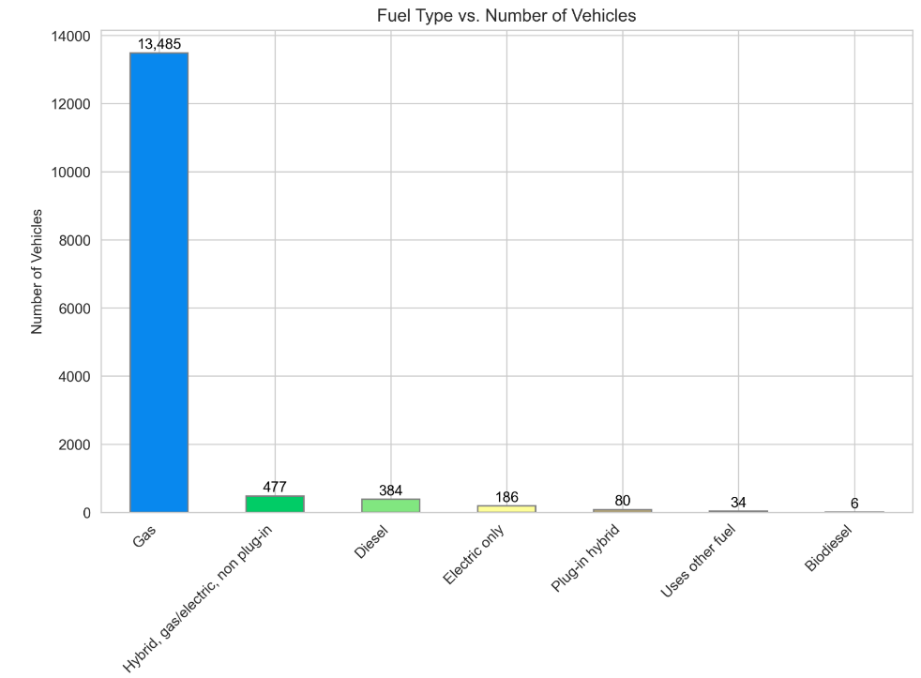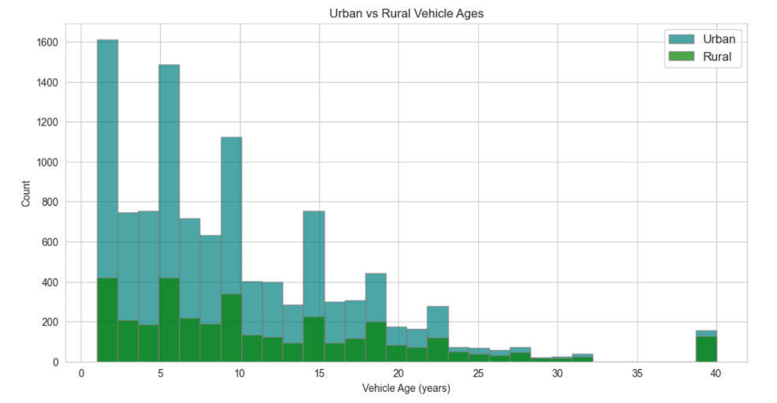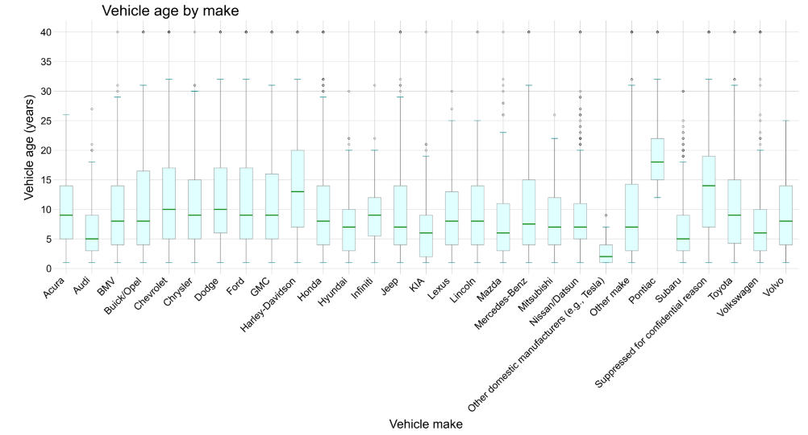
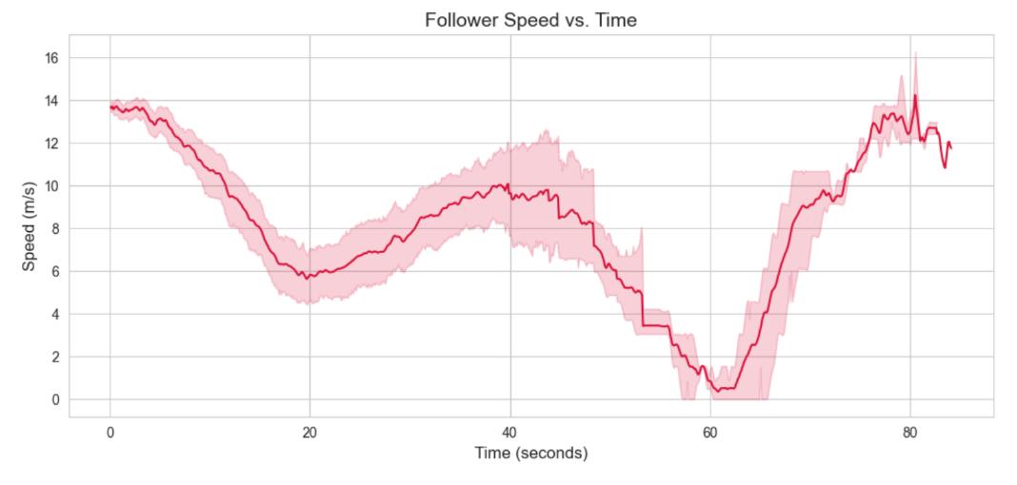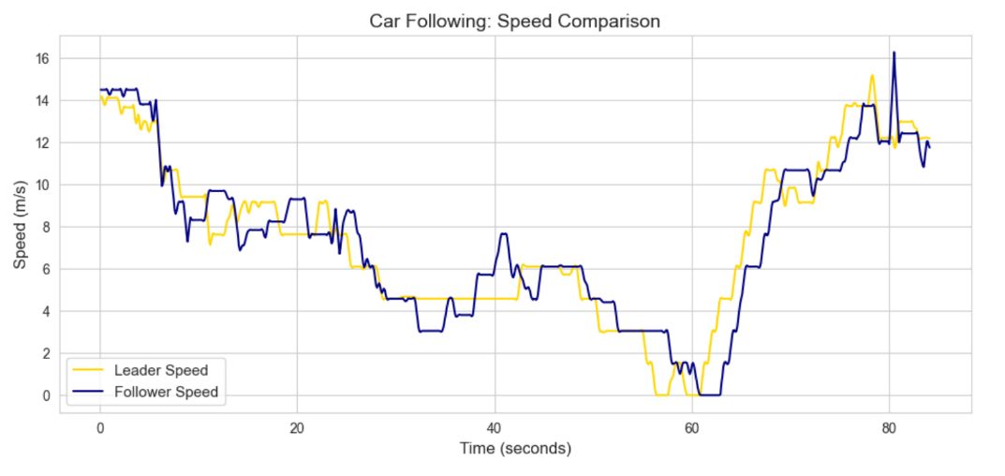

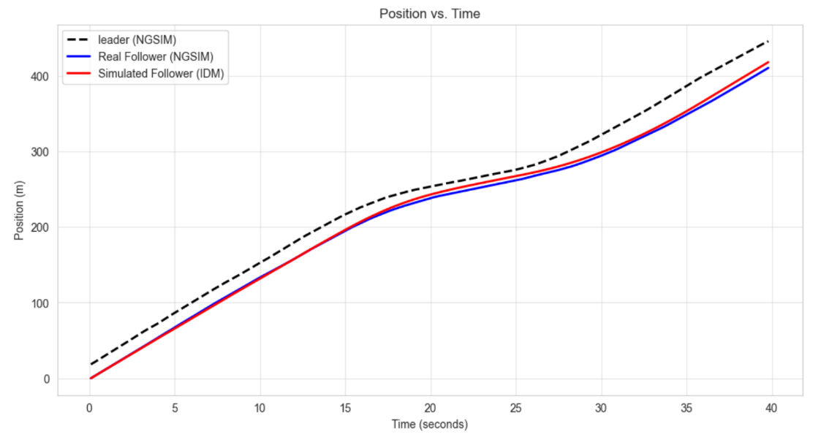

References
NHTS:
National Household Travel survey. National Household Travel Survey. (n.d.). https://nhts.ornl.gov/

NGSIM:
Next generation simulation (NGSIM) open data. DOT Open Data Catalog. (n.d.). https://data.transportation.gov/stories/s/Next-Generation-Simulation-NGSIM-Open-Data/i5zb-xe34

