Contents

**Scope** 2

**ERD** 3

**Cloud Technology** 5

**Potential Security Issues** 6

# **Scope**

The scope for the GymsAreUs business involves the overall vision, objectives, and boundaries of the gym operation. It outlines what the business aims to achieve and the extent of its activities. The scope of the GymsAreUs business can be described as follows:

1. Fitness Services: The primary scope of the GymsAreUs business is to provide fitness services to its members. This includes offering various training programs, classes, and personalized workout plans to help members achieve their fitness goals.
2. Multiple Branches: The business may have multiple branches or locations, each serving a specific geographical area. The scope includes managing and coordinating the operations of these branches effectively.
3. Trainers and Staff: GymsAreUs will employ qualified trainers and staff to provide professional guidance and support to its members. The scope includes hiring, training, and managing the trainers and staff.
4. Membership Management: The gym will maintain a database of its members, including their personal information, membership status, and program history. The scope involves efficiently managing member records and memberships.
5. Training Programs: GymsAreUs will develop and offer various training programs catering to different fitness levels and preferences. The scope includes designing, updating, and monitoring the effectiveness of these programs.
6. Class Scheduling: The gym will conduct group classes and sessions. The scope involves managing class schedules, ensuring proper utilization of resources, and avoiding conflicts.
7. Equipment and Facilities: GymsAreUs will provide modern exercise equipment and facilities to its members. The scope includes maintaining equipment, ensuring safety, and upgrading facilities as needed.
8. Member Engagement and Retention: The business will focus on member engagement and retention strategies to build long-term relationships with its customers. The scope involves providing excellent customer service and incentives for member loyalty.
9. Reporting and Analytics: The gym will use data analytics to track member progress, class attendance, and overall business performance. The scope includes generating meaningful reports for management decision-making.
10. Marketing and Promotion: GymsAreUs will implement marketing strategies to attract new members and promote its services. The scope includes advertising, social media, and promotional campaigns.
11. Compliance and Regulations: The business must adhere to relevant laws, regulations, and industry standards related to fitness services, data privacy, and health and safety. The scope involves compliance and risk management.
12. Continuous Improvement: The scope includes a commitment to continuous improvement, embracing new fitness trends, technology, and best practices to stay competitive and meet member expectations.

Overall, the scope for the GymsAreUs business encompasses all aspects of providing high-quality fitness services, managing operations efficiently, and ensuring member satisfaction and success in achieving their fitness goals.

# **ERD**

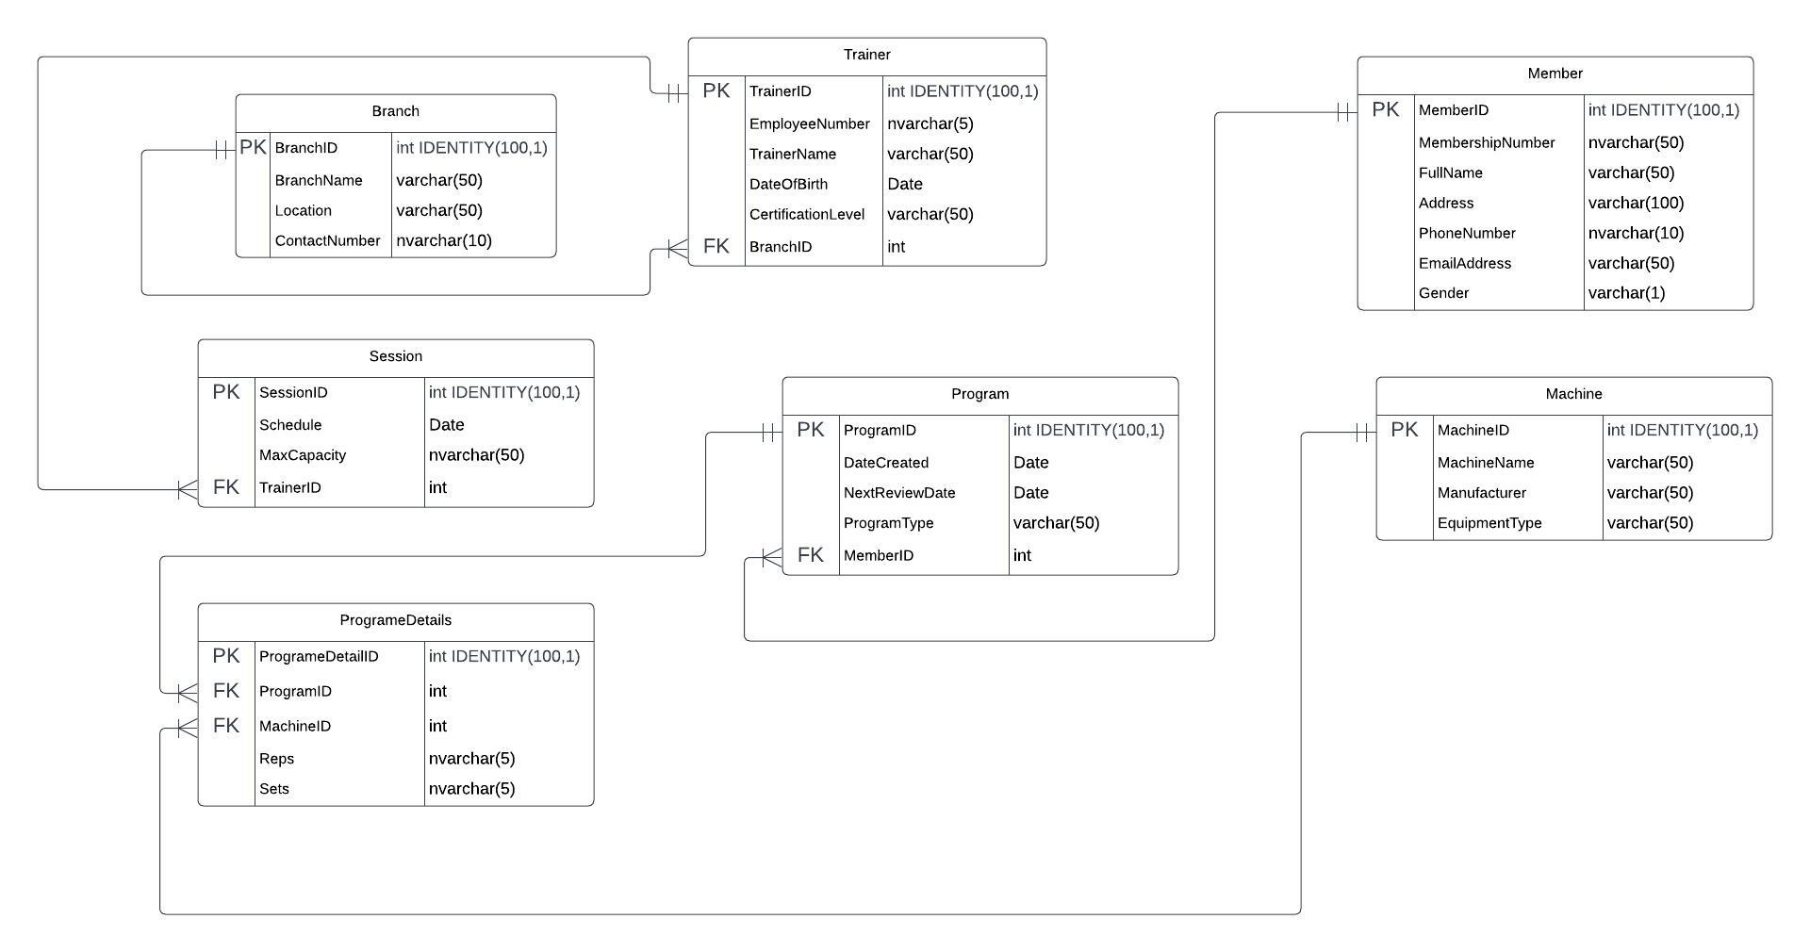

1. **Branch Table:**
   * This table stores information about gym branches.
   * Attributes: BranchID (auto-incremented), BranchName, Location, ContactNumber.
   * Primary Key: BranchID.
2. **Trainer Table:**
   * This table stores information about gym trainers.
   * Attributes: TrainerID (auto-incremented), EmployeeNumber, TrainerName, DateOfBirth, CertificationLevel, BranchID.
   * Primary Key: TrainerID.
   * Foreign Key: BranchID (references Branch table).
3. **Machine Table:**
   * This table stores information about gym machines and equipment.
   * Attributes: MachineID (auto-incremented), MachineName, Manufacturer, EquipmentType.
   * Primary Key: MachineID.
4. **Session Table:**
   * This table stores information about gym sessions/classes.
   * Attributes: SessionID (auto-incremented), Schedule, MaxCapacity, TrainerID.
   * Primary Key: SessionID.
   * Foreign Key: TrainerID (references Trainer table).
5. **Member Table:**
   * This table stores information about gym members.
   * Attributes: MemberID (auto-incremented), MembershipNumber, FullName, Address, PhoneNumber, EmailAddress, Gender.
   * Primary Key: MemberID.
6. **Program Table:**
   * This table stores information about personalized training programs for members.
   * Attributes: ProgramID (auto-incremented), DateCreated, NextReviewDate, ProgramType, MemberID.
   * Primary Key: ProgramID.
   * Foreign Key: MemberID (references Member table).
7. **ProgrameDetails Table:**
   * This table stores details of machines and exercises associated with each training program.
   * Attributes: ProgrameDetailID (auto-incremented), ProgramID, MachineID, Reps, Sets.
   * Primary Key: ProgrameDetailID.
   * Foreign Keys: ProgramID (references Program table), MachineID (references Machine table).

The provided database schema establishes relationships between the entities, enabling efficient data management for the GymsAreUs system. It supports the recording of branch information, trainer details, member profiles, training programs, machines, and their interconnections.

# **Cloud Technology**

**Best-suited Cloud Service: Amazon Web Services (AWS)**

Among the various cloud service providers, Amazon Web Services (AWS) is an excellent choice for GymsAreUs's database needs. AWS is a market leader with a comprehensive set of cloud services that cater to the specific requirements of businesses of all sizes. Here's why AWS is the best-suited cloud service for GymsAreUs:

1. **Scalability:** AWS provides elastic scaling options for its database services like Amazon RDS (Relational Database Service) and Amazon DynamoDB. It allows GymsAreUs to dynamically adjust resources to match demand fluctuations.
2. **Performance:** AWS offers high-performance database options, such as Amazon Aurora and Amazon DynamoDB, which are designed to handle demanding workloads with low-latency responses.
3. **Security:** AWS implements robust security measures, including encryption at rest and in transit, fine-grained access controls, and compliance with various industry standards.
4. **Reliability and Availability:** AWS has a global network of data centers, ensuring high availability and data redundancy. Services like Amazon RDS provide automated backups and automated failover for enhanced reliability.
5. **Data Backup and Recovery:** AWS provides automated and regular backups for databases, ensuring data integrity and offering point-in-time recovery options.
6. **Cost-effectiveness:** AWS offers a pay-as-you-go pricing model, allowing GymsAreUs to pay only for the resources used. AWS also provides cost optimization tools to manage expenses effectively.
7. **Integration and Compatibility:** AWS supports various database engines, making it compatible with popular database management systems like MySQL, PostgreSQL, and Microsoft SQL Server.
8. **Support and Services:** AWS provides reliable customer support through documentation, forums, and various service level agreements (SLAs) for critical services.

Overall, AWS offers a comprehensive cloud solution that fulfils the requirements of the GymsAreUs database system. It provides scalability, performance, security, and cost-effectiveness, making it the best choice to support the growth and success of the GymsAreUs business.

# **Potential Security Issues**

For the GymsAreUs business, there are several potential security issues that need to be considered to protect sensitive information and maintain the integrity of the database. Some of the key security issues include:

1. **Unauthorized Access:** Unauthorized individuals gaining access to the database can lead to data breaches, data manipulation, or theft of sensitive information.
2. **Weak Authentication and Passwords:** Weak or easily guessable passwords can compromise user accounts, allowing unauthorized access to the system.
3. **SQL Injection Attacks:** Improperly sanitized user inputs can lead to SQL injection attacks, where attackers can execute malicious SQL commands and gain unauthorized access to the database.
4. **Cross-Site Scripting (XSS) Attacks:** Insecure web application coding can lead to XSS attacks, where malicious scripts are injected into web pages, potentially stealing session cookies or sensitive data from users.
5. **Data Breaches:** Any security vulnerabilities that allow unauthorized access to the database can result in data breaches, exposing personal and sensitive information of members, trainers, and employees.
6. **Insider Threats:** Employees or trainers with malicious intent or negligence may misuse their access privileges to steal or manipulate data.
7. **Insecure Data Transmission:** Inadequate encryption or lack of SSL/TLS protocols for transmitting data between the application and the database can lead to interception of sensitive information.
8. **Lack of Data Backup and Recovery:** Not having a proper backup and recovery plan can result in data loss due to system failures or cyber-attacks.
9. **Inadequate Authorization Controls:** Improperly configured access controls can lead to unauthorized users gaining access to sensitive data or functionality.
10. **Insecure Session Management:** Weak session management can allow attackers to hijack user sessions, gaining unauthorized access to user accounts.

Mitigation Strategies:

To address these potential security issues, the GymsAreUs business should implement various security measures, including:

1. **Strong Authentication:** Enforce strong password policies and implement multi-factor authentication to enhance user account security.
2. **Input Validation:** Implement input validation and parameterized queries to prevent SQL injection attacks.
3. **Secure Coding Practices:** Follow secure coding practices to prevent XSS vulnerabilities in web applications.
4. **Role-Based Access Control:** Implement role-based access control to ensure that users have appropriate access privileges based on their roles.
5. **Encryption:** Encrypt sensitive data in transit using SSL/TLS and at rest to protect against unauthorized access.
6. **Regular Security Audits:** Conduct regular security audits and vulnerability assessments to identify and address potential weaknesses.
7. **Employee Training:** Provide security awareness training to employees and trainers to prevent insider threats.
8. **Data Backup and Recovery:** Regularly back up the database and implement disaster recovery plans to ensure data availability in case of system failures or data breaches.
9. **Patch Management:** Keep software and applications up to date with the latest security patches to address known vulnerabilities.
10. **Monitoring and Logging:** Implement real-time monitoring and logging to detect and respond to suspicious activities.

By proactively addressing these security issues and implementing appropriate security measures, GymsAreUs can safeguard its database and ensure the privacy and security of its members and business operations