Kassim Nomaan Sayad
A00083522
MACSH6011
Tpot

Declaration form

School of Informatics & Cybersecurity - Assessment Submission Coversheet

Student Information
Student Number: | A00083522
Student Name: | Kassim Nomaan sayad

Module Information
Module Title: | Network Security
Module Code: | MACSH6011

Assessment Information
Assessment Title: | TPot Ca1

Declaration
☐ I confirm that I have read and understood the University’s Academic Integrity Policy.
https://www.tudublin.ie/explore/about-the-university/academic-affairs/academic-quality-assurance-and-enhancement/academic-integrity/
☐ I have completed the TU Dublin AI Driving License theory test.
https://www.tudublin.ie/explore/about-the-university/academic-affairs/lta/lta-resources/artificial-intelligence-driving-license/
☐ I declare that this assessment submission is my own work.
☐ I confirm that I have read and understood the AI traffic light system used as part of this assessment brief and I have adhered to the level of AI usage allowed for this assessment.
Student signature: | Kassim Nomaan Sayad
Date: | 01/11/2026

Abstract

In October 2026, I operated a T-Pot honeynet on AWS, Azure, and GCP for almost fifteen days. 1,257,851 occurrences from 19,336 addresses were recorded. Because my two sensors didn't do anything else, the SSH honeypot Cowrie took around half. More over one-third of it came from ten addresses. Banatsync Srl, the leading network, arrived with 82 silent addresses rather than just one loud one. Three other tools identified all four of the top 10, but SANS ISC classified nine of them as innocuous. I lost 91 hours of data due to a default daily reboot.

1 Introduction
A honeypot is a computer that looks like a real computer, but its only purpose is to attract attacks. Therefore any data a honeypot gathers is questionable. A honeynet is a collection of multiple honeypots. I used T-Pot which integrates more than a dozen of honeypots, Suricata IDS, p0f OS fingerprinting utility, and Elasticsearch and Kibana.
I set up a Hive on AWS (us-east-1d, m7i-flex.large, 2 vCPU, 8 GiB) to run the honeypots and store all logs, and two sensors on Azure (Sweden Central) and GCP (asia-east1-b) that send their logs to it (Figs. 1 and 2). The sensors mostly ran Cowrie, a fake SSH server [5]. The dataset ranges from 17 October 00:00 to 31 October 20:00 UTC (356 h). T-Pot recommends at least 16 GB of RAM for a Hive, while my system has only 8 GB; this may explain some of the Suricata alerts (Section 6). 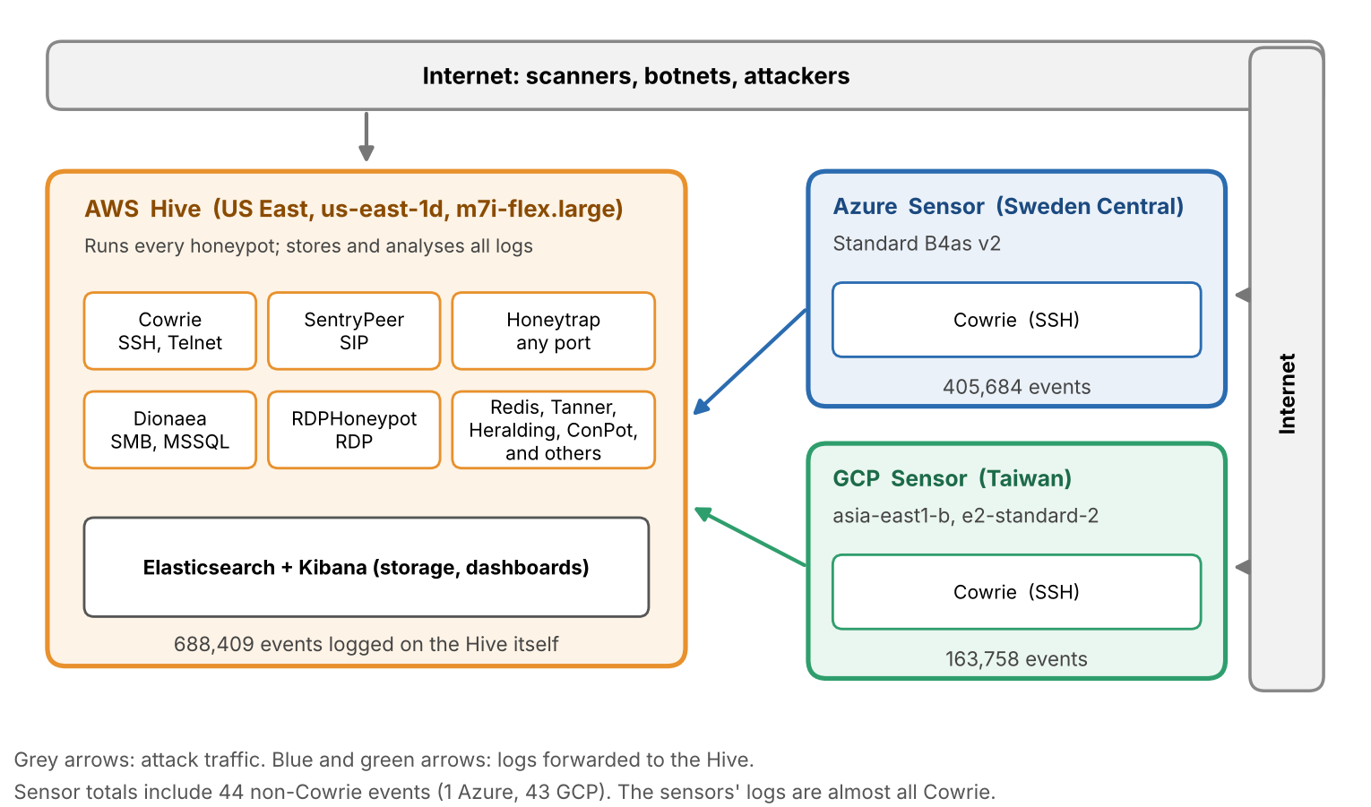
Fig. 1. The honeynet and its event counts.
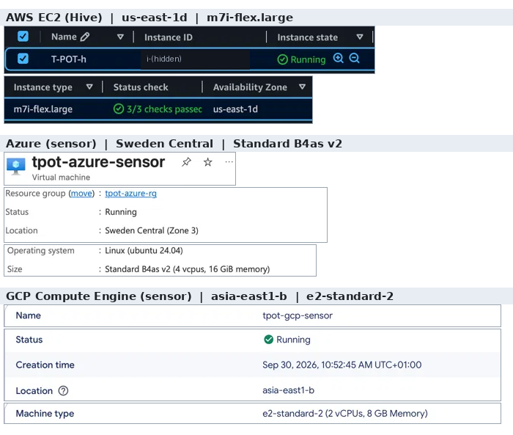
Fig. 2. The three machines in the cloud consoles
2 Data and method
Kibana gave me the summary (Figs. 3 to 5) but only shows the top-10 tables so I wrote a Python script to query Elasticsearch on the Hive in read-only mode. It counts honeypot events separately from the 13.7 million Suricata and 16.0 million p0f entries in the same index, for a total of 1,257,851 events from 19,336 addresses. Another script, extra.py, answered enquiries about a specific address or network (Figs. 10 and 19). Kibana and my script categorise networks in different ways, which results in some differences in totals (Figs. 4 and 8), and I use the totals from the script. I count events, not attacks, and the country is based on the GeoIP tag of T-Pot which has proven to be inconsistent (Section 5). All the scripts and more screenshots that I was not able to embed here, can be found in my GitHub repository [6].
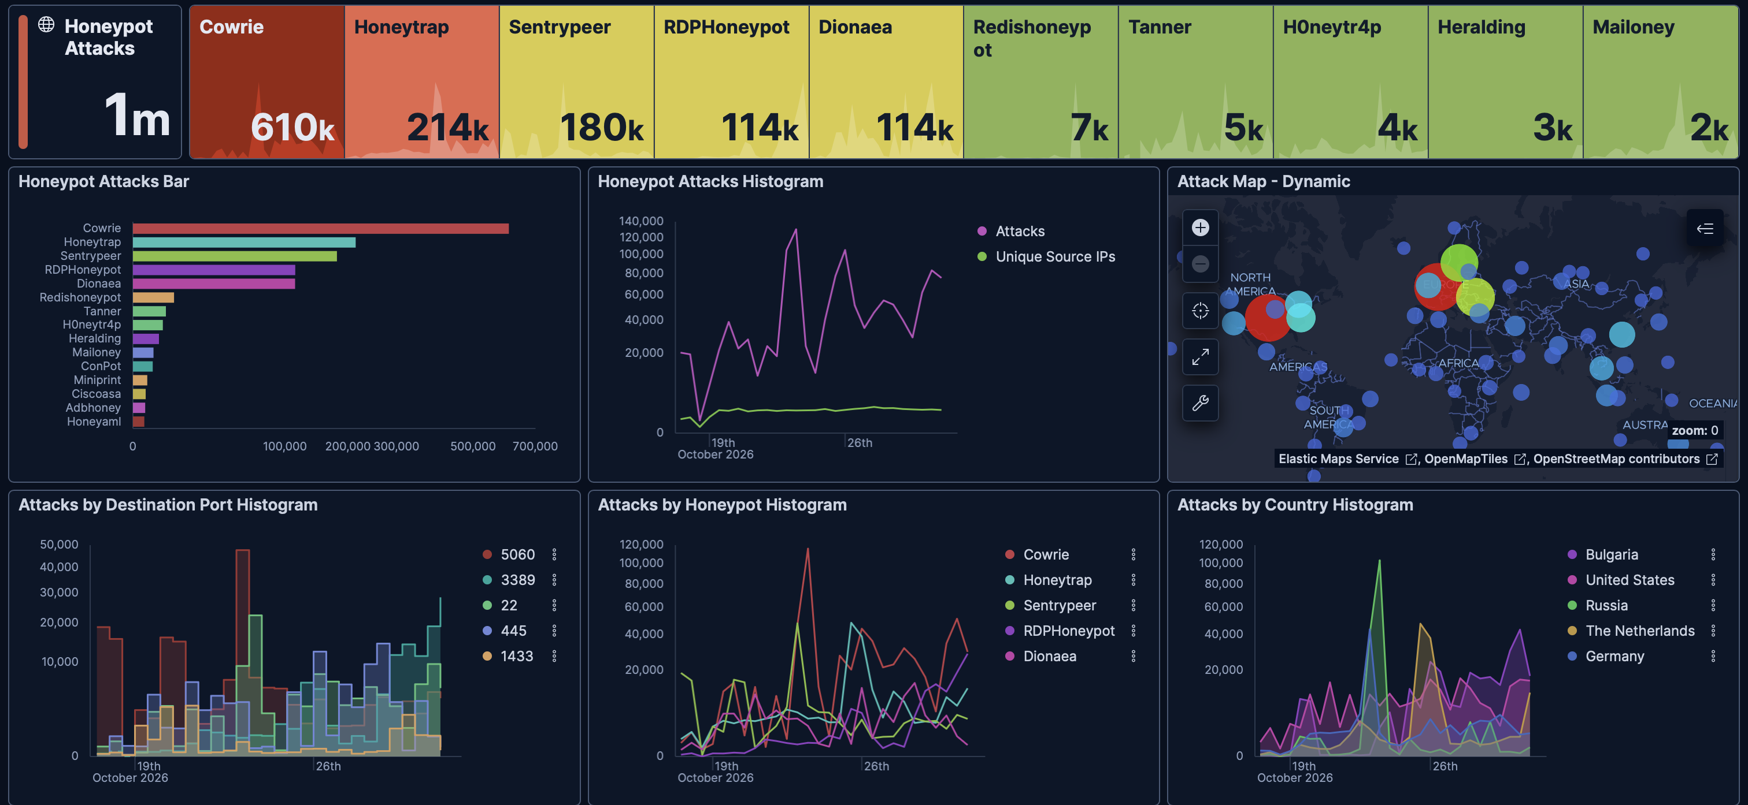
Fig. 3. Kibana overview.
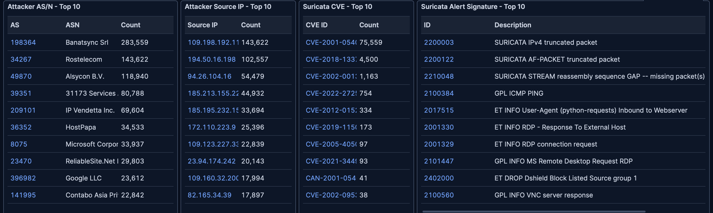
Fig. 4. Kibana top-10 tables.
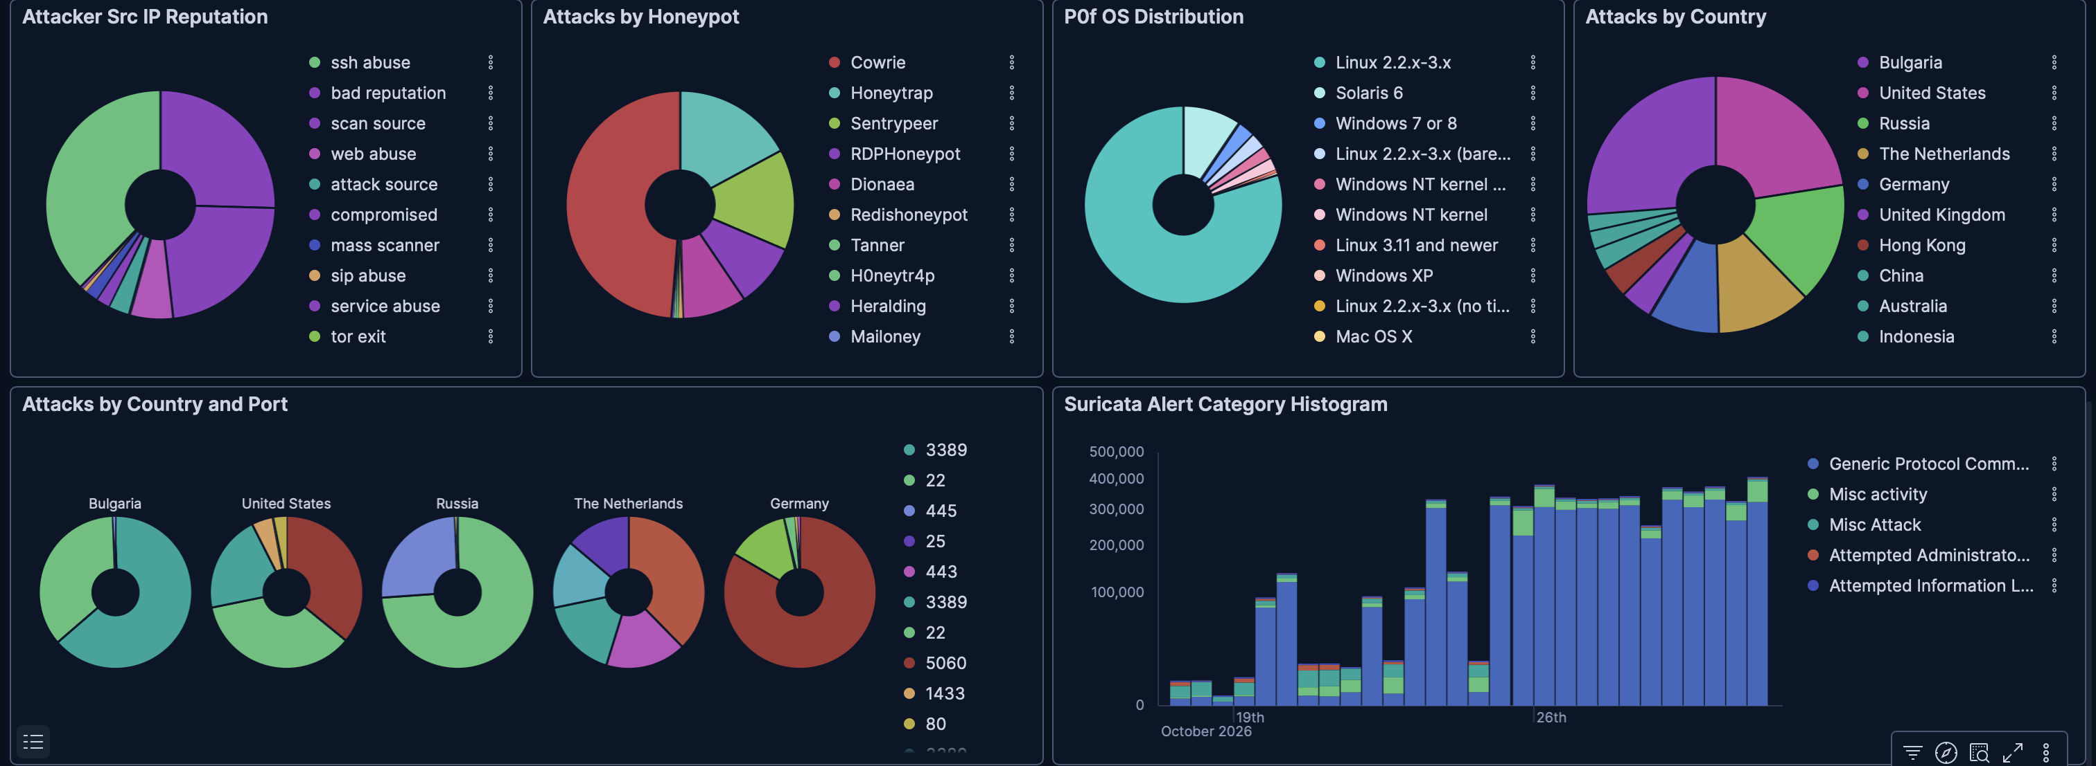
Fig. 5. Kibana shares.

3 What was attacked
Cowrie recorded 610,494 incidents (around fifty percent), followed by Honeytrap (214,311), SentryPeer (179,729), RDPHoneypot (113,975) and Dionaea (113,644) (Fig. 6). Part of the reason that Cowrie is ranked first is by design: the sensors added only a small amount of data, about 569,000 of its events were from the sensors and only about 41,000 from the Hive. Honeytrap would be in charge only on the Hive. Honeytrap is available on any port, leading to a total of 12,790 addresses connecting to it with little traffic, while SentryPeer, which records SIP, saw connections from only 390 addresses, showing that a small number of senders were responsible for its traffic.
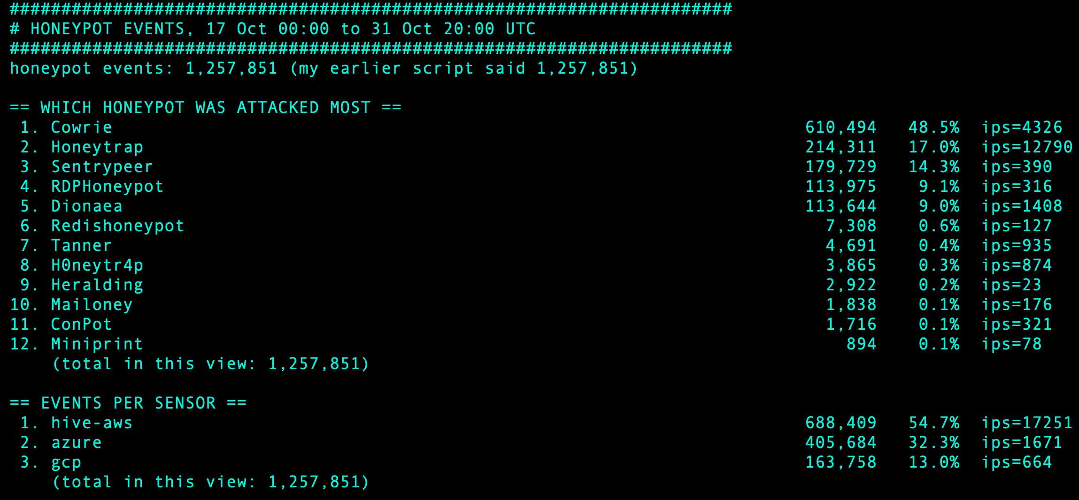
Fig. 6. Honeypots, nodes and top addresses.

The most active ports included 5060, 3389, 22 and 445 (Fig. 7). Port 5060 is the SIP port used for internet telephony and is often probed by attackers looking for open VoIP servers. Port 3389 is associated with the Windows Remote Desktop Protocol (RDP), which is often scanned heavily and has vulnerabilities such as BlueKeep [9]. The number 22 corresponds to SSH, a protocol where attackers attempt to guess passwords [10]. 445 is linked to SMB, a Windows file sharing protocol, which has been exploited by worms, and is related to the MS17-010 vulnerability related to DoublePulsar [11], [12]. Later, ports 1433 (SQL Server), 3306 (MySQL), 23 (Telnet) and 6379 (Redis) became popular targets for worms and weak passwords. The most events were on port 5060 , but the most addresses accessed port 22 ( 2,814 vs 390 ) . This shows that SIP has a few big senders and SSH has many small senders .

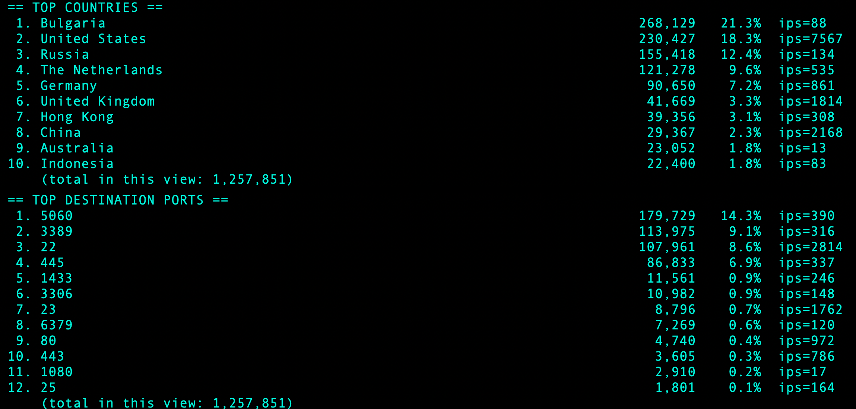
Fig. 7. Countries and ports.

4 Who attacked
Banatsync Srl was the network’s leader with 283,559 events originating from 82 addresses, almost a quarter of the total, followed by Rostelecom (146,769), Alsycon B.V. (118,377), 31173 Services AB (80,499) and IP Vendetta Inc. (69,603) (Fig. 8). The power of Banatsync is in its distribution rather than its power. The most active address logged only 17,994 events, but 82 addresses kept running for long periods. Rostelecom has an opposite story: 143,622 of 146,769 instances came from one address within one day.
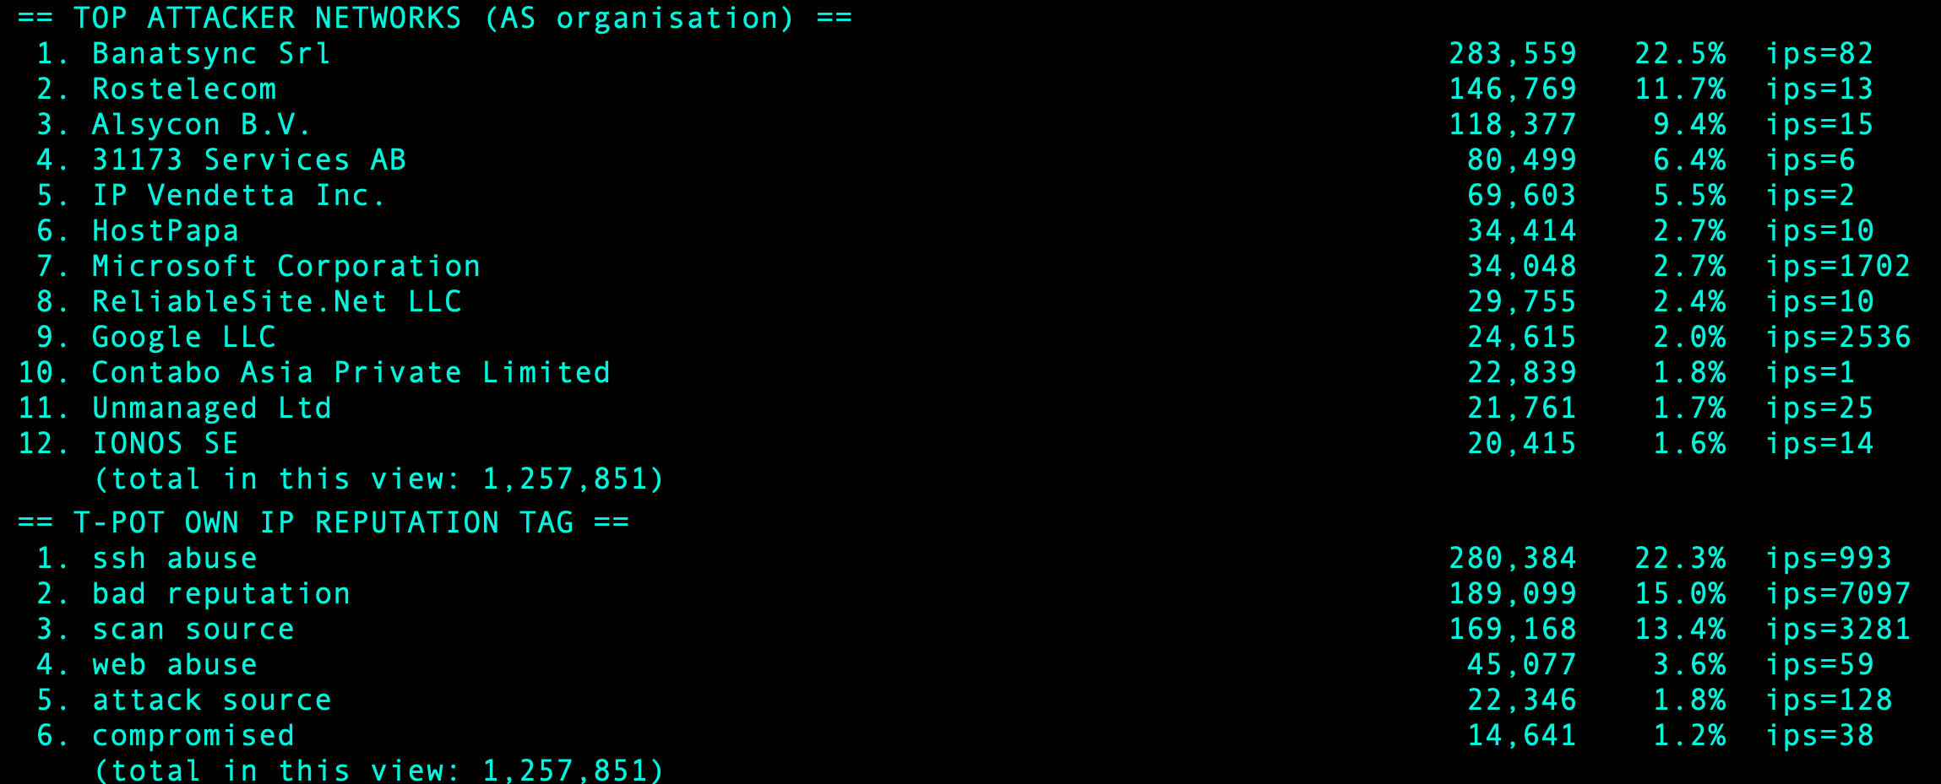
Fig. 8. Attacker networks and reputation tags.
The top ten addresses accounted for 483,553 events, just over one third of the total (Fig. 9). The most active was recorded eight times the occurrences of the tenth (143,622 versus 17,897), but it operated for only one day compared to six, demonstrating that the least active among the ten showed the greatest persistence.
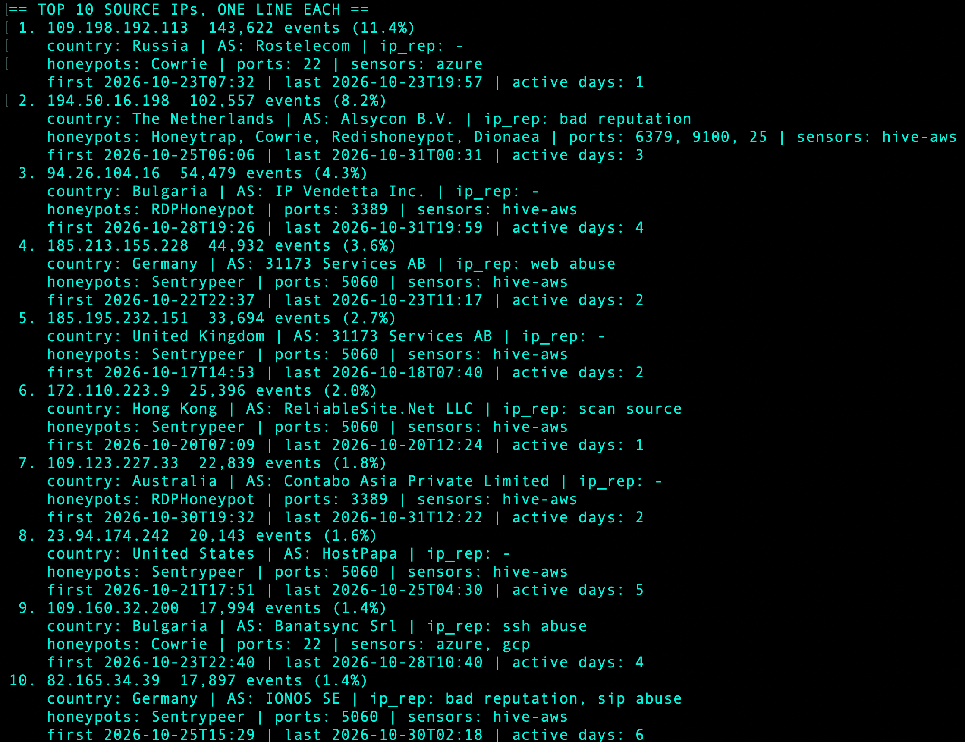
Fig. 9. Profiles of the top addresses.

5 Checking the top addresses
I checked the top addresses and took a look at the top ten from SANS ISC, which gathers firewall logs from its contributors. For the most active addresses, I added: AbuseIPDB (abuse reports) [19], VirusTotal (vendors that flag an address) [20], GreyNoise (entities scanning the internet) [21], IPinfo (ownership of an address) [22], and Shodan (services it hosts) [23].
Only the IP address 194.50.16.198 got a score higher than zero at SANS (a score of 1). The other nine scored 0, although they each submitted between 17,897 and 143,622 events. A score of 0 simply means that no reports were made. Table 1 lists four addresses spanning the four reputation tools, with IPinfo and Shodan taking the top two spots, and two from Banatsync (Section 8.1). AbuseIPDB rates them between 88% and 100%. GreyNoise rates all four as malicious. This means the tools are measuring different parameters, and all of them can be right. The countries had different views: four out of the ten had different assessments for T-Pot and SANS.
Table 1. Reputation scores for four addresses, 1 November 2026.
Tool | 109.198.192.113 (Rostelecom) | 194.50.16.198 (Alsycon) | 109.160.32.200 (Banatsync) | 77.239.124.47 (Banatsync)
AbuseIPDB | 88%, 32 reports | 100%, 47,988 reports | 100%, 6,154 reports | 100%, 3,468 reports
VirusTotal | 4 of 92 vendors | 11 of 92 | 13 of 92 | 13 of 92
GreyNoise | Malicious | Malicious | Malicious | Malicious
SANS ISC risk | 0 | 1 | 0 | 0

The top address
Most of the logged events (approximately one in nine) were transmitted to the SSH honeypot of the Azure sensor by the main IP address 109.198.192.113 (Rostelecom, Russia) between 07:32 and 19:57 UTC on 23 October (Fig. 10). It created 28,724 connections, each one corresponding to a failed attempt to log in as root, often with a different password. None of them worked. All instruments indicate its location in Russia, with IPinfo placing it near Bryansk (Figs. 11 and 12). The entity is mx.varyag.net and Shodan has found open DNS, POP3 mail and port 8081 which suggests it may be a modestly operated mail server, probably compromised (in my estimation). GreyNoise labels it as an SSH Bruteforcer and Ping Scanner. It gained nothing and lost its protection. A ban would have been effective, as it was noisy and stopped after one day, but the instruments show its scope as a /22, a /21, and a /19, and a broad Rostelecom ban would hamper real customers.
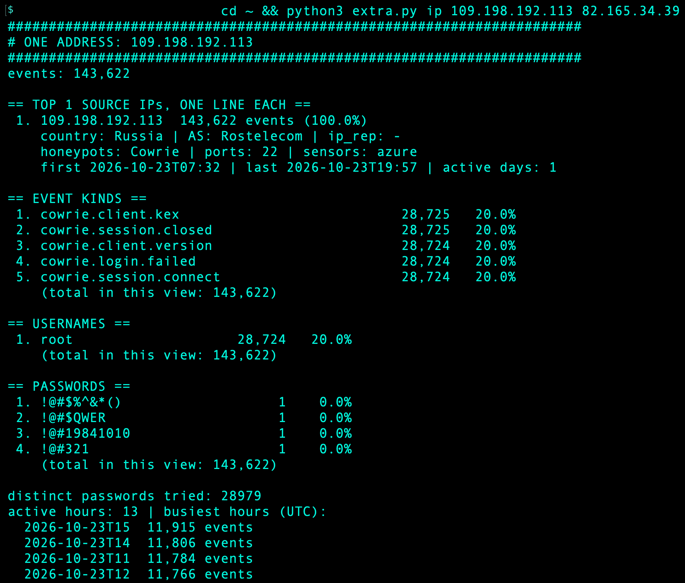
Fig. 10. My script's output for 109.198.192.113.
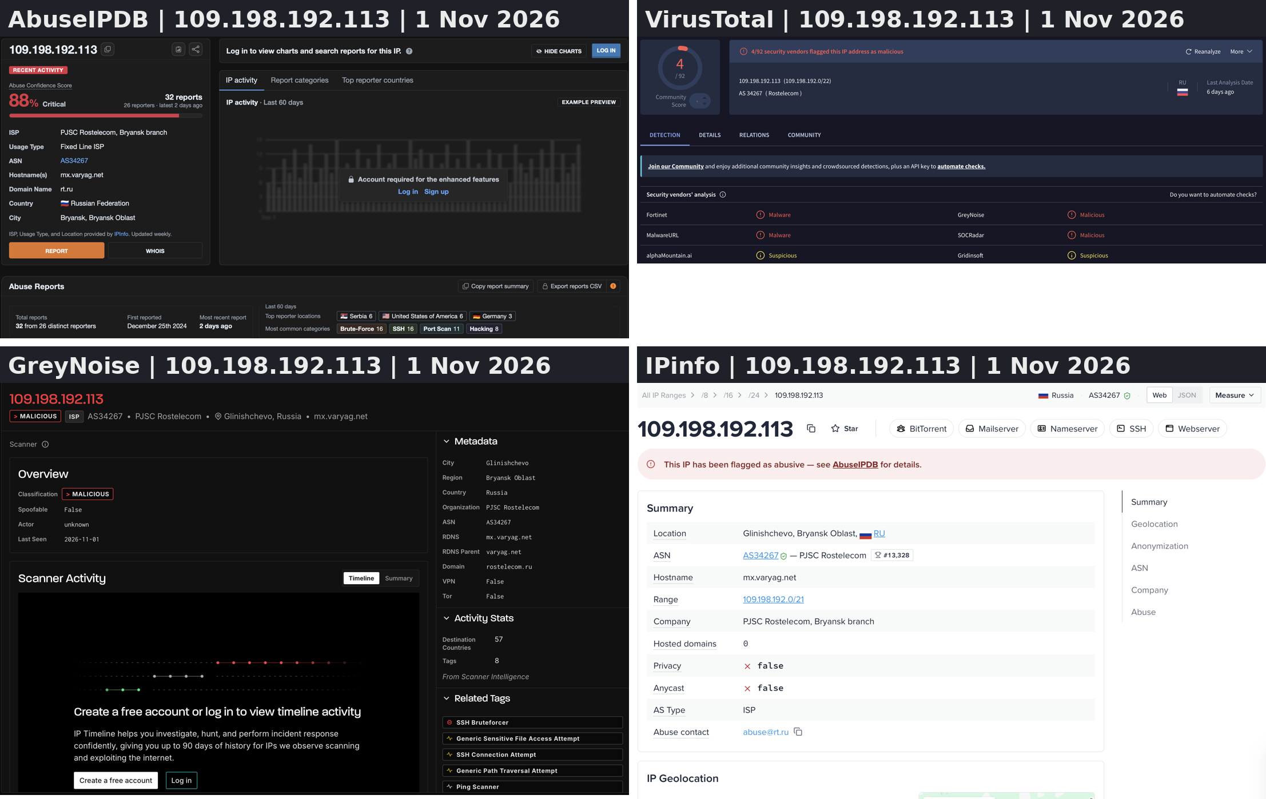
Fig. 11. 109.198.192.113 in four lookup tools.
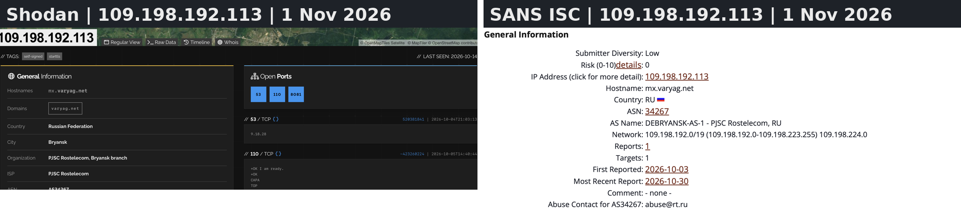
Fig. 12. 109.198.192.113 in Shodan and SANS ISC.

The other addresses
The alternative IP address 194.50.16.198 (Alsycon B.V., Amsterdam) is the one I would confidently label as malicious (Figs. 13 and 14). It sent 102,557 events over three days to 15 flavours of honeypots, mostly on ports 6379 (Redis), 9100 (printing) and 25 (mail). GreyNoise attributes it to FortiOS CVE-2018-13379 and a Python requests client, which matches things in my Suricata data (Section 6) though I didn’t check that this address was the source of them. IPinfo puts it as a hosting service, meaning it's a leased server, and SANS puts it into two threat feeds linked to articles labelled Mirai [24]. Shodan shows CentOS with OpenSSH 7.4 and Apache 2.4.6 which I think is the old CentOS 7 (not verified). It gained nothing, for every honeypot only pretended. Five of the top ten transmitted only SIP and received a score of 0 at SANS. This scanning activity, however, is often observed in VoIP honeynets [25].
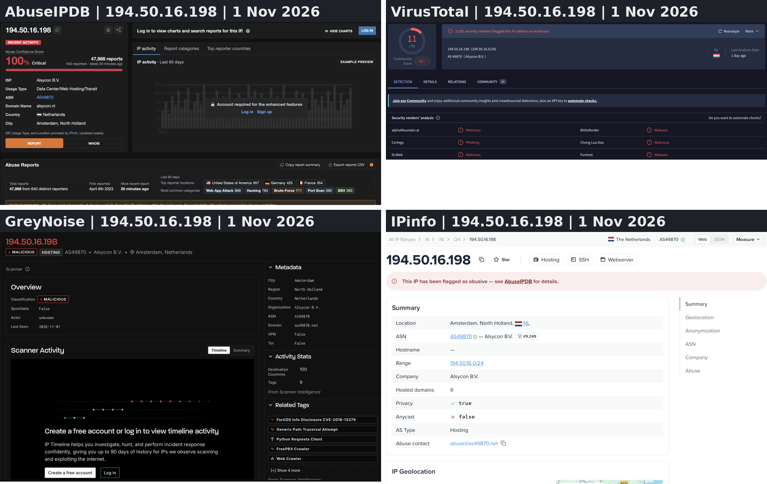
Fig. 13. 194.50.16.198 in the same four tools.
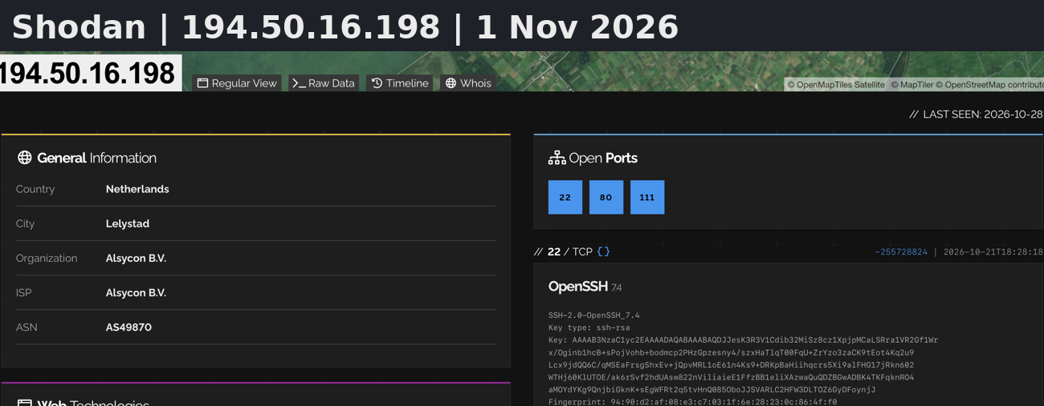
Fig. 14. 194.50.16.198 in Shodan.

6 Suricata observations
In total, Suricata logged 13,689,578 entries, of which 5,699,488 were classified as alerts (Fig. 15). Most of it is just noise. The Generic Protocol Command Decode was responsible for about 5 out of 6 alerts, primarily due to three decoder rules (truncated packets and stream gaps), which points to capture issues on my part. In the absence of these, the top signatures included ICMP ping (157,531), a python-requests client (101,282), RDP traffic, the DShield block list (48,619), and DoublePulsar (34,823), the backdoor associated with the MS17-010 SMB vulnerability.
An alert that has an associated CVE means that the rule is related to a known vulnerability, but it does not mean that the attack was successful (Fig. 16, Table 2). The count for the primary entry, CVE-2001-0540, is almost the same as the count of RDP request signatures (75,543 and 75,539). This shows it is a label for normal RDP alerts and not for 75,000 exploits. The rest of the issues are related to old vulnerabilities in RDP, SIP, SNMP and VPN solutions. Recent examples were rare, such as React2Shell (CVE-2025-55182) which had 18 notifications [26].
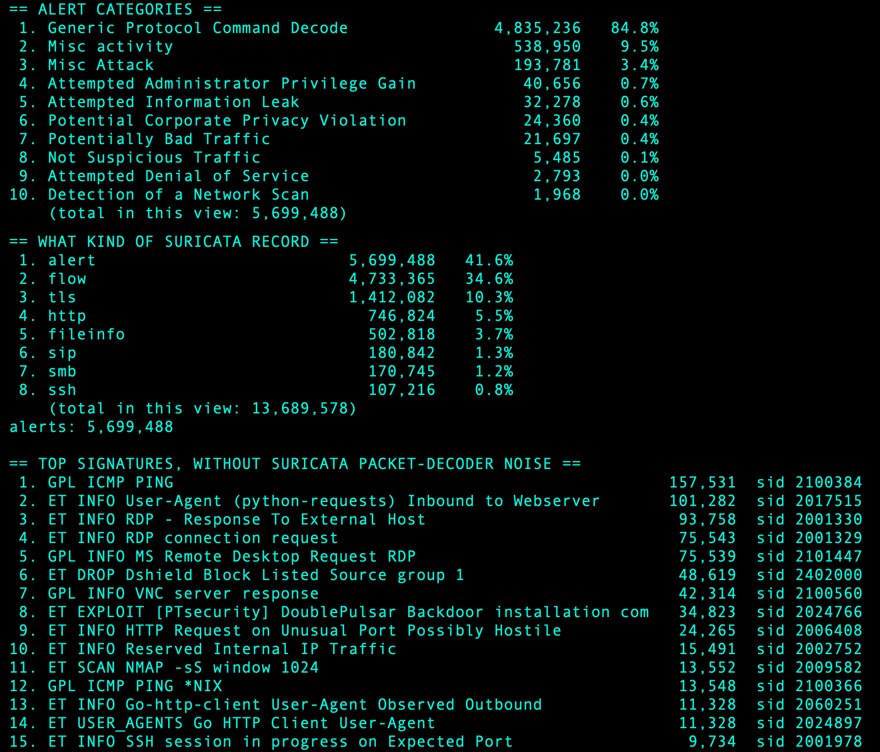
Fig. 15. Suricata categories and signatures.
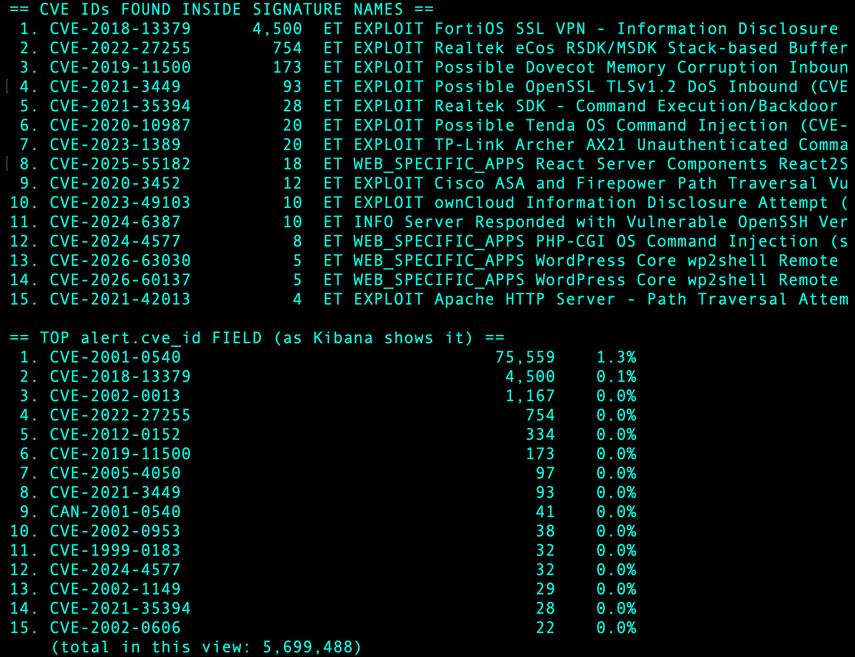
Fig. 16. CVE IDs in Suricata signatures.
Table 2. The five most common CVE IDs in Suricata alerts.
CVE | Alerts | What it is
CVE-2001-0540 | 75,559 | Windows NT and 2000 Terminal Server memory leak, crashed by malformed RDP requests [27]
CVE-2018-13379 | 4,500 | FortiOS SSL VPN flaw that lets an attacker read files [28]
CVE-2002-0013 | 1,167 | Flaws in how devices handle SNMP, which can crash them or give control [29]
CVE-2022-27255 | 754 | Buffer overflow in Realtek router SIP handling, run by one crafted packet [30]
CVE-2012-0152 | 334 | Windows remote desktop flaw that hangs the service [31]

7 Usernames and passwords
A total of 148,979 events included a username, with roughly seventy percent on Cowrie (Fig. 17). The most common usernames were root (approximately 40%), followed by sa, Administrator, Administrateur, and admin for Linux SSH, SQL Server on port 1433, and Windows RDP, respectively. The most common passwords included blank entry (about 20%), 123456, 123, 1234, and 12345678. This relates to password guessing, MITRE T1110.001 [32], and the advice of NCSC to change default passwords and limit login attempts [33] greatly reduces its effectiveness.
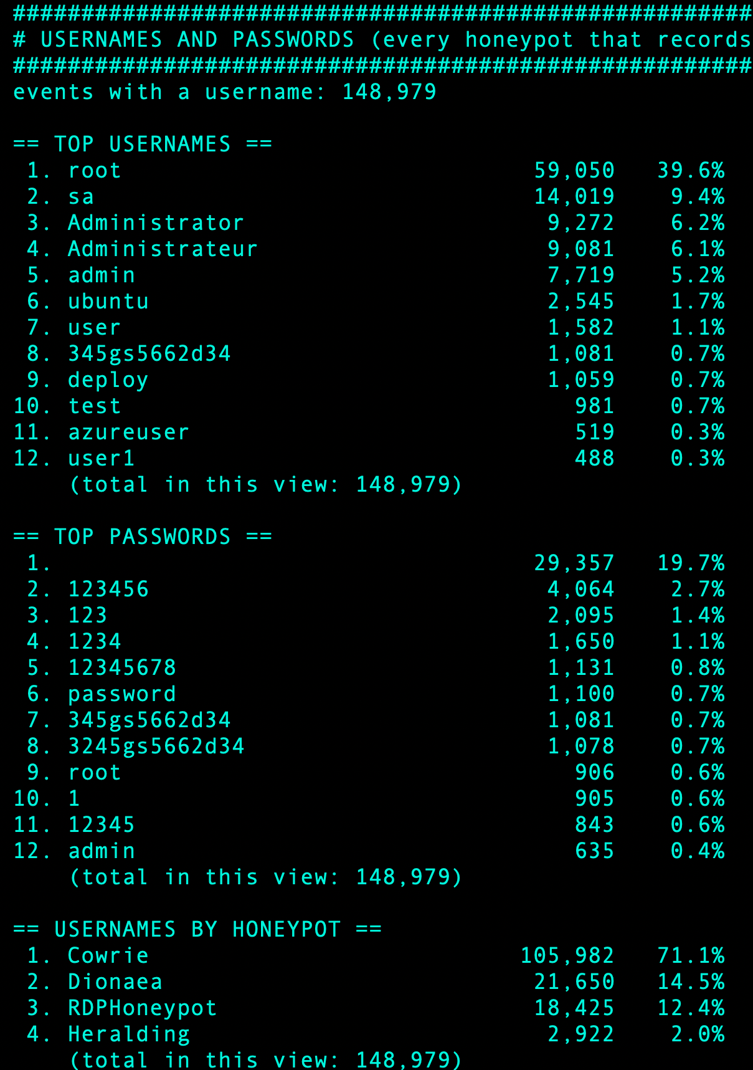
Fig. 17. Usernames and passwords.

8 Interesting findings
8.1 Banatsync Source: Banatsync
The winner of the network was Banatsync Srl (AS198364) and I had to find out more. These two address blocks (109.160.32.0/24 and 77.239.124.0/24) produced a total of 56,722 SSH connections to the sensors, with 38,068 from the former and 18,654 from the latter (Figs. 18 and 19). Each used a Go client (banner SSH-2.0-Go, a specification defined in RFC 4253 [34]), tried one password guess, and then ended the session.
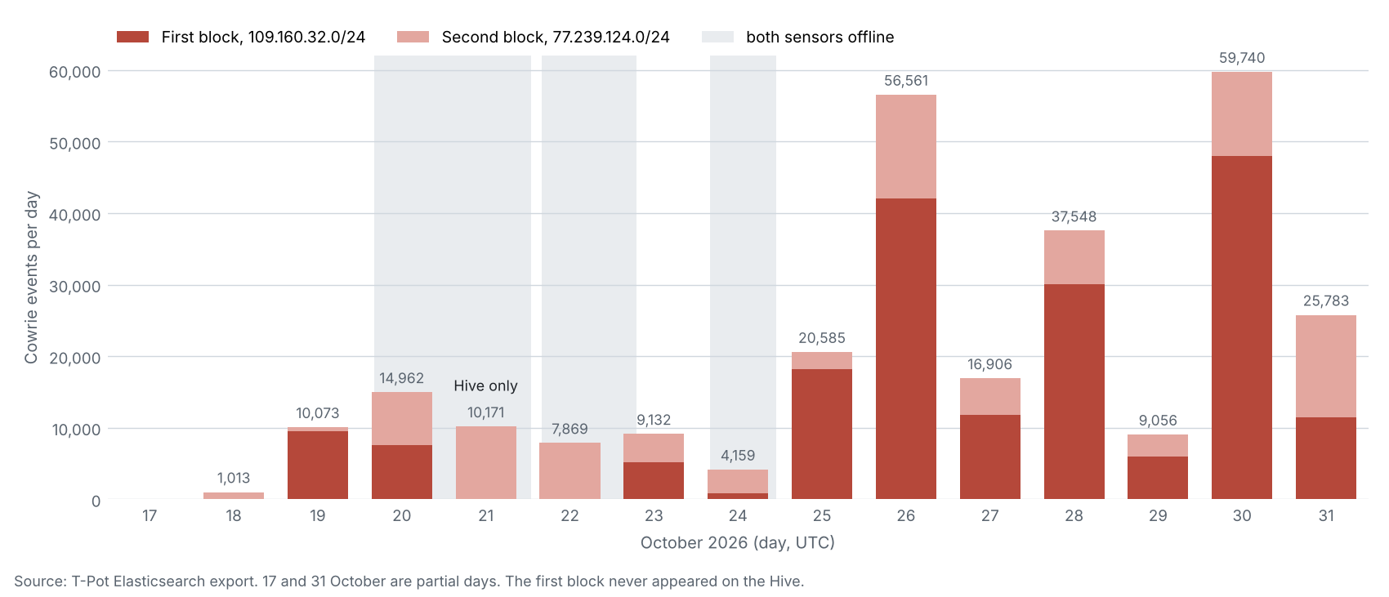
Fig. 18. Banatsync events per day.
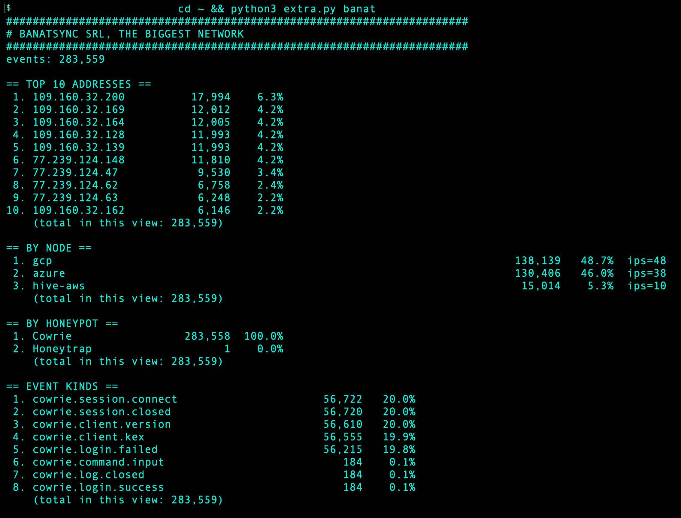
Fig. 19. My script's output for Banatsync.

What did they score? Hardly anything. Only 184 connections were logged . Cowrie deliberately allows some guesses , and each one runs uname -s -v -n -r -m once , then leaves , only getting the false system info of my honeypot ( Fig. 20 ) . They tried mainly "root", "ubuntu" and "admin" with the passwords "123456", "123" and "1234".
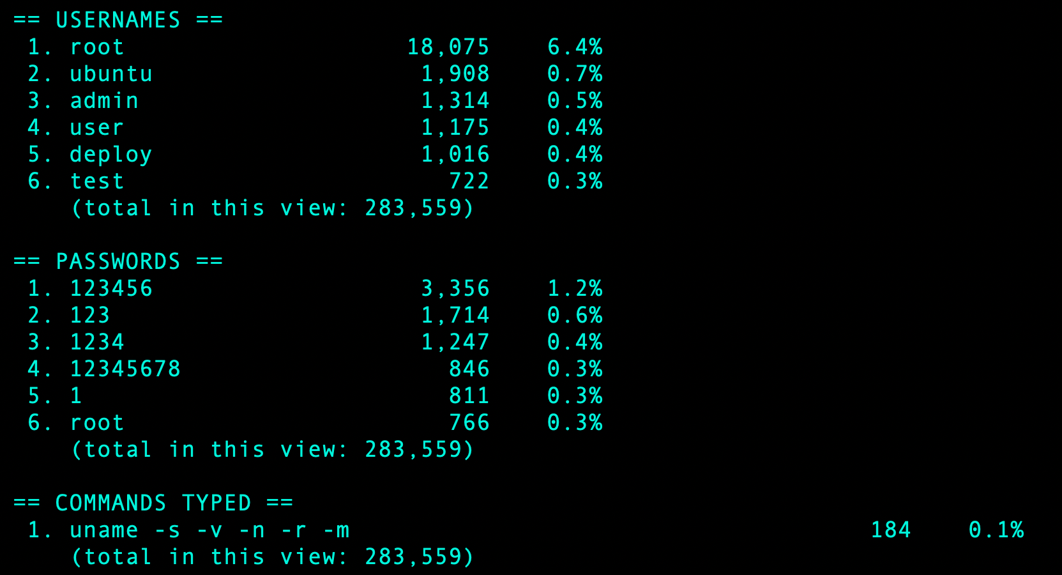
Fig. 20. Banatsync usernames, passwords and commands.
What did they sacrifice? Their hideout. No address exceeded around 1,200 connections per day, but one banner, command and habit now connects 80 addresses, with the DShield list ranking 77.239.124.0/24 number one on November 1st. This is a subtle form of attack: each individual address seems benign, but the entire network shows its true character.
I also processed two of its addresses with the six tools (Figs. 21–23, Table 1). Both were found by AbuseIPDB, VirusTotal, and GreyNoise. SANS gave both a score of 0. Both are operated by Banatsync but registered with two different hosting companies ( Global Communication Net Plc and Rocket & Marinica Ltd ) according to IPinfo . This makes me interpret Banatsync as a network that operates leased servers . This may clarify its prominence without being a singular aggressor ( my hypothesis ) .
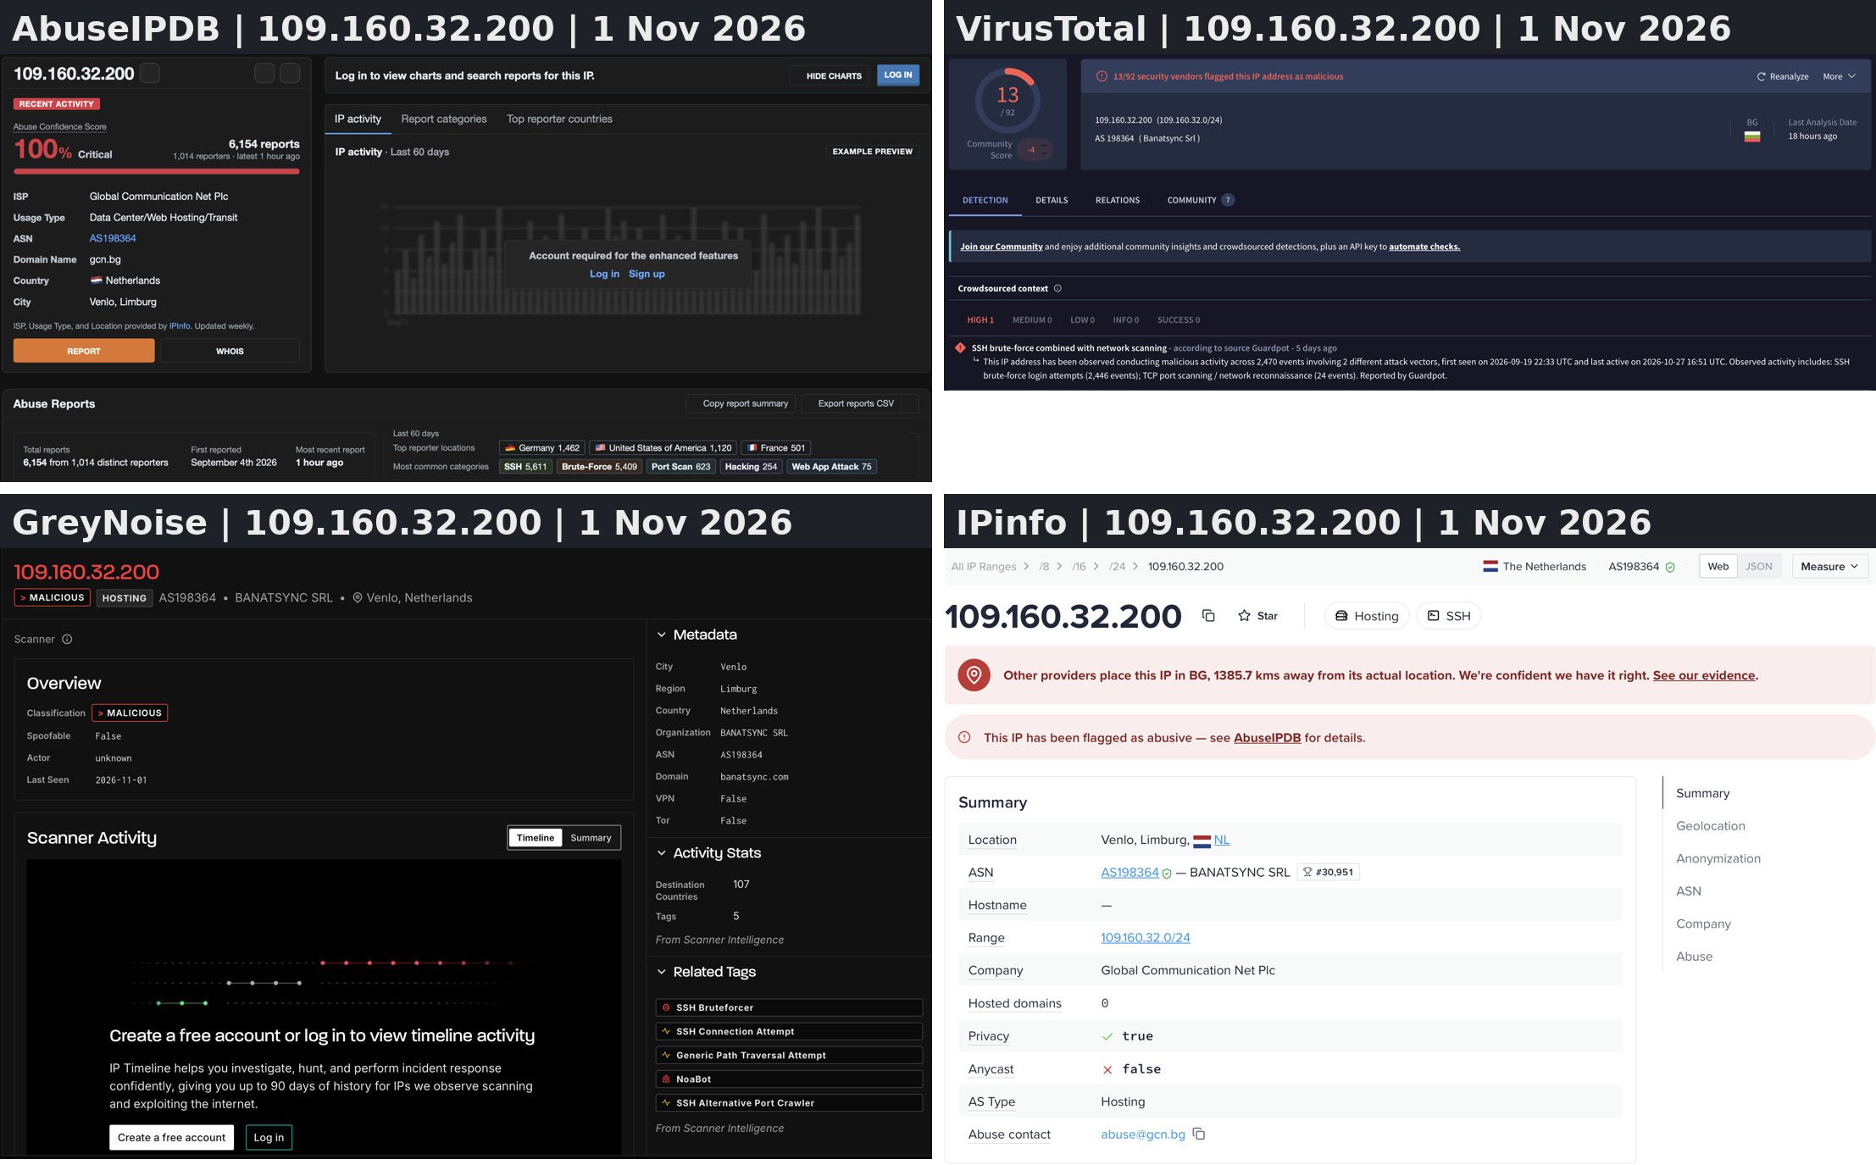
Fig. 21. 109.160.32.200 in four lookup tools.
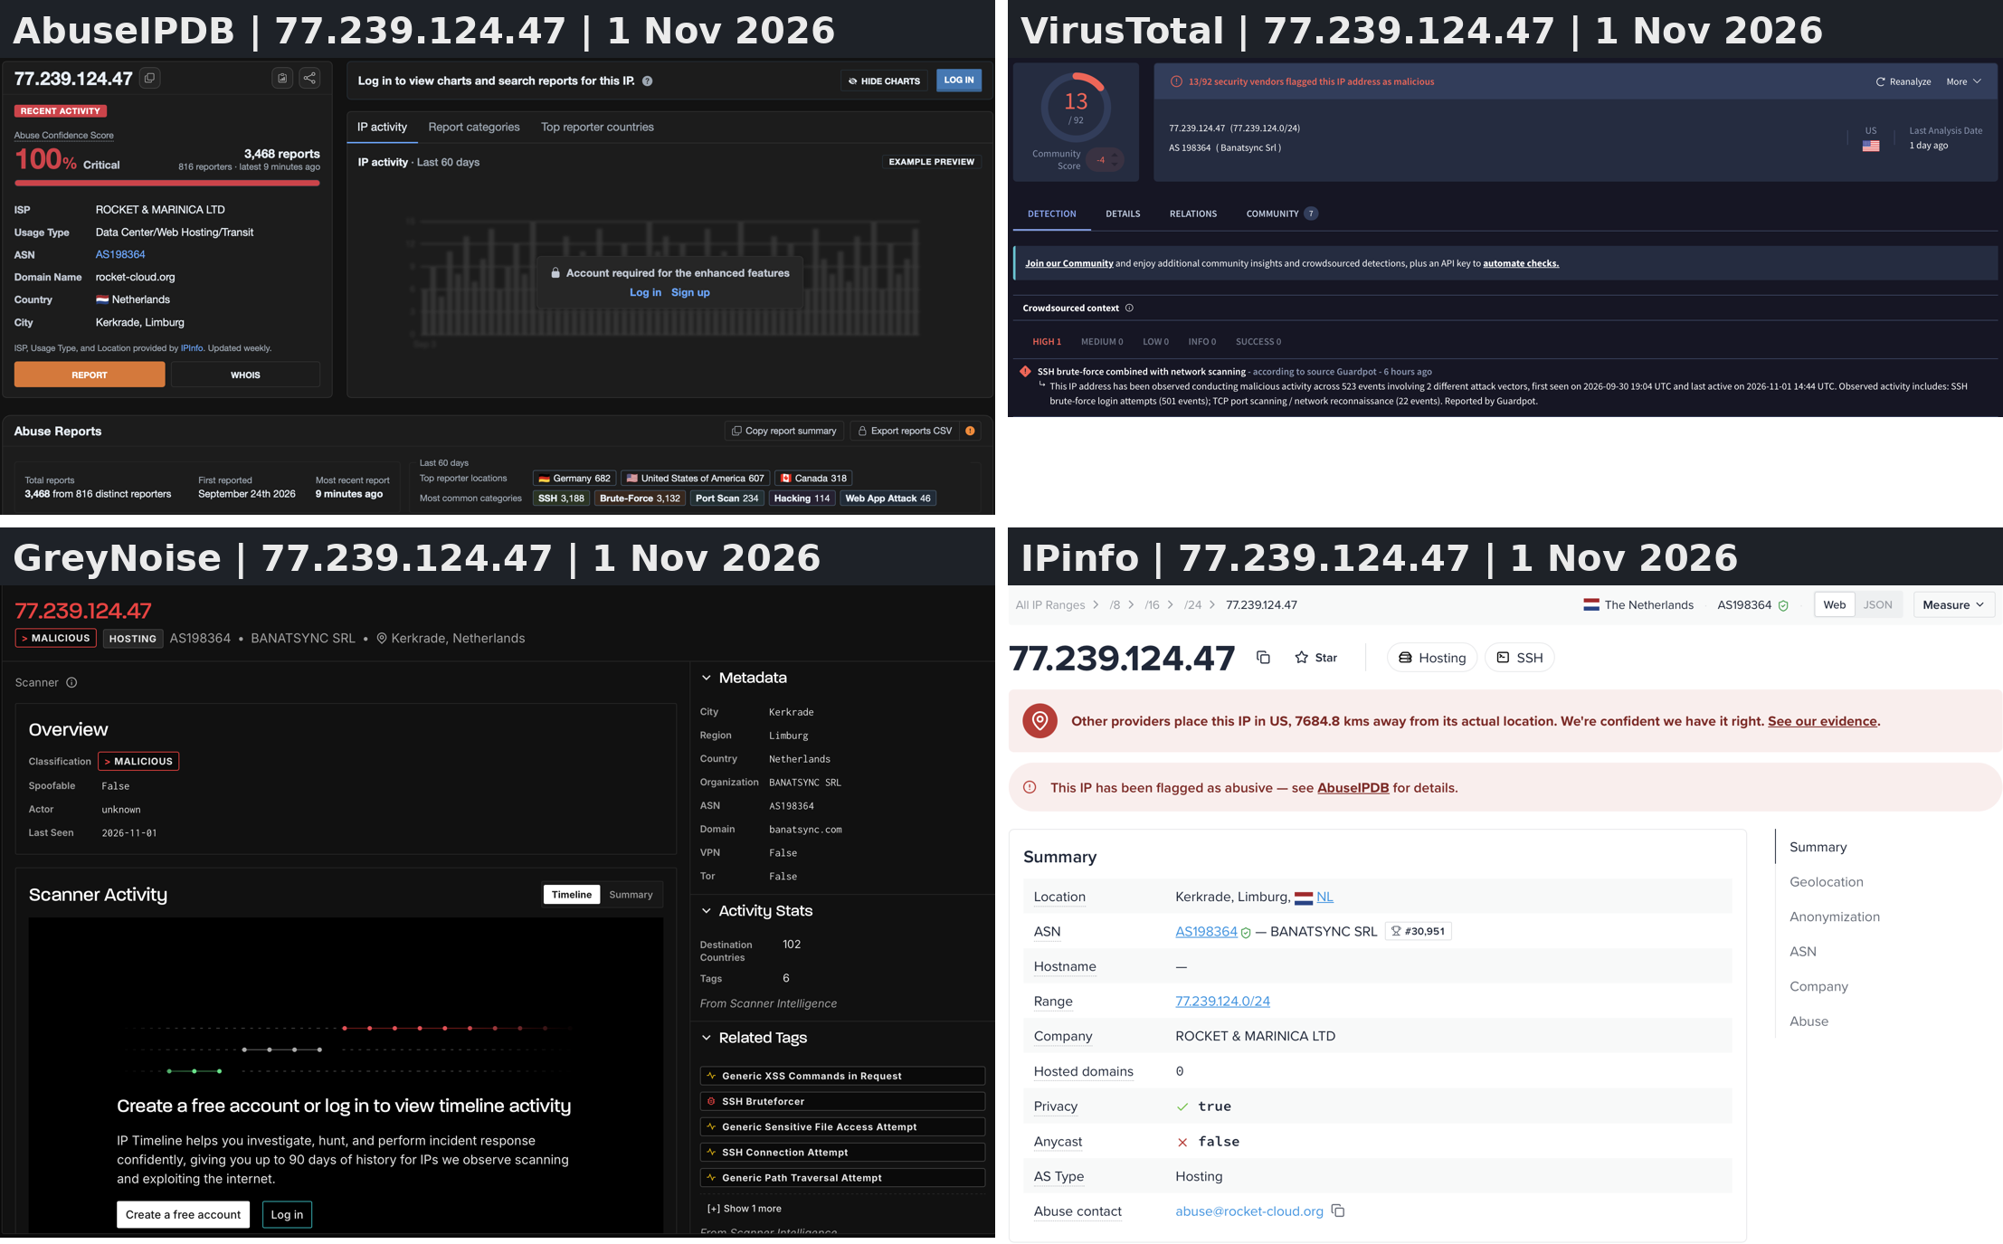
Fig. 22. 77.239.124.47 in the same four tools.
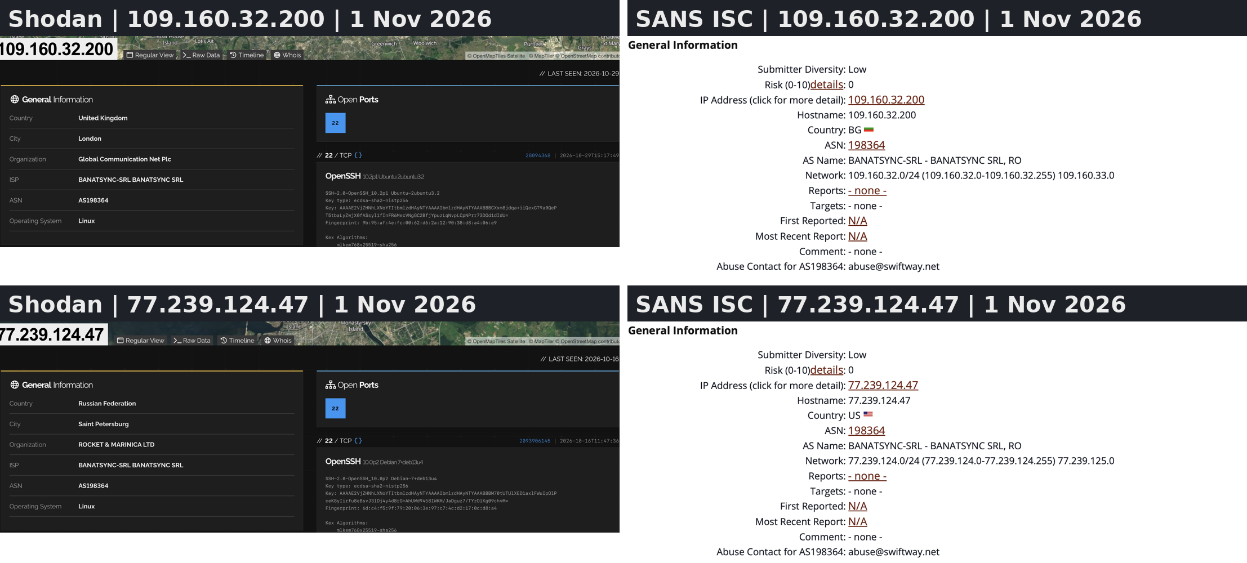
Fig. 23. Both Banatsync addresses in Shodan and SANS ISC.

8.2 PHP2Shell
On 20 October, Akamai reported two vulnerabilities in PHP dubbed PHP2Shell. The first request contains PHP_SESSION_UPLOAD_PROGRESS. Of 336,511 web-honeypot incidents, three requests from 204.76.203.7 were made on 24 October at around 17:03 UTC. They look more like assessments than an assault (Fig. 24).
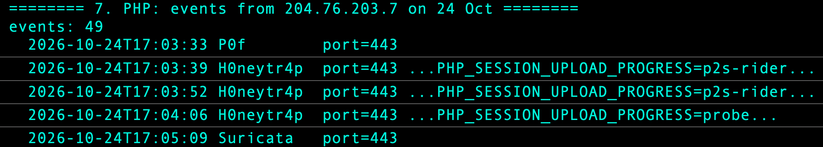
Fig. 24. Events from 204.76.203.7 on 24 October.

9 The 91 hours of lost data
T-Pot adds a daily reboot to root's crontab by default [4]. On the Hive it ran at 03:48 UTC until I commented it out at 23:21 on 24 October (Listing 1). Both sensors went silent together at 04:00 on 20, 22 and 24 October, for 45, 27 and 19 hours, 91 hours in all (Fig. 25). Azure logged in only 205 of 356 hours and GCP in 197. I did not check the sensors' crontabs, so the reboot is the likeliest cause but not proven. The gaps weaken the first-seen dates and node comparisons.
#48 3 * * * bash -c 'systemctl stop tpot.service && ...; /usr/sbin/shutdown -r +1 "T-Pot Daily Reboot"'
Oct 24 23:21:34 crontab[571658]: (root) REPLACE (root)
Listing 1. Crontab entry and my edit (shortened).

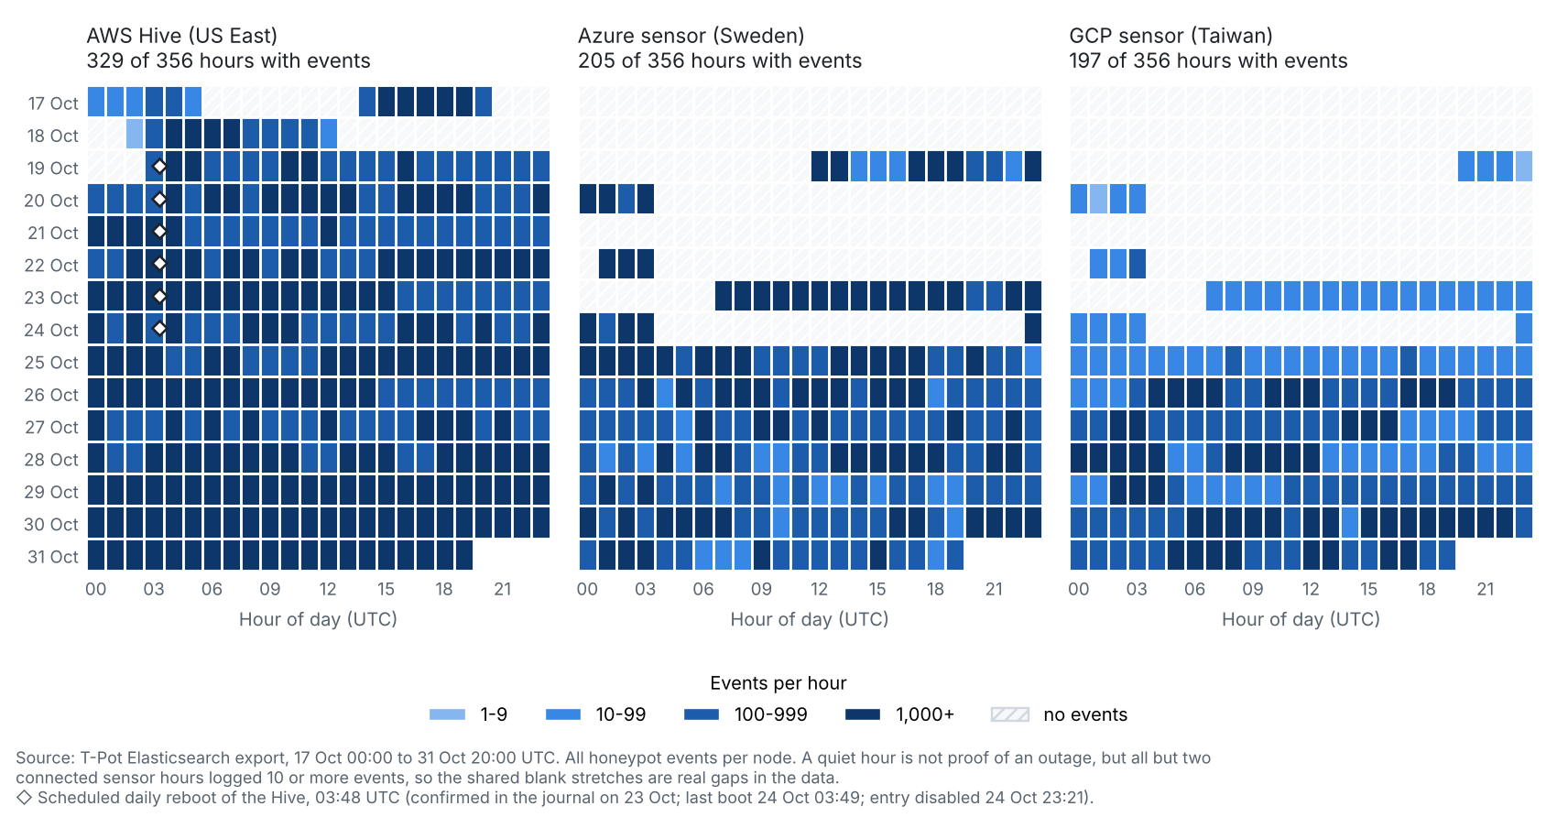
10 Discussion
The honeynet served as an educational tool, teaching the lesson that one should not trust a figure until its meaning is understood. Most of the Suricata alerts were meaningless , one CVE was just a name , and there was disagreement between the country labels and lookup tools . It was also a security operation to run it: it took 91 hours to set it up.
It is a tool of protection, giving localised information. Over a third of the events were from just ten addresses, nine of which would have been missed by relying solely on reputation scores. I would disable password authentication for SSH and RDP [33], limit access by network and address, alert if a sensor goes down, not rely on a single reputation source, and assign the RAM recommended by T-Pot to the Hive. Constraints include one 15-day period, inconsistent uptime, GeoIP inaccuracies, a maximum of four addresses analysed thoroughly, and no statistical evaluations.

11 Conclusion

My honeynet recorded 1,257,851 occurrences from 19,336 unique addresses in roughly 15 days. Cowrie accounted for roughly fifty percent, ten addresses made up over one-third and Banatsync quietly accumulated nearly twenty-five percent from 82 addresses. SANS ISC tagged most of the prominent addresses as clean, but three other tools flagged problems with the four I examined. A honeynet can be a fantastic educational tool and a local blocklist repository if its data is analysed carefully.
References
[1] N. Provos, "A virtual honeypot framework," in Proc. 13th USENIX Security Symp., San Diego, CA, USA, 2004. [Online]. Available: https://www.usenix.org/legacy/event/sec04/tech/provos.html
[2] Open Information Security Foundation, "What is Suricata," Suricata documentation. [Online]. Available: https://docs.suricata.io/en/latest/what-is-suricata.html (accessed Nov. 1, 2026).
[3] M. Zalewski, "p0f v3: passive OS fingerprinter, README," GitHub mirror, 2012. [Online]. Available: https://github.com/p0f/p0f (accessed Nov. 1, 2026).
[4] Telekom Security, "T-Pot: The all in one multi honeypot platform," GitHub. [Online]. Available: https://github.com/telekom-security/tpotce (accessed Nov. 1, 2026).
[5] M. Oosterhof, "Cowrie: SSH and Telnet honeypot documentation." [Online]. Available: https://docs.cowrie.org/en/stable/README.html (accessed Oct. 31, 2026).
[6] K. N. Sayad, "Tpot: honeynet scripts and extra screenshots," GitHub. [Online]. Available: https://github.com/NomaanS/Tpot (accessed Nov. 1, 2026).
[7] J. Rosenberg et al., "SIP: Session Initiation Protocol," RFC 3261, IETF, Jun. 2002. [Online]. Available: https://www.rfc-editor.org/rfc/rfc3261
[8] SANS Internet Storm Center, "Port 5060," ISC port report. [Online]. Available: https://isc.sans.edu/port/5060 (accessed Nov. 1, 2026).
[9] SANS Internet Storm Center, "Port 3389," ISC port report. [Online]. Available: https://isc.sans.edu/port/3389 (accessed Nov. 1, 2026).
[10] SANS Internet Storm Center, "Port 22," ISC port report. [Online]. Available: https://isc.sans.edu/port/22 (accessed Nov. 1, 2026).
[11] SANS Internet Storm Center, "Port 445," ISC port report. [Online]. Available: https://isc.sans.edu/port/445 (accessed Nov. 1, 2026).
[12] Microsoft, "Microsoft Security Bulletin MS17-010 - Critical," Mar. 14, 2017. [Online]. Available: https://learn.microsoft.com/en-us/security-updates/securitybulletins/2017/ms17-010 (accessed Nov. 1, 2026).
[13] Internet Assigned Numbers Authority, "Service name and transport protocol port number registry." [Online]. Available: https://www.iana.org/assignments/service-names-port-numbers/service-names-port-numbers.xhtml (accessed Nov. 1, 2026).
[14] SANS Internet Storm Center, "Port 1433," ISC port report. [Online]. Available: https://isc.sans.edu/port/1433 (accessed Nov. 1, 2026).
[15] SANS Internet Storm Center, "Port 3306," ISC port report. [Online]. Available: https://isc.sans.edu/port/3306 (accessed Nov. 1, 2026).
[16] SANS Internet Storm Center, "Port 23," ISC port report. [Online]. Available: https://isc.sans.edu/port/23 (accessed Nov. 1, 2026).
[17] SANS Internet Storm Center, "Port 6379," ISC port report. [Online]. Available: https://isc.sans.edu/port/6379 (accessed Nov. 1, 2026).
[18] SANS Internet Storm Center, "IP information" pages for the top ten addresses. [Online]. Available: https://isc.sans.edu/ipinfo/ (accessed Nov. 1, 2026).
[19] AbuseIPDB, "Check an IP address, domain name or subnet." [Online]. Available: https://www.abuseipdb.com/ (accessed Nov. 1, 2026).
[20] VirusTotal, "Search IP addresses, domains, files and URLs." [Online]. Available: https://www.virustotal.com/ (accessed Nov. 1, 2026).
[21] GreyNoise Intelligence, "GreyNoise Visualizer: IP lookup." [Online]. Available: https://viz.greynoise.io/ (accessed Nov. 1, 2026).
[22] IPinfo, "IP address lookup." [Online]. Available: https://ipinfo.io/ (accessed Nov. 1, 2026).
[23] Shodan, "Shodan search engine." [Online]. Available: https://www.shodan.io/ (accessed Nov. 1, 2026).
[24] M. Antonakakis et al., "Understanding the Mirai botnet," in Proc. 26th USENIX Security Symp., Vancouver, BC, Canada, 2017, pp. 1093-1110. [Online]. Available: https://www.usenix.org/conference/usenixsecurity17/technical-sessions/presentation/antonakakis
[25] M. Gruber et al., "Global VoIP security threats: Large scale validation based on independent honeynets," in Proc. 14th IFIP Networking Conf., Toulouse, France, May 2015, pp. 1-9. [Online]. Available: https://dl.ifip.org/index.html/db/conf/networking/networking2015/1570062579.pdf (accessed Oct. 31, 2026).
[26] P. Girnus, D. Patel, J. Walsh, L. Silva and A. Verma, "CVE-2025-55182: React2Shell analysis, proof-of-concept chaos, and in-the-wild exploitation," Trend Micro, Dec. 10, 2025. [Online]. Available: https://www.trendmicro.com/en_gb/research/25/l/CVE-2025-55182-analysis-poc-itw.html (accessed Nov. 1, 2026).
[27] MITRE, "CVE-2001-0540," CVE Record. [Online]. Available: https://www.cve.org/CVERecord?id=CVE-2001-0540 (accessed Nov. 1, 2026).
[28] Fortinet, "[FortiOS] file leaking through SSL VPN language resource request," FG-IR-18-384, May 24, 2019. [Online]. Available: https://fortiguard.fortinet.com/psirt/FG-IR-18-384 (accessed Nov. 1, 2026).
[29] MITRE, "CVE-2002-0013," CVE Record. [Online]. Available: https://www.cve.org/CVERecord?id=CVE-2002-0013 (accessed Nov. 1, 2026).
[30] MITRE, "CVE-2022-27255," CVE Record. [Online]. Available: https://www.cve.org/CVERecord?id=CVE-2022-27255 (accessed Nov. 1, 2026).
[31] MITRE, "CVE-2012-0152," CVE Record. [Online]. Available: https://www.cve.org/CVERecord?id=CVE-2012-0152 (accessed Nov. 1, 2026).
[32] MITRE, "Password guessing, sub-technique T1110.001 (v1.7)," MITRE ATT&CK. [Online]. Available: https://attack.mitre.org/techniques/T1110/001/ (accessed Nov. 1, 2026).
[33] National Cyber Security Centre, "Password policy: updating your approach," Nov. 19, 2018. [Online]. Available: https://www.ncsc.gov.uk/collection/passwords/updating-your-approach (accessed Nov. 1, 2026).
[34] T. Ylonen and C. Lonvick, Ed., "The Secure Shell (SSH) transport layer protocol," RFC 4253, IETF, Jan. 2006. [Online]. Available: https://www.rfc-editor.org/rfc/rfc4253
[35] SANS Internet Storm Center, "DShield recommended block list." [Online]. Available: https://www.dshield.org/block.txt (accessed Nov. 1, 2026).
[36] Akamai Security Intelligence Group, "Understanding PHP2Shell: Everything you need to know," Akamai, Oct. 22, 2026. [Online]. Available: https://www.akamai.com/blog/security-research/understanding-php2shell-everything-you-need-to-know (accessed Nov. 1, 2026).

