National Cheng Kung University
Department of Electrical Engineering

Introduction to VLSI CAD (Spring 2024)

Lab Session 2

Design and Simulation of Carry-Lookahead Adder & Parallel-Prefix Adder & Multiplier

Name | Student ID
Practical Sections: |  | Points | Marks
Prob A |  | 15
Prob B |  | 30
Prob C |  | 40
Report |  | 15
Bonus |  | 10
Notes

Due Date: 14:59, March 13, 2024 @ moodle
Deliverables
- All Verilog codes including testbenches for each problem should be uploaded.
NOTE: Please DO NOT include source code in the paper report!
- All homework requirements should be uploaded in this file hierarchy or you will not get the full credit.
NOTE: Please DO NOT upload waveforms!
- Important! TA will use the command in Appendix A to check your design under SoC Lab environment, if your code can not be recompiled by TA successfully using the commands, you will not get the full credit.
- If you upload a dead body which we can’t even compile you will get NO credit!
- All Verilog file should get at least 90% superLint Coverage.
- File hierarchy should not be changed; it may cause your code can not be recompiled by TA successfully using the autograding commands

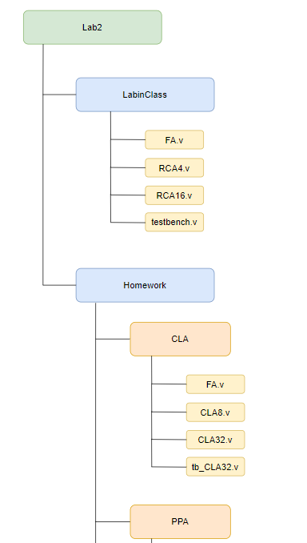
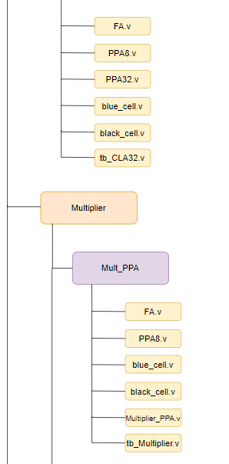
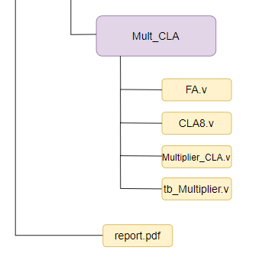
Fig.1 File hierarchy for Homework submission
Objectives:
Help students get familiar with the CAD tools (VCS & Verdi) for digital logic design. Introduce different adder architectures and the algorithms behind them. Please go through the hands-on exercise step-by-step.
Prob A: Design Steps & Carry-Lookahead Adder
- An adder is a digital circuit that performs addition of number. Please design a full adder in gate level.
- The truth table of full adder
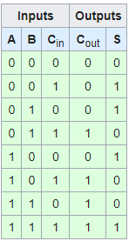
- Draw a full adder in gate level.
- Design a full adder in Structural coding (The module name should be FA. And the file you include should be FA.v)
- Carry-lookahead-adder uses carry generator to alleviate the lengthy carry propagation procedure in ripple-carry-adder.
- Derive the 8th carry bit C₈(ex. C₂ = A₁B₁+(A₁+B₁)C₁ =g₁ + p₁C₁= g₁ + p₁g₀+ p₁p₀C₀)
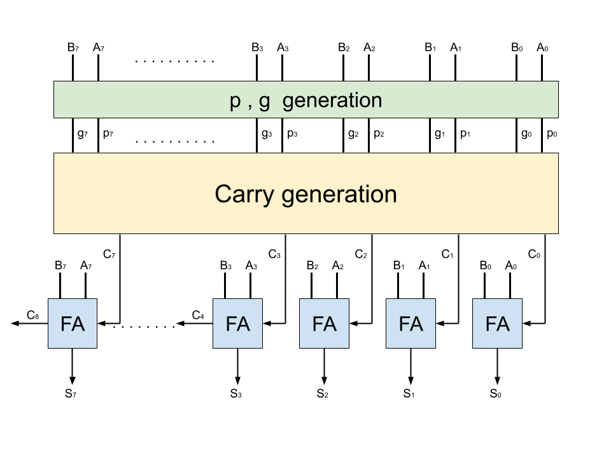
ex. C₂ = A₁B₁+(A₁+B₁)C₁ =g₁ + p₁C₁= g₁ + p₁g₀+ p₁p₀C_{0 ,} g₁ + p₁g₀+ p₁p₀C₀ is the final result.
C₈ =

- Design a 8-bit carry lookahead adder in Structural coding (The module name should be CLA8. And the file you include should be CLA8.v)
- Design a 32-bit carry lookahead adder in hierarchical coding using previously designed CLA8 module. (The module name should be CLA32. And the file should be CLA32.v)
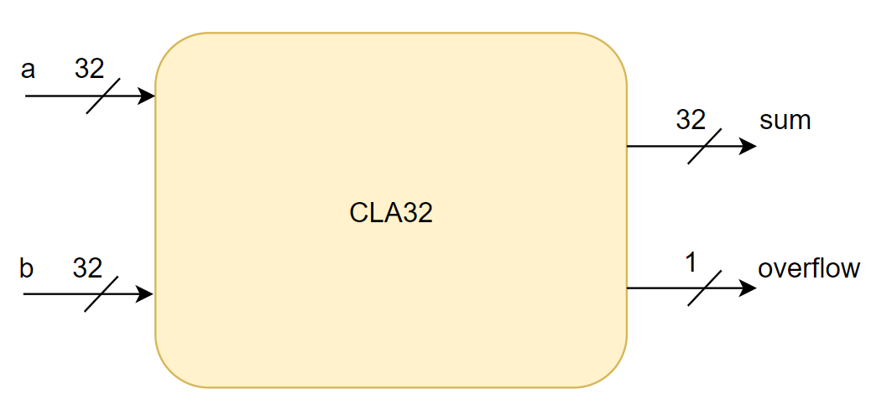
Signal | IO | Bits | Description
a | Input | 32 | Addend
b | Input | 32 | Augend
sum | Output | 32 | Result after calculating
overflow | Output | 1 | Overflow detection

- Simulate your design with the following test pattern in sample testbench.
(Hint: The command for compiling is % vcs -R tb_CLA.32v -full64)
(Hint: The command for simulation is %vcs -R tb_CLA32.v -debug_access+all -full64 +define+FSDB)
- Verify your design by comparing the simulation results with the results you predicted. If the results are not the same, please go back to 2) and revise your code. If the simulation results are correct, please snapshot the simulation result on the terminal and the waveform you dumped and explain your waveform. (Hint : The command to open nWave is %nWave &)
In addition, you should check your coding style, and make sure that there are no error messages and coverage with Superlint must > 90 %. Snapshot the result and calculate Superlint coverage. (Hint: The command to open Superlint is %jg -superlint superlint.tcl)
- You only need to upload your v-code to moodle, do not paste your code here.

Your simulation result on the terminal.
Your waveform :
Explanation of your waveform :
Superlint screenshot and coverage

Prob B: Parallel-Prefix Adder
- Parallel-prefix-adder reduces the complexity of the carry generation circuitry in carry-lookahead-adder.
- Recursive formulation of carry bits:
Q(m, n) = 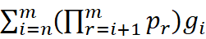
C₀ = 0
C₁ = A₁B₁+(A₁⊕B₁)C₀ = g₁ + p₁C₀ = g₁ = Q(1, 1)
C₂ = A₂B₂+(A₂⊕B₂)C₁ = g₂ + p₂C₁ = g₂ + p₂g₁ = Q(2, 1) = p₂Q(1, 1) + Q(2, 2)
C₃ = A₃B₃+(A₃⊕B₃)C₂ = g₃ + p₃C₂= g₃ + p₃g₂ + p₃p₂g₁ = Q(3, 1) = p₃p₂Q(1, 1) + Q(3, 2)
= p₃p₂Q(1, 1) + p₃Q(2, 2) + Q(3, 3)
C₄ = A₄B₄+(A₄⊕B₄)C₃ = g₄ + p₄C₃= g₄ + p₄g₃ + p₄p₃g₂ + p₄p₃p₂g₁ = Q(4, 1) = p₄p₃Q(2, 1) + Q(4, 3)
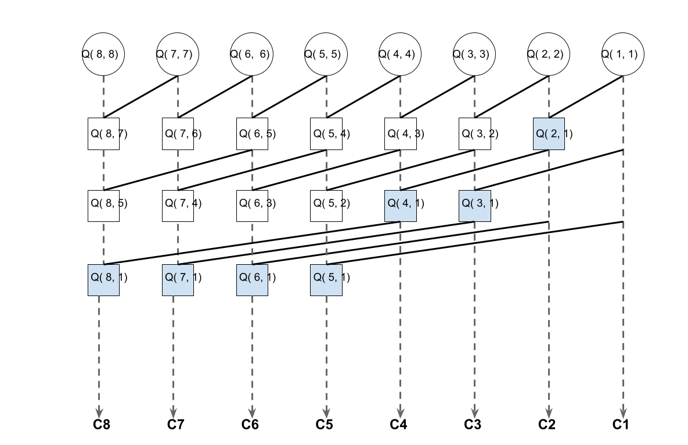
- Design a full adder in Structural coding (The module name should be FA. And the file you include should be FA.v)
- Design black cell & blue cell in Structural coding (The module name should be black_cell & blue_cell. And the file you include should be black_cell.v & blue_cell.v)
- Design a 8-bit parallel-prefix-adder in hierarchical coding using black cell & blue cell as basic unit (The module name should be PPA8. And the file you include should be PPA8.v)
- Design a 32-bit parallel-prefix-adder in hierarchical coding using previously designed PPA8 module. (The module name should be PPA32. And the file should be PPA32.v)
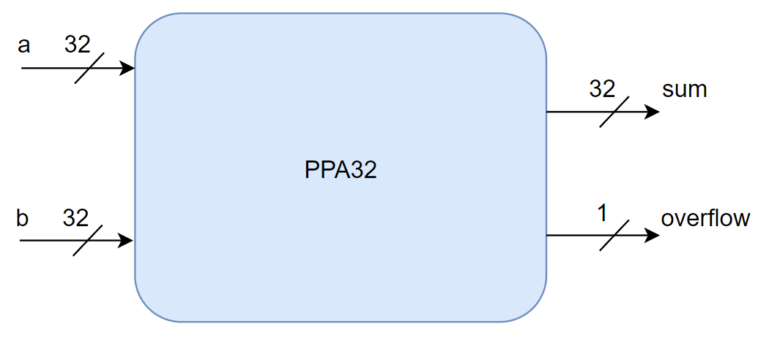
Signal | IO | Bits | Description
a | Input | 32 | Addend
b | Input | 32 | Augend
sum | Output | 32 | Result after calculating
overflow | Output | 1 | Overflow detection

- Simulate your design with the following test pattern in sample testbench.
(Hint: The command for compiling is % vcs -R tb_PPA32.v -full64)
(Hint: The command for simulation is %vcs -R tb_PPA32.v -debug_access+all -full64 +define+FSDB)
- Verify your design by comparing the simulation results with the results you predicted. If the results are not the same, please go back to 2) and revise your code. If the simulation results are correct, please snapshot the simulation result on the terminal and the waveform you dumped and explain your waveform. (Hint : The command to open nWave is %nWave &)
In addition, you should check your coding style, and make sure that there are no error messages and coverage with Superlint must > 90 %. Snapshot the result and calculate Superlint coverage. (Hint: The command to open Superlint is %jg -superlint superlint.tcl)
- You only need to upload your v-code to moodle, do not paste your code here.

Your simulation result on the terminal.
Your waveform :
Explanation of your waveform :
Superlint screenshot and coverage

Prob C: Application
- Design a 8*8-bit multiplier
  - Using CLAs of Prob A
  - Using PPAs of Prob B
  - Design in gate level rather than behavioural modelling. (The module name should be Multiplier_CLA & Multiplier_PPA. And the file you include should be Multiplier_CLA.v & Multiplier_PPA.v)
- Draw your hieratical structure.
- You only need to upload your v-code to moodle, do not paste your code here.
- Simulate your design with the testbench which includes all case of input.
(Hint: The command for compiling is % vcs -R tb_Multiplier.v -full64)
(Hint: The command for simulation is % vcs -R tb_Multiplier.v -debug_access+all -full64 +define+FSDB)
- Verify your design by comparing the simulation results with the results you predicted. If the results are not the same, please go back to 2) and revise your code. If the simulation results are correct, please snapshot the simulation result on the terminal and the waveform you dumped and explain your waveform. (Hint : The command to open nWave is %nWave &)
In addition, you should check your coding style, there are no error messages and over 90% coverage with Superlint. Snapshot the result and calculate Superlint coverage. (Hint: The command to open Superlint is %jg -superlint superlint.tcl)
Draw your hieratical structure.
Your simulation result on the terminal.
Your waveform :
Explanation of your waveform :
Superlint screenshot and coverage

Appendix A : Commands we will use to check your homework

Problem |  | Commands
ProbA | Compile | % vcs -R tb_CLA32.v -full64
ProbA | Simulate | % vcs -R tb_CLA32.v -debug_access+all -full64 +define+FSDB
ProbB | Compile | % vcs -R tb_PPA32.v -full64
ProbB | Simulate | % vcs -R tb_PPA32.v -debug_access+all -full64 +define+FSDB
ProbC | Compile | % vcs -R tb_Multiplier.v -full64
ProbC | Simulate | % vcs -R tb_Multiplier.v -debug_access+all -full64 +define+FSDB

