PROJECT REPORT
EDGE DETECTOR COMPARISON AND ANALYSIS TOOL

Submitted in partial fulfilment of the requirements for the Computer Vision course
Submitted by:
Azaan Ahmed
Registration Number: 24BAI10713
B.Tech in Computer Science and Engineering (AI/ML)
VIT Bhopal University
Submitted to:
Vikas Pal Veelon
Academic Session: 2026–2027

ABSTRACT
Edge detection is one of the basic operations in Computer Vision. It helps identify the boundaries of objects by detecting significant changes in pixel intensity. Different edge detection methods work differently depending on the image, the algorithm used, and the amount of noise present.
In this project, I implemented a tool to compare four classical edge detection techniques: Sobel, Canny, Laplacian of Gaussian (LoG), and Difference of Gaussians (DoG). The application was developed in Python and can be executed directly through the command line.
A synthetic grayscale image containing different geometric shapes was used for testing. Gaussian noise was added at five levels, with sigma values of 0, 5, 15, 25, and 40. Each image was processed using all four edge detectors. The program recorded execution time, edge density, and percentage change in edge density compared with the original image.
The application also generates individual edge maps, a comparison grid, a CSV file containing the experimental measurements, and a noise-robustness plot.
The results showed that the four methods responded differently as noise increased. Sobel and LoG showed substantial increases in edge density at the highest noise level, while Canny changed relatively little at lower noise levels. DoG maintained comparatively stable edge-density measurements throughout the experiment.
This project helped me understand how classical edge detection algorithms work and how image noise can influence their outputs. It also demonstrated why the results of an image-processing experiment should be interpreted carefully rather than judging an algorithm using a single measurement.

1. INTRODUCTION
Computer Vision is a field of computing that deals with extracting useful information from digital images. Many Computer Vision applications begin by identifying important structures within an image, such as object boundaries, corners, and changes in intensity.
Edge detection is one such operation. An edge usually occurs where the intensity of neighbouring pixels changes significantly. For example, the boundary between a dark object and a bright background produces a noticeable intensity transition.
Identifying these boundaries can simplify later image-processing tasks. Edge information can be used in image segmentation, shape recognition, object detection, document analysis, and industrial inspection.
Several algorithms have been developed to detect edges. Some estimate the gradient of an image, while others use smoothing and derivative operations to identify intensity changes. Their outputs can differ depending on their parameters and the characteristics of the input image.
In this project, four classical edge detection techniques are implemented and compared. The experiment also investigates the effect of Gaussian noise on their outputs.
The project is designed as a command-line application so that the processing pipeline can be executed without a graphical user interface.

2. PROBLEM STATEMENT
The main problem addressed in this project is the difference in behaviour between classical edge detection algorithms when applied to the same image under different noise conditions.
An edge detector may identify genuine object boundaries, but it may also respond to unwanted intensity changes introduced by noise. Therefore, comparing the methods only on a clean image may not provide a complete understanding of their behaviour.
The project addresses this problem by applying four edge detection algorithms to a common input image and repeating the experiment with increasing levels of Gaussian noise.
The outputs are compared using visual edge maps, execution time, edge density, and percentage change in edge density.

3. OBJECTIVES
The main objectives of this project are:
- To understand the basic principles of edge detection in Computer Vision.
- To implement the Sobel operator using manual NumPy-based convolution.
- To implement Canny, Laplacian of Gaussian, and Difference of Gaussians.
- To compare the outputs of the four methods on the same image.
- To generate a synthetic image containing geometric shapes for testing.
- To study the effect of different levels of Gaussian noise.
- To measure execution time for each detector.
- To calculate edge density for clean and noisy images.
- To calculate the percentage change in edge density relative to the clean image.
- To automatically generate comparison images, CSV measurements, and a plot.

4. BACKGROUND AND THEORY

4.1 Edge Detection
Edge detection identifies locations in an image where pixel intensity changes significantly. These locations often correspond to object boundaries or transitions between different regions.
An edge detector processes an image and produces an output representing the detected edges. Depending on the algorithm, this output may contain gradient strengths or a binary map in which pixels are classified as either edges or non-edges.
The performance of an edge detector depends on factors such as image contrast, noise, smoothing parameters, and threshold values.

4.2 Sobel Edge Detector
The Sobel operator is a gradient-based edge detection method. It uses two convolution kernels to estimate changes in image intensity in the horizontal and vertical directions.
The gradient magnitude is calculated as:
G = √(Gx² + Gy²)
Here, Gx and Gy represent the horizontal and vertical gradient responses. A larger gradient magnitude indicates a stronger local intensity change.
In this project, the Sobel convolution is implemented manually using NumPy rather than relying on a single built-in Sobel operation. The resulting gradient magnitude is normalized to an 8-bit grayscale image.
Sobel is relatively straightforward to understand and implement. However, noise can introduce additional intensity variations that may produce unwanted edge responses.

4.3 Canny Edge Detector
Canny is a multi-stage edge detection algorithm designed to produce thin and well-defined edges.
Its main stages are:
- Gaussian smoothing to reduce small variations caused by noise.
- Gradient calculation to identify intensity changes.
- Non-maximum suppression to thin the detected edges.
- Double thresholding to classify edge responses.
- Hysteresis-based edge tracking to connect suitable edge responses.

In this project, Gaussian smoothing is applied using a 5 × 5 kernel with sigma 1.0. Canny detection is then performed using lower and upper thresholds of 100 and 200.
The smoothing and thresholding stages can help maintain relatively stable results under lower noise levels. However, sufficiently strong noise can still affect the output.

4.4 Laplacian of Gaussian (LoG)
Laplacian of Gaussian combines Gaussian smoothing with the Laplacian operator.
Gaussian smoothing reduces small intensity variations before the Laplacian calculates second-order intensity changes. This helps reduce some unwanted responses that may occur when derivatives are applied directly to noisy images.
In this implementation, the image is smoothed using a 5 × 5 Gaussian kernel with sigma 1.0. The Laplacian response is calculated, its absolute magnitude is taken, and the result is normalized.
The output depends on the degree of smoothing and the thresholding applied during subsequent processing.

4.5 Difference of Gaussians (DoG)
Difference of Gaussians works by creating two blurred versions of an image using different Gaussian scales and subtracting one from the other.
The difference emphasizes structures that respond differently to the two smoothing scales.
In this project, the image is blurred using two Gaussian filters: a 5 × 5 kernel with sigma 1.0 and a 9 × 9 kernel with sigma 2.0. The absolute difference between the two blurred images is calculated and thresholded.
DoG can highlight local structures and boundaries, although the resulting edge map depends on the selected scales and threshold.

4.6 Gaussian Noise
Gaussian noise introduces random variations into pixel intensities. Such variations can create intensity changes that are incorrectly identified as edges.
The noisy image can be represented as:
I_noisy = clip(I + N, 0, 255)
where I is the original image and N is Gaussian noise with mean zero and a specified standard deviation.
The clipping operation ensures that the resulting pixel values remain between 0 and 255, which is the valid range for an 8-bit grayscale image.
In this experiment, increasing the noise sigma increases the amount of random variation introduced into the image.

5. TECHNOLOGIES USED
The project was developed using the following technologies.
- Python: Used as the primary programming language for implementing the processing pipeline.
- NumPy: Used for numerical calculations, image-array operations, noise generation, and manual Sobel convolution.
- OpenCV: Used for image loading and saving, Gaussian filtering, Canny detection, Laplacian operations, and thresholding.
- Matplotlib: Used to generate the comparison grid and noise-robustness plot.
- CSV: Used to store the measurements in a structured format that can be opened in spreadsheet software.
- Visual Studio Code: Used as the development environment for writing and executing the Python files.

6. PROJECT STRUCTURE
The project contains the following files and directories:
EdgeDetectorProject/
|
|-- sample_images/
| |-- synthetic_test.png
|
|-- results/
| |-- edges_sobel.png
| |-- edges_canny.png
| |-- edges_log.png
| |-- edges_dog.png
| |-- comparison_grid.png
| |-- noise_experiment.csv
| |-- noise_robustness_plot.png
| |-- noisy_sigma_5.png
| |-- noisy_sigma_15.png
| |-- noisy_sigma_25.png
| |-- noisy_sigma_40.png
|
|-- create_sample.py
|-- edge_detectors.py
|-- main.py
|-- requirements.txt
|-- README.md
|-- REPORT.md

The sample_images directory contains the input image. The results directory stores the images and measurements generated by the program.
The file edge_detectors.py contains the detector functions, while main.py controls the experiment. The file create_sample.py generates the synthetic test image.

7. METHODOLOGY
The project follows a sequence of image-processing and measurement steps.

7.1 Input Image
A synthetic grayscale image of size 512 × 512 pixels is generated. It contains geometric shapes such as rectangles, a circle, a triangle, and lines.
These shapes provide clearly defined boundaries that make it easier to observe differences between edge detection methods.

7.2 Noise Generation
Gaussian noise is added to the original image at five levels.
Noise sigma | Description
0 | Clean image
5 | Low noise
15 | Moderate noise
25 | Higher noise
40 | High noise

The clean image is used as the baseline for calculating changes in edge density.

7.3 Applying the Edge Detectors
Each version of the image is processed using all four methods: Sobel, Canny, LoG, and DoG.
The resulting edge maps are saved separately. For the clean image, a comparison grid is also generated to display the four outputs together.

7.4 Edge Density Calculation
Edge density represents the fraction of pixels classified as edges. It is calculated as:
D = Ne / N
where D is the edge density, Ne is the number of pixels classified as edges, and N is the total number of pixels in the image.
For this experiment, the returned detector image is converted to a binary map using a threshold of 50. Pixels with nonzero values after thresholding are counted as edges.

7.5 Percentage Change in Edge Density
The percentage change is calculated relative to the clean-image edge density:
ΔD (%) = ((Dσ − D0) / D0) × 100
Here, Dσ represents the edge density at a particular noise level, while D0 represents the corresponding density for the clean image.
A positive value means that the measured edge density increased. A negative value means that it decreased.

7.6 Runtime Measurement
Execution time is measured using Python’s time.perf_counter() function.
The measurement includes the detector call and the conversion of its output into a binary edge map. Runtime is recorded in milliseconds.
These measurements are used to compare the execution time of the implementations under the same experimental setup.

7.7 Result Generation
After processing the images, the program generates the individual edge maps, comparison grid, CSV file, noise-robustness plot, and noisy test images.
All outputs are saved in the results directory.

8. IMPLEMENTATION
The implementation is divided into three main Python files.

8.1 create_sample.py
This file creates a 512 × 512 grayscale image using OpenCV drawing functions. It includes geometric shapes with different intensities against a dark background.
The generated image is saved as sample_images/synthetic_test.png.

8.2 edge_detectors.py
This file contains the four detector functions.
- sobel_detector() calculates horizontal and vertical gradients using manual NumPy convolution.
- canny_detector() applies Gaussian smoothing and Canny edge detection.
- log_detector() applies Gaussian smoothing followed by the Laplacian operator.
- dog_detector() calculates the difference between two Gaussian-blurred images and applies thresholding.

Each function returns an image representing the detected edge responses.

8.3 main.py
This is the main entry point of the application.
It handles input loading, command-line arguments, noise generation, detector execution, runtime measurement, edge-density calculation, CSV export, and plot generation.
The program also checks whether the input image can be loaded and reports an error if the path is invalid.
A fixed random seed of 42 is used for noise generation to support reproducibility under the same execution conditions.

9. EXECUTION
The project was executed using Python in a virtual environment on Windows.
The required packages are listed in requirements.txt:
- NumPy
- OpenCV
- Matplotlib

The sample image was generated using:
python create_sample.py

The main experiment was executed using:
python main.py --image sample_images/synthetic_test.png --output results

The program successfully completed the experiment for all five noise levels and all four edge detectors.
It generated the expected output files inside the results directory.

10. EXPERIMENTAL RESULTS
The experiment used a 512 × 512 synthetic grayscale image and five Gaussian noise levels. A total of 20 measurements were recorded, corresponding to four methods tested at five noise levels.

10.1 Edge Density for the Clean Image
The edge densities measured on the clean image were:
Method | Edge density
Sobel | 0.0256
Canny | 0.0126
LoG | 0.0373
DoG | 0.0478
Table 1: Edge density on the clean image
DoG produced the highest measured edge density, while Canny produced the lowest.
These values describe the proportion of pixels classified as edges after the common thresholding step. They should not be interpreted as direct measurements of accuracy.

10.2 Edge Density at Different Noise Levels
Noise sigma | Sobel | Canny | LoG | DoG
0 | 0.0256 | 0.0126 | 0.0373 | 0.0478
5 | 0.0256 | 0.0132 | 0.0328 | 0.0469
15 | 0.0255 | 0.0132 | 0.0351 | 0.0447
25 | 0.0295 | 0.0132 | 0.0446 | 0.0431
40 | 0.0810 | 0.0166 | 0.0956 | 0.0471
Table 2: Edge density at each noise level
Sobel and LoG showed noticeable increases in edge density at the highest noise level. Canny changed relatively little at lower noise levels, while DoG remained comparatively stable throughout the experiment.
The results show that adding noise does not necessarily cause the edge density to increase at every step. The measured response depends on the detector, its parameters, and the thresholding procedure.

10.3 Percentage Change in Edge Density
Noise sigma | Sobel | Canny | LoG | DoG
0 | 0.00% | 0.00% | 0.00% | 0.00%
5 | 0.15% | 5.04% | -12.09% | -1.82%
15 | -0.24% | 5.07% | -6.05% | -6.45%
25 | 15.22% | 5.37% | 19.47% | -9.80%
40 | 216.49% | 31.72% | 155.84% | -1.34%
Table 3: Percentage change in edge density relative to the clean image
The percentage changes provide a clearer view of how the measured edge density differs from the clean-image baseline.
At noise sigma 40, Sobel showed an increase of 216.49%, while LoG showed an increase of 155.84%. Canny showed a smaller increase of 31.72%, and DoG had a net change of -1.34%.
The negative values indicate that fewer pixels passed the selected threshold compared with the clean-image result. They do not necessarily mean that the detector became more accurate.

10.4 Runtime Analysis
The measured runtimes for the clean image were:
Method | Runtime (ms)
Sobel | 10.50
Canny | 2.09
LoG | 1.99
DoG | 1.27
Table 4: Runtime on the clean image
In this particular run, DoG had the lowest measured runtime, followed by LoG and Canny. Sobel had the highest runtime because its convolution is implemented using explicit loops over the kernel and image arrays.
These measurements are specific to the current system and implementation. Runtime can vary with hardware, system load, image size, and software environment.

11. VISUAL RESULTS
The program generated several images to help compare the algorithms.

11.1 Comparison Grid
File: results/comparison_grid.png
The comparison grid displays the edge maps produced by Sobel, Canny, LoG, and DoG for the clean input image. It allows the outputs to be examined side by side.
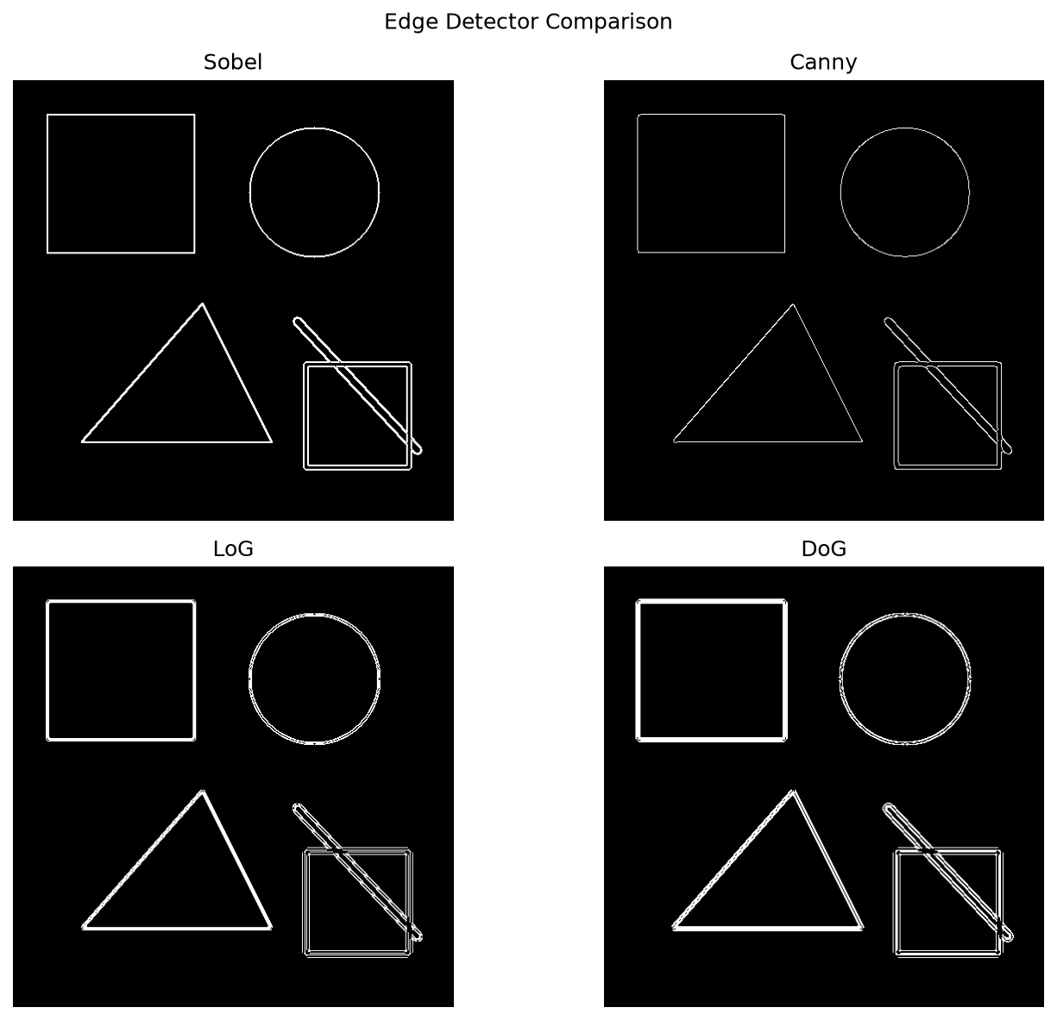
Figure 1: Comparison of the four edge detection methods on the clean synthetic image.

11.2 Noise-Robustness Plot
File: results/noise_robustness_plot.png
The noise-robustness plot shows the percentage change in edge density against Gaussian noise sigma for all four methods.
It makes it easier to observe which implementations show larger changes in their measured edge density as noise increases.
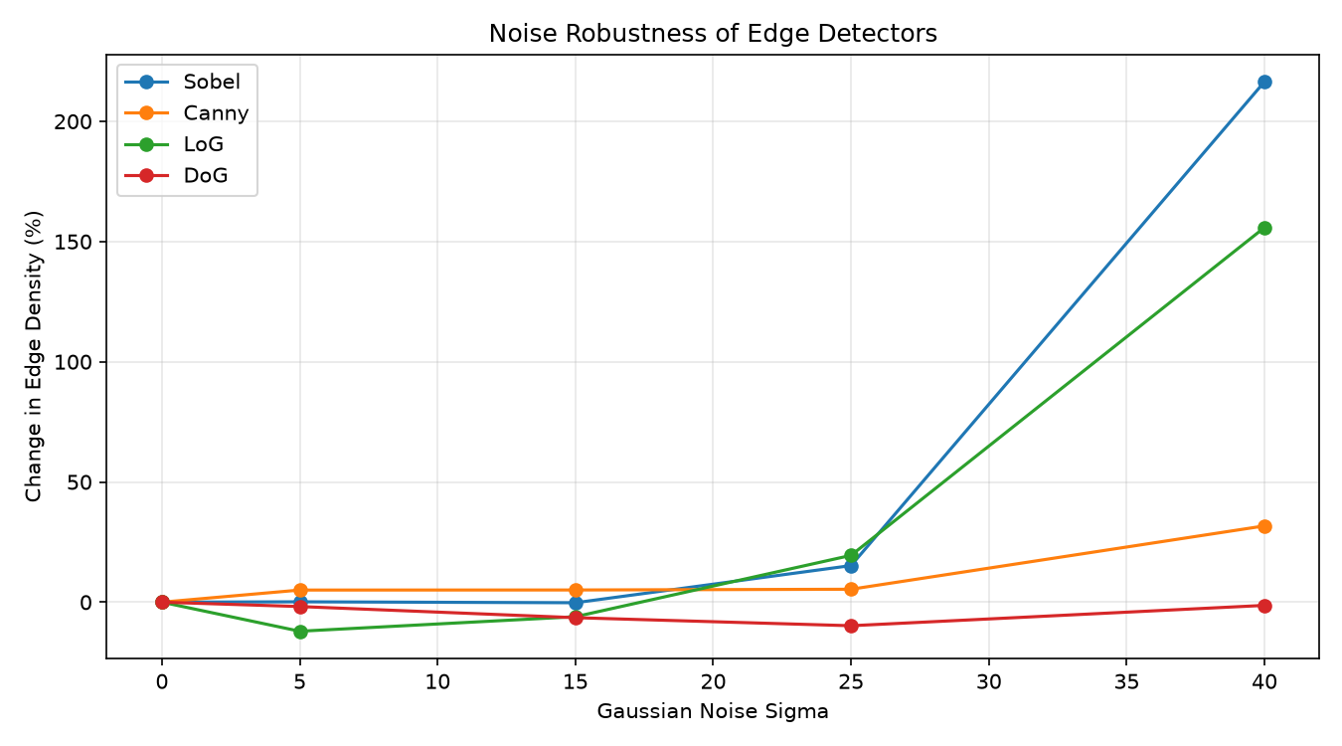
Figure 2: Percentage change in edge density at different Gaussian noise levels.

11.3 Individual Edge Maps
The following images were generated for the clean input image:
- edges_sobel.png
- edges_canny.png
- edges_log.png
- edges_dog.png

These images show the individual outputs of each detector.

11.4 Noisy Test Images
The program saved the noisy images for sigma values 5, 15, 25, and 40.
These images can be compared with the original input to observe the effect of increasing Gaussian noise.

12. DISCUSSION
The experiment shows that the four edge detection methods behave differently under the same noise conditions.
Sobel uses gradient magnitude to identify intensity changes. In this experiment, its edge density increased sharply at the highest noise level. This suggests that many additional pixels crossed the selected edge threshold.
Canny produced comparatively small changes in edge density at lower noise levels. Its smoothing and thresholding stages can help suppress some unwanted responses. However, its edge density also increased at the highest tested noise level.
LoG showed a substantial increase in edge density at sigma 40. Although Gaussian smoothing reduces some small variations, it does not eliminate the effect of strong noise completely.
DoG maintained comparatively stable edge-density measurements across the five tested levels. However, stability in this measurement alone does not prove that all genuine boundaries were preserved or that unwanted edges were eliminated.
One important observation is that edge density should not be treated as a direct measure of edge detection accuracy. An algorithm can produce many edge pixels without correctly identifying the actual boundaries of objects.
Another factor is that the four algorithms do not produce identical types of output. Sobel and LoG return normalized edge-strength images in this implementation, whereas Canny and DoG return binary edge maps. The main program applies a common threshold of 50 before calculating density. This makes the calculation consistent in procedure, but the comparison remains dependent on the chosen threshold and normalization.
The experiment is therefore useful for studying the behaviour of these implementations, but it does not establish a universal ranking of the four algorithms.

13. LIMITATIONS
The project has several limitations.
- The experiment uses one synthetic image rather than a large collection of real-world images.
- Edge density does not directly measure whether detected edges are correct.
- The results depend on algorithm parameters and the selected threshold.
- The output formats and normalization procedures differ between methods.
- Runtime measurements may vary across different computers and execution conditions.
- Only Gaussian noise was investigated.
- The project does not compare classical methods with modern deep-learning-based edge detectors.
- The manual Sobel implementation prioritizes clarity over computational optimization.

These limitations should be considered when interpreting the experimental results.

14. APPLICATIONS
Edge detection is used in a range of Computer Vision applications.
- Image segmentation: Edge information can help separate different regions of an image.
- Object recognition: Object boundaries can provide useful structural information for later recognition tasks.
- Industrial inspection: Edge maps can help identify boundaries, cracks, and irregularities in manufactured components.
- Medical imaging: Edge detection can assist in identifying boundaries between structures in medical images.
- Document analysis: Edge information can help locate text regions, page boundaries, and other document structures.
- Road and lane detection: Changes in intensity can help identify road markings and boundaries under suitable imaging conditions.

The usefulness of each detector depends on the image characteristics and the requirements of the application.

15. FUTURE SCOPE
The project can be improved in several ways.

15.1 Testing More Images
The experiment can be repeated using real-world photographs containing different textures, lighting conditions, and object boundaries.

15.2 Ground-Truth Evaluation
A labelled edge dataset can be used to calculate precision, recall, and F1-score. These metrics would provide a more direct assessment of detection accuracy.

15.3 Parameter Tuning
The program could allow users to modify Gaussian kernel sizes, smoothing parameters, and thresholds directly through command-line arguments.

15.4 Additional Edge Detection Methods
Prewitt, Roberts, and Scharr operators could be added to provide a broader comparison of classical methods.

15.5 Other Noise Types
The experiment could be extended to include salt-and-pepper noise, speckle noise, and other forms of image degradation.

15.6 Runtime Optimization
The Sobel implementation could be optimized to reduce execution time while retaining a manual implementation for educational purposes.

15.7 Learning-Based Methods
The classical detectors could be compared with learning-based edge detection techniques using suitable datasets and evaluation metrics.

16. CONCLUSION
This project implemented and compared four classical edge detection techniques: Sobel, Canny, Laplacian of Gaussian, and Difference of Gaussians.
The application was developed in Python and successfully processed a synthetic grayscale image under five Gaussian noise conditions. It generated individual edge maps, a comparison grid, a CSV file of experimental measurements, a noise-robustness plot, and noisy test images.
In the observed experiment, Sobel and LoG showed substantial increases in edge density at the highest noise level. Canny remained comparatively stable at lower noise levels, while DoG maintained relatively stable edge-density measurements across the tested range.
The results demonstrate that noise affects different edge detection methods in different ways. They also show that edge density and execution time alone are not sufficient to determine which algorithm is best for every situation.
Overall, the project provided practical experience with convolution, Gaussian smoothing, Laplacian operations, thresholding, image-noise generation, and experimental analysis. It also established a foundation for more detailed comparisons using larger datasets and ground-truth evaluation.

17. REFERENCES
- Gonzalez, R. C., and Woods, R. E., Digital Image Processing, Pearson.
- Canny, J., “A Computational Approach to Edge Detection,” IEEE Transactions on Pattern Analysis and Machine Intelligence.
- OpenCV Documentation. Image Processing and Edge Detection. https://docs.opencv.org/
- NumPy Documentation. Numerical Computing with Python. https://numpy.org/doc/
- Matplotlib Documentation. Data Visualization and Plotting. https://matplotlib.org/stable/

