Name : Nomakosazana
Surname : Jubane
Student Number : ST10507027
Module Code : AAPD7112
Module Name : Advanced Application Development
GitHub Repository https://github.com/Nomakosazana/AAPD7112_POE_Part1_ST10507027

1. Compilation and Running Instructions
- Ensure Microsoft Visual Studio (2022 or later) is installed on your computer.
- Open Visual Studio and click on "Open a project or solution".
- Navigate to the MunicipalServicesApp folder inside this submission and select the MunicipalServicesApp.sln file.
- Wait for the solution to load completely.
- Press the green "Start" button at the top of the screen, or press F5 on your keyboard, to compile and run the application.
2. How to Use the Application
- Upon startup, the Main Menu will appear. Note that "Local Events and Announcements" and "Service Request Status" are intentionally disabled, as they will be implemented in later parts of the PoE.
- Click the "Report Issues" button to proceed.
- On the Report Issues form, fill in the Location, select a Category from the dropdown, and write a Description.
- Observe the ProgressBar at the bottom of the form. This is the chosen user engagement feature; it fills up dynamically as you complete the fields to encourage participation.
- Click "Attach Image/Document" to select a file from your computer.
- Click "Submit Report". A success MessageBox will appear, confirming that the data has been saved to the application's internal List data structure.
- Click "Back to Main Menu" to return to the start screen.

3. Application Screenshots
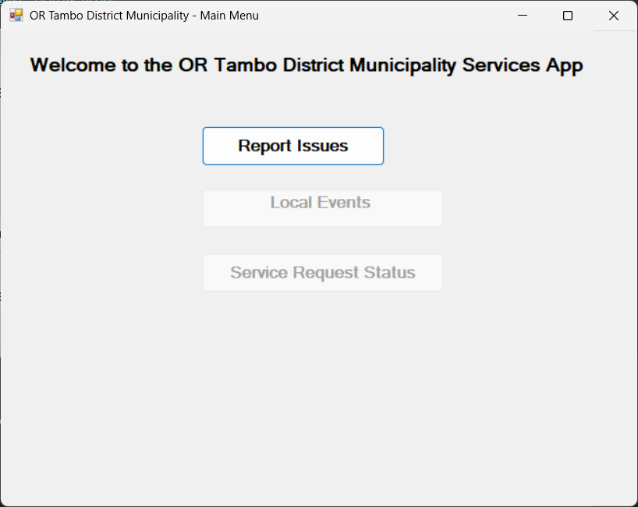
Figure 1: Main Menu startup
This demonstrates that the "Report Issues" task is active, while the "Local Events" and "Service Request Status" buttons are correctly disabled (greyed out).

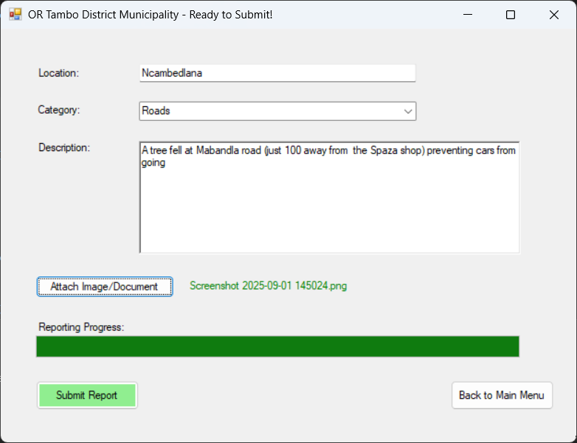
Figure 2: Report Issues
This screenshot displays the Report Issues form for the OR Tambo District Municipality. It highlights the user input fields (Location, Category, Description), the media attachment button, and the dynamic ProgressBar engagement feature actively indicating reporting progress.

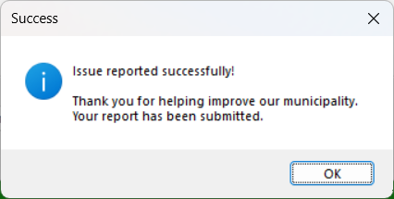
Figure 3: Output feedback mechanism
Output feedback mechanism displaying the success MessageBox that appears after the user clicks "Submit Report", confirming that the issue has been successfully captured and stored in the application's data structure.

4. Source Code Snippets
Data Structure (IssueReport.cs):
public class IssueReport
{
public string Location { get; set; }
public string Category { get; set; }
public string Description { get; set; }
public string AttachedFilePath { get; set; }
public DateTime ReportDate { get; set; }
}

public static class DataManager
{
public static List<IssueReport> ReportedIssues = new List<IssueReport>();
}
Submit Button Logic (ReportIssuesForm.cs):
private void btnSubmit_Click(object sender, EventArgs e)
{
if (string.IsNullOrWhiteSpace(txtLocation.Text) || cmbCategory.SelectedIndex == -1 || string.IsNullOrWhiteSpace(rtxtDescription.Text))
{
MessageBox.Show("Please complete all fields.", "Validation Error", MessageBoxButtons.OK, MessageBoxIcon.Warning);
return;
}

IssueReport newIssue = new IssueReport
{
Location = txtLocation.Text,
Category = cmbCategory.SelectedItem.ToString(),
Description = rtxtDescription.Text,
AttachedFilePath = attachedFileName,
ReportDate = DateTime.Now
};

DataManager.ReportedIssues.Add(newIssue);

MessageBox.Show("Issue reported successfully!\n\nThank you for helping improve our municipality.", "Success", MessageBoxButtons.OK, MessageBoxIcon.Information);

txtLocation.Clear(); rtxtDescription.Clear(); cmbCategory.SelectedIndex = -1;
lblFileName.Text = "No file attached";
progressBar1.Value = 0;
}

