Name : Nomakosazana
Surname : Jubane
Student Number : ST10507027
Module Code : AAPD7112
Module Name : Advanced Application Development
Assessment : Portfolio of Evidence (PoE) Part 1
Date : 02 September 2026
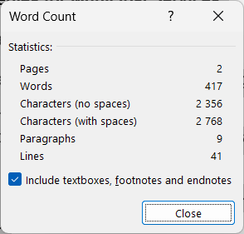

- List of Five User Engagement Strategies Considered
- Gamification and reward systems (e.g., awarding digital badges or points for problem reporting).
- Community Impact Dashboards (giving visual feedback on the fixed concerns in the user’s area).
- Two-way Communication Loops (sending SMS or push notification status updates to citizen).
- Multi-channel Accessibility (including USSD/SMS for those without smartphones).
- Social Voting and Prioritisation (enabling residents to upvote important local problems to put them on the municipality’s agenda).

- Explanation and Justification of the Chosen Strategy
Citizen confidence in service delivery is generally poor for distressed South African towns owing to a perceived lack of response . According to Hart et al. (2019), basic service technologies often fail since they are one-way communication channels and people do not know whether their complaints had been received and acted upon or not. To mitigate this, the user engagement approach used for the OR Tambo District Municipality application is the construction of a Community Impact Dashboard, enabled by a dynamic visual progress indicator.
The idea behind this is that it may provide the user instant concrete feedback. In the built application this is accomplished by the dynamic ProgressBar, which gets filled as the user fills the reporting form, and by clear success MessageBox notifications upon completion of the submission. This micro-level visual feedback feeds into the larger idea of a Community Impact Dashboard by confirming that the municipality is actively working on and appreciating the user’s input.
Hart et al. (2019) argue that if individuals can clearly see the status of their service requests, their desire to engage in municipal government is much enhanced. Visual clues lower the cognitive strain on the user and turn a potentially stressful bureaucratic procedure into an engaging, transparent experience. The program closes the feedback loop that is notably missing from many South African municipal systems, indicating the user their complaint has gone from pending to filed.
Also, this technique is very scalable and inclusive. This is unlike more complicated gamification systems which might be intimidating for older or less tech-savvy users; a simple progress bar and unambiguous success notifications are comprehended by all age groups. It uses very little data, which is a huge factor for those who are dependent on mobile data in South Africa. Finally, the use of visual feedback systems allows us to directly address the key problem described by Hart et al. (2019), the disconnection between citizen reporting and municipal action, to encourage prolonged active engagement.

Reference List
Hart, T.G.B., Nhamo, G. and Mupfiga, L., 2019. Innovation for Development in South Africa: Experiences with Basic Service Technologies in Distressed Municipalities. Forum for Development Studies, 47(1), pp.23-47.

