**Module: R4: Computer Architecture**

**Section:** Caches **Task:** Cache Visualization

**Task 1**

**Cache Visualization**

* **Question:**

1. **Venus Setup:**

Opened the terminal in my Lab Directory and ran this command to connect my labs to venus:  
  
java -jar tools/venus.jar . -dm

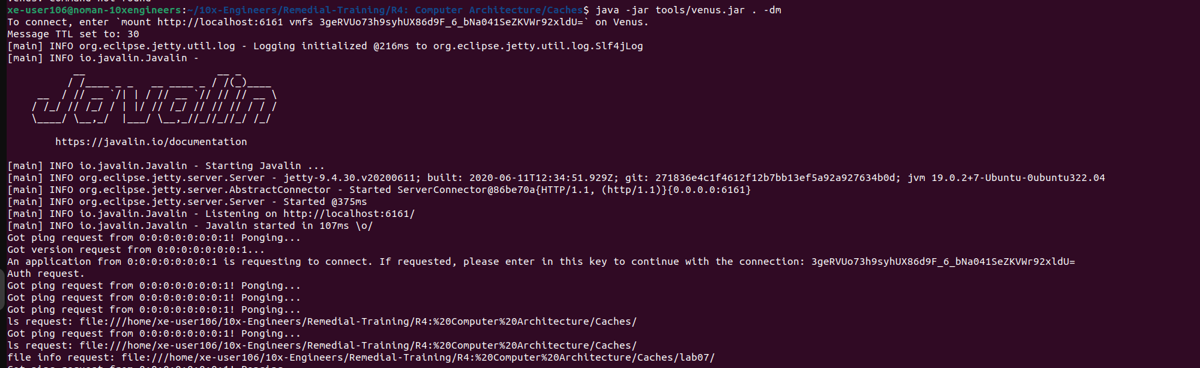

1. **Cache Simulation:**

Ran the cache.s in my venus simulator.

