**Module: R4: Computer Architecture**

**Section:** Caches **Task:** Memory Accesses

**Task 2**

**Memory Accesses**

**Scenario 1**

1. **Program Parameters:**



1. **Cache Parameters:**

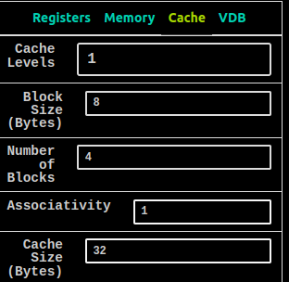

* **Questions:**
  1. ***What combination of parameters is producing the hit rate you observe?***

The combination of parameters that is producing the hit rate are **“step-size**

**and block size”**. Because step-size in bytes is exactly equal to the block

size in bytes (8 bytes). So, whenever we try to write to a block while it is

warmed up, it results into a conflict miss because we have updated the

index to (index = index + step-size). So it always tries to write a different

value to the same index(0th row) in cache which results into a conflict

miss. So we are missing everytime. **Hit Rate = 0.0**

* 1. ***What is the hit rate if we increase Rep Count arbitrarily?***

Increasing rep-count arbitrarily won't affect the hit rate because there were

no hits in the cache in the first place. As rep-count increases, the program

will still fail to find data in the cache and will result in misses. Therefore,

the hit rate will remain 0.

* 1. ***How could we modify one program parameter to get an increased hit rate?***

We can actually do it by 2 ways.

1. [a0] = 32 bytes ***#by changing array size***
2. [a1] = 32 bytes ***#by changing step-size***

