**Module: R4: Computer Architecture**

**Section:** Caches **Task:** Memory Accesses

**Task 2**

**Memory Accesses**

**Scenario 2**

1. **Program Parameters:**

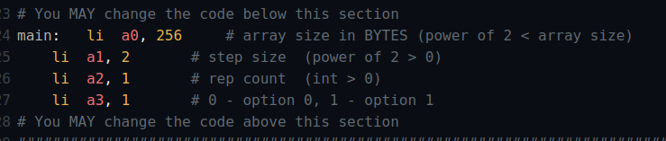

1. **Cache Parameters:**

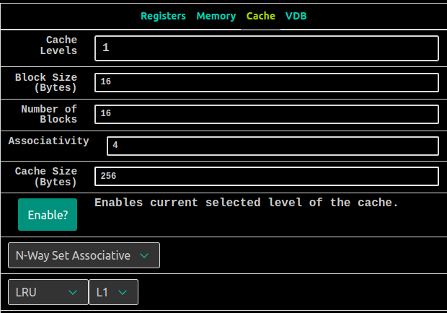

* **Questions:**
  1. ***How many memory accesses are there per iteration of the inner loop (not the one involving Rep Count)?***

***Hit Count: 48***

***Accesses: 64***

Since each iteration of the inner loop involves two memory accesses (read

and write), we can calculate the number of memory accesses per iteration:

Memory accesses per iteration = $\frac{Total Accesses}{2 * rep}$

Memory accesses per iteration = = 32

* 1. ***What is the repeating hit/miss pattern?***

The repeating hit/miss pattern can be determined from the visualization.

We observe from the accesses and the hit count which demonstrates that

every 4 accesses result in 3 hits and 1 miss. Henceforth, the hit rate of

0.75.

The repeating pattern is *mhhh*.

* 1. ***Keeping everything else the same, what does our hit rate approach as Rep Count goes to infinity?***

As we increase our rep-count, our Hit Rate approaches to 1 which can be calculated from the following formula:

**Assuming: Rep-Count = 88**

Hit Rate = $\frac{Hit Count}{Total Accesses}$ = $\frac{5612}{64 * 88}$ = 0.99644 ≅ 1.0

* 1. ***Fill in the BLANKS***

We should try to access one [ **segment** ] of the array at a time and apply all of

the [ **functions** ] to that [ **segment** ] so we can be completely done with it

before moving on, thereby keeping that [ **segment** ] hot in the cache and not

having to circle back to it later on.