**Module: R4: Computer Architecture**

**Section:** Caches **Task:** Memory Accesses

**Task 2**

**Memory Accesses**

**Scenario 3**

1. **Program Parameters:**

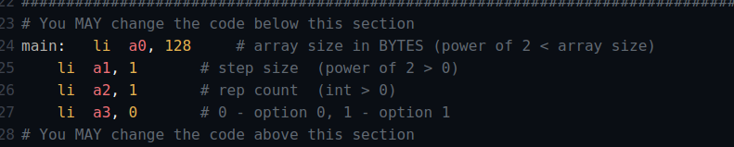

1. **L1 Cache Parameters:**

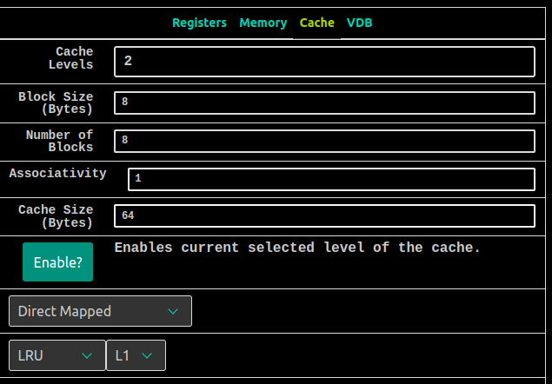

1. **L2 Cache Parameters:**

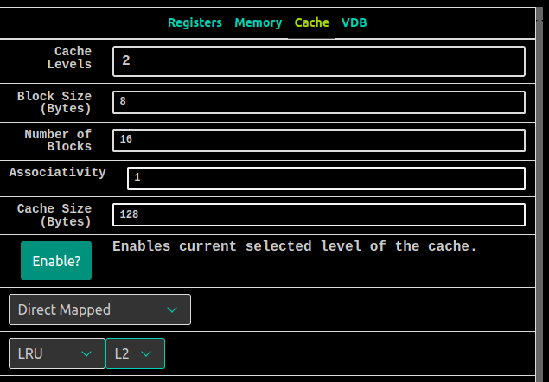

* **Questions:**
  1. ***What is the hit rate of the L1 cache? The L2 cache? Overall?***

**Hit Rate of L1:** Hit Rate of L1 Cache is 50% (mhmhmh) i.e. 0.50 in decimals.

**Hit Rate of L2:** Hit Rate of L2 Cache is 0% (mmmmm) i.e. 0.00 in decimals.

**Overall Hit Rate:** 0.50 + 0.00 = 0.50 (same as L1 cache). Since all the

miss accesses in L1 will also be misses in L2 cache, so overall hit rate will

be the same as L1 Cache.

* 1. ***How many accesses do we have to the L1 cache total? How many of them are misses?***

Total accesses to the L1 cache are 32 and 50% is the hit rate which

means half of the 32 accesses are misses. So there are a total 16 misses

in L1 cache.

* 1. ***How many accesses do we have to the L2 cache total?***

Total accesses to the L2 cache are 16 since we’ll only be accessing L2

cache when there is a miss in L1 cache. Since there are 16 misses in L1

cache, hence, the total number of accesses to L2 are 16 as well. (L2

accesses = L1 Misses)

* 1. ***What program parameter would allow us to increase the L2 hit rate, but keep the L1 hit rate the same?***

We can improve the hit rate for L2 cache by increasing the repcount. Changing this parameter will keep the L1 hit rate the same as previously (0.50) but the hit rate for L2 cache will increase.

For example, by setting the repcount=2, the L2 hit rate increase from 0.0 to 0.50. And for repcount=4, the hit rate for L2 cache will be 0.75 while hit rate for L1 cache is still 0.50.

* 1. ***Do our L1 and L2 hit rates decrease (-), stay the same (=), or increase (+) as we (1) increase the number of blocks in L1, or (2) increase the L1 block size?***
     + ***Increasing the no. of blocks in L1***

Increasing the number of blocks in L1 cache will potentially decrease the hit rate as we have now less space in a single block to store our data, therefore the hit rate for L1 will decrease **(-)** . While the hit rate for L2 will be the increase. **(+)**

* + - ***Increasing the size of blocks in L1***

Increasing the block size in L1 cache will also increase the hit

rate as we have more space now to store our data, therefore

the hit rate for L1 will improve **(+)**. While the hit rate for L2 will

be the same **(=)** as previous.