**Module: R4: Computer Architecture**

**Section:** Caches **Task:** Loop Ordering

**Task 3**

**Loop Ordering**

* **Action Item: Think about what the strides are for the nested loops in other five implementations.**
  1. ***Loop Order 1: ijk***

A = n;

B = 1;

C = 0;

* 1. ***Loop Order 2: ikj***

A = 0;

B = n;

C = n;

* 1. ***Loop Order 3: jik***

A = n;

B = 1;

C = 0;

* 1. ***Loop Order 4: jki***

A = 1;

B = 0;

C = 1;

* 1. ***Loop Order 5: kij***

A = 0;

B = n;

C = n;

* 1. ***Loop Order 1: ijk***

A = 1;

B = 0;

C = 1;

* **Terminal Output:**

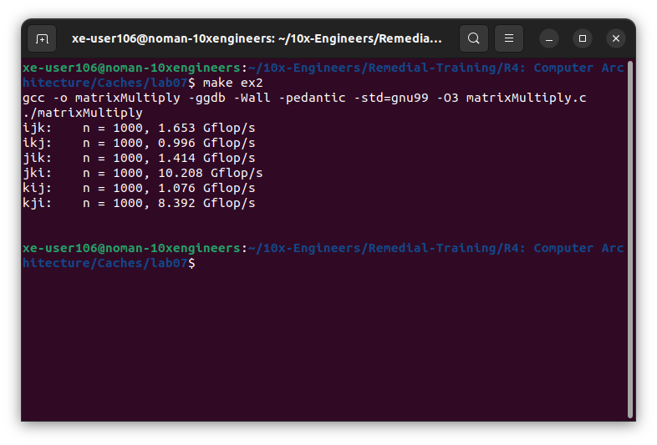

* **Questions:**
  1. ***Which 2 orderings perform best for these 1000-by-1000 matrices?***

The best 2 orderings are:

1. **“jki”** (Loop Order 4)
2. **“kji”** (Loop Order 6)
   1. ***Which 2 orderings perform the worst?***

The worst 2 orderings are:

1. **“ikj”** (Loop Order 2)
2. **“kij”** (Loop Order 5)