**Module: R5: RV-fpga**

**Section:** C Programming **Task:** Mirror Switches to LEDs

**Assessment 2.3**

**Mirror Switches to LEDs**

* **Mirror Switches to LEDs:**
  + **Description:** This program mirrors the value of the switches on the LEDs. For instance, if the switches are set to 1010 0001, the LEDs display 1000 0101.
  + **Code Explanation:**
    1. **Main Function:**

Two variables are declared: en is set to 0xFFFF to enable all GPIO pins, and inp_val is declared to store the input value from the switches. Another variable, output, is declared to store the mirrored value.

* + 1. **Infinite Loop:**

The program enters an infinite loop where it continuously reads the input value from the switches. The input value is then shifted 16 bits to the right to isolate the relevant bits.

The reverse function is called to mirror the bits of the shifted input value. The mirrored value is then written to the LEDs.

* + 1. **Reverse Function:**

The reverse function takes a 16-bit integer and returns its bitwise mirror. The function initializes a variable to store the reversed value.

It iterates 16 times, once for each bit in the 16-bit integer.

During each iteration, it shifts the reversed value left by one bit and copies the least significant bit of the input number to the reversed value.

The input number is then shifted right by one bit.

After all iterations, the function returns the mirrored value.

* + 1. **Terminal Output:**

Use the following command in source folder.

make flash

make watch

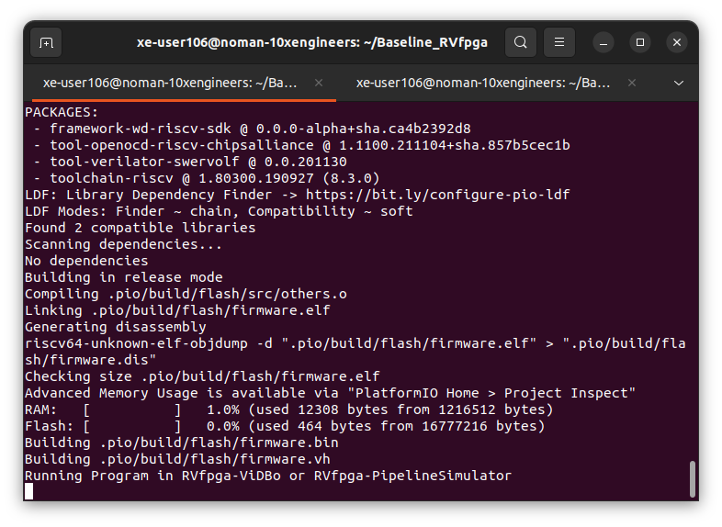

Visit this link to visualize Virtual Board: <http://localhost:8000/nexys-a7.html>

