**Module: R5: RV-fpga**

**Section:** C Programming **Task:** Check Palindrome

**Assessment 2.4**

**Check Palindrome**

* **Check Palindrome:**
  + **Description:** The program is designed to check if the binary representation of a value read from switches is a palindrome. If the value is a palindrome, all LEDs are turned on; otherwise, they are turned off. The program utilizes GPIO for input and output operations and includes functions to reverse the binary representation of a number and check for palindromes.
  + **Code Explanation:**
    1. **Main Function:**

The core functionality is within an infinite loop. In each iteration, the program reads the input value from the switches and shifts it 16 bits to the right to obtain the relevant portion of the input.

* + 1. **Palindrome Check:**

The program then calls a function to check if the shifted input value is a palindrome. This function reverses the binary representation of the input value and compares it to the original value. If they are identical, the value is a palindrome.

* + 1. **LED Output:**

Based on the result of the palindrome check, the program either turns all LEDs on or off. This is achieved by writing specific values to the GPIO controlling the LEDs. If the value is a palindrome, all LEDs are turned on by writing a value that sets all bits to 1. If it is not a palindrome, all LEDs are turned off by writing a value that sets all bits to 0.

* + 1. **Conclusion:**

The program effectively demonstrates how to manipulate and check binary values using bitwise operations and control hardware components like LEDs based on the results.

* + 1. **Terminal Output:**

Use the following command in source folder.

make flash

make watch

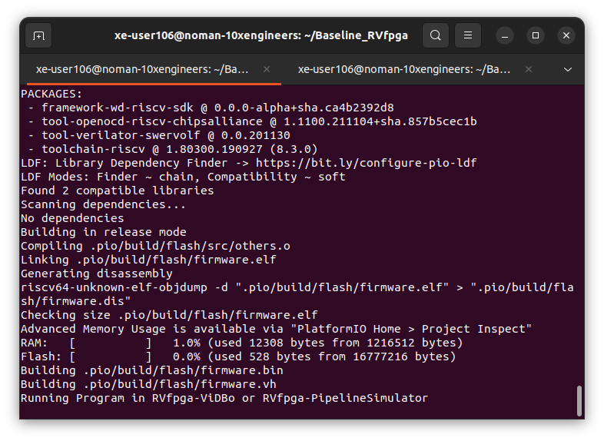

Visit this link to visualize Virtual Board: <http://localhost:8000/nexys-a7.html>

