**Module: R5: RV-fpga**

**Section:** RISC-V VeeR Core **Task:** Final Assessment

**Final Assessment**

* **Hello World Program:**
  + **Command:**

make -f ${RV_ROOT}/tools/Makefile

* + **Terminal Output:**

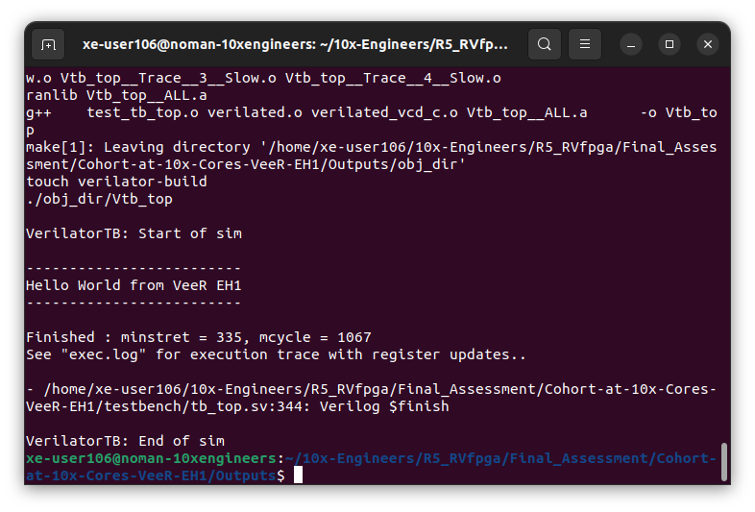

Here are the files that has been generated:

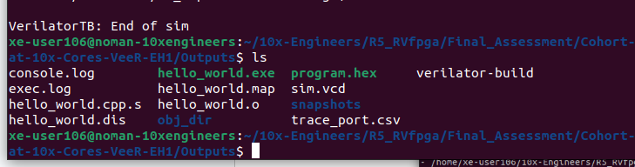

* **How to run an Example Test Program:**
  + **Steps:**
    1. Make a directory for the generated output files. E.g.

**mkdir temp**

* + 1. Change the directory as following:

**cd temp**

* + 1. Use the following command to run the test example program:

make -f $RV_ROOT/tools/Makefile verilator TEST=example_asm_test

* + **Terminal Output:**

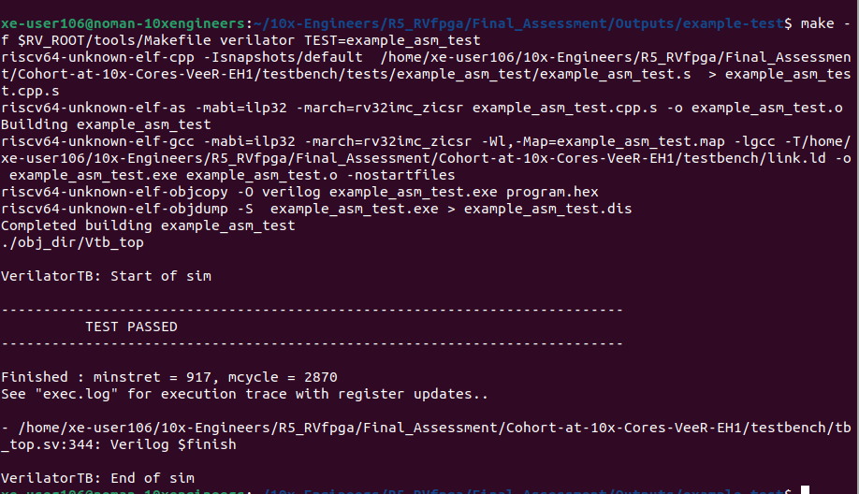

Here are the files that has been generated:

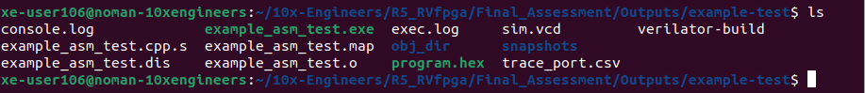

* + **Makefile Explanation:**
    1. **Command:**

make -f $RV_ROOT/tools/Makefile verilator TEST=example_asm_test

* + 1. **Purpose:**

This command runs the verilator target from the specified Makefile, while setting the TEST variable to **example_asm_test**.

* + 1. **Environment Check:**

The Makefile checks if the **RV_ROOT** environment variable is set correctly. If it doesn't point to a valid directory, the process will stop with an error.

* + 1. **Building the Test Program:**

The Makefile will look for a RISC-V GCC toolchain (riscv64-unknown-elf-gcc). If found, it compiles the **example_asm_test** file into a hex file (**program.hex**). If the toolchain is not found, it uses a precompiled hex file instead.

* + 1. **Verilator Build:**

The verilator-build target is executed, which compiles the Verilog source files using Verilator. It prepares the necessary files for simulation.

* + 1. **Running the Simulation:**

The verilator target is then executed. It runs the Verilator simulation with the compiled hex file (program.hex). The simulation will produce output based on the **example_asm_test program**.

* **Block Diagram of VeeR EH1 core complex:**

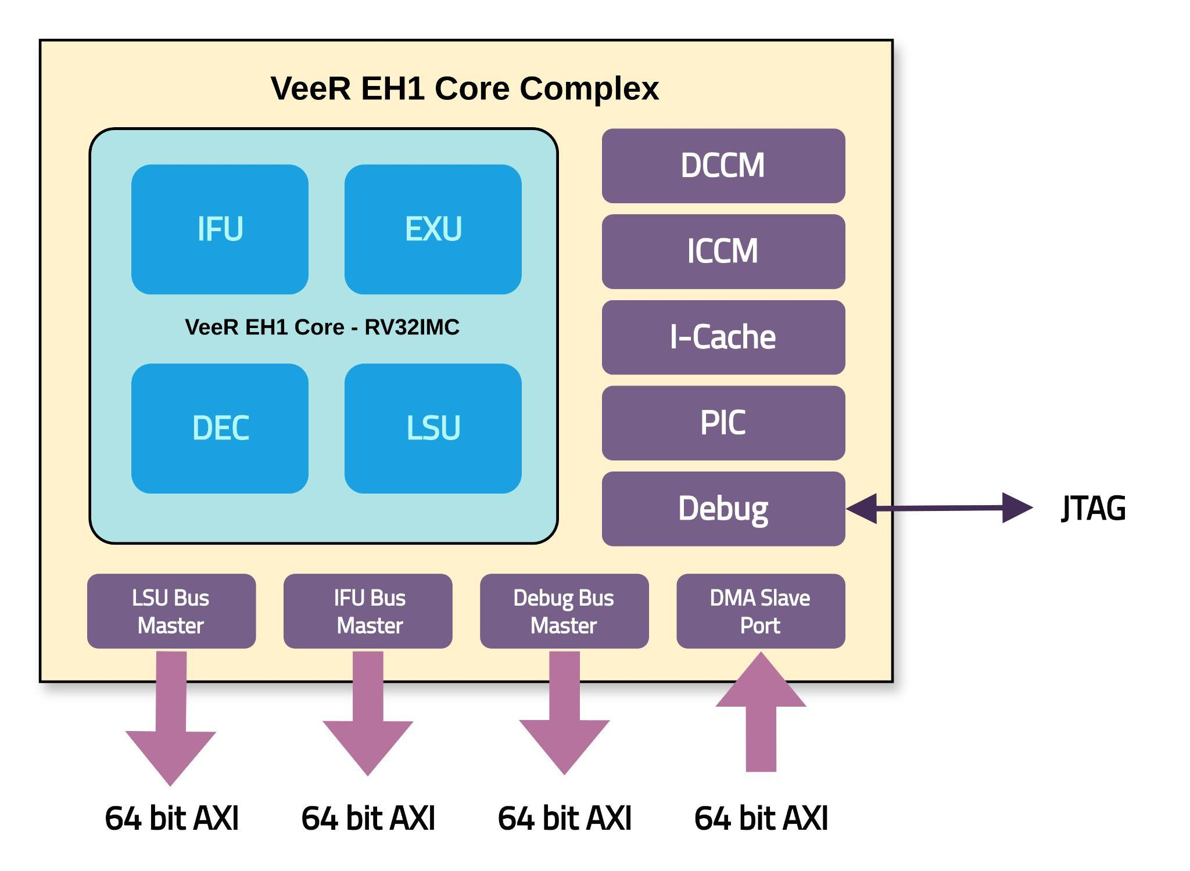

* **Block Diagram of Testbench Top File:**

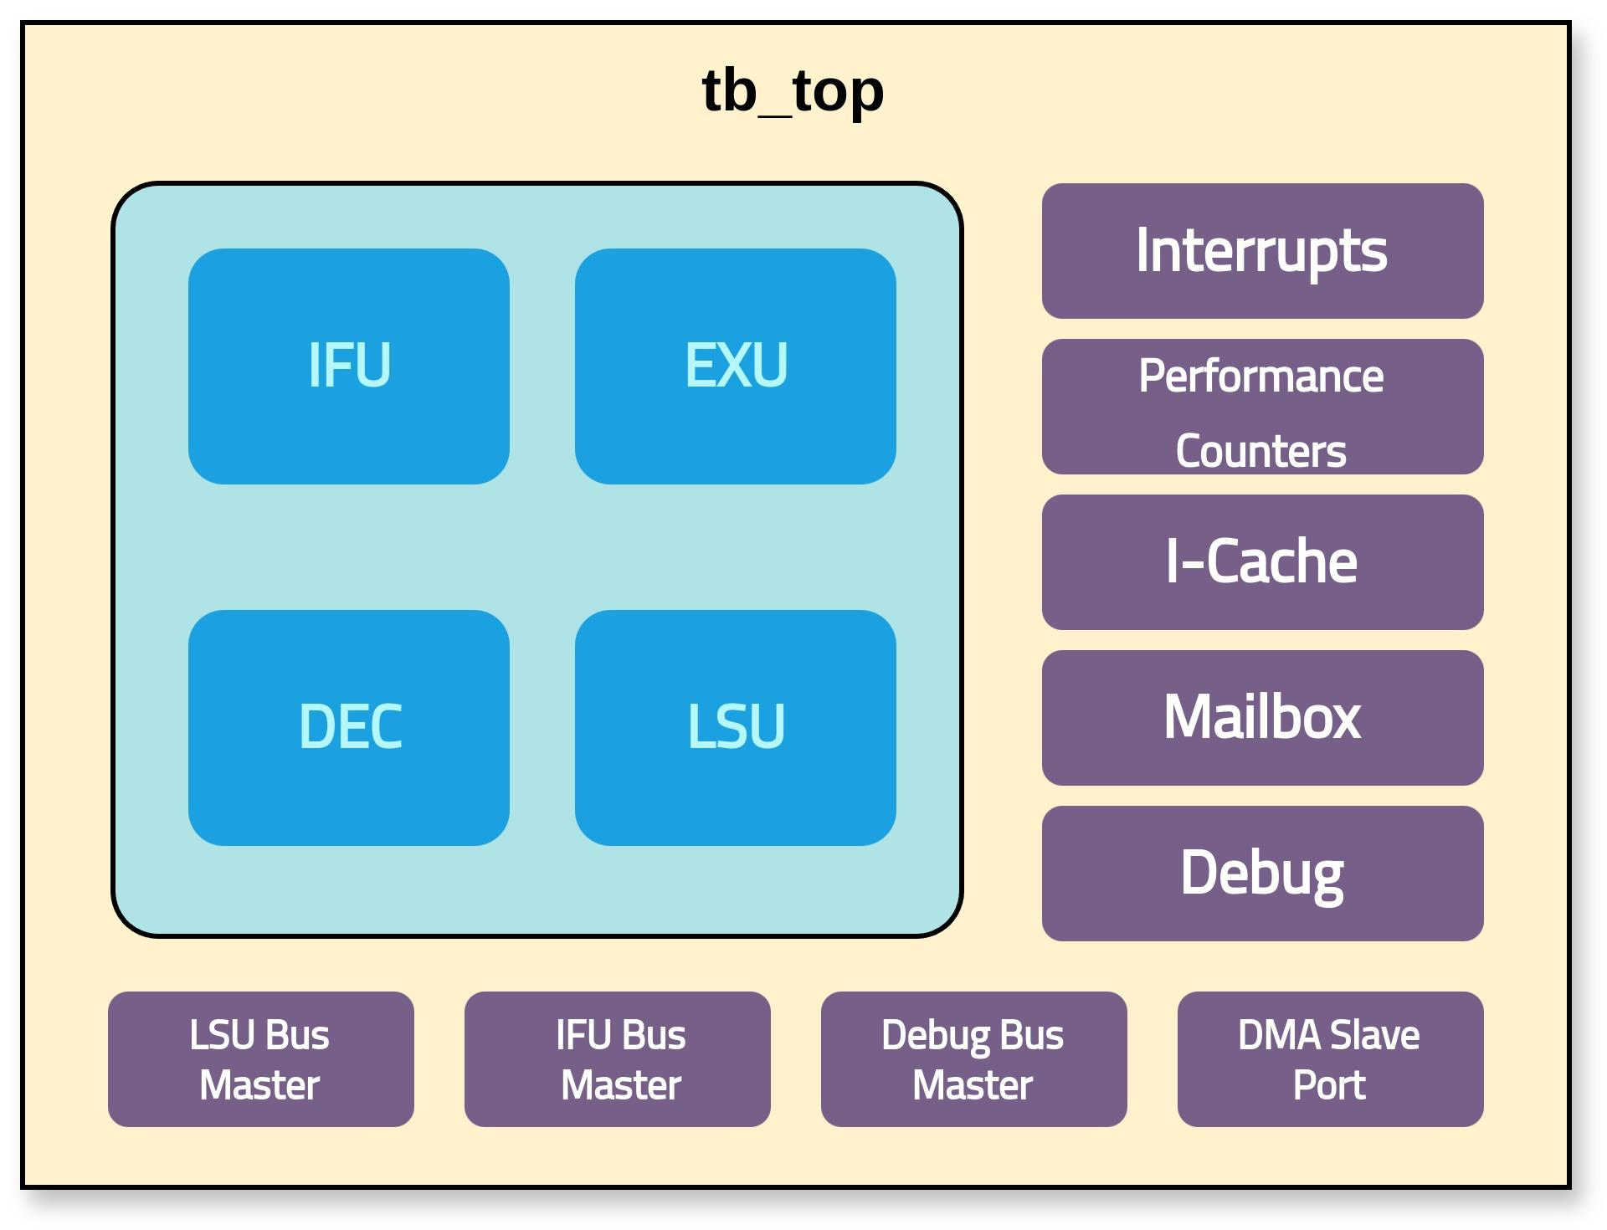

* **Testplans:**

The testplans can be found at the following link: [TESTPLAN](https://docs.google.com/spreadsheets/d/17z2MuNscjXZKYsNTLu15YemURzcrsqH-EUcoThfFN2M/edit?usp=sharing)